OEA/Ser.G
CP/INF. 6570/12
6 November 2012
Original: Spanish

NOTE FROM THE SECRETARY GENERAL OF THE OAS TO THE CHAIR OF THE PERMANENT COUNCIL CONCERNING THE BUDGET CEILING FOR THE 2013 PROGRAM-BUDGET ESTABLISHED BY THE GENERAL ASSEMBLY

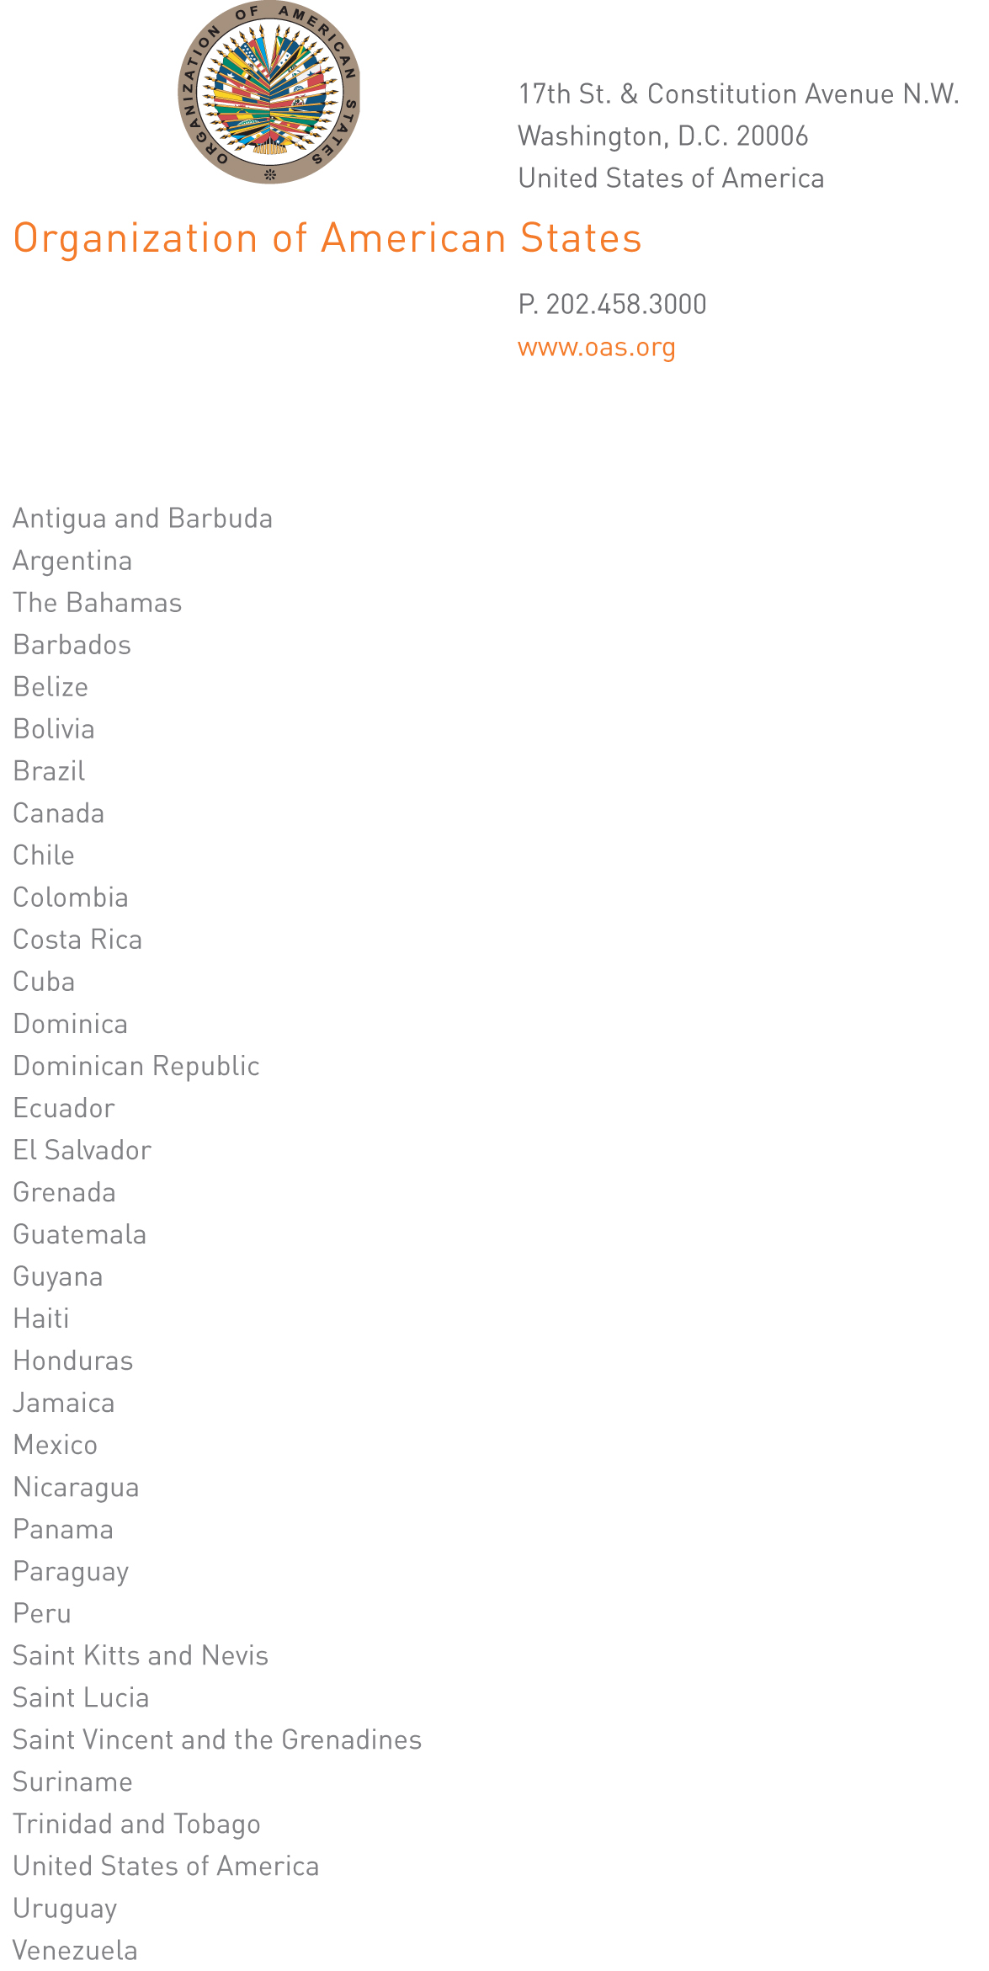

November 5, 2012

His Excellency Joel Hernández
Ambassador, Permanent Representative of Mexico
to the Organization of American States
Chair of the Permanent Council
Washington, D.C.

Excellency:

As you know, at its second plenary session on June 4, 2012, the General Assembly held in Cochabamba approved the financing of the program-budget of the Organization for 2013, setting the budget ceiling at $82.0 million.

Although quotas of $81.1 million were assigned in said resolution, operative paragraph 2.a.iii established a $1.8 million reduction in the budget ceiling of the Regular Fund. This calculation was based on an erroneous premise, which was to establish the budget ceiling based on the assumption that any or some of the member states would not pay their established 2013 quotas. However, based on agreements with member countries that were in arrears with their quota payments, it could be assumed that the quotas in arrears would not be a significant amount. It is worth noting that the supposed fact has no documented basis or precedent in the formulation of previous budgets.

Given that the forty-third special session of the General Assembly to adopt the 2013 program-budget of the Organization is so close, I believe there is an opportunity to recommend that the Preparatory Committee of said Assembly session consider proposing that the member states change the total amount of the budget ceiling agreed on last June by General Assembly resolution. To that end, I propose that said ceiling be set at $83.8 million to reflect, together with other incomes, the total quotas assigned to the member countries.

I must point out that, should the change I am proposing be adopted, it would not affect the levels of reserves to be generated from payment of quota arrears by member countries, which would add to the Reserve Subfund of the Regular Fund at the time of payment. In concrete terms, if a country has an agreement on quota arrears payment, each time it makes a payment, that income is included in the Reserve Subfund. Since an agreement of this kind exists, we anticipate a total of US$1.7 million going into that Subfund in December and that a further US$3.4 million could flow in during the course of 2013.
input.doc

Accept, Excellency, renewed assurances of my highest consideration.

José Miguel Insulza
Secretary General

