OEA/Ser.G
CP/INF. 6593/12
21 November 2012
Original: Spanish

NOTE FROM THE SECRETARY GENERAL
OF THE ORGANIZATION OF AMERICAN STATES
TO THE CHAIR OF THE PERMANENT COUNCIL CONCERNING THE COMMENTS AND
OBSERVATIONS OF THE UNITED STATES SENATE COMMITTEE ON FOREIGN AFFAIRS WITH REGARD TO THE ORGANIZATION

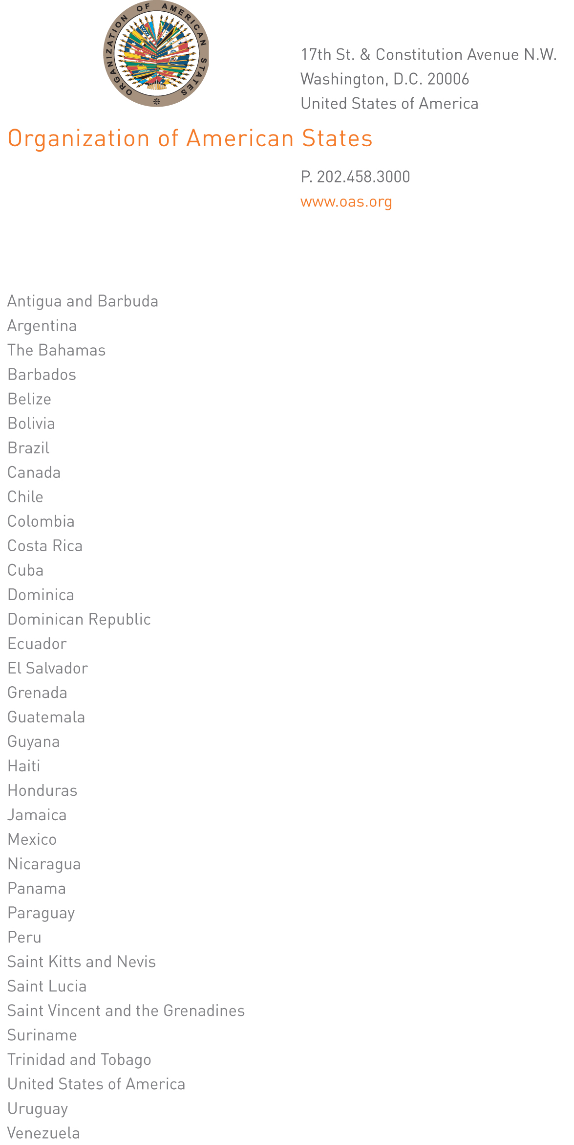
November 21, 2012

His Excellency,
Ambassador Joel Hernández,
Permanent Representative of Mexico
to the Organization of American States,
Chair of the Permanent Council,
Washington, D.C.

Excellency:

I am in receipt of a copy of a letter sent to you by four Distinguished Senators who sit on the Foreign Relations Committee of the United States Congress, in which they express their points of view regarding the way our Organization is being run. I have also seen a request to you from the head of that member state's Permanent Mission to the OAS for that letter to be distributed to the other member of the Permanent Council prior to the next regular meeting.

Under the circumstance, and given that the letter in question makes frequent references to the performance of the executive leadership of the General Secretariat, I believe it advisable to make some comments and offer some clarifications that I consider useful. Moreover, I respectfully request that this letter be delivered to the other members of the Permanent Council prior to its next regular meeting.

I must emphasize, first of all, the parallel between the analysis by the Members of Congress and the proposal I have been making to the OAS Permanent Council and the General Assembly since the beginning of the year, which has enjoyed broad support from the member states. I am referring to the need to prioritize mandates that our Organization can and must fulfill with respect to its four fundamental pillars, in order to be more efficient in the pursuit of its objectives in a context of resource constraints imposed by the economic circumstances that the region faces. I consider it important and encouraging that this message, which I have been reiterating emphatically for the past year, is now being supported by the Honorable Senators as a new proposal.

In my opinion, it is essential to consider the following issues:

1.- Strategic focus.

On December 19, 2011, I presented to the Permanent Council a document entitled "A New Strategic Vision of the OAS" (CP/doc.4673/11), in which I shared some general thoughts about our Organization and made proposals to prioritize what I called "fundamental tasks of the OAS." I suggested as well that this should be done through "concerted action between the member states and the General Secretariat toward the objectives that our members set as priorities." This document reflects a series of considerations and proposals that I have been presenting to the member states for the past several years.

In the general considerations, I said:

"I firmly believe that we must return to a strategic vision that centers on the core missions of the OAS and relies on them to guide the use of the Organization’s resources and the contextual measures that need to be adopted immediately. If we return to giving strict priority to the core OAS missions, that would lead us to concrete measures that we could carry out efficiently and achieve the objectives that the member states have set. Today we have clear budgetary restrictions, many of them diagnosed in recent months. The assumption is that by concentrating on fundamentals, not only can we overcome the short-term situation, but also dispel many doubts about what role the OAS is destined to play in the hemispheric context."

The tasks that I proposed we should focus on were the same as those I now read, one year later, in the letter from the United States senators. In the region’s premier political forum, the defense and promotion of democracy and human rights, attention to regional security concerns, and the facilitation of development are of the essence: they define the key role it plays in regional affairs.

However, I did not merely put forward these broad ideas. I made suggestions as to how they might be implemented, once again coinciding with the vision proposed by the U.S. Senators, one year later. I quote:

“These proposals seek to strengthen OAS capabilities in areas in which the countries recognize its contribution and in which the Organization creates the greatest value-added. This is based on two fundamental approaches:

1. To allocate Regular Fund resources exclusively to carrying out our core tasks, and with respect to other activities that the member states might wish to entrust to the Organization, create specific funds in each instance to finance them.

2. To examine the content of each task to determine whether the OAS is the organization best placed in the inter-American system to carry it out, and if not, identify potential opportunities for partnership with other agencies of the system in order to implement them, allocating our resources in a more efficient and rational manner.”

I have insisted repeatedly over the past year that this task must be pursued as soon as possible. It is unfortunate that the Honorable Senators had not been informed about these developments. Nonetheless, I believe it to be a positive thing that, even so, they do agree with this vision.

2.-Financial decisions.
With respect to the need to make difficult financial decisions, I should let the Honorable Senators know that for the past year the member states have been working very diligently on a review of the Organization's mandates.
Once again, not only do I agree with the need for this: this year I proposed a budget that reduces expenditure on OAS-related entities and programs that, in my view, do not correspond to its core missions.
Less than a week ago, at its forty-third special session, the OAS General Assembly adopted the “Program-Budget of the Organization for 2013 and Contributions for FEMCIDI” (AG/RES.1 [XLIII-E/12]), which partly modified my proposal but recalled that:
“human rights, democracy and good governance, integral development, and multidimensional security were posited as priority areas of the Organization, which have since been recognized as “the four pillars” of the Organization, as is reflected in the document titled “A Strategic Vision of the OAS” (CP/doc.4673/11).
At that special session, the General Assembly also resolved to:
“instruct the Permanent Council to complete the work related to the prioritization of the mandates of the Organization as soon as possible and to instruct the General Secretariat to include the results of that work in the preparation and presentation of the proposed program-budget for 2014.”
There is, therefore, a clear commitment by the member countries, whose responsibility it is to do this, to make the tough financial decisions demanded by the crisis facing several member countries.

3.- Human resource policy

At its forty-second regular session in June 2012 in Cochabamba, Bolivia, the General Assembly adopted a resolution entitled “Human Resources Policy of the General Secretariat of the Organization of American States” (AG/RES. 2755 – XLII-O/12), providing for the Organization's human resource policies to be reformed to ensure that OAS staff will be recruited via an efficient, transparent, and competitive process, and for the Organization's human resource structure to be transparent, professional, and in keeping with its strategic objectives. The resolution also amended OAS human resource rules to cut the maximum percentage of OAS staff that can be hired in "positions of trust," to 4%. That percentage is much lower than what it used to be. Nevertheless, I implemented the new rule quickly, as a result of which I withdrew a considerable number of staff members in management positions, replacing them with people already working for the Organization.

In September 2012, the OAS General Secretariat published a proposed human resource strategy (CP/CAAP/3186/12) to implement this vision. The strategy we put forth, which was discussed with the OAS Staff Association, proposed changes to the General Standards of the Organization to govern policies for open and transparent competition for hiring of all staff, including a clear definition of the targets to be achieved by each newly hired staff member.

It also provides for the job requirements of all OAS staff to be regularly updated and for the performance evaluation system to be modernized. It is now in the hands of the Permanent Council, as decided by the General Assembly at its special session last week, to discuss the necessary changes to the administrative regulations for the new Human Resource Strategy to be fully implemented in time for formal adoption at the next OAS Assembly General, to be held in June 2013 in Guatemala.

It is important to remember that the Organization has to face the structurally embedded fact that every year staff salaries have to be adjusted according to United Nations cost of living estimates without member states’ quotas being adjusted accordingly. That necessarily entails cutting positions. The term “cannibalization” has been used to describe this situation, which will continue as long as the structural constraint persists. For that reason, I have proposed on several occasions in the past few years that quotas automatically be adjusted in line with the salary increases.

Finally, Distinguished Chair, I wish to reiterate my readiness at all times to provide any further information that the permanent mission may need in order to forward it, in the manner they deem appropriate, to the members of their Congresses.

In a changing international world, I consider it essential that the Congresses of this Hemisphere are kept fully abreast of major developments concerning the Americas. That naturally includes any administrative and budgetary matter of interest to them.

The OAS is and must continue to be the premier political institution in our Hemisphere. Its undoubted prestige in areas such as the promotion of democracy, the defense of human rights, electoral observation, gender equality, governance, transparency and efforts to combat corruption, public safety, the fight against drug trafficking and organized crime, institution-building, the forging of cooperation networks, and the training of human resources for development; all of that based on a set of legal instruments unparalleled by any other institution in the Hemisphere, will ensure its ongoing relevance.

That depends, however, on all of us accepting that times have changed in our region and that they now demand cooperation rather than imposition. Throughout my term in office, for more than seven years, I have striven to ensure that this institution is truly inclusive and democratic and I will continue to do so until the end of my mandate. It is no easy task to get 34 countries to agree on the best way to manage and prioritize matters as important as those I have mentioned. Nowadays, that can only come about through the sincere practice of democracy, dialogue, tolerance of diversity, and the quest for points of consensus.

Sincerely yours,
José Miguel Insulza,
Secretary General.

input.doc

