OEA/Ser.G
CP/INF. 6648/13
14 February 2013
Original: English

REMARKS BY THE SECRETARY-GENERAL OF THE ORGANIZATION OF THE
UNITED NATIONS, HIS EXCELLENCY BAN KI-MOON,
PROTOCOLARY MEETING OF THE PERMANENT COUNCIL OF THE
ORGANIZATION OF AMERICAN STATES

Wednesday, February 13, 2013
Washington, D.C.

U N I T E D N A T I O N S N A T I O N S U N I E S
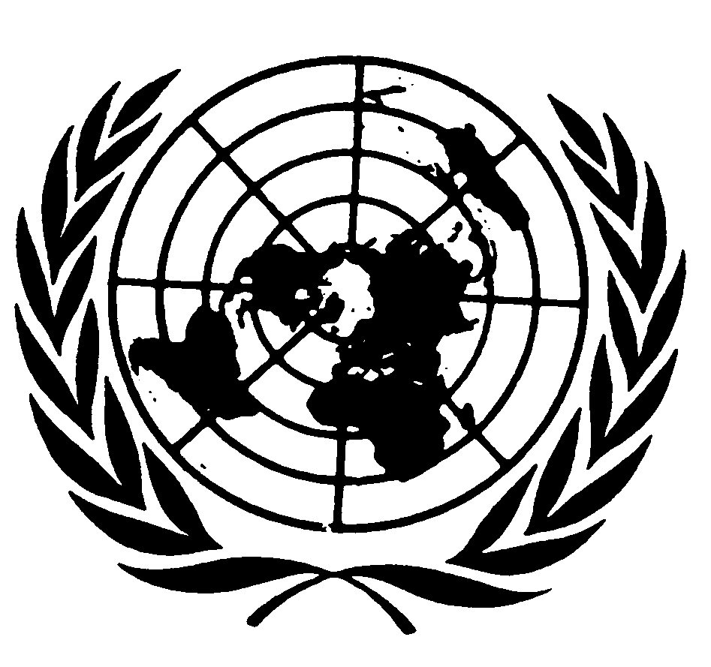

THE SECRETARY-GENERAL
---
REMARKS TO PERMANENT COUNCIL OF THE
ORGANIZATION OF AMERICAN STATES
Washington, 13 February 2013

Your Excellency Ambassador Denis Ronaldo Moncada Colindres, Chairman of the Permanent Council and Permanent Representative of Nicaragua,
Your Excellency José Miguel Insulza, Secretary General of the Organization of American States,
Your Excellency Albert Ramdin, OAS Assistant Secretary General,
Distinguished Permanent Representatives,
Excellencies,
Ladies and gentlemen,

Thank you for your warm welcome to this extraordinary House of the Americas.

I am pleased to be here and finally make good on Secretary-General Insulza’s kind and longstanding invitation.

It is a profound honour to address the Permanent Council of the Organization of American States.

You are the world’s oldest regional organization. The history and vision of the OAS are reflected in every corner of this remarkable building.

I am here to pay tribute to that legacy.

But I am also here to look ahead with you and to highlight the importance of an even deeper strategic partnership among us.

That is my main message today: I am convinced that the United Nations can play a greater role in your region — just as your region can play an ever more important role in the UN.

The time is right.

You have experiences to share … ideas to spread … energy to help fuel global solutions.

I know it because I have seen it.

Over the last six years as United Nations Secretary-General, I have had the honour of working closely with your countries and travelling throughout the Americas.

In addition to extensive visits around the United States and Canada, I travelled to Panama for the OAS General Assembly in my first year as Secretary-General.

I went to Jamaica and was proud to be the first UN Secretary-General to address a Summit of the Caribbean Community.

I visited Haiti and Chile soon after terrible earthquakes.

I travelled to Guatemala and took part in a meeting of the Central American Integration System.

I have attended the Americas Summit and journeyed through South America on numerous occasions.

I have even seen more than I had planned. In 2011, I had firsthand experience with the volcanic ash cloud that spread across South America.

Our flight was diverted from Buenos Aires to Córdoba.

Our delegation completed the 700 kilometre journey by overnight bus.

Along the way, I had the unexpected pleasure of enjoying alfajores in a roadside gas station.

This was in the city of Rosario - which happens to be the hometown of my Chef de Cabinet, Susana Malcorra, who is with me today.

By the time I made it to Buenos Aires, it was national news.

Some Argentineans smiled and said, “Please remember. The alfajores are from Argentina. But the ash is from Chile!”

All joking aside, I have seen tremendous progress and promise wherever I have been.

Many economies in the region are growing. Democratic institutions are strengthening. Global influence of the Americas as a whole is on the rise.

You are expanding your role as a bridge between the nations of North and South as well as among the South.

You are also exploring new and dynamic ways to integrate your efforts and approaches.

There are different configurations in which you work together – some regional, others subregional. CELAC. Mercosur. UNASUR. Caricom. SICA.

These reflect your views on how best to associate and advance different issues and objectives.

But in whatever form, you are working to fight poverty and inequality – tackle the legacy of past human rights violations – and promote the rule of law and social inclusion.

And there is no doubt in my mind: The engagement of the Western Hemisphere and its regional structures are crucial to addressing 21st century challenges and carrying forward our common agenda.

That is why I am here.

Excellencies,
Ladies and Gentlemen,

I am also here in the midst of many other pressing realities in the world around us.

Let me begin with this week’s nuclear test conducted by the Democratic People's Republic of Korea.

This was an outrageous and reckless act. I have deep concerns about the impact on regional stability and the global effort to curb nuclear proliferation. Yesterday, I met with the Security Council which strongly condemned the test and is exploring further action.

It is in this context that I want to commend your proud record of making Latin America and the Caribbean a zone free of nuclear weapons more than 45 years ago. The Treaty of Tlatelolco is a model for the world. Today more than 110 countries are covered by nuclear-weapons-free-zones. With your help, we can make it all 193 UN Member States – and that can begin with the long overdue entry-into-force of the Comprehensive Nuclear Test Ban Treaty.

I am also deeply concerned about Syria.

As you know, well over 60,000 people have been brutally killed.
The political environment within Syria and across the region remains polarized.

The Security Council remains paralyzed.

Meanwhile, the death toll keeps climbing. We continue to see unrelenting human rights violations, including widespread sexual violence. Every day, another 5,000 Syrians flee the country.

Despite the difficulties, we must keep pushing for a political solution. Joint Special Representative Lakhdar Brahimi continues his diplomatic efforts.

It is essential for the Security Council to overcome the deadlock, and find the unity that will make meaningful action possible.

In the wider region, we must also keep working for Israeli- Palestinian peace. With change across the Middle East, it is long past time to resolve this conflict.

We know what a just and permanent solution must look like. In the year ahead, we must stop finding excuses and start finding answers.

The crisis in Mali is also front and centre.

The international community has responded to the government of Mali’s call for help against armed and terrorist groups. These actions are centered on the goal of fully restoring Mali’s constitutional order and territorial integrity.

But as acute as the problems are, we cannot lose sight of the context in which Mali is only a part: a sustained, systemic crisis across the Sahel region.

Climate change, political turmoil, terrorist activity and arms smuggling are spilling over borders and threatening peace and security.

Drug trafficking is also a fundamental part of the picture.

The crisis in the Sahel illustrates our interconnections. It shows how much what happens there is related to what is happening in Latin America.

Drugs and crime are not simply matters of North and South, but also East and West.

Central America and the Caribbean are being used as a bridge to North America, but the Americas are a staging post for Europe. One of the trafficking routes is through West Africa.

And the notion of origin, transit and destination countries is also fast disappearing. For example, once purely a transit region, West Africa now confronts increased consumption of cocaine. Several countries in the Americas face similar concerns.

At the Sixth Summit of the Americas in Cartagena last year, hemispheric leaders called upon the OAS to analyse the results of current drug policies and explore new approaches. The UN is contributing to inform that policy review.

Transnational organized crime and drug trafficking are causing enormous fears for personal safety and fueling rising levels of violence, including some of the highest homicide rates in the world. The United Nations is committed to working with you to combat these regional, and indeed, global challenges.

Excellencies,
Ladies and gentlemen,

In Syria, Mali and elsewhere – regional organizations have played a vital role.

As you know, Chapter 8 of the UN Charter underscores regional arrangements.

But in our increasingly integrated world, cooperation between the United Nations and regional organizations is not just an aspiration, it is a necessity.

We must continue to promote innovative arrangements and ensure that each partnership arrangement draws on respective comparative advantages.

The UN and the OAS have a solid foundation on which to build.

Our organizations have cooperated closely to promote peace in Central America.

Exactly twenty years ago this month, we jointly created the International Civilian Mission in Haiti — the first and only joint mission of the UN and OAS.

We have worked to coordinate our electoral activities.

The Economic Commission on Latin America and the Caribbean … the UN Development Programme … the Pan-American Health Organization … and the International Labour Organization are partnering with the OAS, the World Bank and the Inter-American Development Bank to support follow-up to the Summits of the Americas’ recommendations.

The UN Office on Drugs and Crime works closely with the OAS Secretariat on issues of citizen security, the fight against corruption, drug trafficking and organized crime.

There are important synergies between the regional human rights bodies and the UN human rights machinery, including the Office of the High Commissioner for Human Rights.

In all these areas and more, our complementary agendas are clear.

Excellencies,
Ladies and gentlemen,

As I began my second term as Secretary-General, I identified five areas where needs are greatest and where collective action can make the greatest difference: sustainable development … prevention … supporting nations in transition … building a more secure world … and empowering women and young people.

These imperatives align with the four pillars of the OAS -- democracy, human rights, security and development.

In recent decades your experiences and successes have helped show the crucial interconnections between these pillars.

Beginning with the promotion and protection of democracy: the OAS Charter, of course, features a democratic stipulation for participation in the organization.

In 2001, the OAS adopted the Inter-American Democratic Charter, codifying essential elements and recognizing people’s right to democracy.

Your experiences in democratic transitions have benefitted the region and hold valuable lessons far beyond.

Many countries of the Americas have also been pioneers in the field of transitional justice.

This includes the establishment of truth seeking mechanisms … reparations for victims of human rights violations … and the preservation of memory.

As many countries now transition from conflict to peace, from authoritarian rule to democracy, they can learn from you.

In the wake of the Arab Spring, the UN has provided a space for several countries of the Americas to share their experiences on democratic transitions with the countries of the Middle East and North Africa. We can and should build on this important work.

That leads me to your second pillar, human rights.

Once again, the OAS has helped blaze the trail. Your American Declaration of the Rights and Duties of Man predates even the Universal Declaration of Human Rights. You have also led the way with the first binding treaty in history to address violence against women.

As the UN High Commissioner for Human Rights has stressed, the Inter-American Commission on Human Rights and the Inter-American Court of Human Rights are pioneering examples demonstrating the vitality and effectiveness of regional human rights bodies.

I encourage you to preserve the precious legacy and achievements of the Inter-American human rights system – and I encourage full participation by all Member States.

Let me now turn to the third pillar, security

Since day one as Secretary-General, I have been encouraged that during episodes of tension in the region, this Permanent Council provides a forum for peacefully resolving differences.

The Americas region also helps promote peace and security more broadly. Today, some of the top troop contributors of UN peacekeeping hail from the Americas. I thank you deeply.

I am also grateful for the Americas’ unwavering support to Haiti and our UN Stabilization Mission, MINUSTAH.

MINUSTAH remains a critical element for Haiti’s long-term stability and social and economic development. The Mission has been led by officials from the region—a testament to the importance that the United Nations attaches to your special role.

Excellencies,
Ladies and gentlemen,

Finally, let me turn to development – sustainable development.

The Americas have made significant progress in reducing poverty and meeting the Millennium Development Goals.

Your economies showed tremendous resiliency in the face of the 2008 financial crisis. But structural problems persist. Inequality runs deep. And we know inequality feeds instability.

After several years of economic growth, low inflation, poverty reduction and higher employment, the challenge before the region is to close important gaps that conspire against sustainable development and security.

That means creating decent jobs. It means moving toward higher productivity and more sustainable patterns of production. It means opening new doors of opportunity for women, youth and indigenous peoples.
And it means addressing the clear and present danger of climate change. We have many of the solutions already but we need to accelerate and scale-up implementation.

Some countries in the Americas are embracing the transition to a low-carbon, low-emissions future. I encourage you all to do more and my Sustainable Energy for All initiative aims to support and expand such efforts.

A global climate change agreement would give us the engine we need to advance decisively on this path. We must work together and mobilize the capital and political will for a global, legally binding climate change agreement by 2015.

For my part, I will continue to press for action at every opportunity and plan to convene world leaders next year to focus on making the big decisions the world so urgently needs.

Following the success of Rio-plus 20, the time is ripe to rethink the development agenda with sustainability at the core and equality as a driver of growth.
input.doc

To forge the way ahead and help begin to define new goals for sustainable development, I have appointed a High-level Panel on the post-2015 development agenda.

The Panel includes five distinguished members from Brazil, Colombia, Cuba, Mexico and the United States. I look forward to the Panel’s recommendations as an input for the inter-governmental process.

Finally, let me say that this region has great potential to strengthen the global partnership for development.

I would highlight three initiatives that you have been pursuing in this regard: The Energy and Climate Partnership of the Americas; Connectivity for the Americas; and the public-private partnership, Pathways for Prosperity.

These are good examples of your dynamism and experience in tackling central problems
Excellencies,
Ladies and gentlemen,

I have addressed many challenges and opportunities today – but each underscores the interconnections between policies and people. And each highlights the vitality of Latin America and the Caribbean and the Americas region as a whole.

You are crucial to leading us all to a better world of dignity, prosperity, opportunity and social justice.

Thank you once again for your commitment. We have a full agenda before us and I look forward to continuing to work closely with you at this pivotal time to advance our shared values and common goals.

