OEA/Ser.G
CP/INF. 6666/13
5 March 2013
Original: Spanish

The Secretariat of the Permanent Council presents its compliments to the permanent missions and, on instructions from the Chair, Ambassador Denis Moncada Colindres, Permanent Representative of Nicaragua, forward herewith a copy of the note conveying condolences on the death of President Hugo Rafael Chávez Frias.

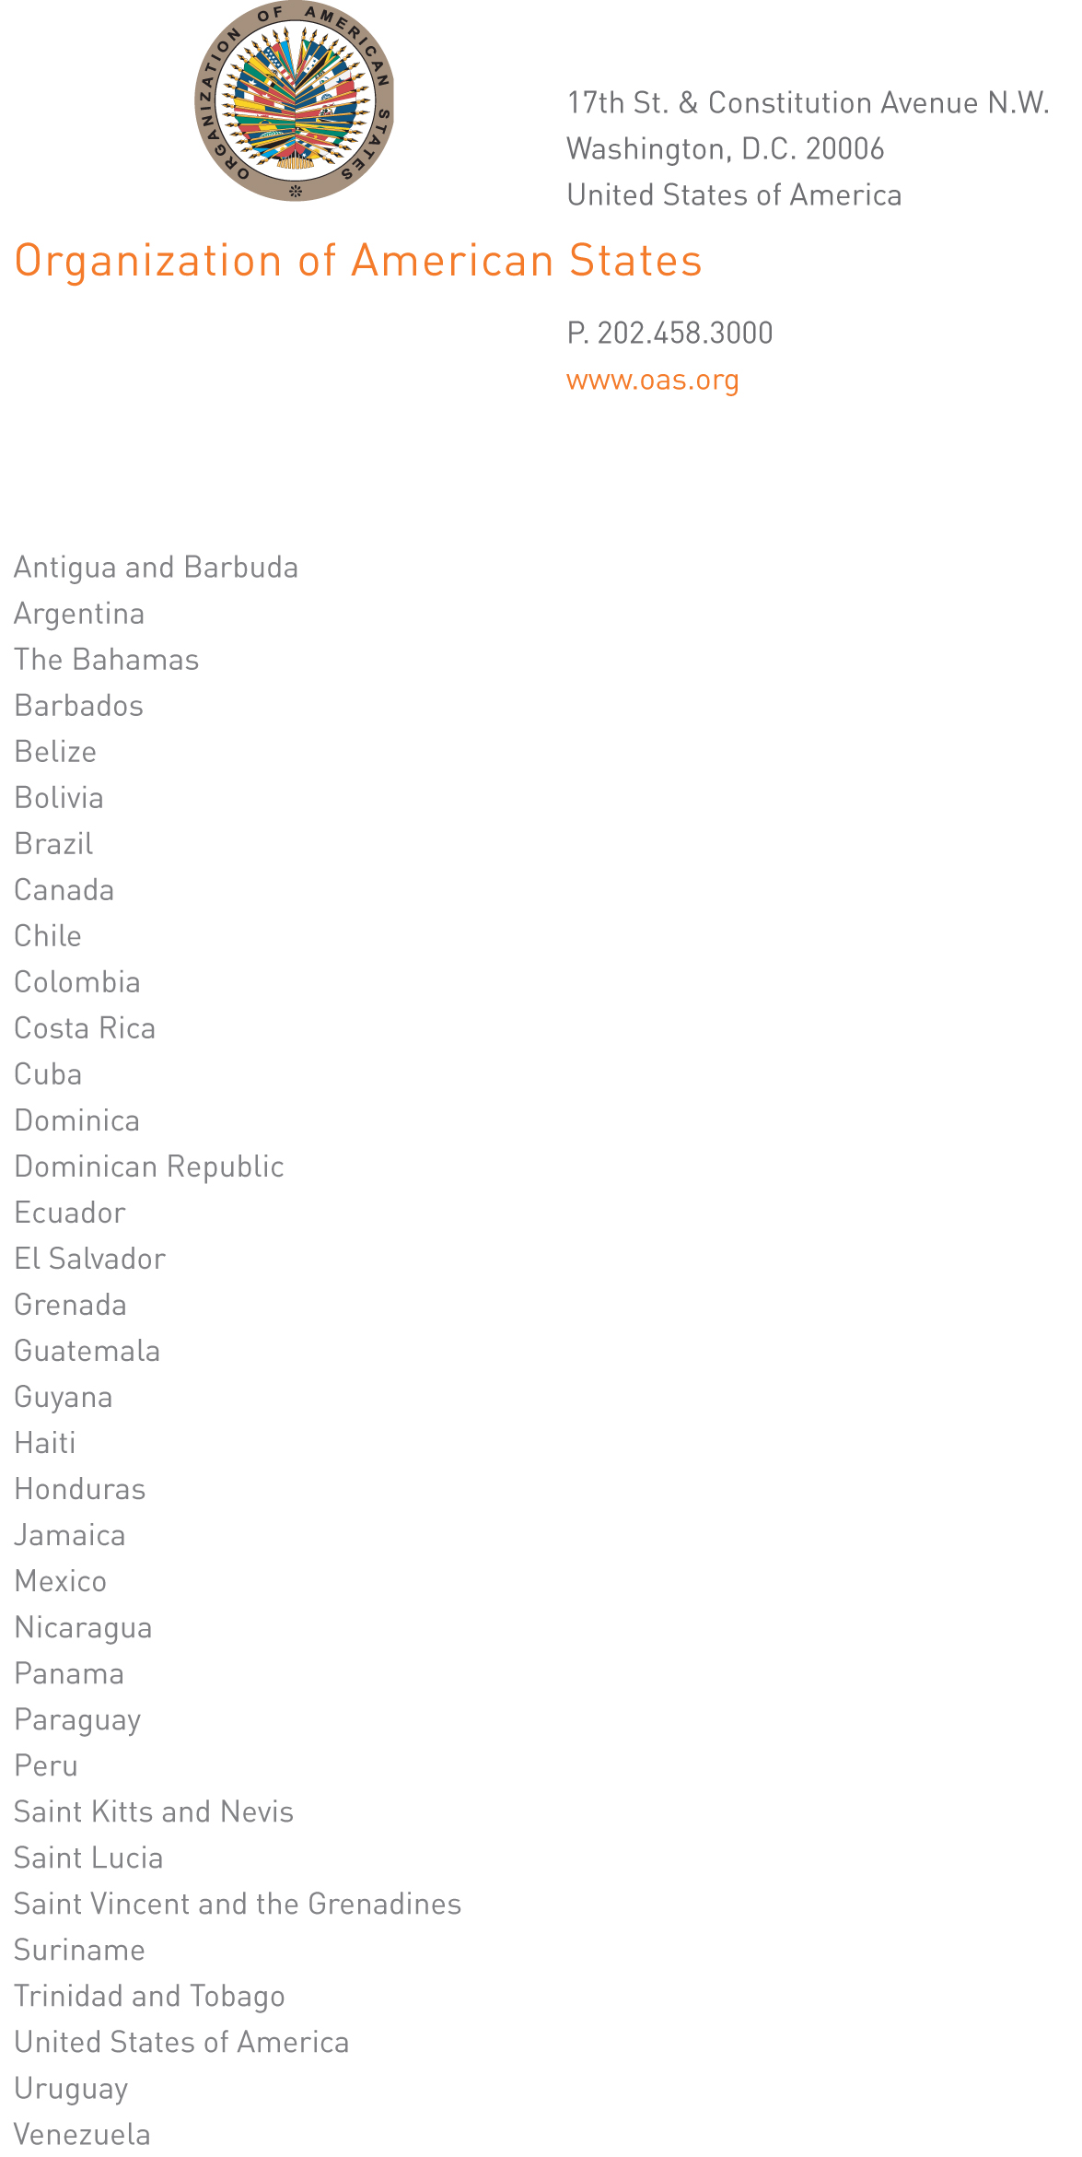

Washington, D.C., March 5, 2013

Excellency:

On behalf of the Permanent Council of the Organization of American States, and on my own behalf, I hereby convey deepest sympathies and heartfelt condolences on the death this afternoon of His Excellency President Hugo Rafael Chávez Frías.
input.doc

At this sad moment in the history of the Venezuelan nation and in our Americas region, we salute and pay homage to the political career and to the legacy of President Chávez as a leader, head of government, humanist, and statesman.

I should be most grateful, Ambassador, for these sentiments of solidarity to be conveyed to the people and Government of your country and to President Chávez’ family.

Accept, Excellency, renewed assurances of my highest consideration.

Ambassador Denis Moncada Colindres
Permanent Representative of Nicaragua
to the Organization of American States
Chair of the Permanent Council

Ambassador Roy Chaderton
Permanent Representative of the
Bolivarian Republic of Venezuela
to the Organization of American States
Washington, D.C.

