OEA/Ser.G
CP/INF. 6726/13
10 May 2013
Original: Spanish

NOTE FROM THE CHAIR OF THE COMMITTEE ON JURIDICAL AND POLITICAL
AFFAIRS REQUESTING THE INCLUSION OF THE TOPIC “ELECTION OF AN ALTERNATE GOVERNMENT MEMBER TO THE WORKING GROUP TO EXAMINE THE NATIONAL REPORTS CONTEMPLATED IN THE PROTOCOL OF DE SAN SALVADOR” ON THE ORDER OF BUSINESS OF THE REGULAR MEETING OF THE
PERMANENT COUNCIL TO BE HELD ON MAY 15, 2013
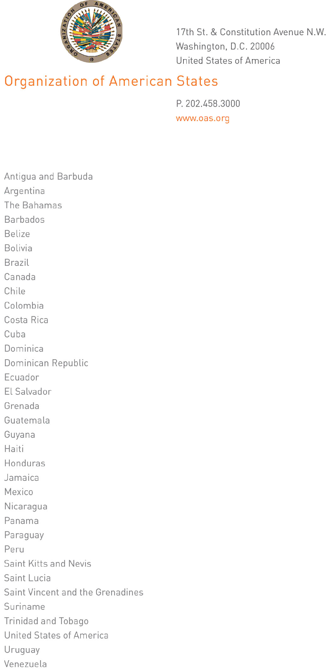
May 10, 2013

His Excellency
Ambassador Arturo Ulises Vallarino Bartuano
Permanent Representative of Panama to the OAS
Chair of the OAS Permanent Council
Washington, D.C.

RE: Election of the alternate government expert to the Working Group to Examine the National Reports Contemplated in the Protocol of San Salvador

input.doc

The Chair of the Committee on Juridical and Political Affairs presents its compliments to the Chair of the OAS Permanent Council and has the honor to request that it include a topic on the order of business for the Permanent Council’s regular meeting to be held on May 15, 2013.

Excellency, the Chair of the Committee on Juridical and Political Affairs would like, at that meeting, to update the members of the Permanent Council on this Committee’s discussion of the mandate contained in resolution AG/RES. 2713 (XLII-O/12), concerning the task of electing the alternate government expert to the Working Group to Examine the National Reports Contemplated in the Protocol of San Salvador.

Indeed, Excellency, a decision was taken at the regular meeting of the CAJP on April 25, 2013, to refer to the Permanent Council the recommendation for the nominee of the Government of Uruguay (a state Party to the Protocol), Mr. Andrés Scagliola, to be elected as an alternate government expert on the Working Group to Examine the National Reports Contemplated in the Protocol of San Salvador.

The Chair of the Committee on Juridical and Political Affairs avails itself of this opportunity to convey to the Chair of the OAS Permanent Council the renewed assurances of its highest consideration.

Andrés González Díaz
Ambassador, Permanent Representative of Colombia to the OAS
Chair of the Committee on Juridical and Political Affairs

