OEA/Ser.G
CP/INF.6741/13
19 June 2013
Original: Spanish

REQUEST FROM THE LEO S. ROWE PAN AMERICAN FUND COMMITTEE
FOR THE ELECTION OF ONE MEMBER TO BE INCLUDED ON THE ORDER OF
BUSINESS OF THE MEETING TO BE HELD ON JUNE 26, 2013
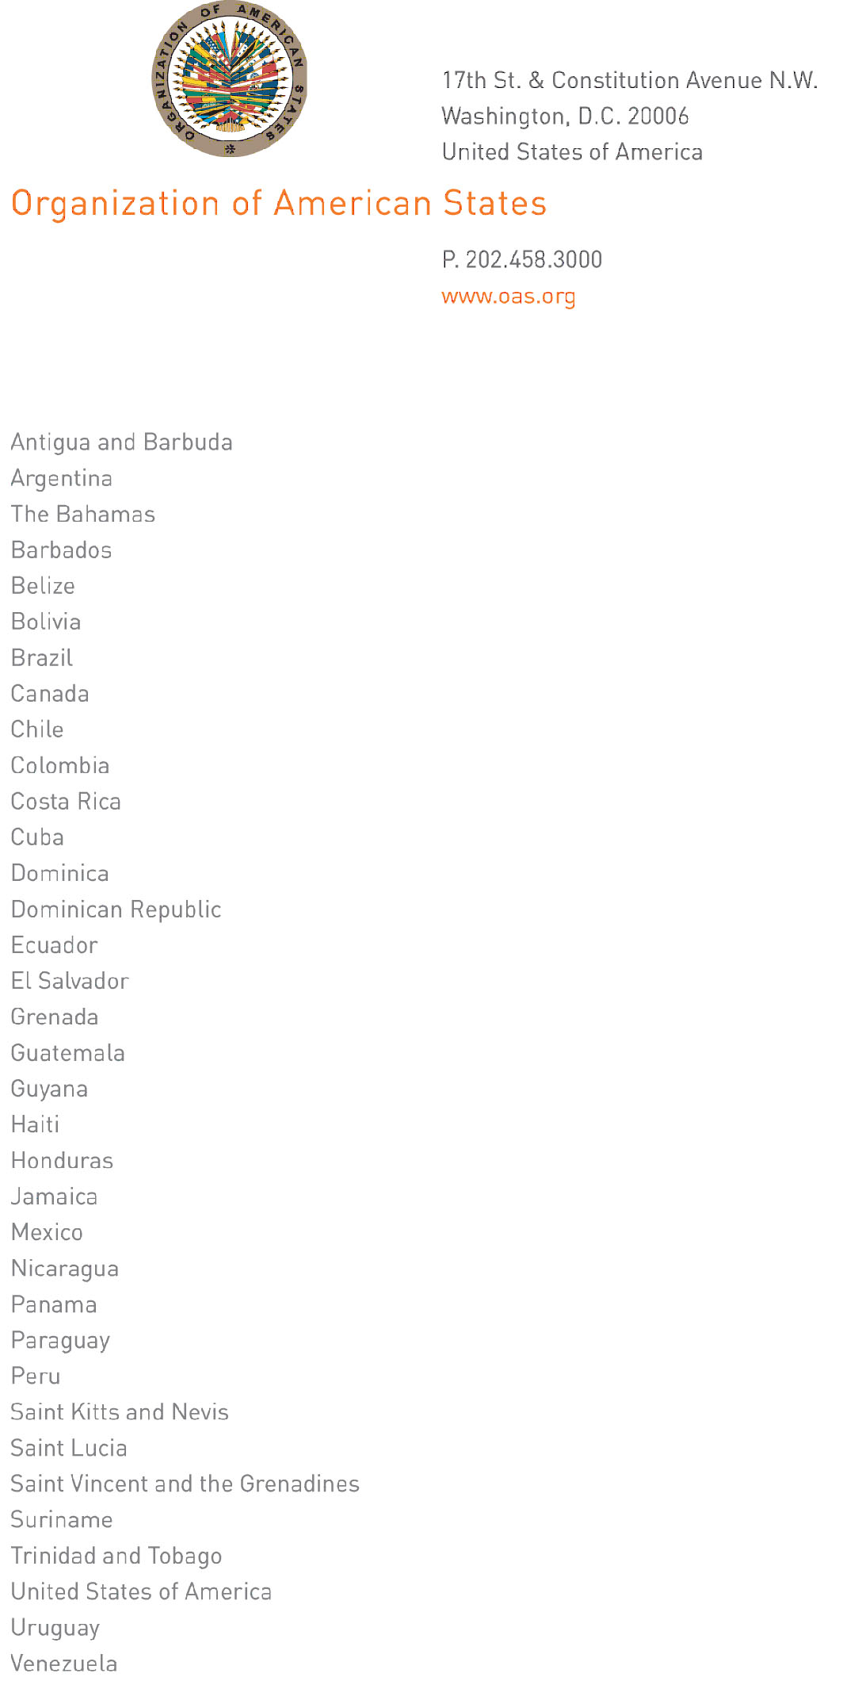
June , 2013

His Excellency
Ambassador Arturo Ulises Vallarino Bartuano
Permanent Representative of Panama to the OAS
Chair of the Permanent Council

Dear Ambassador:

I have the honor of writing you on behalf of Ambassador Deborah-Mae Lovell, Permanent Representative of Antigua and Barbuda and Chair of the Leo S. Rowe Pan American Fund Committee, to request that the election of one member to the aforementioned Committee be included on the order of business for the next meeting of the Permanent Council, scheduled for June 26, 2013.
input.doc

The election of a new member to the Committee must be conducted in accordance with Article 3 of the Statutes of the Fund, given that the term of Antigua and Barbuda, one of the four member countries on the Committee, is expiring.

Sincerely,

Lina M. Sevillano
Technical Secretariat
Leo S. Rowe Pan American Fund
Department of Human Development,
Education, and Culture
CP31315E04

