OEA/Ser.G
CP/INF.6743/13
21 June 2013
Original: Spanish

NOTICE

The Secretariat of the Permanent Council of the Organization of American States presents its compliments to the permanent missions and has the honor of forwarding a copy of a letter from the Secretary General to the Chair of the Permanent Council, informing him that he will be away from headquarters from June 21 to 25, 2013.
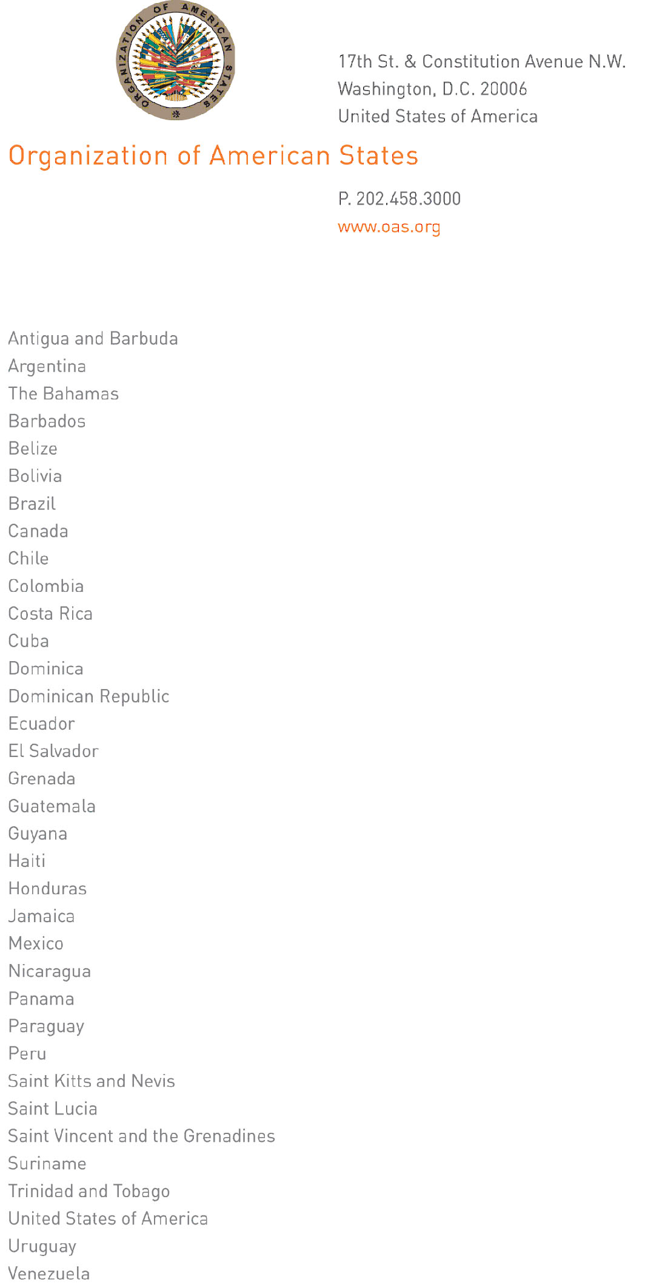
June 20, 2013

His Excellency
Arturo Vallarino Bartuano
Ambassador, Permanent Representative of Panama
to the Organization of American States
Chair of the Permanent Council
Washington, D.C.

Excellency:

I have the pleasure of writing to advise that I will be away from headquarters from June 21 to 25, 2013.

In my absence Ambassador Albert Ramdin, Assistant Secretary General, will be in charge of the General Secretariat.

Accept, Excellency, the renewed assurances of my highest consideration.

José Miguel Insulza
Secretary General

input.doc

