OEA/Ser.G
CP/INF. 6759/13
30 July 2013
Original: Spanish

N O T I C E

The Secretariat of the Permanent Council of the Organization of American States presents its compliments to the permanent missions and has the honor to enclose herewith a copy of a letter from the Secretary General to the Chair of the Permanent Council, informing the latter that he will be away from headquarters on July 30 and 31, 2013.
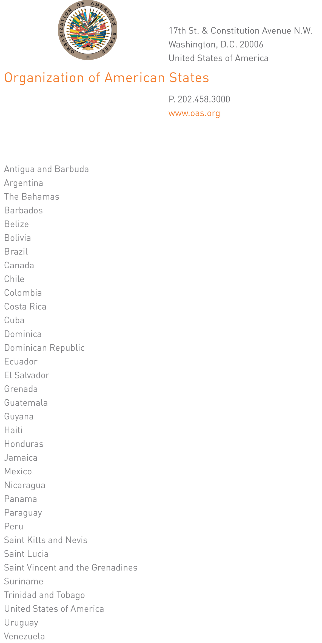

July 29, 2013

His Excellency
Martín Sannemann
Ambassador, Permanent Representative of Paraguay
to the Organization of American States
Chair of the Permanent Council
Washington, D.C.

Excellency,

I have the honor of writing to advise that I will be away from headquarters on July 30 and 31, 2013.

In my absence, Ambassador Albert Ramdin, Assistant Secretary General, will be in charge of the General Secretariat.

Accept, Excellency, renewed assurances of my highest consideration.

José Miguel Insulza
Secretary General
input.doc

