OEA/Ser.G
CP/INF.6767/13
9 September 2013
Original: Spanish

N O T I C E

The Secretariat of the Permanent Council of the Organization of American States presents its compliments to the permanent missions and has the honor to enclose herewith a copy of a letter from the Secretary General to the Chair of the Permanent Council, informing the latter that he will be away from headquarters from September 9 to 13, 2013.

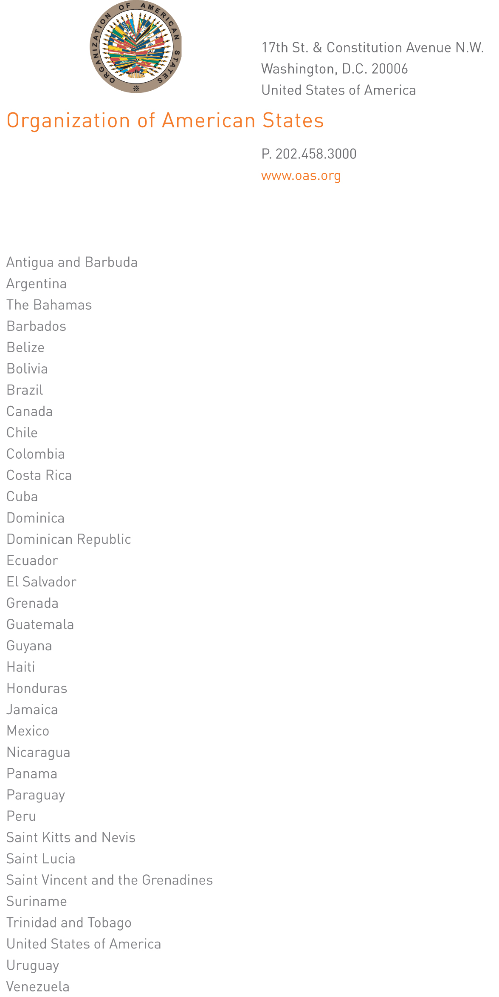
September 6, 2013

His Excellency
Martín Sannemann
Ambassador, Permanent Representative of Paraguay
to the Organization of American States
Chair of the Permanent Council
Washington, D.C.

Excellency:

I have the honor of writing to advise that I will be away from headquarters from September 9 to 13, 2013.

In my absence, Ambassador Hugo de Zela, Chief of Staff, will be in charge of the General Secretariat.

Accept, Excellency, renewed assurances of my highest consideration.

José Miguel Insulza
Secretary General
input.doc

