OEA/Ser.G
CP/INF.6798/13
18 October 2013
Original: Spanish

NOTICE

The Secretariat of the Permanent Council of the Organization of American States presents its compliments to the permanent missions and has the honor to forward a copy of a letter from the Secretary General to the Chair of the Permanent Council, informing the latter that he will be away from headquarters on October 18, 2013.
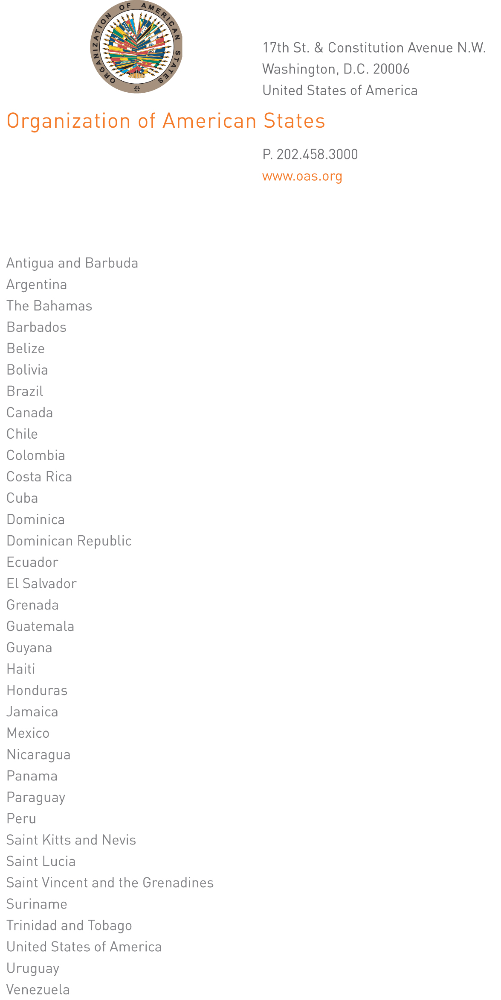
October 17, 2013

His Excellency
Walter Albán
Ambassador, Permanent Representative of Peru
to the Organization of American States
Chair of the Permanent Council
Washington, D.C.

Excellency:

I have the honor to address Your Excellency to inform you that I will be away from headquarters on October 18, 2013.

During my absence, Ambassador Hugo de Zela, Chief of Staff of the Secretary General, will be in charge of the General Secretariat.

Accept, Excellency, renewed assurances of my highest consideration.
CP31745E04

José Miguel Insulza,
Secretary General

