OEA/Ser.G
CP/INF. 6802/13 rev. 1
25 October 2013
Original: Spanish/English

SPEAKERS’ RESUMES
SPECIAL MEETING OF THE PERMANENT COUNCIL TO COMMEMORATE THE TENTH ANNIVERSARY OF THE ADOPTION OF THE DECLARATION ON SECURITY IN THE AMERICAS – “SECURITY AND SOCIAL DEVELOPMENT”
WASHINGTON, D.C., OCTOBER 28, 2013

VANESSA RUBIO MARQUEZ

Under-Secretary for Latin America and the Caribbean Vanessa Rubio Marquez holds a degree in international relations from the Autonomous National University of Mexico (UNAM) and a Master of Science degree from the London School of Economics. She has served in a variety of public-sector posts, most notably as Director of Economic Cooperation and Development at the Ministry of Foreign Affairs; Director for North America, Asia-Pacific and the Caribbean and Chief of the International Financial Affairs Unit, in both capacities at the Ministry of Finance and Public Credit; and Executive Director for Mexico to the Caribbean Development Bank.

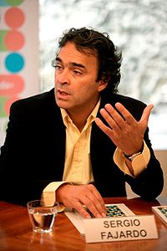

Sergio Fajardo Valderrama
Governor of Antioquia, Colombia

- Sergio Fajardo Valderrama is a Colombian politician and mathematician.

- He has been Governor of Antioquia since January 1, 2012.

- In 2003, he was elected mayor of Medellín, after winning what was up to that point the highest number of votes in that city’s history.

- During his four years as governor, he presided over the great transformation of Medellín, which earned him the title of Best Mayor of Colombia for the 2004-2007 period. The Financial Times also named him the 2007 Man of the Year in Latin America.

Academic Background
- Bachelor's degree in Mathematics (1977) and Master's in Mathematics (1979) from University of the Andes, Bogotá.
- Master's degree in Mathematics (1981) and Doctorate in Mathematics (1984). University of Wisconsin–Madison, United States.
- Full-time professor of Mathematics, University of the Andes, Bogotá.
- Head of the Department of Mathematics, University of the Andes, Bogotá.
- Director of Research, University of the Andes, Bogotá.
- Director of the Antioquia Center for Science and Technology.
- Member, National Commission for Basic Sciences.
- Member, National Commission for Master's and Doctorate degrees.

Public Sector
- Leader and founder of the civic movement Compromiso Ciudadano (2000-2010).
- Mayor of Medellín (2004-2007).
- Vice Presidential Candidate for the Green Party (2010).

Award and Honors
- Best Mayor of Colombia 2004–2007, awarded by Fundación Colombia Líder.
- 2006 Person of the Year, Cambio magazine.
- Person of the Year 2004, 2005, 2006, and 2007, by El Colombiano newspaper.
- Honorary Doctorate, Menéndez Pelayo International University, Santander – Spain, 2009.
- In 2009, he received the Doctor Jean Mayer Award for “global citizenship through innovation and valiant leadership in creating an open and livable city.”
- Recognition as 2007 Person of the Year in Latin America, for positive leadership in the transformation of the city - awarded by fDi magazine (publication on business and globalization, a subsidiary of the Financial Times Group, London).
- Gold Medal awarded by the Pan American Federation of Architecture Associations for the Social Urbanism Program, 2008.
- 2009 Curry Stone Design Prize, awarded by the Curry Stone Foundation – shared with architect Alejandro Echeverri.
- Recognition with 2007 Americas Award for Excellence in Public Service as one of eight leaders of the region. Awarded by the OAS Secretariat for Integral Development (SEDI) and the United Nations Institute of Training and Research (UNITAR) International Training Centre for Local Authorities.
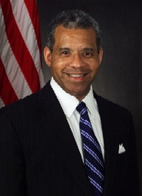

Clark Ervin
Director of the Aspen Institute’s International Security Program
- He earned a B.A. degree cum laude in Government from Harvard in 1980, an M.A. degree in Politics, Philosophy, and Economics from Oxford University in 1982 as a Rhodes Scholar, and a J.D. degree cum laude from Harvard Law School in 1985.  - Clark Kent Ervin is the Director of the Aspen Institute Homeland Security Program. He joined the Institute in 2005.  - He served as the first Inspector General of the United States Department of Homeland Security, from January, 2003 to December, 2004.  - He served as the Inspector General of the United States Department of State and the Broadcasting Board of Governors, from August, 2001 to January, 2003.  - His service in the administration of President George W. Bush is preceded by his service as the Associate Director of Policy in the White House Office of National Service in the administration of President George H.W. Bush.  - A native Houstonian, he served in the state government of Texas from 1995 to 2001, first as Assistant Secretary of State, and then as a Deputy Attorney General.  - He has practiced law twice in the private sector, with the Houston based firms of Vinson & Elkins, and Locke, Liddell, & Sapp, respectively.  - In addition to his work at The Aspen Institute, Mr. Ervin is a member of the Wartime Contracting Commission on Iraq and Afghanistan.  - He was appointed by Secretary of Homeland Security Janet Napolitano to the Homeland Security Advisory Council.  - He has been an analyst and contributor at CNN, where he focused on homeland security, national security, and intelligence issues, and he continues to appear as a guest commentator on that television network and other TV and radio networks.  - He is frequently cited as an expert on these matters by major national and international publications, including The Wall Street Journal, Time magazine, and The Economist. His opinion pieces have appeared in, among other papers, The New York Times and The Washington Post. His book titled, “Open Target: Where America is Vulnerable to Attack,” was published in May, 2006. | - Tiene una Licenciatura grado cum laude de Harvard en 1980; una maestría en Política, Filosofía y Economía en la Universidad de Oxford en 1982, como becario Rhodes, y un JD cum laude de la Escuela de Derecho de Harvard en 1985.  - Es el Director del Programa de Seguridad Internacional del Aspen Institute desde 2005.  - Se desempeñó como primer Inspector General del Departamento de Seguridad Nacional de los Estados Unidos, de enero de 2003 a diciembre de 2004.  - Se desempeñó como Inspector General del Departamento de Estado y la Junta de Gobernadores de Radiodifusión de Estados Unidos, a partir de agosto de 2001 a enero de 2003.  - Su servicio en la administración del Presidente George W. Bush está precedido por su cargo como Director Adjunto de Política de la Oficina de la Casa Blanca del Servicio Nacional de la Administración del Presidente George H.W Bush.  - Es originario de Houston, se desempeñó en el gobierno del estado de Texas, entre 1995 a 2001, primero como Secretario de Estado Adjunto y luego, como Fiscal General Adjunto.  - Ha ejercido como abogado en dos ocasiones en el sector privado, en Despachos con sede en Houston de Vinson & Elkins, y Locke, Liddell, y Sapp, respectivamente.  - Además de su trabajo en el Instituto Aspen, el Sr. Ervin es miembro de la Comisión de Contratación en Tiempos de Guerra de Irak y Afganistán.  - Fue nombrado por la Secretaria de Seguridad Nacional Janet Napolitano al Consejo Asesor de Seguridad Nacional.  - Ha sido analista y colaborador de CNN, en el tema de seguridad nacional, la seguridad nacional e inteligencia. Es comentarista invitado en esa cadena de televisión y otras cadenas de tv y radio.  - A menudo se cita como un experto en la materia por las principales publicaciones nacionales e internacionales, como The Wall Street Journal, la revista Time y The Economist. Sus artículos de opinión han aparecido en el New York Times y The Washington Post. Su libro "Open Target: Where America is Vulnerable to Attack”, fue publicado en mayo de 2006.

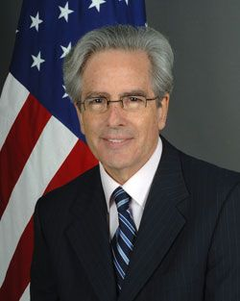

Arturo Valenzuela
Professor of Government and Director of Georgetown University's Center for Latin American Studies

- Arturo Valenzuela Bowie is a Chilean-American political scientist and academic who is Professor of Government and Director of the Center for Latin American Studies at Georgetown University.
- From 2009 to 2011 he served as United States Assistant Secretary of State for Western Hemisphere Affairs, having been appointed by President Barack Obama to the highest office held exclusively by a Latin American in US history.
- Prior to that he was professor of political science at the Council on Latin American Studies at Duke University. He earned a PhD and a Master’s degree in Political Science from Columbia University and a Bachelor of Arts summa cum laude in Political Science and Religion from Drew University.
- He was appointed Deputy Assistant Secretary for Inter-American Affairs in the United States Department of State by President Bill Clinton, during that President’s first term. His primary responsibility there was United States foreign policy towards Mexico.
- In President Clinton's second term, he was appointed Special Assistant to the President and Senior Director for Inter-American Affairs at the National Security Council at the White House.
- His merits: Director of the Center for Latin American Studies at the Edmund A. Walsh School of Foreign Service, Georgetown University
- Consultant to the Free Foundation, board member of the National Council of La Raz.
- Member of Human Rights Watch Americas Advisory Committee, Inter-American Foundation/Former Personnel.
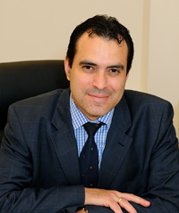

Kevin Casas-Zamora
OAS Secretary for Political Affairs
- Dr. Casas-Zamora is currently Secretary for Political Affairs at the Organization of American States.

- He holds a Bachelor of Laws from the University of Costa Rica and a Master’s and PhD in Political Science, from Essex and Oxford Universities, respectively. He has authored numerous studies on campaign financing, elections, democratic governance, and citizen security in Latin America.

- He is also a Senior Fellow in International Politics at the Brookings Institution in Washington D.C., and previously served as Minister of National Planning and Economic Policy as well as Second Vice President of Costa Rica.

- He also served as program officer with the Arias Foundation for Peace and Human Progress and as General Coordinator of Costa Rica’s National Human Development Report for the United Nations Development Programme.

- His doctoral dissertation was entitled “Paying for Democracy in Latin America: Political Finance and State Subsidies for Parties in Costa Rica and Uruguay.”

- He won the European Consortium for Political Research (ECPR) 2004 Jean Blondel Prize for best doctoral dissertation in Political Science in Europe, which the ECPR published in 2005.

- In 2007, Dr. Casas was appointed by the World Economic Forum as a member of the Young Global Leaders Network.

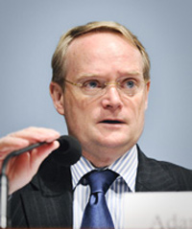

Adam Blackwell
Secretario de Seguridad Multidimensional de la OEA.
- Adam Blackwell, a Canadian diplomat.

- He served as OAS Secretary for External Relations until August 2010.

- He has served as Assistant Secretary for Finance and Administration (Treasurer) of the OAS General Secretariat.

- From 2005 to 2006 he was Director General of Strategy and Services in the Bilateral Relations Branch of Foreign Affairs and International Trade Canada.

- From 2002 to 2005 he served as Ambassador Extraordinary and Plenipotentiary in the Dominican Republic.

- He was also Consul General in Mexico City and New York, and served in various assignments in Africa.

- In 2005 he published the book Canada and the Dominican Republic: 50+ years of diplomatic relations.

- He has participated in and led various electoral observation missions.

- He has received several honors.
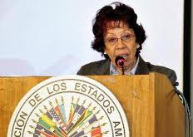

Carmen Moreno Toscano
Secretaria Ejecutiva de la Comisión Interamericana de Mujeres de la OEA:
- Carmen Moreno has served as the Mexican ambassador to Costa Rica and Guatemala, as well as the Permanent Representative of Mexico to the Organization of American States. In 1994, Ms. Moreno was awarded the rank of Eminent Ambassador.  - Ms. Moreno was a member of the Mexican Delegation to the first UN Conference on Women and a delegate to ECOSOC for the establishment of the UN Decade for Women, Equality, Development and Peace (1985).  - In December 2003, was appointed by the Secretary-General of the United Nations, Kofi Annan, as Director of the United Nations International Research and Training Institute for the Advancement of Women (UN-INSTRAW, now part of UN Women).  - In July 2009, the Secretary General of the Organization of American States appointed Ambassador Moreno as Executive Secretary of the Inter-American Commission of Women. | - Carmen Moreno ha sido embajadora de México en Costa Rica y Guatemala, así como el Representante Permanente de México ante la Organización de los Estados Americanos. En 1994, la Sra. Moreno fue galardonado con el rango de Embajador Eminente.  - La Embajadora Moreno fue miembro de la Delegación Mexicana a la primera Conferencia de la ONU sobre la Mujer y delegada al ECOSOC para el establecimiento del Decenio de las Naciones Unidas para la Mujer, Igualdad, Desarrollo y Paz (1985).  - En diciembre de 2003, Carmen Moreno fue nombrado por el Secretario General de las Naciones Unidas, Kofi Annan, como Directora del Instituto Internacional de Investigaciones y Capacitación para la Promoción de la Mujer (UN-INSTRAW, ahora parte de ONU Mujeres).  - En julio de 2009 fue nombrada Secretaria Ejecutiva de la Comisión Interamericana de Mujeres.

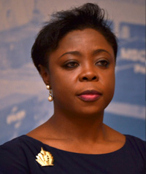

Sherry Tross
Secretaria Ejecutiva para el Desarrollo Integral de la OEA.
- Ms. Tross directed the Summits of the Americas Secretariat from 2010-2012 and was instrumental in the planning and execution of the Sixth Summit of Heads of State and Government of the Americas.  - The coordination of technical support of twelve international financial institutions and regional organizations that comprise the Joint Summit Working Group (JSWG), and the facilitation of government-civil society dialogue in the Summit process.  - From 2006-2010, Ms. Tross was Chief of Staff to the Assistant Secretary General of the OAS. In that capacity, she managed the Secretariat to the General Assembly, Meetings of Consultation, Permanent Council and Subsidiary Organs, and directed the work of the technical teams supporting the Organization’s political bodies.  - Prior to that appointment, she was political advisor and principal speechwriter for the OAS Assistant Secretary General.  - Ms. Tross has provided consulting services for government agencies and private companies. She has been a speaker, commentator and rapporteur at public fora on a range of development and security topics. | - La Sra. Tross dirigió la Secretaria de Cumbres de las Américas de 2010-2012, donde tuvo a cargo la planeación y ejecución la Sexta Cumbre de Jefes de Estado y Gobierno de las Américas.  - Asimismo, dirigió la coordinación del apoyo técnico a doce instituciones financieras internacionales y organizaciones regionales que conforman el Grupo de Trabajo Conjunto de Cumbres (GTCC), y la facilitación del gobierno civil y dialogo de la Sociedad en los Procesos de Cumbre.  - De 2006-2010, la Sra. Tross fue Jefa de Gabinete del Secretario General Adjunto de la OEA. En ese puesto coordinó la Secretaría a la Asamblea General, Reuniones de Consulta, Consejo Permanente y Órganos Subsidiarios, y dirigió el trabajo de los equipos técnicos de apoyo a los Órganos Políticos de la Organización.  - Antes de los nombramientos mencionados, era consejera política y escritora principal de discursos del Secretario General Adjunto de la OEA.  - La Sra. Tross ha prestado servicios de consultoría para agencias gubernamentales y empresas privadas. Ella ha sido comentarista y ponente en foros públicos sobre temas de desarrollo y seguridad.

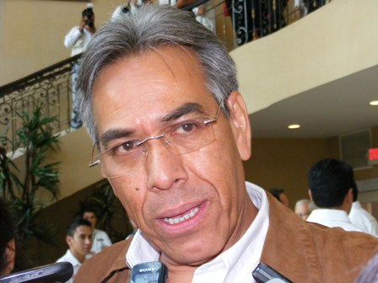

Enrique González Tiburcio
General Coordinador of Advisors to the Secretariat of Social development of Mexico: Food Security and the Crusade against Hunger.
- He holds a Bachelor's degree in Economics and a Master's in Economic Sciences from the National Autonomous University of Mexico (UNAM).

- Since 1983, he has held various social and community development-related positions in the federal public service: (National Solidarity Program (89-91), National Solidarity Institute (92-93), National Indigenous Institute (94-98), and the Secretariat of Social Development (99-01).

- He has also worked for various international organizations (FAO, UNDP, and UNICEF) as a consultant.

- He has been a research professor at UNAM (1980-2008) and the National Institute of Public Administration (INAP 1990-2000), which honored him with the National Award for Public Service in 1990.

- He has authored and co-authored several books and articles on economic policy, development and social cohesion, economic crisis, and fighting poverty.

- In 2009, he served as Director General for Social Services and Institutional Relations at the Federal Institute of Access to Public Information.

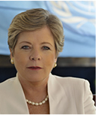

Alicia Bárcena
Executive Secretary of the Economic Commission for Latin America and the Caribbean (ECLAC)
- She earned a Bachelor's degree in Biology and a Master's in Public Administration from Harvard University. After completing courses for a Master's degree in Ecology, she enrolled for a PhD in Economics at the National Autonomous University of Mexico.

- Alicia Bárcena assumed the post of Executive Secretary of the Economic Commission for Latin America and the Caribbean (ECLAC) on July 1, 2008.

- She previously served as Under-Secretary-General for Management at the United Nations Headquarters in New York, where she also served as Chief of Staff and prior to that as Deputy Chief of Staff to then United Nations Secretary-General Kofi Annan.

- At ECLAC she has also served as Deputy Executive Secretary and Director of the Environment and Human Settlements Division.

- At the United Nations, she was Coordinator of the United Nations Development Programme (UNDP) Program for Sustainable Development in Latin America and the Caribbean and Coordinator of the United Nations Environment Programme (UNEP).

- She also founded and directed the Earth Council, a Costa Rica-based nongovernmental organization that monitors agreements signed at the United Nations Conference on Environment and Development (UNCED), held in Rio de Janeiro (Brazil) in 1992.

- Alicia Barcena has been a professor and researcher at the National Autonomous University of Mexico and has published numerous articles on sustainable development, public policy, the environment, and public participation.
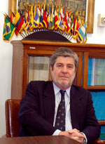

Jean Michel Arrighi
OAS Secretary for Legal Affairs
- Secretary for Legal Affairs for the OAS General Secretariat. He joined the OAS in 1993 as legal advisor.

- Professor of Public International Law of the University of the Republic of Uruguay.

- Member of Institut de Droit International.

- He has authored several books and articles on international law, particularly books and courses on the inter-American system and the OAS.

- Visiting professor at several universities in the Americas and Europe, as well as professor of the Academy of International Law at The Hague.

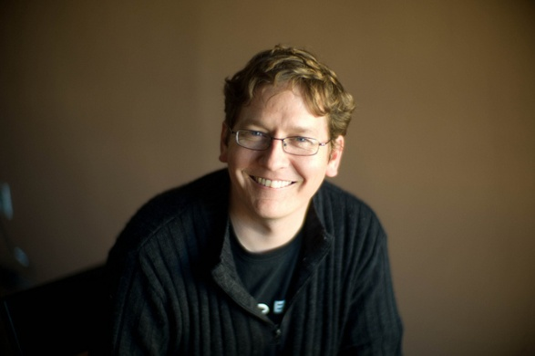

John Wilbanks
Experto en el tema Acceso a la Información y Salud de la empresa Consent to Research.
- John Wilbanks is the Chief Commons Officer at Sage Bionetworks and a Senior Fellow at the Ewing Marion Kauffman Foundation and at FasterCures. He runs the Consent to Research Project.  - Consent to Research (CtR) is a project that provides a platform for people to donate their health data for the purposes of scientific research and the advancement of medicine. Since health data is restricted and expensive, this project provides people the opportunity to freely donate information that can only positively benefit medicine and patients at large.  - Consent to Research is connected the Access2Research project, which aims to free access over the Internet to scientific journal articles that are already taxpayer-funded.  - Wilbanks founded the project in 2011.  - From 1994 to 1997, he worked in Washington, DC as a legislative aide to Congressman Fortney "Pete" Stark.  - During this time Wilbanks was also a grassroots coordinator and fundraiser for the American Physical Therapy Association.  - John was the Berkman Center for Internet & Society's first Assistant Director from the fall of 1998 to the summer of 2000.  - Wilbanks led a “We the People” petition supporting the free access of taxpayer-funded research data, which gained over 65,000 signatures.  - In February 2013, the White House responded, detailing a plan to freely publicize taxpayer-funded research data. | - John Wilbanks es Director en Sage Bionetworks y Senior Fellow de la Fundación Ewing Marion Kauffman y de FasterCures. Dirige el proyecto Consent to Research.  - Consent to Research (CTR) es un proyecto que ofrece una plataforma para que la gente done sus datos de salud con fines de investigación científica y avance de la medicina. Dado que los datos de salud son limitados y caros, este proyecto ofrece a las personas la oportunidad de donar libremente información que sólo puede beneficiar positivamente la medicina y los pacientes en general.  - Consent to Research está conectado al proyecto Access2Research, cuyo objetivo es el libre acceso a través de Internet a artículos de revistas científicas que ya están financiado por los contribuyentes.  - Wilbanks fundó el proyecto en 2011.  - De 1994 a 1997, trabajó en Washington, DC como asistente legislativo del Congresista Fortney "Pete" Stark.  - Durante este tiempo Wilbanks era también coordinador de las bases y recaudador de fondos para la Asociación Americana de Terapia Física.  - John fue el primer asistente director del Centro Berkman del otoño de 1998 al verano de 2000.  - Wilbanks encabezo una petición de “We the People”, apoyando el libre acceso de los datos de investigación financiados por los contribuyentes, que ganó más de 65.000 firmas.  - En febrero de 2013 la Casa Blanca respondió, detallando un plan para dar a conocer libremente los datos de investigación financiados por los contribuyentes.

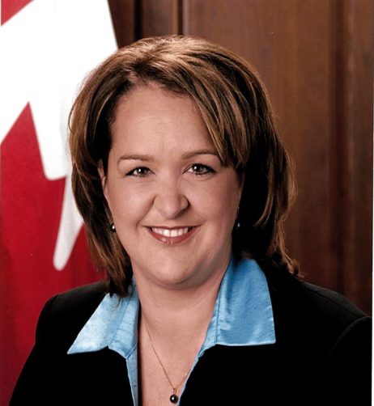
input.doc
Marianick Tremblay
Director for Hemispheric Affairs, Interamerican Relations and Haiti

    - She earned a BBA in Civil and International Law in 1989 and LLB in 1990 from Sherbrooke University.

    - Marianick Tremblay worked as a litigator with Laurentienne Générale in Montreal prior to joining the Department of External Affairs and International Trade in 1993.

    - She has since served abroad in Havana, Mexico, Rabat, Santiago and most recently as the Canadian Ambassador to the Republic of El Salvador.

    - At Headquarters, she has served as counsel with the Legal Operations Division, senior counsel with the Environmental Law Division, coordinator for the human security program and senior counsel on small arms, as well as deputy director for Brazil and Southern Cone, in the South America and Inter-American Affairs Division.

    - Since her return from El Salvador in 2012, she has served as the Director for Hemispheric affairs, Interamerican Relations and Haïti.
input.doc

