OEA/Ser.G
CP/INF.6848/14
14 January 2014
Original: Spanish

NOTICE OF ABSENCE OF CHAIR OF PERMANENT COUNCIL
FROM OAS HEADQUARTERS

(January 18 to 25, 2014)

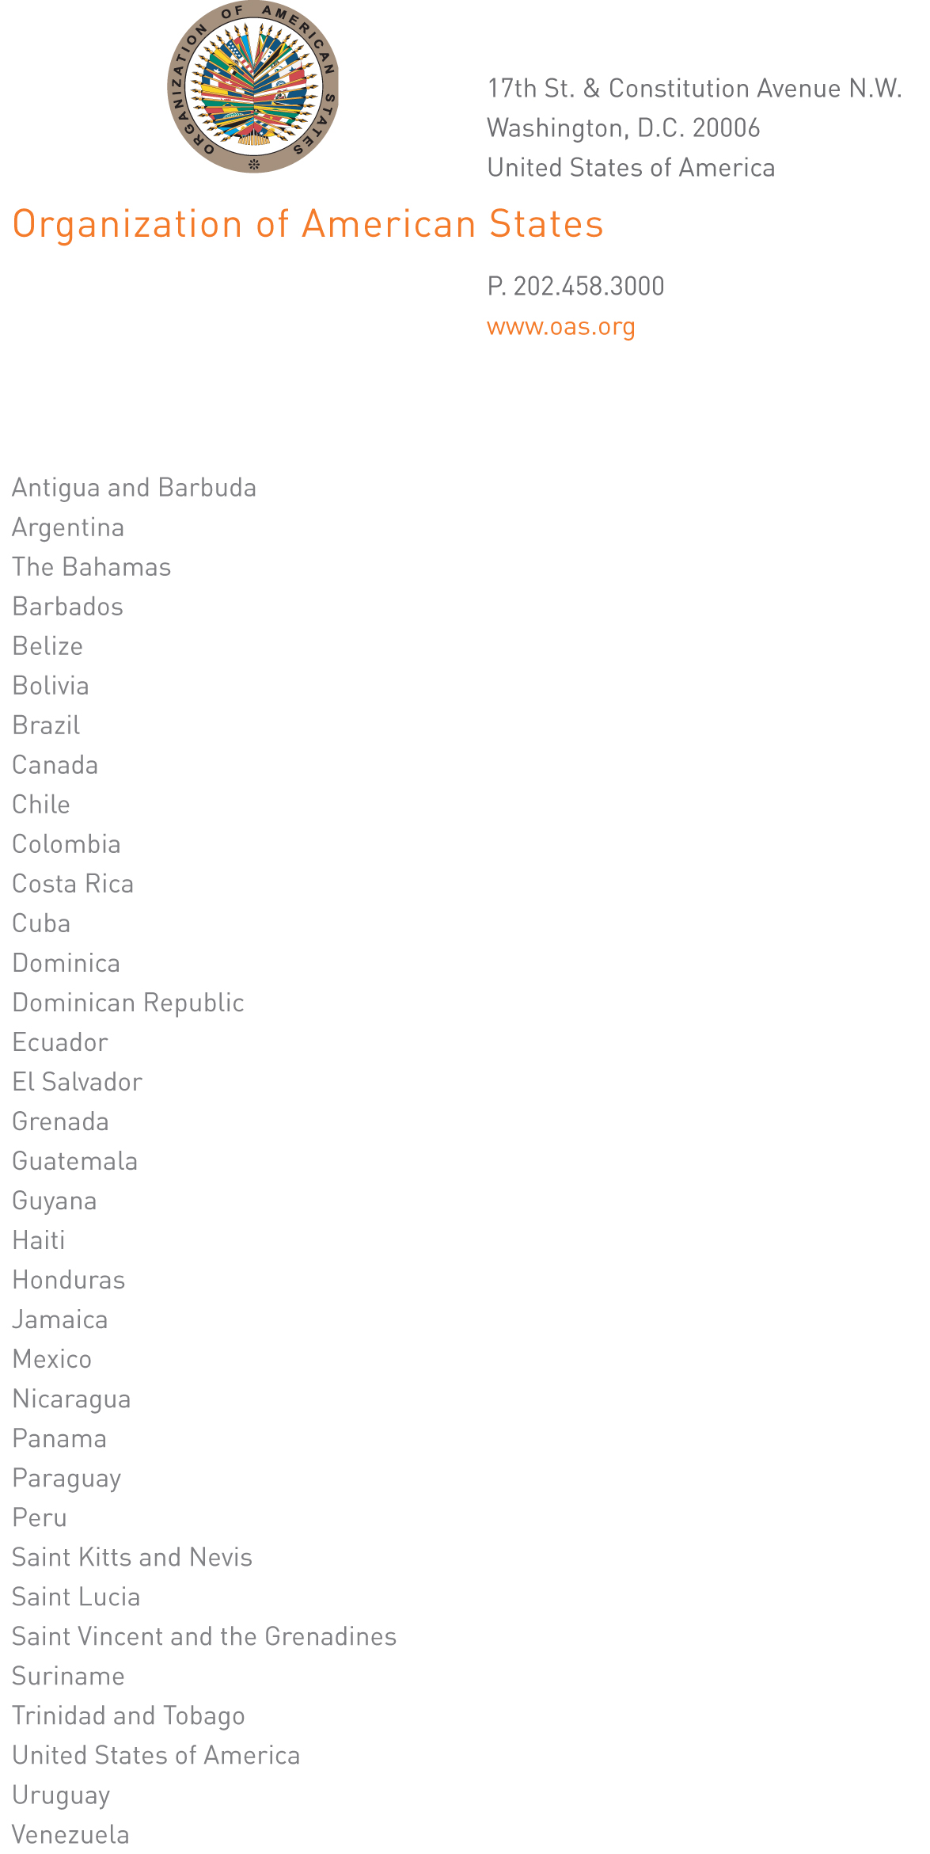
CP-001/14
January 14, 2014

Excellency:

I have the honor to address Your Excellency to let you know that I will be away from headquarters from January 18 to 25, 2014.

Accept, Excellency, the renewed assurances of my highest consideration.
input.doc

Pedro Vergés Ciman
Ambassador, Permanent Representative
Chair of the Permanent Council

His Excellency
José Miguel Insulza
Secretary General
Organization of American States
Washington, D.C.

