OEA/Ser.G
CP/INF.6849/14
14 January 2014
Original: Spanish

NOTICE OF ABSENCE OF THE SECRETARY GENERAL FROM OAS HEADQUARTERS

(From January 15 to 18, 2014)
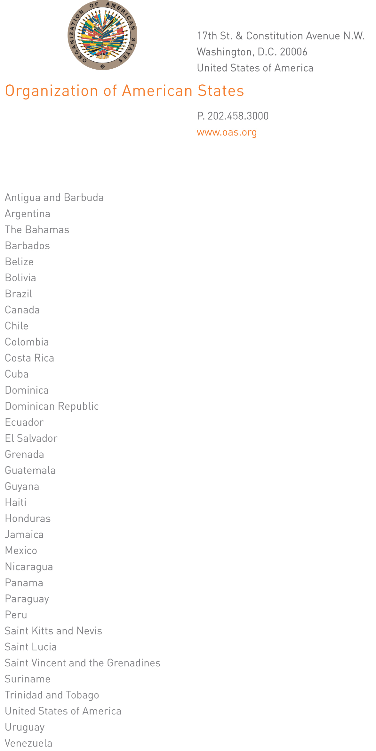

January 14, 2014

His Excellency
Pedro Vergés
Ambassador, Permanent Representative
of the Dominican Republic to the
Organization of American States
Chair of the Permanent Council
Washington, D.C.

Excellency:

CP32114E06
I have the honor to address Your Excellency to inform you that I will be away from headquarters from January 15 to 18, 2014.

During my absence, Ambassador Albert Ramdin, Assistant Secretary General, will be in charge of the General Secretariat.

Accept, Excellency, the renewed assurances of my highest consideration.

José Miguel Insulza
Secretary General

