OEA/Ser.G
CP/INF.6853/14
27 January 2014
Original: Spanish

NOTICE OF ABSENCE OF THE SECRETARY GENERAL FROM OAS HEADQUARTERS
(from January 27 to 29, 2014)
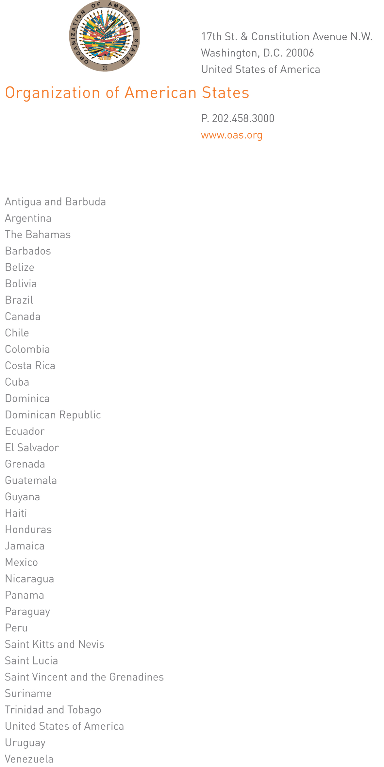

January 24, 2014

His Excellency
Pedro Vergés
Ambassador, Permanent Representative of the Dominican Republic
to the Organization of American States
Chair of the Permanent Council
Washington, D.C.

Excellency:

I have the honor of writing to advise that I will be away from headquarters from January 27 to 29, 2014.

During my absence Ambassador Albert Ramdin, Assistant Secretary General, will be in charge of the General Secretariat.

Accept, Excellency, the renewed assurances of my highest consideration.

José Miguel Insulza
Secretary General

input.doc

