OEA/Ser.G
CP/INF.6865/14
18 February 2014
Original: Spanish

NOTICE THAT SECRETARY GENERAL WILL BE AWAY FROM OAS HEADQUARTERS
(From February 18 to 21, 2014)

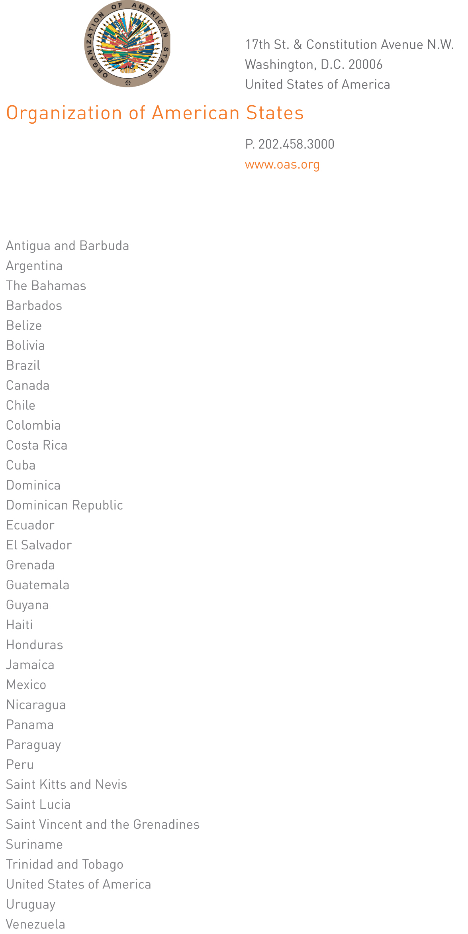

February 14, 2014

His Excellency
Pedro Vergés
Ambassador, Permanent Representative
of the Dominican Republic
to the Organization of American States
Chair of the Permanent Council
Washington, DC

input.doc
Excellency:

I have the honor to address Your Excellency to advise you that I will be away from Headquarters from February 18 to 21, 2014.

During my absence, the following officials will be in charge of the General Secretariat:

Ambassador Hugo de Zela, chief of Staff of the Office of the Secretary General, on February 18.

Ambassador Albert Ramdin, Assistant Secretary General, from February 19 to 21.

Accept, Excellency, the renewed assurances of my highest consideration.

José Miguel Insulza
Secretary General

