OEA/Ser.G
CP/INF.6869/14
21 February 2014
Original: Spanish

ABSENCE OF THE CHAIR OF THE PERMANENT COUNCIL
AWAY FROM OAS HEADQUARTERS

(from February 22 to 26, 2014)

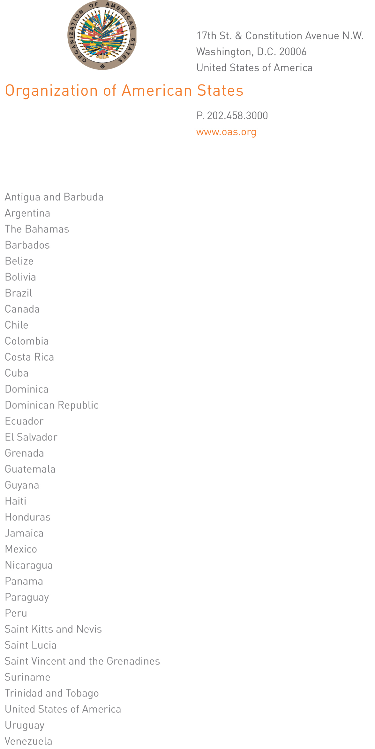

CP-002/14

February 21, 2014

His Excellency
José Miguel Insulza
Secretary General
Organization of American States
input.doc
Washington, D.C.

Excellency:

I have the honor to address Your Excellency to let you know that I will be away from headquarters from February 22 to 26, 2014.

Accept, Excellency, the renewed assurances of my highest consideration.

Pedro Vergés Ciman
Ambassador, Permanent Representative of
the Dominican Republic to the
Organization of American States
Chair of the Permanent Council

