OEA/Ser.G
CP/doc.4365/09 corr. 1
9 February 2009
Original: Spanish

TWELFTH QUARTERLY REPORT OF THE SECRETARY GENERAL TO THE PERMANENT COUNCIL ON THE MISSION TO SUPPORT THE PEACE PROCESS IN COLOMBIA (MAPP/OAS)

This document is being distributed to the permanent missions and
will be presented to the Permanent Council of the Organization.
THE SECRETARY GENERAL’S TWELFTH QUARTERLY REPORT TO THE PERMANENT COUNCIL ON THE MISSION TO SUPPORT THE PEACE PROCESS IN COLOMBIA (MAPP/OEA)

This quarterly report of the Secretary General on the Mission to Support the Peace Process in Colombia (MAPP/OEA) is submitted to the Permanent Council of the Organization of American States (OAS) in accordance with resolution CP/RES. 859 (1397/04), in which the Council resolved “[t]o instruct the Secretary General to provide quarterly reports to the Permanent Council on the work of the MAPP/OEA and its continued ability to contribute, through its work in Colombia, to the fulfillment of the values and principles contained in the Charter of the Organization of American States and the Inter-American Democratic Charter.”

I.- GENERAL CONSIDERATIONS

Now that two years have gone by since the last demobilization of a unit of the United Self-Defense Forces of Colombia (AUC), under a process that began towards the end of 2003 with the demobilization of the Bloque Cacique Nutibara, the political, social, and security situation surrounding the armed phenomenon of paramilitary groups has changed substantially, and so the work of MAPP has also changed accordingly. Whereas initially its mission was to verify the disarmament and demobilization of a political and military force, albeit with criminal objectives, today this force no longer exists in that form. The Self-Defense Forces of Colombia are no longer the organization they used to be, and their leaders are for the most part in prison or dead.

This does not mean that this process has come to an end, since other illegal groups that are a product of demobilization remain, along with other unresolved problems, which affect the stability of the limited peace achieved with the disappearance of the AUC.

Thus our recent reports to the Permanent Council have referred more to these aspects than to the disarmament process per se, since the Secretary General is convinced that today our main tasks are to monitor the upsurge and persistence of armed groups, the process of reinsertion of ex-combatants, activities related to the Justice and Peace Law, and reparations for the victims of armed violence.

One of the main threats to building the peace process in Colombia is the existence of zones that are still under the influence of armed factions closely linked to illegal economic activities. Criminal organizations have established alliances with guerrilla groups and drug traffickers continue to use violence to prevent law and order, the consolidation of institutions, and the building of social ties based on the peaceful settlement of disputes.

Some nongovernmental organizations and analysts have indicated that these illegal situations should be interpreted as a continuation of the paramilitaries. In the opinion of the national government, this situation has to do with the emergence of criminal gangs working for drug traffickers. Although we share this interpretation, the Mission also believes that the views of social leaders and communities should be given serious consideration. Thus, setting aside definitions, as a result of the influence of illegal armed factions which continue to seed fear, communities still perceive that the phenomenon remains active, regardless of its political or criminal connotations. From this standpoint, the effect on the local people is proof of the influence of illegal groups operating in an area, and evidence of the existence of an armed faction capable of intimidating the people. For MAPP/OEA, monitoring the security conditions of these communities is an essential part of its work.

But the presence of armed factions in the service of drug traffickers is a multidimensional threat that not only affects communities, but also has an impact on the reintegration of former soldiers, and on efforts to secure truth, justice, and reparations for victims.

MAPP/OEA has identified 28 affected zones, comprising 153 municipalities (14% of total municipalities in Colombia). In these areas, the presence of illegal armed units of a criminal nature has a direct negative impact on the communities, and especially on vulnerable sectors of the population, such as women, children, indigenous peoples, and Afro-Colombians, and is also one of the principal obstacles to efforts to ensure the transition to civilian life of former combatants. In certain zones, the pressure exerted on demobilized persons by armed factions operating outside the law is intense, and has in some cases led them to rejoin these groups, or has resulted in their death or displacement. This situation has a negative effect on the work done by the Department of Reintegration (ACR), and makes it difficult to retain the demobilized population in the programs established for reinsertion in civilian life.

As for implementation of the Justice and Peace Law, MAPP/OEA views with concern the fact that in some areas of the country, victims continue to live in fear, which in turn has repercussions on their level of participation. The presence of an illegal armed faction not only runs counter to guarantees of non-recidivism, but also prevents persons who were affected by paramilitary operations from claiming their rights. One of the main challenges of the post-demobilization period is to bring justice to those areas where the AUC imposed its rules and conditions, for specific purposes. As long as situations of illegality persist, this task will be difficult to accomplish.

This situation poses a huge challenge to democratic institutions, which are trying to recover space, regain the confidence of citizens in those zones affected by the presence of illegal armed factions, and make headway in achieving peace. The Mission to Support the Peace Process of the Organization of American States (MAPP/OEA) recognizes the enormous efforts made by institutions and the continued determination of Colombians to counter the challenge of these illegal armed groups.

Law enforcement authorities have organized a special mechanism to monitor the “emerging criminal gangs,” that comprises the government security organizations, the Public Prosecutor’s Office, and the Reintegration Department (ACR). In addition, on a regional level, special plans to combat these illegal armed factions have been put into effect, and have dealt a forceful blow to these groups operating outside the law. The capture of mid-level commanders, the seizure of weapons, and confrontations with these groups have helped to contain their activities. In some zones, such as Montes de María, these operations have helped improve security conditions, while in other territories, despite the law enforcement efforts, a situation of illegality persists, along with a notable capacity to adapt.

Two determining factors in this situation are the continued recruitment of youth and demobilized persons, and the persistent influence of corruption in institutions. Judicial investigations have helped to bring to light the infiltration capacity of these armed factions. In the face of this situation, the Mission would point out decisions by the Colombian Government and the National Police to punish members of the police and the armed forces for any irregularities.

The ACR has taken on the task of supporting the transition of former soldiers and their families to civilian life. This institution has expanded its presence in the territory and has monitored the psychological adjustment of demobilized persons to civilian life, which has given it a better understanding of this population. One of the greatest achievements of this past quarter is the inclusion in municipal development plans of some components of the reintegration policy.

Under a state intervention plan that focuses on the training of demobilized persons and creation of job options, the Mission recognizes the extensive coverage achieved by the ACR in the form of institutions in the fields of health and education. As for the employability of former soldiers, there are no reliable data that would make it possible to quantify the number of demobilized persons who are working. However, in various regions, demobilized persons have voiced their concern to MAPP/OEA over difficulties in inserting themselves in the job market and in gaining access to productive work.

In the efforts by the ACR to handle employment, it has constantly faced situations of illegality, stigmatization of former soldiers, and municipalities with a large informal market and, in some cases high levels of unemployment. Given this picture, it is important to the MAPP/OEA that a time horizon for reinsertion is defined, and that progress is made in offering real alternatives to the ex-combatants, so that they will not be tempted to take up illegal work.

In addition, it is important to mention that out of the 31,651demobilized persons, 23,008 are currently active. In other words, if we discount the ex-combatants who lost their lives--for various reasons, but mostly due to murder—who numbered 1,658 as of September 2008, around 7,000 demobilized AUC members are not participating in the Program. Here we must factor in reports received that in regions such as Bajo Cauca, Córdoba, Santander, and Norte de Santander, demobilized groups continue to operate illegally while participating in the Program.

As for application of the Justice and Peace Law, important progress has been made in investigating crimes committed by paramilitary groups. In voluntary statements, AUC demobilized members have confessed to more than 2,709 crimes, and referred to 8,196 others. In addition, as a result of these confessions, 1,328 mass graves containing 1,698 bodies have been exhumed; 538 corpses have been preliminarily identified and the remains of 223 have been turned over to their families.

The Mission reports that about 160,000 victims have begun to participate actively in the judicial process with the processing of forms [diligenciamiento de los formatos]. The gradual increase in this number is evidence of the progress made by institutions in disseminating Law 975 and in providing guidance to persons who were affected by paramilitary violence. Despite these efforts, there is still a large number who has not come forward, especially residents of zones where armed illegal factions hold sway and a distrust of the local authorities persists.

To break the inertia in these situations of illegality and the multidimensional threat they represent, concerted, joint action by government institutions is needed, with a focus on the most critical areas, while at the same time they maintain an active presence in those territories where greater progress has been made and the situation is more stable. This report will show the areas of the country that require special attention to ensure conditions of security for the local people and demobilized ex-combatants, and especially for victims, so that they can come forward, with guarantees of receiving the truth, justice and reparations. The government’s capacity to establish an effective presence in these zones and its determination to combat the armed factions and different manifestations of illegality will be crucial to its ability to regain the confidence of the local people and to guarantee that the violence they have suffered under the AUC groups will not be repeated.

In this context, the guarantees offered to victims, not only in terms of security, but also in terms of guidance, legal defense, and access to justice, are fundamental. Greater participation by victims reinforces and legitimizes the justice and peace process, as an important means for prosecuting and punishing the responsible parties, providing acceptable standards of truth, justice, and reparations, and as a viable and effective tool to ensure transition to a future of peace and reconciliation.

***

During the period covered by this report, MAPP/OEA reports the demobilization of the Guevara Revolutionary Army, a dissident group of the National Liberation Army that was operating in the municipality of Carmen de Atrato (Chocó). MAPP/OEA verified the surrender of weapons by that organization, as part of a process in which 37 adults and 8 minors participated--and were turned over to the Colombian Family Welfare Institute—in addition to 15 members who were in prison, who will be applicants [postulados] under the Justice and Peace Law. The demobilization of this group of insurgents occurred under a new strategy of the national government, aimed at initiating direct dialogue with regional units, fronts, and groups, in view of the problems encountered in initiating talks with the highest ranking national commanders.

II. ARMED FRACTIONS LINKED TO DRUG TRAFFICKING AS A MULTI-DIMENSIONAL THREAT TO THE PROCESS

In the post-AUC-demobilization phase, situations of illegality remain in certain areas of the country, with the presence of armed factions linked to drug traffers, and have a direct impact on the local population. This situation presents a multi-dimensional threat to the process, affecting not only the security of the regions, but also the transition to civilian life of former combatants and application of the Justice and Peace Law.

In previous reports, the Mission noted how these factions have emerged without a political motivation or counter-insurgency implications. From this standpoint, the MAPP/OEA is concerned that some of these illegal armed groups have attempted to present themselves as a resurgence of paramilitaries, by circulating threats against so-called “leftist” sectors, social organizations, groups of victims, and the church. This situation has had a negative impact on the process and requires an effort on the part of the authorities to determine the parties responsible for these activities.

As part of the special observance of human rights and international humanitarian law and efforts to monitor public order, in the zones of influence where the demobilized self-defense forces were operations, during this past quarter (April-September 2008), MAPP/OEA has learned of the possible occurrence of at least 50 cases of extrajudicial executions, including the discovery of 19 bodies in the rural zone of the municipality of Ocaña (Norte de Santander). In this last case, the Mission underscores the response of the national government and the police, which dismissed 27 members of the Armed Forces—including three generals and ten colonels—as a clear message of zero tolerance for human rights violations.

A determining factor of the inertia in these situations of lawlessness is the recruitment capacity of the armed structures. The primary persons affected are demobilized combatants and youth, who continue to reinforce the ranks of the illegal groups as a result of pressure exerted by the groups and, in some cases due to economic problems. Despite the efforts of the responsible institutions, zones where recruitment of minors and youth persist have been identified in Norte de Santander, the Sierra Nevada, Cauca, Nariño, Córdoba, Antioquia, and Chocó. As for the demobilized population, the following territories have been identified: Urabá, Bolívar, Santander, Antioquia, Magdalena, Córdoba, y Chocó.

This situation has a major impact on the reinsertion process, and directly affects the security of demobilized combatants. Preliminary results of a research project conducted by the Mission, with a view to identifying the causes of reversion to illegal activities on the part of this population—based on interviews with former combatants who were captured following the dismantlement of the AUC--show that one of the main reasons is the influence of the situation of illegality. Moreover, it is worth noting that a good percentage of the demobilized persons who are in prison were an active part of the program at the time they were captured. According to official data, in 2008 257 demobilized persons linked with the so-called “emerging gangs” were captured. Most of these persons (183 former combatants) also had contact with the ACR during the month prior to their arrest. Of these 183 persons, at least 50% were linked to psycho-social workshops.

In this context, the Mission is concerned over the increased number of deaths among demobilized persons. Since the start of the process, statistics show that 1,658 former combatants have lost their lives, most of them as victims of homicide, during disputes between illegal armed factions. For MAPP/OEA, an investigation into these events and guarantees of security for demobilized persons are a priority for ensuring the normal development of the reintegration process.

In addition, the important work performed by the ACR has been affected by threats to its employees, especially the team of psychologists who have been monitoring demobilized persons. In some zones, the activities of that organization have been undermined by illegal armed factions. In Puerto Boyacá (Boyacá), the center had to be shut down due to these circumstances.

As for application of the Justice and Peace Law, in places where illegal armed factions are present, victims have decided to refrain from active participation, due to the lack of security guarantees and a weak institutional presence. An example of this situation is the Darién area of Chocó, where inhabitants affected by AUC operations are not participating in the justice and peace process. Given this scenario, two fundamental factors in access by victims to justice are the active presence of competent institutions and the existence of grass-roots organizations, which not only help shield them from the action of illegal groups, but also allow them to learn about their rights.

There is still a large percentage of victims who have not received adequate guidance, especially in places where the National Reparations and Reconciliation Commission does not have regional offices or has not been active for security reasons. This situation is detrimental to vast areas of the national territory, for instance, in the departments of Caquetá, Guaviare, Vichada, Casanare, and Arauca, where most of the local residents do not know about the justice and peace process.

Bearing in mind these three dimensions of the process—security of communities affected by violence, reinsertion of former combatants, and access by victims to the justice and peace process—MAPP/OEA has identified 153 municipalities in 28 zones that have been verified as adversely affected by the presence of illegal armed factions linked to drug trafficking (see Annex A). On the basis of these areas, the Mission has identified a critically affected corridor which starts in Urabá, and runs eastward through the southern part of Córdoba, Bajo Cauca, the South of Bolívar, Barrancabermeja and several villages, and the southern part of Cesar, as far as the Province of Ocaña, in the municipality of Norte de Santander (See Annex B).

Following demobilization of the AUC, there was a decrease in indicators of violence and an improvement in security conditions in most of these territories. However, over time, the positive impact of the demobilization of the AUC has diminished. Situations of illegality persist in these areas, with the active presence of armed factions, which have given rise to cycles of violence arising from disputes for control of drug trafficking.

The Department of Córdoba is one of the areas most affected by an increase in homicides. In a little over half of its municipalities, the number of deaths has doubled—and in some cases tripled—over 2007 figures. This situation is attributed primarily to the expansion of illegal armed factions and their disputes, while the demobilized population is the most affected. This has hampered the reinsertion process, which has also been affected because a large number of former combatants are participating in the Program at the same time as they are involved in criminal activities. Weak security conditions have been noted by the Office of the Prosecutor General of the Nation, pointing to a need for the National Police and the ACR to establish preventive programs and guidelines.

In the south of the Department, some communities are in a permanent state of anxiety, as a result of the presence of different armed factions patrolling in the area dressed in camouflage gear. Confrontations among these units are frequent, and have a direct impact on the local people. In July, in the municipality of Puerto Libertador, seven persons were murdered in two nearby places, presumably in acts of vengeance by these groups.

Another department that registered a drop in indicators of violence, especially homicides, since demobilization was Antioquia. However, in some localities, this trend has begun to reverse itself. Out of 125 municipalities, 62 showed an increase in the first quarter of 2008, which caused a 9% rise in the departmental figures, contrary to the national trend. According to the Institute of Legal Medicine, between January and June 2008, there was a 31.9% increase in homicides in Medellín over the previous year. During this time, a change in law and order patterns was noted in this city and its metropolitan area, based on a reshuffling of mid-level commanders of the so-called “Envigado Office” and a change in local leaders. Compounding this picture is the incursion of the armed faction under the command of Daniel Rendón Herrera, alias "Don Mario," a situation that has especially affected communities and demobilized persons, in the form of threats, homicides perpetrated by hired guns, recruitment, territorial disputes over drug markets, extortion, and selective assassinations.

It is important to note the direct relationship between these disputes and the confrontationtaking place in the affected corridor. While the faction under the command of “Don Mario” is trying to extend its influence from Urabá eastwards, moving into the capital of the department, the “Envigado Office” and its armed branch, “Los Paisas,” is trying to expand its presence beyond Medellín to the southern part of Córdoba, and is extending its influence towards Barrancabermeja (Santander).

This situation has jeopardized the security of victims. Widespread fear persists among the persons who were affected by the paramilitary presence in Bajo Cauca and Córdoba Department. This situation is associated with a distrust of local officials, who at times do nothing, as well as the absence of the National Police or its failure to exercise control in various corregimientos [districts] of Tarazá, such as Puerto López, Puerto Claver del Bagre, Pato, Vegas de Segovia, Guaimaro, Piamonte (Cáceres), and Cuturú (Caucasia). Further aggravating this situation is the scarce presence of organizations for victims in these areas.

A similar situation occurs with victims in the southern part of Cesar, where fear generated by the presence of illegal armed factions is compounded by the control of the Prada family over the local institutions, and the degree of social control. Especially in San Martín, victims report that when filing the form on crimes committed, municipal officials refuse to write down the names of the possible perpetrators—members of the Prada family.

As for threats to the reinsertion process, the most critical circumstances are found in southern Córdoba, Bajo Cauca, southern Bolívar, and Barrancabermeja (Santander). In this last city, in August there was an attack against a group of demobilized persons who were attending a psycho-social workshop. As a result, a psychologist and three participants were wounded. This attack could have to do with retaliation for refusals to be recruited, or with a dispute among the different groups within Puerto Petrolero. This act led to the displacement of some demobilized persons and provided further evidence of the presence of an armed faction, of which there had been signs following the appearance of hooded men carrying shotguns, who moved around some of the communes in trucks with windows with one-way glass. In the southern part of Bolivar former combatants have also been forced to leave due to threats they received after they refused to participate in the illegal armed factions operating in the zone.

In these illegal scenarios, an alliance between armed factions linked to drug trafficking and guerrilla groups has further complicated the situation and created a climate of uncertainty among the inhabitants. In Antioquian and Chocoan Urabá, there is evidence leading to possible links between the structure headed by mid-level commanders of the demobilized Bloque Élmer Cárdenas and subversive groups operating in the zone. It is important to note that the northern part of Chocó Department is the area with the largest number of recent mass kidnappings. One of the ones with the greatest impact occurred in the Atrato River; the victims were nine persons who were going from the municipality of Turbo (Antioquia) to the capital of Chocó Department. An armed faction of the FARC was responsible for this act, and the persons were later released. It is also relevant to consider the displacement that has occurred in the Alto Baudó region, where information was received on the forced exit of 200 persons and the confinement of 2,250 inhabitants in different communities, events that were not recorded by the authorities, since they did not reach the urban area of the municipality.

Ocaña Province and the region of Catatumbo are also areas of concern. Illegal armed groups have formed alliances to defend themselves against the offensive of the National Police. Agreements concluded in the past between the FARC and ELN now involve armed factions linked to drug trafficking. This type of alliances has also been seen in the southern part of Bolívar.

In these territories, the police has engaged illegal structures in combat, and has apprehended commanders and members of these groups. It has also seized chemical precursors, processed drugs, and weapons. However, these operations have not managed to break the inertia of the context of illegality, which has been gaining strength in these regions for over a decade due to the drug trafficking economy. This situation requires a coordinated strategy on the part of the government, to protect the civilian population, offer security guarantees to demobilized persons, and create conditions in which the victims can participate in the justice and peace process. To accomplish this, it is recommended that the primary goal shift from a count of the number of groups as a criterion for measuring progress, to the reduction of the territorial influence of these illegal armed factions. In this context, following police operations, it is important to note that from 2006 to September 11 of 2008, the number of “criminal gangs” decreased by 52%, according to data of the national police, while the reduction in the number of municipalities under their influence is only 15%.

It is also important to include in the strategy to reduce the territorial influence of illegal armed factions the Sierra Nevada de Santa Marta, in areas bordering Cesar and La Guajira Departments, where the population is still affected as a result of disputes between illegal groups. Along the western side of the Sierra, in the jurisdiction of Magdalena Department, around 400 families in the corregimiento of Guachaca, Santa Marta municipality, were displaced due to threats from an armed structure that has penetrated that area. This displacement occurred as a result of direct threats to the civilian population and the assassination of a campesino in the village of Miramar. In Valledupar, in the sector of Villa Germania, the corregidor of that district was murdered. Although the judicial authorities pursued this case diligently, the fear in the communities as a result of the reappearance of this phenomenon in the area cannot be discounted. In addition, in the Mamón region of the municipality of Valledupar, a person recognized as a member of an illegal armed group gathered together a group of mothers in the community to show them how to conduct themselves with entities providing supplies. This act of social control also created anxiety among the local people.

It is also important to bear in mind the fact that situations of illegality persist in the southern part of Cauca, Chocó, and Caquetá, and along the Pacific coastal area in Nariño and the Cauca Valley, in addition to a large number of the municipalities in the departments of Meta, Casanare, and Vichada, and localities in Magdalena Medio, the northwestern part of Antioquia, and la Alta Guajira. In each of these territories, there are still affected communities, despite government efforts. As long as this situation lasts, it will be difficult to move forward with the reconstruction of the State and social links, two key aspects for consolidating democracy and building peace.

III. PARTICIPATION OF VICTIMS: AN IMPERATIVE FOR THE JUSTICE AND PEACE PROCESS

Now that three years have gone by since application of the Justice and Peace Law, the participation of victims in the judicial process is still insufficient. Although it is important to recognize the approximately 160,000 victims who have come forward, and the massive attendance at some of the voluntary statements, most of the people affected by the operations of the AUC have not taken steps to become part of the jutice process, and many of them do not even see themselves as victims. Although the levels of participation have exceeded forecasts by some organizations and sectors critical of the process, there is still a long way to go.

In the work to follow up on the Justice and Peace Law, MAPP/OEA has identified five key points for increasing victim participation: 1) Recognition by the persons affected by paramilitary violence that they are victims; 2) Guarantees of protection; 3) Guidance, assistance, and legal defense; 4) Monitoring and strengthening of grass-roots organizations and victim networks; 5) A specific response to the expectations of victims and adoption of special mechanisms to follow up on vulnerable population groups..

The Mission has observed the fact that in many of the territories affected by paramilitary violence, the people do not see themselves as victims. In zones with a weak institutional presence where illegal groups continue to hold sway, the local people view the existence of armed units as part of their daily life. These are people who have lived under the influence of these groups for years, and have opted for silence as a way of survival. In this context, the inhabitants are not aware of their rights and the legal means available for access to justice.

This situation is exacerbated by the economic and material needs of victims, which make it difficult for them to have an adequate knowledge of their rights, hinder efforts to approach authorities to request guidance and support, and have a negative impact on their full participation in the judicial process. Studies on victims have demonstrated this, and have identified this group as the weakest part of the process.

It is a matter of urgency to reach these communities and it is a responsibility of the Justice and Peace Law operators. The role of personeros [local officials] as activists for the process in the local communities is very important. Their knowledge of the Law and their legal training can make a difference in areas where it is difficult for government entities to gain access. MAPP/OEA is aware of this, and has supported institutions and their coordination, to develop spaces for training these officials, to help disseminate the Law in regions such as Urabá and Ocaña Province. The commitment of local officials is also important. In this regard, the inclusion of victims on the agendas of some departmental and municipal governments is underlined. This is the case of the departments of Atlántico, Antioquia, Nariño, Santander, Norte de Santander, Cesar, Putumayo, and Magdalena and the municipalities of Medellín, Apartado, San Carlos, Puerto Berrío, and Barrancabermeja, among others. MAPP/OEA hopes that these initiatives will bring more victims into the process.

The second key issue in bringing victims forward has to do with guarantees of security and protection. As long as situations of illegality and the presence of armed factions exist, it will be very difficult for victims to join the process and participate actively. Bear in mind the fact that the illegal groups are conducive to and promote a climate of impunity. In these circumstances, citizens who were affected by paramilitary violence prefer to remain anonymous, out of fear of retaliation.

In view of this panorama, the action of local institutions in cities such as Medellín and Bucaramanga, where emblematic cases of victims at risk have been handled and followed up on by the responsible entitles, takes on importance. In Pasto (Nariño), the issue has been discussed extensively, with a view to identifying ways to promote victim participation and to preventing them from being victimized again. At a central level, the Victim and Witness Protection Program continues to operate. In September 2008, it reported that 414 victims applied for protective measures, and 108 of them were accepted. This Program is currently under review, as the Constitutional Court ordered the Ministry of Interior and Justice, and the Office of the Prosecutor General of the Nation to adapt it to “a comprehensive strategy for protection of victims and witnesses in proceedings in which serious or systematic crimes ... are investigated.”

A third way to help bring victims forward is to provide them guidance, assistance, and legal defense. Once they recognize themselves as persons with rights, it is essential that institutions support and attend to the persons who were affected by paramilitary violence, by providing them information on the law and how it works. From this perspective, it is urgent to implement the integral care model created by the subcommittee for integral care of victims. This is an ambitious proposal for inter-institutional coordination, since under this plan, every entity involved would assign an employee to work on a permanent basis in victim care centers. According to the proposal made three months ago, this model would begin to be implemented in various centers that would be established in different cities. However, no progress in this direction has been noted.

As for their legal defense, little judicial representation of victims has been seen. Although the Public Defender’s Office has gradually increased its staff of public defenders, a large number of persons still do not have legal defense. In August 2008, 23,463 victims had a legal representative, broken down as follows: Medellín, 10,503 victims for 15 Defenders; Barranquilla, 8,910 victims for 25 Defenders; and Bogotá, 4,050 for 38 Defenders. In other words, each defender is responsible for 300 victims, which clearly hampers their ability to assist them. This is a risky situation in the new judicial proceedings where there is direct contact between victims and victimizers. In this context, the Office of Public Defenders and the Prosecution need to take steps to guarantee adequate legal protection and defense.

A fourth area to focus on is follow-up to and strengthening of grass-roots organizations and victim networks. In their efforts to follow up on application of the Justice and Peace Law, the MAPP/OEA acknowledges the key role played by these groups in disseminating victims’ rights, and in guiding and supporting them. Here it is relevant to mention that it is the responsibility of the Prosecution to promote mechanisms for the participation of social organizations to assist victims. This effort has fallen short so far. In the view of the Mission, if this work were done, it could make a real difference in some regions in encouraging victims to become part of the process and to demand their rights.

The Mission in concerned over the low levels of victim participation in those territories where the presence of armed groups is more evident. In these circumstances, the assistance of civil organizations and institutions and the support of the international community are critical. The Mission encourages the creation of victim networks in certain parts of the country, along the lines of the ones established in southern Bolívar, los Montes de María, and el Norte de Santander. These entities can help ensure greaterand better participation by victims, in that they ensure optimal levels of organization and guarantee decent treatment during the proceedings, protection of privacy, and the security of victims and their next of kin and witnesses.

Finally, providing a concrete response to victims’ expectations and adopting special mechanisms to follow up on vulnerable population groups also enhances the visibility of the communities affected by violence. As part of efforts to seek the truth, the Mission has noted that in voluntary statements, a large number of crimes that were never prosecuted were reported, and the Mission learned of the reasons for the assassination of civilian and political leaders, the involvement of political officials and the police, the commission of massacres, homicides, torture, forced disappearances, recruitment of minors, cases of sexual abuse, expropriation of land and confinement of communities, among other things. Moreover, as a result of these confessions, the number of exhumed mass graves has increased, as have bodies found and handed over to the next of kin.

This situation shows the advances made in the search for the truth, and even though it is still partial, it tells of a period of violence attested to by the perpetrators themselves. This has made it possible to get an idea of the actual magnitude of the phenomenon of the self-defense forces and to clarify many crimes that affected a substantial proportion of Colombian families and communities. It is important to mention that the investigation into these events is still experiencing difficulties, with an insufficient number of prosecutors, due to the complexity and magnitude of the cases. For the Mission, the slow pace at which the Justice and Peace Law is being implemented is a risk factor that could put off the active participation of victims.

During the last quarter, MAPP/OEA notes that a program for individual reparations by the government was put in place, to provide monetary compensation to persons who suffered violations of their rights. The program, which is a supplement to judicial reparations, only provides for monetary compensation, in amounts ranging from 10 to 40 minimum wages. This process has been in operation for only two months, and already over 126,000 applications for this social assistance have been filed. For the Mission, although this program has the potential to mitigate somewhat the suffering and conditions of vulnerability still experienced by the victims of the violence, it will be effective only as a supplement to reparations, and should not hinder other mechanisms contemplated by the law (judicial reparations) and international treaties providing for reparations to victims.

The Mission believes that although for the universe of persons covered by the program, it presents recognition to all the victims of violence, including victims of guerrillas and the displaced population, it also represents an enormous challenge for the government from an operational and fiscal standpoint.

In this context, the Mission has observed that victims’ expectations in terms of reparations present different dynamics, depending on their economic, social, and cultural situation, security conditions, and their basic needs, among other aspects. The difficult economic situation of victims is such that frequently they view the reparations as aid provided to them by the government or merely as compensation for damages caused. Despite the information campaigns organized by civil organizations and institutions, there are still many victims in the country who are unaware of what the reparations consist of and their various components. In view of these circumstances, it is important when victims come forward or are identified, that they be informed of their rights and that the capacity of the government to provide for reparations, including restitution, compensation for damages, rehabilitation, measures of redress or satisfaction, and guarantees of non-repetition, be strengthened.

Despite the programs, entities, and tools created by the Colombian State to meet this challenge, there is still a long way to go in guaranteeing the right of victims to reparations. To achieve this objective, the Colombian government should adapt its programs and practices to the new requirements of a transitional justice process. This is critical to ensure that victims are not scared away from the process because of all the procedures and red tape. On the contrary, victims should be assured of the fact that flexible evidence procedures will be used to support their requests and to create presumptions in the proceeding that are in their favor.

Moreover, a major effort should be made to ensure that former combatants turn over legal and illegal property in their possession or held by third parties. Part of the process involves provision for the possibility that the government will jointly and severally supplement the resources of the Reparation Fund for victims, but it is the perpetrators of the crimes who should be the first ones required to pay reparations to the persons affected by their action. On this point, identification of the hectares of land taken by force, the land available, and the land in the possession of the perpetrators of crimes is a matter of priority that must be immediately addressed.

On another issue, the Mission points to the special treatment given to the recruitment of minors in voluntary statements. In view of the importance and national and international implications of this subject, the Public Prosecutor has provided for it to be dealt with in special sessions. In this regard, there have been voluntary statements made by the former commander of the Bloque Elmer Cárdenas, Freddy Rendón Herrera, alias ‘El Alemán,’ who confessed during a special session that 358 minors were recruited, and a statement by the former head of the Magdalena Media Self-Defense Forces, Ramón Isaza, who admitted to the recruitment of 49 minors. The Mission urges that this mechanism be expanded to include gender violence, and acts against vulnerable sectors of the populations, such as indigenous peoples and Afro-Colombians, as well as to groups that were victimized by the action of paramilitaries, such as labor union members, journalists, and human rights defenders. Knowledge of how these groups were affected would enhance their visibility, and clarify the damages caused by the operations of paramilitary groups.

IV. CONCLUSIONS

- The Secretary General once again reiterates upport for the disarmament and demobilization process initiated by the Colombian Government. He has a strong conviction regarding the importance of this process, which has addressed agendas and challenges and opened the way for the gradual building of peace in this country.
- The report not only recognizes advances in this direction, but it also points out what, in the view of the MAPP/OEA, are the obstacles and problems that need to be tackled to consolidate achievements and enhance their impact and influence.
- Armed groups linked to drug trafficking that have emerged since demobilization in various parts of the country generate situations of illegality that are one of the primary threats to the process. If objectives are to be met, this threat will have to be dealt with and overcome. Due to the complexity of the situation, not only is a detailed analysis of damages needed, but also decisive action to counter these groups. The OAS has identified organized crime as one of the principal threats to democracy in the Hemisphere.
- The problem of the “emerging gangs” since demobilization and their link to drug trafficking has put limits on the Mission’s verification operations. This goes beyond its mandate. However, how they affect communities is part of its verification work and commitment to follow up.
- The policy of reintegration of former combatants is once again put to the test in a difficult situation in which the continuity of programs is of the utmost importance. There is a special need to include departmental and municipal governments in this task. In this regard, murders of demobilized persons continue to be a key source of concern.
- Another critically important task is to strengthen the institutions in charge of implementing the Justice and Peace Law. More efforts are needed to ensure closer coordination among them, support for their work, and the dissemination of their objectives.
- Actual achievements in the form of confessions to crimes, and the many common graves exhumed and bodies identified and turned over to family members point to the importance of stepping up and pursuing these efforts.
- The focus on the victims is of enormous importance in this process. International and nongovernmental organizations that had been critical of the process have now begun to recognize them as a reality. The Mission confirms its commitment to follow up on the victims and on all the programs to help them come forward and exercise their rights to truth, justice, and reparations.
- The Secretary General expressed his appreciation to the member countries, the Group of Friends of the MAPP, and cooperation agencies for their support, and their crucial understanding and assistance. In view of the enormous amount of work ahead and major challenges to confront together, he expressed the hope that they would continue their assistance in this effort.
- It has been five years since this Permanent Council and the General Secretariat took on this commitment with Colombia. They continue to be firm and clear in their decision. The progress achieved to date strengthens the support and cooperation for the peace efforts being deployed by Colombia.
ANNEX A
153 municipalities where the population has been affected by remaining situations of lawlessness
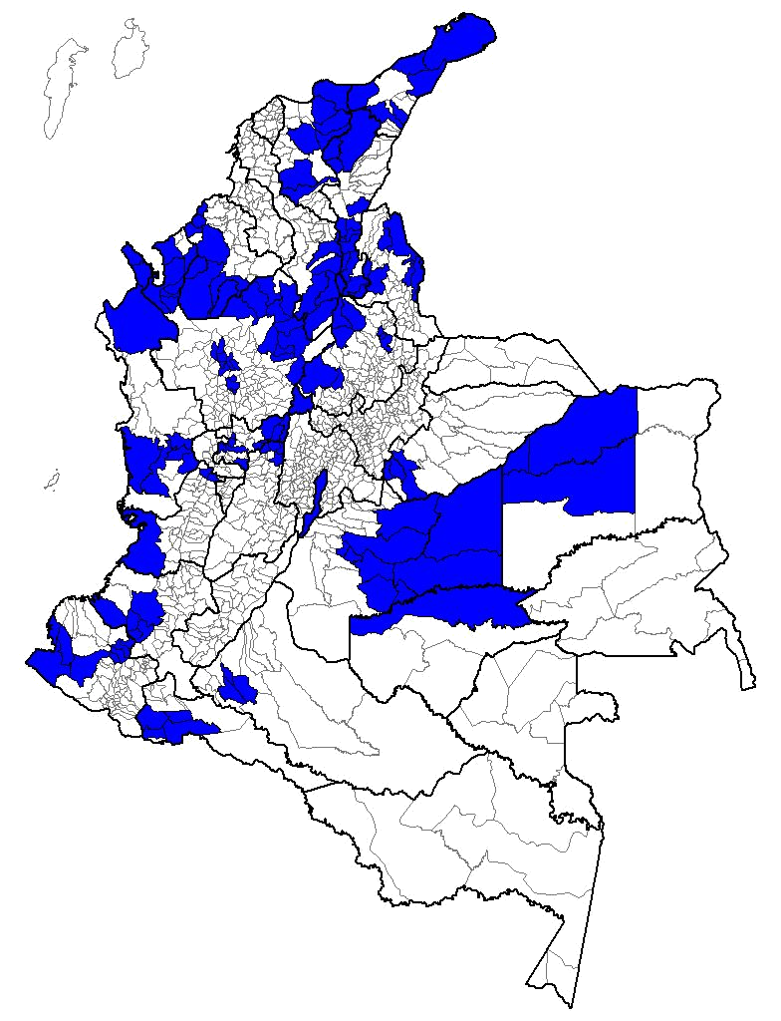
ANNEX B
Affected corridor

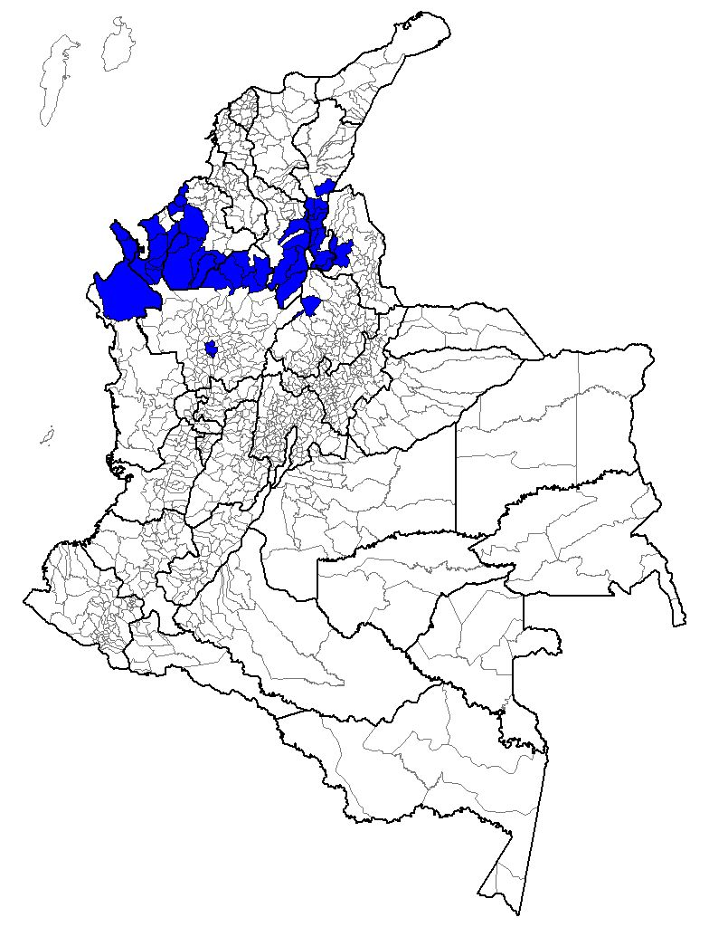
input.doc

August 2008.
The term active demobilized persons is understood to refer to those persons who have participated in at least one psychosocial activity in the past three months.
Including ex-combatants who have been captured and those who have not been located.
The five departments where the largest number of mass graves have been found are as follows: Magdalena with 238, Putumayo with 182, Antioquia with 164, Meta with 154 , and Córdoba with 140.
Form of the Inter-Institutional Justice and Peace Committee of August 31, 2008.
Most of these cases occurred in the Departments of Norte de Santander and Cesar. For the most part, the “data on casualties” were presented as the results of operations against the so-called “emerging gangs,” although the Mission also learned about action taken against guerrillera organizations. The following patterns were noted in these events: 1) Youth who received job offers in rural areas on the outskirts of their places of residence, and were reported as disappeared persons by their families, and were then presented as having died in combat by the Police; 2) Youth who received promises of work, and had to move to areas far from their places of residence, and who were considered by their families as disappeared persons, and then appeared as “caasualties” by the Police.
This case received special coverage by the media and generated an immediate response by the national government. In events under investigation by the competent authorities, the bodies of eleven youth who had been reported as disappeared in Soacha and Ciudad Bolívar (in southern Bogotá), appeared in the municipality of Ocaña.
It is important to note—and this was identified by the Public Defender’s Office in one of its recent reports-- 83% of minors and youth joined illegal armed groups voluntarily, which poses a greater challenge to the government.
Up to November 2008, the Mission conducted over 100 interviews of demobilized persons who reverted to illegal activities, and who are now in prison.
48% of those surveyed say that demobilized combatants, criminal groups, guerrillas, or newly emerging gangs controlled public order in the neighborhood in which they were living prior to being apprehended.
In regions of the country such as Norte de Santander, Bajo Cauca, Córdoba, and Urabá, MAPP/OEA has received information regarding the vulnerable situation of some of the persons providing psycho-social services.
It is important to point out that these territories, and especially the ones located in the Northwest, are where the Self-Defense Forces of Córdoba and Urabá arose, and later the Self-Defense Forces of Colombia. This zone was also an important operating area of the Bloque Minero and of Central Bolívar.
In San Martín, Cesar, it is known that despite the demobilization of the self-defense forces, a large majority of the municipal govenrment is related by marriage or by blood to the family of Juan Francisco Prada, who represents the demobilized Héctor Julio Peinado front. The new mayor is a relative of the Prada family, and was the manager of the property where the front demobilized. The secretary of the government is the brother-in-law of Prada and his niece is the personera [a local official].
Office of the Prosecutor General of the Republic (Justice and Peace Information System (SIJYP) and studies performed by the CNNR of the Northeast and Antioquia Regions.
In Memorandum 057 of August 15, 2008, the Office of the Prosecutor General gave instructions to prosecutors in the Justice and Peace Unit to interrogate demobilized persons on the basis of the following: Convention on the Rights of the Child and its Optional Protocol ratified by the Colombian State, regarding the participation of children in armed conflicts; the Geneva Convention, pertaining to prohibition of the recruitment of minors; the Penal Code with regard to the illegal recruitment of persons under 18 years of age; and, Law 975 of 2005 regarding one of the requirements for elegibility for turning over all children and adolescents linked to illegal groups.

