OEA/Ser.G
CP/doc. 4405/09
18 May 2009
Original: English

NOTE FROM THE PERMANENT MISSION OF TRINIDAD AND TOBAGO REQUESTING THE INCLUSION OF A NEW TOPIC ON THE AGENDA OF THE THIRTY-NINTH REGULAR SESSION OF THE GENERAL ASSEMBLY

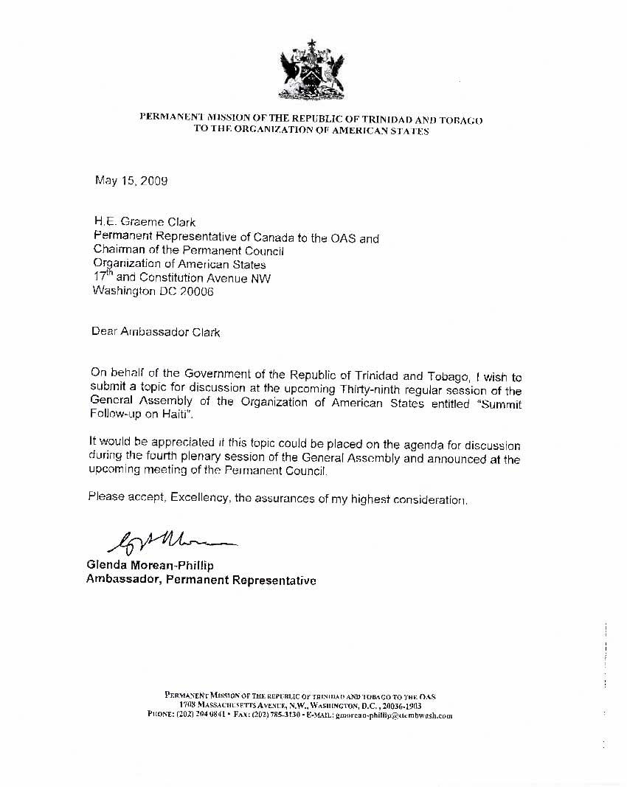
input.doc

