OEA/Ser.G
CP/doc.4417/09
23 June 2009
VERBATIM

FINAL REPORT OF THE GENERAL ELECTIONS IN ANTIGUA AND BARBUDA
MARCH 12, 2009

http://scm.oas.org/pdfs/2009/CP22590T.pdf

ORGANIZATION OF AMERICAN STATES

Final Report of the general elections in antigua and barbuda
march 12, 2009

Secretariat for Political Affairs

CONTENTS

Executive Summary 1

CHAPTER I. BACKGROUND AND NATURE OF THE MISSION..............................3

CHAPTER II. Political system and electoral organization................................4
A. Historical Overview……………………………………………………...4
B Political Systems and Actors…………………………………………….4
C. Voting Procedure………………………………………………………...7
D. Political financing………………………………………………………..8

CHAPTER III. Mission activities and observations…………………………………9
A. Pre-election……………………………………………………………..9
B. Election Day………………………………………………………….. 10
C. Post-election process………………………………………………….. 14

CHAPTER IV. Conclusions and Recommendations………………………………...14

CHAPTER V. Financial report

APPENDICES

- agreement of privileges and immunities
- agreement on electoral guarantees
- letters of invitation and acceptance
- forms completed by observers
- list of observers
VII. press releases and post-election report
VIII. official results
IX. electoral calendar

EXECUTIVE SUMMARY

On January 9, 2009, the Government of Antigua and Barbuda invited the Organization of American States to field an Electoral Observation Mission to observe the General Elections to be held on March 12, 2009. The Organization of American States responded positively to this request and arranged to observe elections on the islands. This was the first such mission that the OAS has mounted in Antigua and Barbuda. Dame Billie Miller served as Chief of Mission, assisted by OAS Senior Specialist Steven Griner as Deputy Chief of Mission.

A preliminary OAS mission visited Antigua and Barbuda in February 2009, to address concerns that had been raised by political parties and the Electoral Commission about preparations for the elections. On March 10, 2009, the OAS Mission signed an agreement of privileges and immunities with the Government of Antigua and Barbuda and, subsequently, another agreement of electoral guarantees with the Electoral Commission of Antigua and Barbuda. The same day, Dame Miller, Assistant Secretary General Albert Ramdin and the Deputy Chief of Mission called upon the Prime Minister, the Leader of the Opposition, the Governor-General and the members of the Antiguan Electoral Commission. In particular, the members of the Commission granted the Mission a long meeting, at which they discussed frankly the difficulties that they had faced in preparing for these elections, but at which they expressed their confidence that they would be ready for polling day.

The OAS Mission to observe the General Elections in Antigua and Barbuda consisted of 23 observers from 13 different countries. Observers participated in a day of training, familiarizing themselves with their duties and with the electoral districts where they would be deployed. On Election Day, observers deployed to the seventeen constituencies of Antigua and Barbuda and visited all of the 151 polling sites, witnessing firsthand the electoral preparations, voting, and counting of ballots. The observers also interviewed presiding officers, poll clerks, party agents, police officers and members of the public regarding preparations and the conduct of the elections.

The main issue of concern in this election was that many polling stations opened late throughout the country. In a number of polling sites, election materials were not received on time or key personnel were absent and this led to delays ranging from two hours to more than six hours before voting could begin. The problem was widespread, affecting six constituencies, including the constituency of the Prime Minister and some Antigua Labour Party strongholds. The delays did not thus, in the Mission’s opinion, affect one party more than another. Eventually, all polling stations did open and election workers and the public showed extraordinary commitment to ensuring that all who wished to vote were given an opportunity to do so. As stipulated in the legislation, those voters who were in line at 6pm were permitted to vote, even where that process took several more hours to complete. In the view of the mission, although small numbers of electors who had hoped to cast their votes in the morning might not have voted, the numbers of such electors were not significant enough to alter the final result. Turnout was high at 81% and the vast majority of voters displayed great tenacity and fortitude in waiting to cast their votes.

Despite the considerable difficulties and delays experienced in some polling stations, the general observations of these elections were positive. In eleven constituencies, the polling stations opened on time at 6 am and all the necessary election materials and election officials were present. Observers noted that most people identified their polling sites easily. Presiding officers, poll clerks and party agents for the most part followed procedures scrupulously and professionally in accordance with Election Laws. The party agents worked harmoniously with the electoral authorities throughout the day.

Police were present in all of the polling sites, effectively maintaining security. The environment in which citizens exercised their franchise was peaceful and without incident. The observers noticed some instances of campaign materials from both parties within the 100-yard limit. However, there were no reported instances of voter intimidation or any other serious irregularities on Election Day.

Indeed, the behaviour of the electors of Antigua and Barbuda, particularly where they faced serious delays, was exemplary. Waiting to exercise their franchise, voters remained calm and patient at every polling station. Despite their understandable frustration and exhaustion in some locations, the OAS Mission did not witness or hear reports of scuffles or confrontations. Polls closed as soon as the last electors in line at 6pm had voted and the count proceeded carefully and efficiently.

The elections were closely contested and in some seats a recount was performed, but the results issued late on 13 March confirmed that the United Progressive Party had won nine seats, the Antigua Labour Party seven seats, and the Barbuda People’s Movement, one seat. UPP Party Leader Baldwin Spencer retains the office of Prime Minister.

The OAS Mission was able to achieve its objective of providing objective analysis of the electoral process, with thorough coverage of the island’s polling sites, and maintaining dialogue with the Electoral Commission and other stakeholders, which helped facilitate communication and allay public concerns on Election Day and will hopefully assist in identifying areas where problems occurred that can be prevented in future. Clearly, there are some areas in which the electoral process in Antigua and Barbuda could be improved and these are detailed in the conclusions and recommendations of the report below.

The OAS Mission wishes to recognize the work to those involved in the General Elections of 2009 in Antigua and Barbuda, including the Supervisor of Elections and the Electoral Commission, Government officials, participating political parties and candidates, Presiding Officers, Poll Clerks and Party Agents and the many citizens who offered the members of this Mission their own perspectives on the electoral process. The Mission would also like to thank the Governments of Brazil, Canada, the United Kingdom and the United States for providing crucial financial support and observers. In particular, the Mission wishes to congratulate the citizens of Antigua and Barbuda on their conduct during the election and on their evident commitment to the democratic process.

CHAPTER 1: BACKGROUND AND NATURE OF THE MISSION

In an exchange of correspondence beginning on January 9, 2009, the Government of Antigua and Barbuda invited the Organization of American States to field an Electoral Observation Mission to observe the General Elections due to take place in 2009. The OAS responded positively to this request and set in motion preparations for a mission that would observe all of Antigua and Barbuda’s 151 polling stations. This was the first OAS Electoral Observation Mission in Antigua and Barbuda and the most comprehensive yet undertaken by any group.

Dame Billie Miller served as Chief of Mission, assisted by Senior Specialist Steven Griner as Deputy Chief of Mission. During a short preliminary mission, from February 11 to 13, 2009, Assistant Secretary General Albert Ramdin met with the Electoral Commission and other political and administrative actors to discuss preparations for the elections. On March 10, 2009, the OAS Mission signed an Agreement of Privileges and Immunities with the Government of Antigua and Barbuda and an Agreement of Electoral Guarantees with the Electoral Commission of Antigua and Barbuda.

The same day, Dame Miller, Ambassador Ramdin and the Deputy Chief of Mission met with the Prime Minister, leaders of the opposition party, the Governor-General, members of the Electoral Commission and the Supervisor of Elections, and representatives of civil society. The OAS Mission met with the electoral authorities during a two-hour meeting at which a variety of issues were discussed including the number of voters registering late and/or coming late to collect their voter identification cards; minor variations in the appearance of voter identification cards produced at different periods; and the accuracy of the voter list given the failure of all parties to utilize the claims and objections process. The Commission acknowledged the difficulties it was labouring under to complete its work, but professed itself ready for March 12.

On Election Day, the OAS Mission to observe the General Elections in Antigua and Barbuda consisted of 23 observers from 13 different countries. Observers participated in a day of training, familarizing themselves with their duties and with the electoral districts where they would be deployed. On Election Day, March 12, the mission deployed teams in all of Antigua and Barbuda’s 17 constituencies and observed 100% of polling stations, visiting each at least once and often returning on more than one occasion to monitor progress. Observers recorded their general impressions of polling and the answers to specific questions for each polling station, such as ‘were all the necessary election materials present?’, on special forms, samples of which are appended to this report. They spoke firsthand with Presiding Officers, Poll clerks, Returning Officers, police officers, party agents, and members of the public, building a comprehensive picture of the conduct of these Elections. Observers communicated their observations both verbally, in a Mission meeting immediately after the close and counting of the poll, and in written form. The report that follows describes their findings and outlines the Mission’s conclusions and recommendations.

The report begins with an overview of the political history of Antigua and Barbuda, the main political parties and other stakeholders, the voting procedure, and the legislative situation with regard to political financing. Chapter III then describes the Mission’s observations before, during and after the Elections. Chapter IV presents the Mission’s conclusions and recommendations. Appendices contain the financial statement and other documents relevant to the Mission’s activities in Antigua and Barbuda.

CHAPTER II: Political system and electoral organization

A. Historical Overview

Antigua and Barbuda are islands lying between the Caribbean Sea and the North Atlantic Ocean. Antigua has a land area of 280 square kilometers and Barbuda 161 square kilometers; their territory also includes the tiny island of Redonda. Together they have a population of around 85,600 persons. The economy of the islands is dependent on tourism and financial services; employment is also provided by the construction industry; a small amount of domestic agriculture, limited by local water resources; light manufacturing, and assembly for export of goods such as electronic components.

The rise of a strong labour movement in the 1940s provided the impetus for independence. In 1967, Antigua became an associated state of the Commonwealth with Barbuda and Redonda as dependencies. In 1981 Antigua and Barbuda achieved full independence. The country’s first Prime Minister was Vere Cornwall (V.C.) Bird of the Antigua Labour Party, who had achieved prominence in the labour movement and had acted as Chief Minister of Antigua from 1960.

Antigua and Barbuda’s subsequent political history was, until 2004, one of remarkable continuity. V.C. Bird retained the office of Prime Minister from 1981 to 1994, when he was succeeded by his son, Lester Bird, who was Prime Minister from 1994 to 2004, leading the longest-serving elected government in the Caribbean. In the 2004 General Election, the Antigua Labour Party was ousted from power by the United Progressive Party, led by Baldwin Spencer, which won twelve of the seventeen seats in Parliament. The Antigua Labour Party won four seats in the 2004 election, while the Barbuda People’s Movement won the one seat on Barbuda. On the eve of the 2009 General Election the UPP had, then, been in power for a single term and was seeking re-election, while the ALP was seeking a return to office.

B. Political System and Actors

Antigua and Barbuda operates a parliamentary system of government on the Westminster model. Since 1981, the country has been an independent sovereign state, but remains a member of the British Commonwealth, and the Queen of Great Britain is the nominal Head of State; her representative in Antigua and Barbuda is the Governor-General. The legislature is bicameral, with a lower house, the House of Representatives, and an upper house, the Senate. The island has seventeen constituencies and these seventeen seats in the House of Representatives are contested in General Elections: members are elected by popular vote on a “first past the post” basis, to serve five-year terms. The leader of the party securing the majority of seats in Parliament is named Prime Minister by the Governor-General. The leader of the party winning the next largest bloc of seats is named leader of the Opposition.

The seventeen members of the Senate are appointed by the Governor-General. Ten members are appointed on the advice of the Prime Minister, four on the advice of the Leader of the Opposition, one on the advice of the Barbuda Council, one resident of Barbuda on the advice of the Prime Minister, and one at the Governor General’s discretion.

The Supervisor of Elections administers and supervises the conduct of the elections. The Electoral Commission, chaired by Sir Gerald Watt, employs and deploys election officials. Each polling station is manned by a Presiding Officer and a Poll Clerk, who report to the Returning Officer for that constituency. Returning Officers are in turn responsible to the Supervisor of Elections, Ms. Lorna Simon. All eligible Antiguan and Barbudan citizens over the age of eighteen are entitled to vote, as are Commonwealth citizens who have been resident in Antigua and Barbuda for three years prior to their application to register as electors.

Political Parties

Four political parties and three independent candidates contested the election in Antigua and Barbuda. None of the independent candidates succeeded in gaining a large number of votes. Over the last decade, two parties, The Antigua Labour Party and the United Progressive Party have dominated the competition for seats on Antigua, while the Barbuda People’s Movement has captured the majority of votes in the single seat on Barbuda.

The Antigua Labour Party (ALP)
Party colour: red Party symbol: heart with a flaming torch

The Antigua Labour Party, which grew out of the labour movement in the 1940s, first ran candidates in the 1946 elections and became the majority party in 1951. It was formed by trades unionists and led by Vere Cornwall (V.C) Bird, who had been president of the Antigua Trades and Labour Union since 1943. Bird in 1951-2 led a strike of sugar plantation workers to obtain better wages and conditions. The success of this strike underwrote Bird’s prominence and popularity. The ALP under V.C. Bird was the reigning party in Antigua from 1951 to 1971 and again from 1976 to 1981. (Between 1971 and 1976, the Progressive Labour Movement, a predecessor to the UPP, governed.) After independence in 1981, the Antigua Labour Party, under the leadership of V.C. Bird, who was succeeded in 1993 by his son - Lester Bird, continued to win every election until 2004. Lester Bird remains the party leader.
In 2009, the ALP campaigned under the slogan “Providing Safety and Prosperity.” Its manifesto stressed the fear of crime on the island, claiming that gun crimes had risen 233% and that it would combat the problem by increasing police recruitment and incentives, establishing CCTV surveillance in the capital, St John’s, and new forces to protect beaches and hotels. It also pledged to “eliminate burdensome taxes,” reviewing sales tax, rejecting personal income tax and reducing corporate tax. It promised an “economic stimulus package” that would include enhanced benefits for public sector workers and pensioners, 2000 EC dollars for every eligible newborn child, and increased investment in education, including a new University of Antigua and Barbuda.
The United Progressive Party (UPP)
Party colour: blue and yellow Party symbol: sun

The United Progressive Party was formed in 1992 through a merger of the Antigua Caribbean Liberation Movement, the Progressive Labour Movement and the United National Democratic Party. Its platform is one of opposition to the dynastic history of Antiguan politics under the Bird leadership and it emphasizes fiscal restraint and private sector growth. The UPP came to power for the first time under its leader, Baldwin Spencer, in 2004, when it gained 55.3% of the popular vote.

In 2009, the UPP campaigned under the slogan “Right Track, Right Direction.” Its manifesto stressed the economic achievements of its first term of government, such as the reduction of the country’s debt to GDP ratio, and promised to build on these with further measures designed to stimulate business activity, attract inward investment, and promote “economic democracy.” In particular, it proposed divestment of various formerly publicly-owned utilities including the Airport and Port Authority, the State Insurance Company, Telecoms, and energy providers. It also proposed measures including the introduction of Unemployment Relief and the creation of a National Youth Service, a volunteer organization designed to encourage teenagers to serve Antigua and Barbuda via military or social, environmental and community work in return for a basic monetary stipend and “education credits” toward the cost of their tertiary education.

Barbuda People’s Movement (BPM)

The Barbuda People’s Movement, led by Trevor Walker, represents the interests of Barbudans. In particular, it has historically argued for restructured financial and administrative arrangements between the islands of Antigua and Barbuda that would give Barbudans greater autonomy and control over developments in Barbuda. The 2009 manifesto, under the slogan ‘Gateway to the Future’ alludes to a Commonwealth Report that the BPM claims supports the land rights claims of Barbudans and their right to resist development without consent. It proposes improved infrastructure on Barbuda, including expanded airport facilities, a dedicated port of entry, better roads and improved public utilities. Mr Walker has strong links with the UPP. In 2004 with 400 votes each, the BPM tied the Barbuda People’s Movement for Change, which had strong links with the ALP. A by-election was subsequently held and Mr. Walker was elected with 408 votes against the BPMC’s 394. The BPM has held the seat on Barbuda since 1999.

Organisation for National Development (OND)

The Organisation for National Development is a new party, formed in 2003 by a group that broke off from the UPP. Its leadership group includes Glentis Goodwin, Melford Nicholas, and Valerie Samuel.

Civil Society

Antigua and Barbuda boasts a wide variety of civil society organizations, many of which are involved in some aspect of voter education or informally monitor the campaign and election process. The Antigua Christian Council and United Evangelical Association recruited twenty-eight local volunteer observers, who toured the country’s polling stations observing voting procedures on Election Day. Antigua and Barbuda does not, however, have a civil society organization dedicated to this activity.

On March 10, 2009, the OAS Mission met with a variety of representatives of Civil Society to hear their impressions of the pre-election situation. Present were members of the Antigua and Barbuda Chamber of Commerce and Industry, the Antigua and Barbuda Disability Association, the Antigua and Barbuda Trades and Labour Union, the Antigua and Barbuda Workers’ Union, the Caribbean Institute for Women in Leadership, Concerned Citizens, the Employers’ Federation, the Professional Organisation for Women in Antigua and Barbuda. Among the concerns that they raised was the accuracy of the voter list, the accessibility of polling sites and the electoral process for physically challenged voters, and the lack of adequate legislation to ensure transparency and accountability in campaign spending, which all agreed had become worryingly high, particularly in view of current economic conditions.

The Antigua and Barbuda Chamber of Commerce and Industry published a press release on March 7, 2009, ahead of its meeting with the EOMs, drawing attention to changes in the electoral register between 2004 and 2009. In five constituencies – St Peter, St John’s Rural West, St John’s City South, St John’s City West, and Barbuda – the number of registered electors increased markedly after the re-registration exercise in 2004. In St Peter the number of registered electors rose by 41%, in St John’s Rural West by 31%, in St John’s City South by 29%, in St John’s City West by 26%, and in Barbuda by 28%. The Chamber of Commerce and Industry expressed its view that these rises were out of step with actual population shifts between parishes on the island, suggesting that in St John’s City South, St John’s City West, and Barbuda, all closely contested seats in the 2004 election, “empirical data suggests that there was a population shift away from all three constituencies, yet the number of registered electors increased at a rate above the national average. Something is definitely amiss and warrants further investigation.” Other civil society organizations agreed, in their meeting with the OAS EOM, that the voter list had not been subject to sufficient scrutiny in the claims and objections period and was likely over-inflated. Nonetheless, it was agreed that while the list might be inflated – a problem widespread in the region – this did not necessarily imply or provide the conditions for electoral fraud.

The Caribbean Institute for Women in Leadership, sponsored by the OAS produced a “Women’s Manifesto of Antigua and Barbuda” in the run-up to the election, providing “a platform of a common set of demands for the achievement of gender equality” and a “space to articulate our concerns in the 2009 Elections and beyond.” It was agreed at a CIWIL workshop of December 2008 whose participants were drawn from NGOs, women’s groups and other Antiguan and Barbudan civil society organizations that they would work collaboratively to promote the acceptance and use of the Manifesto by government, political parties, the private sector and civil society.

International Community

In addition to the OAS Election Observation Mission, a three-person Commonwealth Expert team observed the election. The Caribbean Community (CARICOM) also mounted a nine-person observer mission. Both these organizations had observed the 2004 elections and were the first EOMs to observe in Antigua and Barbuda. Members of the OAS Mission met both the 2009 teams in the field and liaised with them: all recorded similar observations.

C. Voting Procedure

Each polling station is manned by a Presiding Officer and a Poll Clerk. These election officials report to a Returning Officer, responsible for the electoral district. Members of the police are present to secure each polling station, and a party agent for each candidate contesting the election is permitted to be present to witness the conduct of the poll, as are accredited international observers.

Polls open at 6 a.m. and close at 6 p.m. Just before the opening of the poll, the Presiding Officer and Poll Clerk display the empty ballot box to all present, then lock it. Each elector, on entering the polling station, approaches the Presiding Officer’s table, states his or her name and produces his or her identification card. The voters’ list is checked; the number, name and description of the elector as stated on the list is called out. A tick is placed against the number of the elector.

The voter’s right index finger is checked and, if it is free of electoral ink, the voter is given a ballot stamped with the official seal. The applicant proceeds into the voting compartment and marks the ballot., returning to the Presiding Officer’s table with the ballot folded so that the mark is concealed. The elector shows the Presiding Officer the official seal. The elector must dip his or her finger in the electoral ink, after which s/he deposits the ballot in the ballot box and exits the station.

If at 6 p.m. there are any voters standing in line they are permitted to vote, but no-one who arrives after 6 p.m. is permitted to vote. At the close of the poll, in the presence of the poll clerk and the candidates or their agents, the presiding officer counts the number of voters whose names appear in the poll book as having voted, counts the spoiled ballot papers (if any) and the unused ballot papers and checks this total against the number of ballots supplied by the returning officer, to ascertain that all ballot papers are accounted for. Having completed an account of these figures, the Presiding Officer seals the ballot box and securely packs the election materials, which are collected by the Returning Officer and transported to the place where the count will be held.

The Returning Officer opens the ballot boxes in the presence of Election Officials, party agents, candidates and accredited observers, and counts the votes for each candidate, giving full opportunity to those present to examine each ballot paper, and finally displaying the empty box.

D. Political financing

In Antigua and Barbuda, there is no limit on the total amount that a party or a candidate is permitted to spend. There is also no provision for the public funding of parties, either directly or indirectly. However, in response to criticism and concern about the lack of transparency and accountability in political financing, the Parliament in 2001 passed an amended Representation of the People Act that called for disclosure by candidates of contributions exceeding EC$ 25,000, a prohibition on anonymous contributions exceeding EC$ 5,000, authorised audits by the Elections Commission of contributions received by candidates and sanctions for non compliance. The revised Act stipulates that no political party shall accept monetary or other contributions exceeding five thousand dollars “unless it can identify the source of the money or other contribution to the Commission”.

Section 6(5) mandates the Electoral Commission to report on Campaign financing following an election. Following the 2004 election, the three main political parties contesting the election submitted reports on the financing they had received and their records and audited accounts were examined by the Commission, which were subsequently supposed to make recommendations about how the legislation regarding political financing might be strengthened. The Mission does not have any knowledge that these recommendations were presented, though.

Clearly, these provisions are commendable and represent a step in the right direction, toward greater transparency and accountability, that other countries in the region might usefully replicate. However, some concerns remain. The figures involved are artifically low: a sanction of EC $2,000 a day pales in comparison to the amount of money potentially being raised in violation of the legislation and may not provide ample deterrence. Likewise, it is not wholly clear whether the prohibition on anonymous or unidentified donations exceeding EC $5000 applies only to individuals, or also to families and enterprises/ business networks: smaller sums might apparently be given by multiple donors but actually stem from a single donor. The nature of “other contributions” exceeding EC $5000 is vague. The facts that many contributions in Antiguan and Barbudan politics are ‘in kind’, that parties maintain offshore bank accounts and accept funds from multinational companies with complex financial interests and identities, and that the Electoral Commission has limited staff and expertise to trace funds mean that these prohibitions are difficult to enforce.

No one has proven that electoral contributions are derived from illegal activities, but many allege widespread corruption. In particular, these critics note the findings of the McIntyre Commission of Inquiry into the Medical Benefits Scheme that revealed manipulation by senior civil servants in the course of general elections in Antigua and Barbuda. No one can be certain as to the amount of money that is spent on elections by any party but there is a general perception that campaigning is becoming ever-more lavish, with increased use of giant billboards, radio, television and internet-based advertising, and solicitation of votes by telephone. The OAS Mission urges all actors in the Antiguan and Barbudan political process to continue to strengthen the legislation and monitoring of political financing in Antigua and Barbuda and to show leadership in promoting fairness and transparency in political financing and campaigning across the region.

CHAPTER III: MISSION ACTIVITIES AND OBSERVATIONS

A. Pre-election

The atmosphere in the run-up to this election was unusually tense. Antigua and Barbuda had been in the eye of a media storm following the English cricket team’s tour of the West Indies in February 2009. A new state of the art cricket stadium, the Sir Vivian Richards Stadium, was built for the 2007 Cricket World Cup. There was national embarrassment when, on the first day of play between England and the. West Indies in 2009, the stadium proved unfit for purpose and the match was obliged to transfer to Antigua’s old cricket stadium. Cross-party accusations followed.

Then, in February 2009, it was revealed that the U.S. Securities and Exchange Commission was investigating Sir Allen Stanford, an entrepreneur from Texas who owns multiple businesses in Antigua. The civil charges against him and two associates included suspicion of running a fraudulent investment scheme involving the sale of eight billion US dollars’ worth of certificates of deposit, the proceeds of which appeared to be missing. Accounts at Mr. Stanford’s bank were frozen. With the global economic slump affecting tourist numbers and the Obama administration in the United States announcing plans to curtail certain kinds of offshore banking, on which the Antiguan economy has partly depended, many Antiguans and Barbudans were worried about the prospect of financial loss and potential unemployment, with concomitant effects on social conditions and crime on the islands.

The 2009 election campaign was acrimonious, with negative campaigning and mud-slinging on all sides. The Antigua Labour Party campaign used billboards featuring the play on words “CORUPPTION” in large, bold type and personalized accusations such as a picture of a UPP candidate with the slogan “Doing Nothing in Parham for 5 Years.” The ALP also circulated a video entitled “Deception,” making various claims about the UPP government.

The UPP, meanwhile, adopted equally negative tactics, devoting a section of its campaign website to inviting visitors to choose the “worst ALP campaign moment,” claiming that ALP candidate Asot Michael had called for “blood to flow through the streets” and dubbing Antigua under the Bird leadership a “preeminent kleptocracy.” The Antigua Christian Council reported an incident of stone-throwing during the campaign motorcades and there were complaints that campaign materials had been destroyed by rival supporters. On February 16, 2009 the Jamaica Observer reported that “two constituency offices of the Antigua Labour Party were completely destroyed by fire on Saturday night amid a spreading hostile election climate with the voting date still to be announced”. There were no reports of serious incidents of violence against individuals, but much defamatory media coverage.

Various stakeholders, meanwhile, voiced concern about the Electoral Commission’s readiness to hold elections in March, and the accuracy of the voter list following the setting of new constituency boundaries and a complete voter re-registration process in 2004. In 2004, Antigua adopted a system of continuous voter registration. Previously voters had only specified and limited opportunities to present themselves to register. Under the new system, they could register at any time, though if they registered later than December 2008, their registrations would not likely be processed in time to vote in the 2009 elections. The new system led to a marked and laudable increase in the number of voters registering, particularly young voters: 47% of new registrants were between 18 and 25.

However, some were skeptical: The Antigua and Barbuda Chamber of Commerce and Industry published a late challenge on March 7, 2009 suggesting that the increase in registrants of between 30% and 40% in some parishes did not reflect actual geographical and demographic shifts but was artificially inflated by the inclusion of ineligible persons. The new system, with an unpredictable volume and flow of registrants and many late registrants, put various strains on the Commission’s infrastructure, while politicized criticism from both ends of the party spectrum tended to undermine confidence.

In a lengthy meeting on March 10, leaders of the OAS Election Observation Mission discussed concerns with the Electoral Commission including the new constituency boundaries, the accuracy of the voter list, perceived (but in fact negligible) differences between identity cards issued at an earlier and a later date, and how many citizens who had attempted to register too late would not be able to vote on Election Day.

The Commission acknowledged that the re-registration process from 2004 had involved difficulties. The changes in the electoral boundaries had to go through a legislative process that left little time for site visits. The Commission, in its own words, had done “all that the law requires but not as much as we would have liked.” A surge of late registrants created an administrative backlog in the months immediately preceding the elections. Some 1,300 potential voters who registered late, in January and February 2009, would not have completed the claims and objections process in time to be eligible to vote in March.

Although the Commission acknowledged that it might better have anticipated some of these problems, it was evident to the OAS EOM that some of the problems might have been avoided had there been more timely action from parties, civil society, and the general public. No claims and objections were received by the Commission in the period between 2004 and 2009: the process designed to cleanse the voter list of inaccuracy was not being used by the citizens of Antigua and Barbuda. Similarly, more timely action on the part of citizens to register and collect their voter ID cards – and more timely reminders from parties to their members to do so – would have obviated the late rush that hobbled the Commission’s administrative resources immediately before the election.

At the March 10 meeting the Commission professed itself ready to run the General Elections of March 12; it was subsequently evident, however, that this was an over-optimistic analysis and that the problems identified before the election contributed to a situation of unreadiness.

B. Election Day
All observers completed a day of training to familiarize themselves with the electoral system of Antigua and Barbuda, the rules and norms governing Electoral Observation, and the districts that they would be monitoring. Observers, working alone but accompanied by a local driver, were assigned to cover the polling stations in one of Antigua and Barbuda’s seventeen constituencies. Since there were 23 observers, some constituencies were monitored by more than one team. On Election Day, March 12, 2009, the Mission visited 100% of Antigua and Barbuda’s 151 polling stations, visiting each at least once and often visiting a polling site more than once to see how voting was progressing.
On the morning of Election Day, each observer arrived at a selected polling station between 5 and 5.45 a.m. to observe the preparations for voting, the inspection and sealing of the ballot box and other opening procedures. Throughout the day, observers circulated to different polling stations in their constituencies. The teams then returned to the polling station where they had witnessed the opening, to observe the closing of the poll and the counting of the ballot.
On special forms (see Appendix), the observers collected information about the opening and closing of the polls and the conduct of the voting. They obtained this information through firsthand observation and through interviews with the election officials, policemen, and voters at the polling stations. Observers delivered their completed forms and a short report to the Mission rapporteur; they also gave a verbal account of their impressions to the Mission at a debriefing session following the close of poll.
Observer Testimony
Observers reported that in eleven of Antigua and Barbuda’s constituencies polling stations opened on time at 6 am and all necessary electoral materials were present. Voter lists were usually displayed outside polling stations and opening procedures were correctly followed. Given the emphasis subsequently placed on polling sites that experienced problems in this election, it seems important to emphasize that in the majority of polling centres, voting ran smoothly from the start to the close of Election Day.
In six constituencies – St George, St Johns Rural West, St John’s Rural South, St Mary’s North, St Mary’s South, and St Peter – there were significant delays in opening polling stations, chiefly to due to the late arrival of the photographic list of voters. These delays ranged from two hours to over six hours. At Greenbay polling station in St John’s Rural West, among the worst affected centres, the registers did not arrive until 12.15 pm and voting did not commence until 12.45 pm, leaving voters with little more than five hours in which to present themselves to vote. An observer at Sea View farm Primary School in All Saints West reported that the polling station R-Z lacked an updated list of electors but began with voting anyway, the Poll Clerk and party agents simply recording names of those who voted in the poll book.

Where there were delays in opening the poll, long lines of several hundred voters necessarily formed and the area outside polling centres became cramped and sometimes confusing for those seeking the correct station. Polling stations are allocated by alphabetized division, according to the voter’s surname. Signs for individual stations were not always clearly written or readily visible at a distance. One observer was distressed by the case of a woman who had presented herself successively at several wrong stations, only to find, by the time that she reached the front of the line, that she could not vote there. Members of the mission observed in some polling centres ushers who directed voters to the correct line, which alleviated confusion and disorder.
Nonetheless, the great majority of voters found the correct polling station without difficulty. Voters displayed exemplary patience and fortitude in waiting to vote, even when this took several hours. Chairs were brought from nearby houses, people read books, and a peaceful atmosphere of stoic determination prevailed. Observers at the stations affected by long delays noted that, while there were isolated cases of voters who were obliged to work in the afternoon (such as a pilot booked to fly to Monserrat) or whose travel arrangements prevented them from remaining to vote, almost all the voters interviewed expressed and carried out their intention of waiting “as long as it took” to be sure of exercising their franchise. Average turnout of 81.7% over the eleven unaffected constituencies, with average turnout of 79.7% in the six constituencies affected by the delays, tended to confirm that most voters had not been deterred from voting.
Observers in the polling centres affected by the delays noted that better communication from the Electoral Commission to the Election Officers, and thence to voters, on the nature and likely length of the delay would have been helpful. However, all observers stressed that there had been no incidents of disorder or violence reported or witnessed throughout the day. Voters dealt with physical discomfort, irritation and uncertainty ‘heroically’, without a single confrontation or scuffle. One voter in protest refused to leave until he was allowed to vote: that was the sternest measure of public displeasure reported to the Mission.
Police were present in all of the polling sites, effectively maintaining security. At Greenbay Public School, where there was serious overcrowding and noise levels rose, observers suggested that the police presence could have been upgraded. Police numbers were increased in the course of the day at this station. Party agents from the UPP and ALP were present in all polling stations; less frequently an agent from one of the other parties contesting the election was also present. All worked harmoniously with Election Officials throughout the voting and counting process.
Presiding Officers and Poll Clerks and party agents for the most part were appropriately trained and followed procedures professionally in accordance with Election Laws. The secrecy of the ballot was maintained and voter identification and eligibility were rigorously checked. Several observers felt that the identification procedure, however, involved unnecessary duplication of labour, and sometimes exacerbated existing delays. Both Presiding Officers and Poll Clerks trace the voter’s name on the list, ID cards are passed along a long line from Presiding Officer to party agents, and the voter’s index finger is checked twice – once before and once after voting. A division of labour would be preferable, where the Poll Clerk is responsible for the ID check and the Presiding Officer deals only with giving out ballots, instructing the voter, and seeing the ballot into the box. Ballot papers were physically large and folding them multiple times to fit them into the ballot box also took unnecessary time.
Observers noted that some Presiding Officers were overly officious, while a few were very terse. Instruction given to voters, while impartial, was often very basic. Some were simply asked or told: ‘You know how to vote?’ and given a ballot. The Instruction Manual for Election Workers could be clearer on this point and about the respective duties of Presiding Officers and Poll Clerks.
In several constituencies, observers reported violations of the 100-yard limit beyond which campaign materials (billboards, posters) may not be displayed. In St George’s, at Potters Primary School, posters on lampposts and a billboard advertising the ALP candidate were removed after a complaint was received. There was also a tendency in some polling centres for candidates, party agents, or media representatives to congregated within the 100-yard barrier, spending significant periods interacting with voters and potentially affecting the process, rather than merely paying a brief visit for information or to vote themselves. In St John’s Rural North an observer noted that there was apparently food distribution to voters by party representatives within the 100-yard limit. At Golden Grove Primary in St John’s Rural South, a television crew set up a van in the yard, filming live within the compound.
Other observers noted that on Election Day, radio stations were “still in campaign mode” and were broadcasting defamatory and sometimes offensive material about candidates and parties. Observers commented that “voters can be influenced by what they see and hear.”
In St Pauls, at Liberta School, a couple of voters in separate lines complained that they had suffered harassment by supporters of the party they did not support. One claimed that UPP supporters were threatening people in the local bakery. Another claimed that objects had been thrown at her car while she was wearing party colours and that she had received phone calls from an anonymous caller who swore at her when she declared her party affiliation. A similar complaint was voiced by a Presiding Officer at Cobbs Cross Primary School in the same constituency, who had received phone calls from an anonymous caller who swore at her.
Although the majority of polling sites were fit for purpose and the secrecy of the ballot was maintained, several observers encountered polling stations which were unduly cramped and where the layout could be improved to enable greater ease of access, particularly for elderly or physically challenged voters. This was a major problem at Greenbay and at polling stations in St Peter. In a couple of polling stations, cramped conditions meant that a view of the voting compartment was potentially available through a window or from a nearby polling station, although observers saw no evidence of this being abused. Problems of space were most acute where there were 8 polling stations at one polling site, and/or where polling stations had in the region of 400 voters on their list. 250 voters per station, one experienced observer mentioned, is a more realistic target.
Elderly and challenged voters were generally treated with kindness and informally prioritized in line, but in many locations greater thought could be paid to the provision of ramps, seating, and facilities to expedite entry and exit for vulnerable citizens. Observers noted considerable variation across polling station in the treatment of challenged voters: on one occasion a policeman wrongly assisted a mentally challenged voter who had spoiled his ballot to complete it; on another a Presiding Officer “took over” too often for physically or mentally challenged voters. Some of the OAS observers suggested that improved and more uniform training and instruction in the Election Officers’ Manual on this issue would help.
Legislation in Antigua and Barbuda does not provide for the possibility of polling being extended beyond the 6pm deadline. However, all who are in line at 6pm are entitled to vote. This procedure was correctly followed at all polling sites; where there had been significant delays, lines often took several more hours to process. The closing of the poll and the count were also, in general, procedurally correct. Exhaustion and inexperience led to occasional glitches and delays, with some uncertainty about the affixing of extra seals to ballot boxes by party agents. Observers noted that the security of the room used for the count could often be tighter: nobody attempted to molest the ballot boxes or interrupt the count, but the windows and doors of the rooms in which the close and count of poll were completed were often open, with an audience of party loyalists, relatives, and media representatives following the final stages of the process from a short distance away. Results began to be transmitted on the evening of March 12, but delays and recounts in some constituencies meant that the final result was not known until the following day.
OAS observers were everywhere welcomed with courtesy and friendliness by both election officials and members of the public. The Chief of Mission also particularly welcomed the frankness of the Electoral Commission and the time it devoted to communication with the Mission, which enabled the Mission to gain invaluable insights into the wider situation affecting the electoral process in Antigua and Barbuda and better to perform its duties.

C. Post-election Process

The final results of the General Elections in Antigua and Barbuda were declared by the Electoral Commission on March 13. The United Progressive Party had won nine seats, the Antigua Labour Party seven seats, and the Barbuda People’s Movement, one seat. UPP Party Leader Baldwin Spencer retains the office of Prime Minister. The day after the elections was declared a public holiday. The Chief of Mission held a Press Conference and issued a press release outlining the Mission’s preliminary findings.
The Antigua Labour Party early expressed its disgruntlement with the running of the election, claiming that many Antiguans may have been disenfranchised due to the delays in six constituencies and that the result was therefore unsafe. Criticism of the Electoral Commission continued during the weeks succeeding the election and one member of the Commission, Bishop Ewing Dorsett, resigned.
On April 22, UPP St John’s City West candidate Colin Derrick challenged the Electoral Commission to respond to a request for information concerning what he regarded as a “grave illegal registration contained in the current published Register of Electors,” which he claimed contained the names of many electors who had applied for registration on the basis of three-year residency in Antigua and Barbuda, but whose residency could not be confirmed by appropriate recording in their passport. Mr Derrick alleged that, for such electors, receipts for payment of arrears by the immigration department were wrongly accepted as evidence of residency, when in fact the applicants were not legally entitled to become registered voters.
Sir Gerald Watt, Chairman of the Election Commission, responded to this and other criticisms on April 23, by alleging that the election, with the exception of the delays in some constituencies, had been successfully run, but that “misinformation and general propaganda” was “systemically disseminated” on political platforms and at news conferences leading up to the polls, most notably by the UPP chairman, with the intention of undermining the Electoral Commission, deflecting onto it criticism that should have been leveled at government, and that it had not been provided necessary funds, with the UPP treating it as “just another governmental department.”

CHAPTER IV: CONCLUSIONS AND RECOMMENDATIONS

The OAS Electoral Observation Mission wishes to recognize the commitment and dedication to the people of Antigua and Barbuda, the Supervisor of Elections and the Electoral Commission, party leaders, election officials, and members of the police force, on the peaceful and orderly conduct of the General Elections of March 12, 2009. Overall, the observations of the Mission were positive and the observers were particularly impressed by the exemplary patience, courtesy, and determination of voters to exercise their franchise with civility despite, in some areas, waiting for many hours to vote. Clearly, however, there are some areas in which the electoral process in Antigua and Barbuda could be improved and in the spirit of constructive engagement with the electoral authorities and political leaders of Antigua and Barbuda, the Mission would like to present the following conclusions and recommendations:
A. Conclusions

- The Electoral Commission faced great pressure on its human and technological resources in the immediate run-up to these elections. Since the introduction of continuous registration in Antigua and Barbuda, electors have been able to register and obtain their voter identification cards throughout the year. A very large number, however, waited until the last minute to collect new identification cards or replace old and lost cards.

- The Commission extended its previous, self-imposed deadlines to allow as many voters as possible to obtain their cards and vote in these elections. In doing so, it overextended itself with regard to other duties, particularly the printing of the photographic voter list for polling stations required on Election Day. This left it vulnerable to the technological breakdown that occurred. The immediate cause of this breakdown was a printer malfunction in the days preceding Election Day (Thursday March 12), but the systemic source of the breakdown was unsustainable pressure on the Commission’s technical resources and personnel in the weeks to March 10, on which day the Commission was still processing voter identification cards. The Electoral Commission made an error of judgement about its readiness in the days immediately preceding the election. On Election Day it was clear that the Commission had been working through the night and that the Supervisor of Elections had not slept.
- On Election Day, polling ran smoothly in eleven out of seventeen constituencies. In the other six constituencies, the absence of a photographic voter list and (in one instance) key personnel, delayed the opening of polling stations by periods ranging from two hours to six hours. The Electoral Commission was slow to communicate to these polling stations the likely extent of the delay and to advise voters when it might be resolved.
- Despite these problems, in the Mission’s view, the election process was fair and the result was credible. No one party was affected more than the others by the delays. Eventually, all polling stations did open and election workers and the public showed extraordinary commitment to ensuring that all who wished to vote were given an opportunity to do so. As stipulated in the legislation, those voters who were in line at 6pm were permitted to vote, even where that process took several more hours to complete. In the opinion of the mission, although small numbers of electors who had hoped to cast their votes in the morning might not have voted, the numbers of such electors were not significant enough to alter the final result. Turnout approached 81% and few voters appeared deterred by the delays.
- The Electoral Commission informed the Mission that there had been no claims and objections with regard to the voter list in the four years since the last election. This is disappointing and suggests that the Register of Electors where, in some constituencies, numbers have risen by 40% due to boundary changes and an influx of new registrants, is not being maintained to the high standard of accuracy such a process should provide.
- While commendably thorough, the procedures for running polling stations in Antigua and Barbuda involve unnecessary duplications of labour, particularly in the identification of voters. In some places, the cumbersome nature of this process exacerbated existing delays on Election Day. The ballots themselves were extremely large, necessitating much time-consuming folding and unfolding. Most Election Day workers performed their duties to a high standard of professionalism. In some cases, however, further training would have assisted in facilitating a faster and more uniform process. Some Presiding Officers were unduly officious, while others gave very little instruction to voters about how to vote.
- The Training Manual for Election Day Workers could be improved. At present it is not as explicit as it might be about which Officer should undertake which activity. Polling Officials are “expected to report for duty no later than 5:45 a.m.,” rather late in view of ensuring a timely opening at 6 a.m.
- Some polling sites contained multiple polling stations in a relatively cramped area. This made conditions especially crowded where delays occurred and created confusion for some voters, particularly those challenged with regard to the alphabetized divisions of the voter list between stations. Some polling stations were also difficult to access for elderly and/or physically challenged voters.
- There were occasional infringements of the 100-yard line, beyond which no campaign materials (posters etc.) should be displayed. Some observers also reported that candidates, party agents who were not officially observing in the polling station, and media representatives tended to congregate within the boundaries of a polling station for long periods, canvassing voters and potentially affecting the polling process rather than merely visiting for information and/or to cast their own votes and leaving promptly.
- In this election the ALP fielded 3 female candidates, the UPP 2 female candidates. Only one woman won a seat – the same as in the previous general election. By contrast, a very large number of Election Day workers and party agents were female. 2004 saw the election of Antigua and Barbuda’s first female Member of Parliament. Like other countries in the region, Antigua and Barbuda has some way to go in encouraging and supporting equal female political candidacy and participation at the highest levels.
- The Mission notes that election campaigning in Antigua and Barbuda, as elsewhere in the Caribbean, is becoming increasingly expensive, with increasing use of the media. The situation is propitious for parties to agree to rules on campaign financing and use of the media that promote fairness, transparency, and accountability.
- The tone of the election campaign was often acrimonious, with candidates and supporters on both sides accusing those in the other party of malfeasance. Observers heard some complaints from voters who had received unsolicited and sometimes malicious telephone calls, e-mails, or text messages from persons claiming to represent a particular party. A few voters also claimed that it was well known that certain inducements (laptops, work contracts) were offered to vote for a particular party or, conversely, that they had been publicly harassed by supporters of the rival party. While most voters reported nothing of this kind and the few that did were eager to emphasize that it had not affected their voting intentions, even the perception that politics in Antigua and Barbuda is clouded by partisan interests and animosities is potentially destructive and does not serve the highest democratic ends. Polls commissioned by parties in the pre-election period, with dubious validity, added to a tense atmosphere.

B. Recommendations
- Producing an accurate and timely voter lists represents a significant challenge for many of the countries where the OAS has observed elections. Often, the civil and electoral registries are organically linked. In some countries in the Caribbean and Central America, for instance, when a citizen reaches the age of 18, or the legally stipulated voting age, he or she is automatically included on the electoral registry and provided an identification card. The Parliament of Antigua and Barbuda should analyze these relevant models and consider implementing reforms to more closely link the civil and electoral registries, perhaps even promoting an automatic registration of voters.
- The Mission encourages the Electoral Commission in future to stick to deadlines necessary to provide it with sufficient time to perform all its duties and allow for mishaps in the run-up to Election Day.
- The Electoral Commission’s human and technical resources also need to be sufficiently flexible, robust, well-resourced and well-prepared to withstand the considerable pressures and complete the necessary tasks of the pre-election period. Back-up plans in case of sudden technological breakdown are essential.
- The Mission also encourages political parties, candidates, and individual citizens to take greater responsibility for ensuring the timely registration of voters and their provision with identification cards. The introduction of a National Identification card, suitable for multiple purposes, might be economical and helpful in obviating the rush for voter identification cards prior to an election.
- Political parties and individual citizens need to play a greater role in continuously monitoring the voter list, ensuring that it is accurate and up to date. Posting voter lists online could serve an important role in this process. The Claims and Objections period should be used productively to cleanse the list of deceased or absent voters and to establish the existence of citizens who are eligible to vote, but whose details may have changed since the list was last updated.
- Some efficiency gains could be made in the procedures for running polling stations in Antigua and Barbuda. In particular, the method for establishing voter identification and eligibility seems unnecessarily cumbersome. Both Presiding Officers and Poll Clerks trace the voter’s name on the list, ID cards are passed along a long line from Presiding Officer to party agents, and the voter’s index finger is often checked twice for electoral ink – once before and once after voting. A division of labour would be preferable, where the Poll Clerk is responsible for the ID check and the Presiding Officer deals only with giving out ballots, instructing the voter, and seeing the ballot into the box. Ballot papers could be smaller, for ease of handling.
- Voter instruction could be improved and made more uniform: many Presiding Officers, pressed for time, merely said: ‘You know how to vote?’. Basic, impartial instruction should be given to all voters. The Training Manual for Election Workers could be more comprehensive and explicit on this point and on the precise division of duties outlined above. Polling Officials are “expected to report for duty no later than 5:45 a.m.” While, in practice, most Officials arrived much earlier, an earlier time should be mandated to ensure timely opening of the poll.
- The Mission recommends greater attention to the signage and layout of polling sites, for enhanced ease of access by the physically challenged and elderly and ease of use by all voters. Among possible improvements would be the appointment of ushers to assist those who found themselves in the wrong line to speedily locate and join the correct one.
- It is important that the 100-yard boundary surrounding polling stations is maintained free of campaign materials and that candidates, party agents who are not officially observing in the polling station, and media representatives do not spend undue amounts of time within the 100-yard limit or seek to monitor or influence voters as they arrive.
- Political parties should actively consider and pursue mechanisms to recruit, train and finance women to be candidates for public office. The Mission notes that the 2009 Women’s Manifesto of Antigua and Barbuda suggests “a minimum of 40% female candidacy nomination in all party races at all levels.”
- The OAS Mission would welcome a cross-party accord on campaign financing and media access that would promote transparency and accountability both in Antigua and Barbuda and across the region.
- The Mission notes that the role of political leaders and candidates in promoting a peaceful and constructive political environment in Antigua and Barbuda is critically important. The OAS Mission recommends that parties, possibly in collaboration with civil society, sign an accord on conduct during the campaign to which they would be held accountable, and to address standards of campaign broadcasting and advertising and use of mobile telephones and other electronic media to solicit support. A media monitoring unit could be established to monitor adherence to agreed standards of civility.
- The Mission also recommends that protocols be established regarding the financing, conduct, and methodology of polls commissioned by parties in the pre-election period.

APPENDICES

APPENDIX I.
AGREEMENT OF PRIVILEGES AND IMMUNITIES

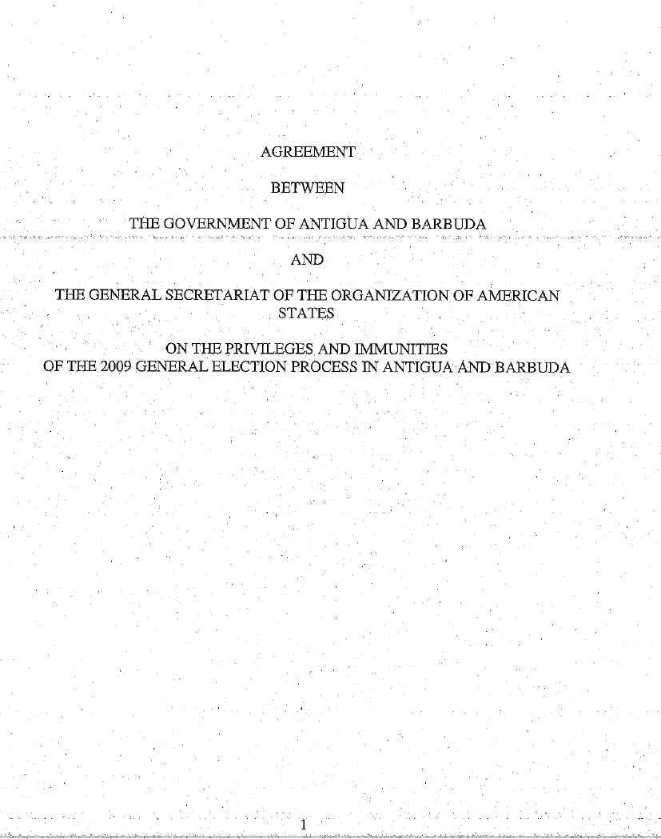

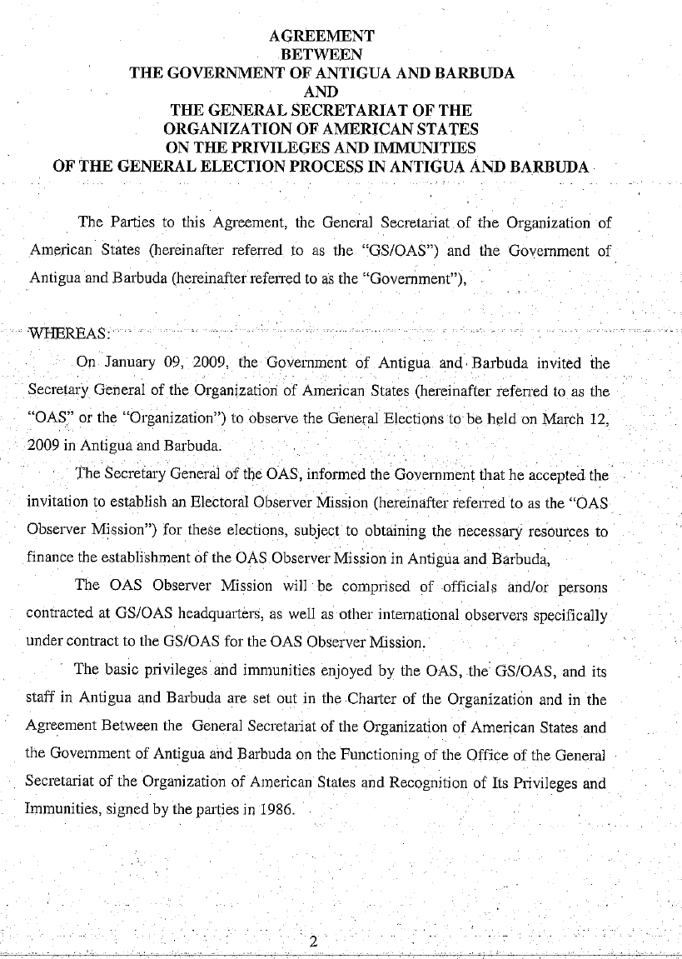

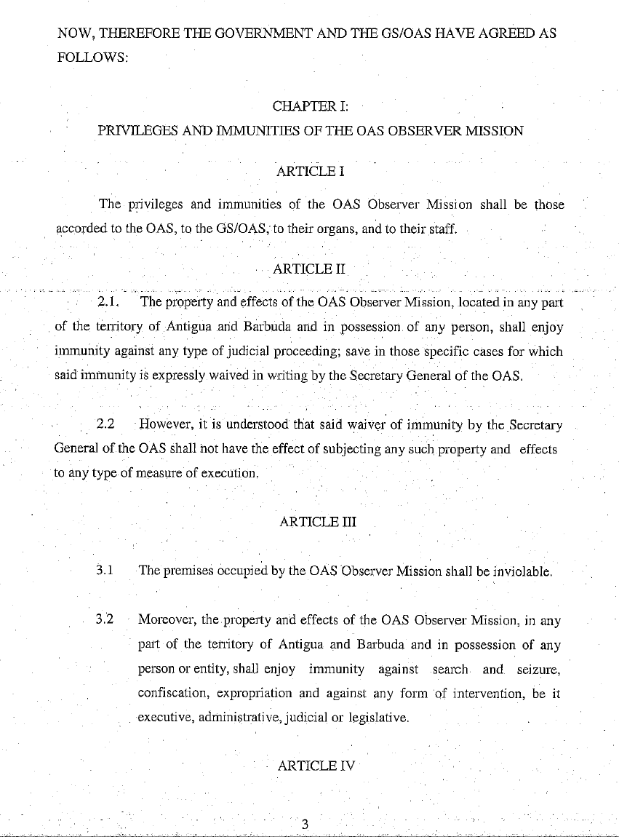

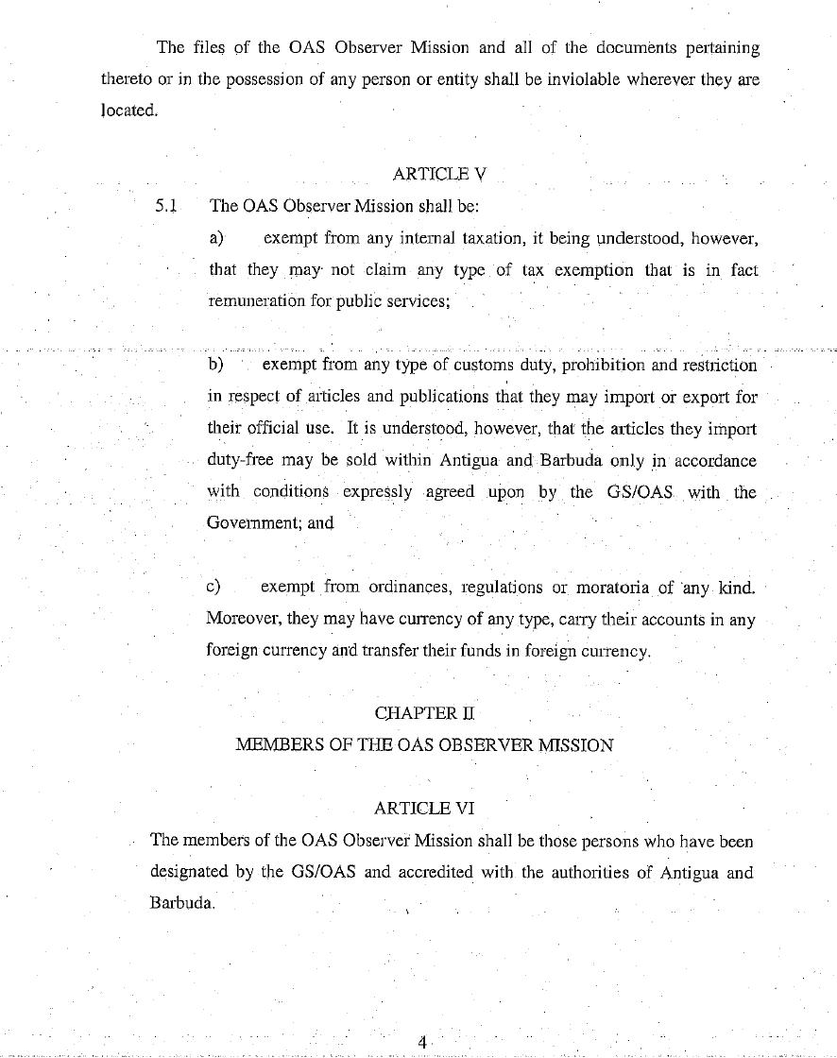

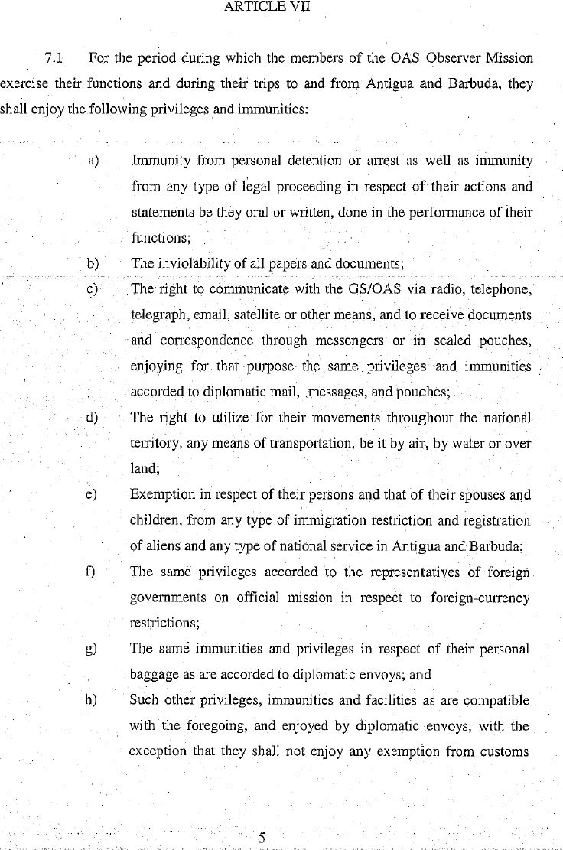
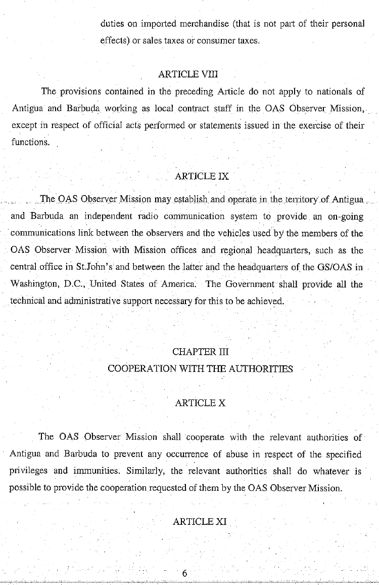

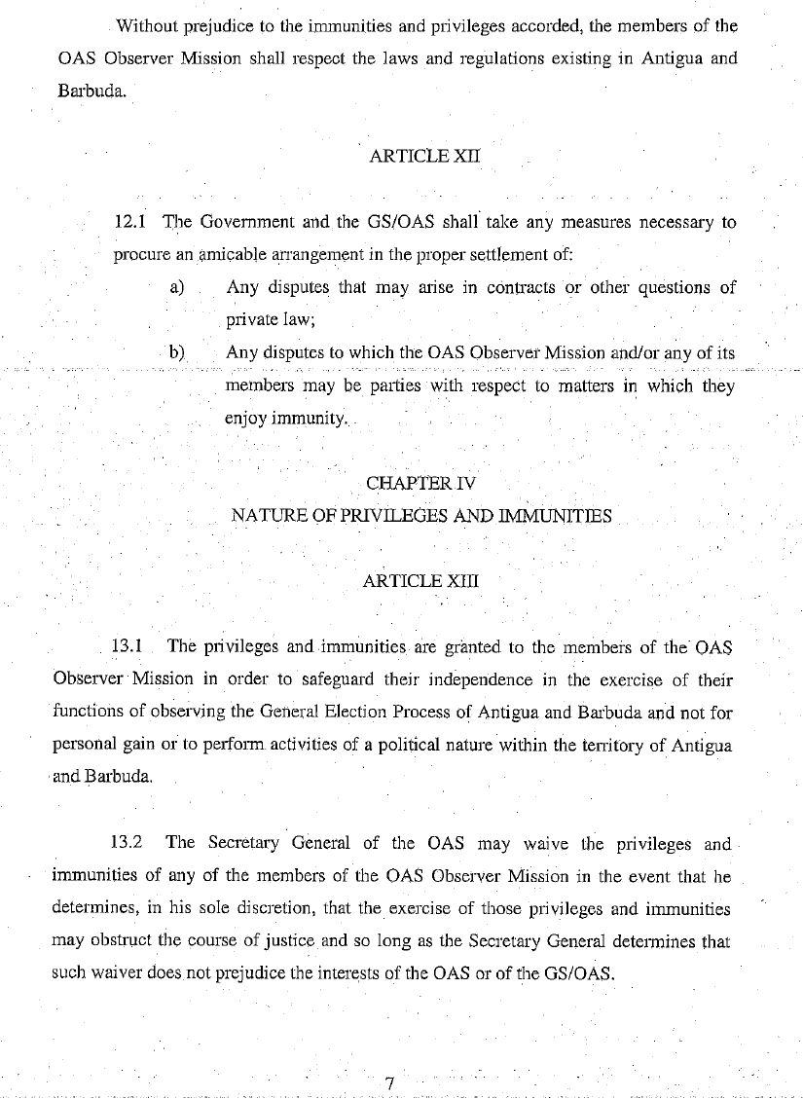

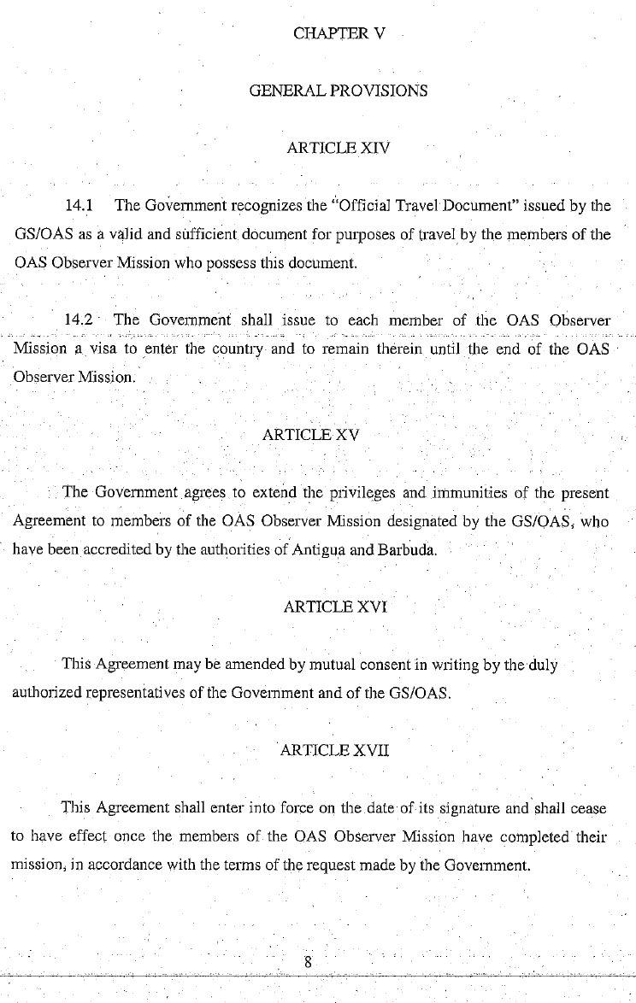

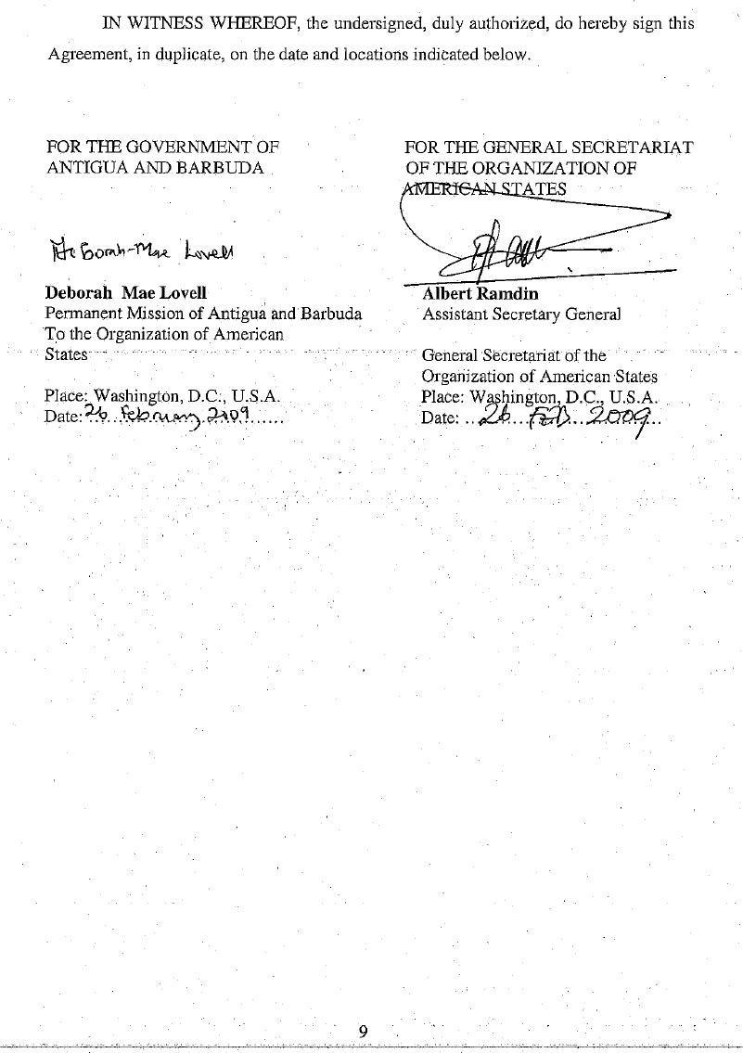

APPENDIX II.

AGREEMENT ON ELECTORAL GUARANTEES
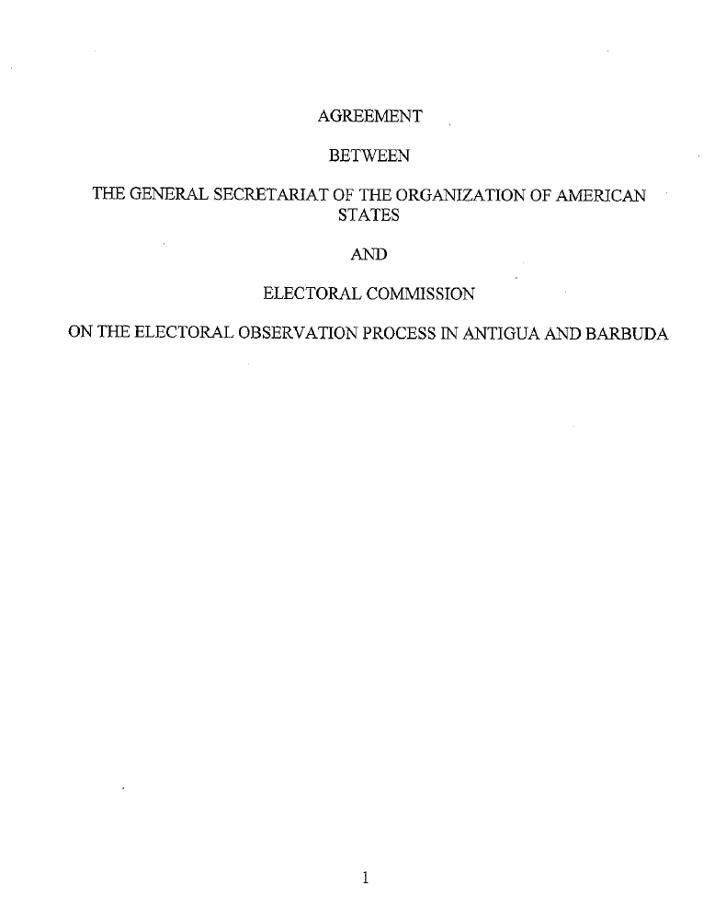

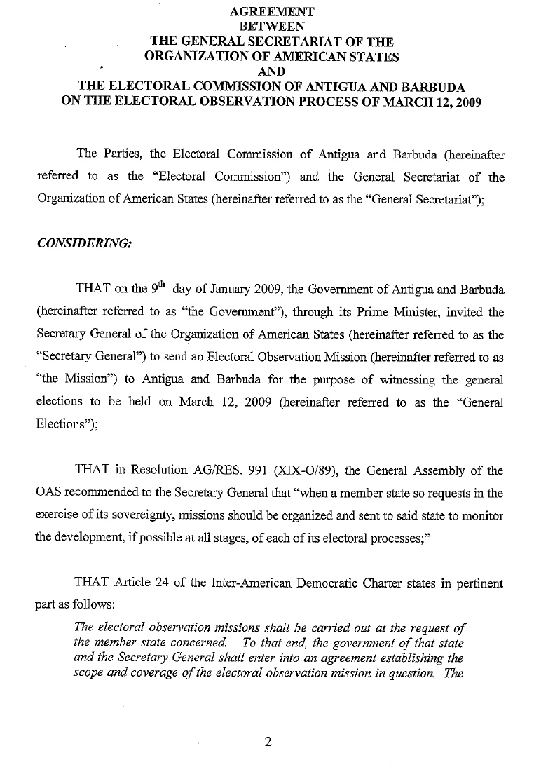

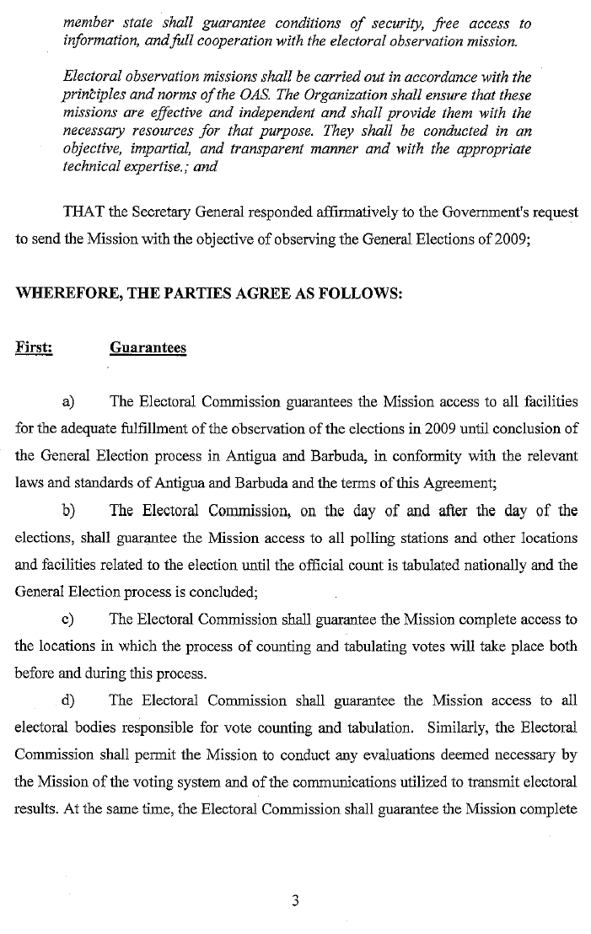

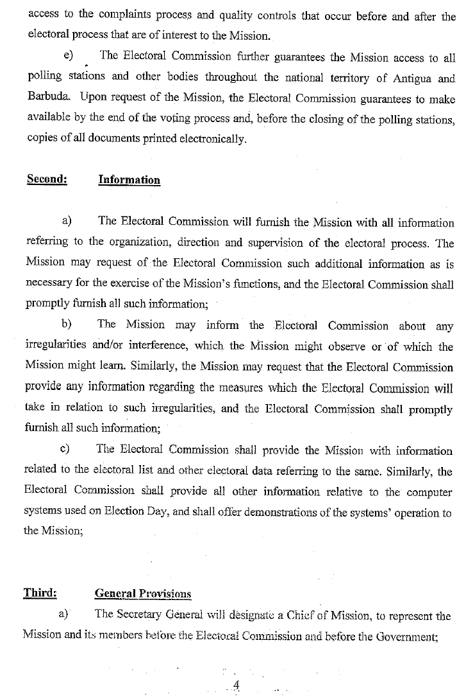

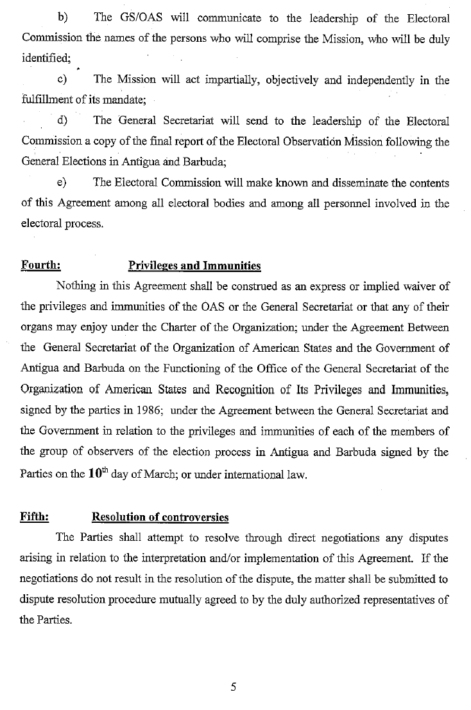

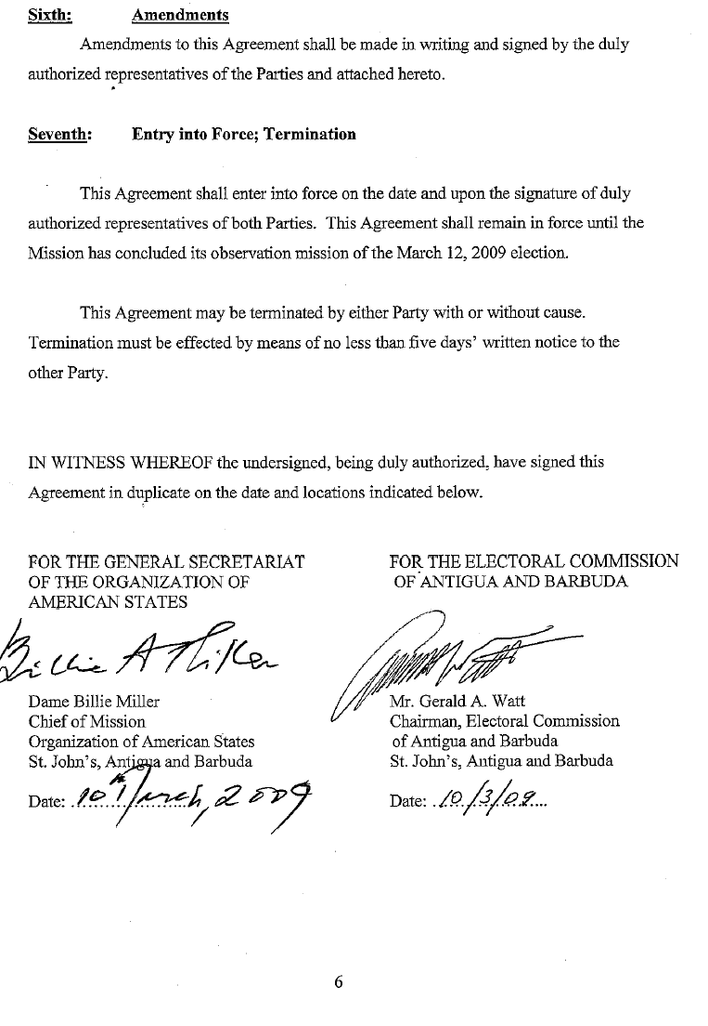

APPENDIX III.
LETTER OF INVITATION
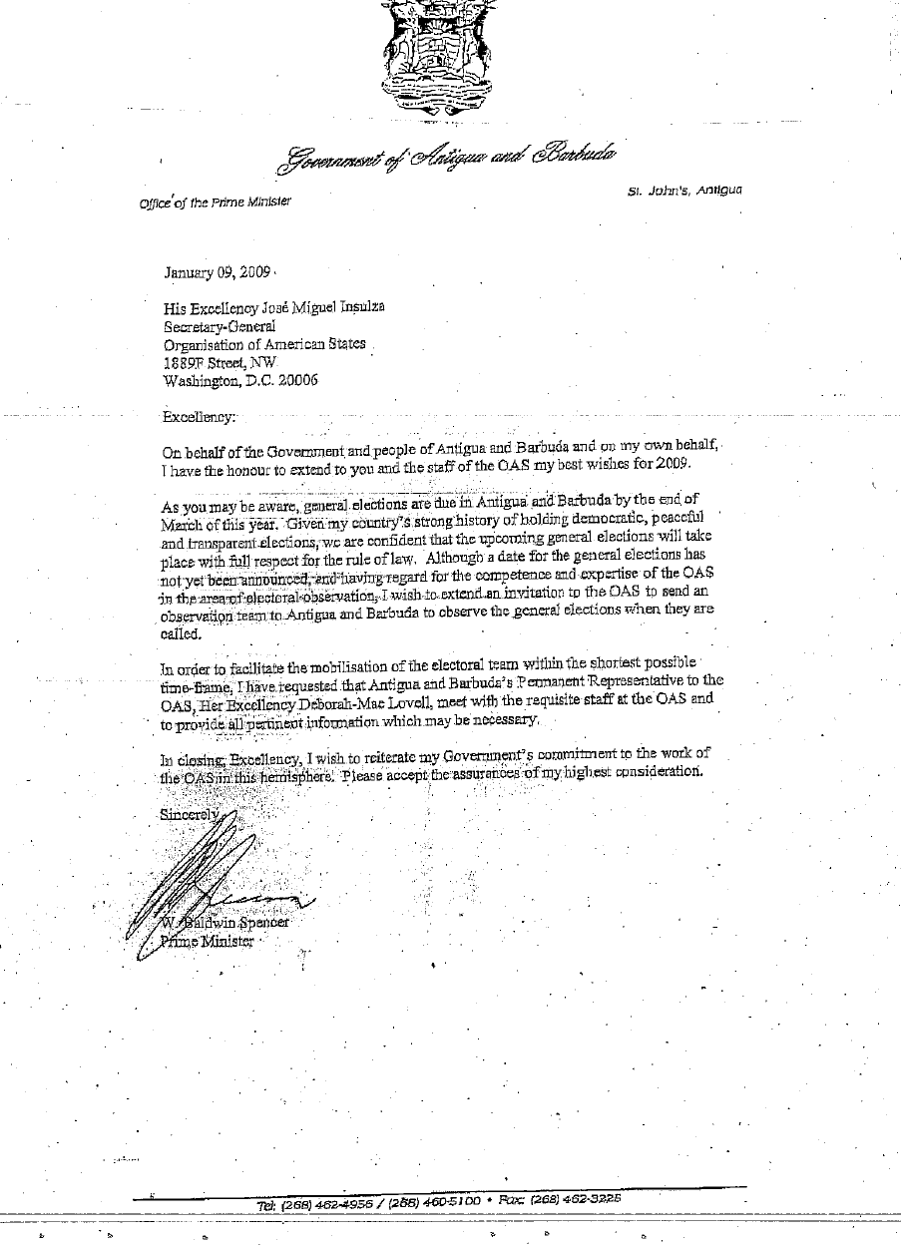

LETTER OF ACCEPTANCE
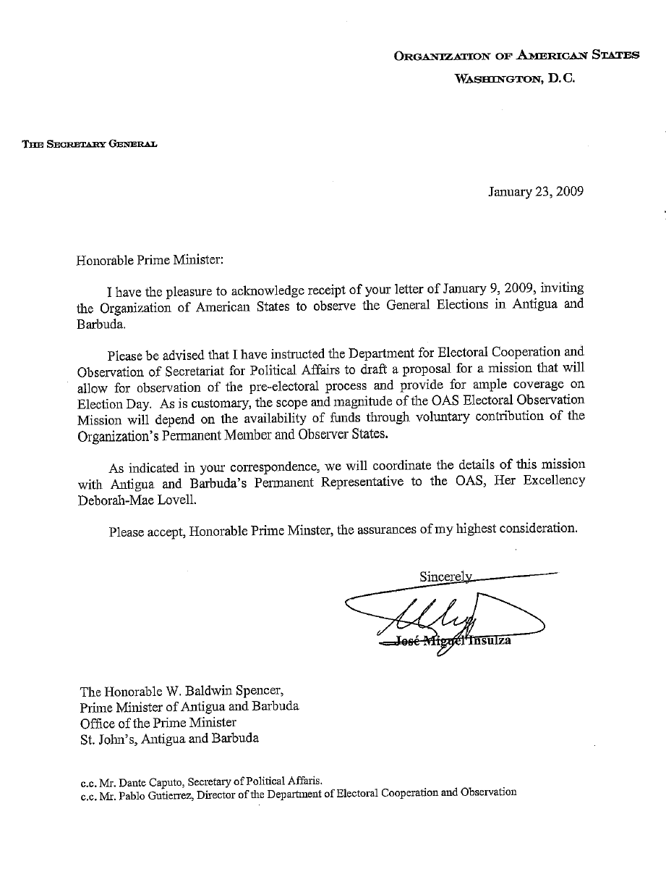

APPENDIX IV.

FORMS COMPLETED BY OBSERVERS

ORGANIZATION OF AMERICAN STATES
ELECTORAL OBSERVATION MISSION

ANTIGUA AND BARBUDA
General Elections
Thursday, March 12, 2009

OPENING OF THE POLLING CENTER/STATION

NAME OF OBSERVER: __________________________

CONSTITUENCY: _______________________________

POLLING DIVISION: _____________________________

POLLING CENTER: _______________________________

ADDRESS OF POLLING STATION / PLACE____________________

Arrived _________ Departed____________ Total time of observation ____________

Number of voters on the voter list ________

Number of ballots cast while observer was at the polling station _______

OPENING

- Did the Presiding Officer ensure that all required signs and notices including Official List of Electors or part thereof, Notice of Poll, and Directions for Voting were placed outside the Polling Station prior to the Opening of the Poll?

Yes _____ No _____

- Did the Polling Station open at 6: 00 a.m.? Yes _____ No _____

If not at what time did it open? _________

- Did the presiding officer, poll clerks and agents make the declaration of secrecy before the opening of the poll?

Yes _____ No_____

- Were all electoral officials present? Yes _____ No_____

If not, who was absent?

Presiding Officer _____ Poll Clerk _____

- Indicate political party agents that were present.

ALP_____

UPP _____

Others_____

- Were procedures generally followed in opening the polling station?

Yes _____ No_____

ELECTORAL OBSERVATION MISSION

ANTIGUA AND BARBUDA
General Elections
Thursday, March 12, 2009

OBSERVATION OF VOTING
(One per polling station)

NAME OF OBSERVER: __________________________

CONSTITUENCY: _______________________________

POLLING DIVISION: ____________________________

POLLING CENTER/PLACE: _____________________________

ADDRESS OF POLLING STATION / PLACE____________________

Arrived _________ Departed ____________ Total time of observation ________

- Were all the electoral materials available? Yes _____ No _____
If not what materials were missing?

a. Ballot papers _____ b. Ink _____
c. Copies of the register of electors _____ d. Ballot box_____
e. Poll Box ________ f. Other ______

- Were the Presiding Officer and Poll Clerk present? Yes _____ No_____

If not, state who was absent and why? (use reverse side of form)

- Was a police officer present at the polling station? Yes _____ No_____

- Were party agents present at polling site? Yes _____ No_____

If not, which party was not present? (use reverse side of form)

- Was the secrecy of vote maintained? Yes _____ No_____

If not, explain on reverse side.

- Did the Presiding Officer and Poll Clerks follow the proper voting procedures?
Yes _____ No_____

- Was the identity of the voters properly checked? Yes ______ No _____

- Did the Presiding Officer and poll Clerks provide impartial instructions to the voter?

Yes _____ No_____ If not, explain on reverse side of form.

- Did the observer notice any campaign materials (posters, stickers, photos) or activities within the polling station or any other campaigning on Election Day?

Yes _____ No____

- Did the observer notice or receive any information about incidents and/or irregularities in or near the polling station? If so, explain on reverse side.

Yes _____ No_____

- Did the observer notice or receive any information about intimidation of voters?

Yes _____ No_____

- Were there other observers present (International/National)?

Yes _____ No_____ Which ones?___________________

- Was proper assistance given to physically challenged Voters?

Yes _____ No_____ Not observed___________

- What is your overall assessment of the voting process?

________ Good – No significant problems.
________ Minor problems – Not sufficient to affect outcome.
________ Major problems – May affect results

ELECTORAL OBSERVATION MISSION

ANTIGUA AND BARBUDA
General Elections
Thursday, March 12, 2009

CLOSING OF THE POLLING CENTER/STATION
(Same polling station observed during opening)

NAME OF OBSERVER: _________________________

CONSTITUENCY: _______________________________

POLLING DIVISION: ____________________________

POLLING CENTER/PLACE: _____________________________

ADDRESS OF POLLING STATION / PLACE____________________

Arrived _________ Departed ____________ Total time of observation ________

Number of voters on the voter list ________ Number of ballots cast _______

- Did the polling station close on time at 6:00 p.m.? Yes _____ No _____

- Were there voters in line at 6:00 p.m.? Yes _____ No_____

If yes, were they allowed to vote? Yes _____ No_____

- Were closing procedures followed? Yes_____ No_____
If not, explain on reverse side of form.

- Were police officers present at the closure of the poll?

Yes _____ No ____

- Were agents of parties present in the polling station at the closing of the poll?

Yes _____ No ____

Please add comments (including any incidents at the closure of the poll) on the reverse side of this form.

APPENDIX V.

LIST OF OBSERVERS
ELECTORAL OBSERVATION MISSION-ANTIGUA AND BARBUDA
OBSERVER LIST
GENERAL ELECTIONS-MARCH 12, 2009
No. | Core Group
 | NAME |  | RESPONSIBILITY |  | NATIONALITY
1 | Dame Billie Miller |  | Chief of Mission |  | Barbados
2 | Steven Griner |  | Deputy Chief of Mission |  | United States
3 | Wendy K. Martinez |  | General Coordinator |  | United States
4 | Sara Lodge |  | Final Report |  | United Kingdom
5 | Ruben Rudolph |  | Legal Department |  | United States
6 | Ian Edwards |  | Press |  | Jamaica
7 | Clara Hoyos |  | Financial Officer |  | Colombia
8 | Chris Healy |  | Logistics |  | Suriname
9 | Johanna Schraffl |  | Political Follow-up |  | Chile
 | Observers |  | Departing From |  | Nationality
10 | Charlotte Blumenshein |  | Barbados |  | Canada
11 | Rick Switzer |  | Barbados |  | United States
12 | Kevin Tierney |  | Barbados |  | United States
13 | Rebeca Omaña |  | Washington |  | Venezuela
14 | Francis McBarnette |  | Barbados |  | Trinidad & Tobago
15 | Steven Surujbally |  | Guyana |  | Guyana
16 | Ambassador Jorge Skinner-Klee |  | Washington, D.C. |  | Guatemala
17 | Ambassador Izben C. Williams |  | Washington, D.C. |  | Saint Kitts & Nevis
18 | Terence Craig |  | Grenada |  | Suriname
 | Volunteers
19 | Daniel Caruthers |  | Barbados |  | United Kingdom
20 | Jessica Mackie |  | Barbados |  | United Kingdom
21 | Debra Worrel |  | Barbados |  | United Kingdom
22 | Douglas Holland |  | Barbados |  | Canada

APPENDIX VI.

PRESS RELEASES AND POST-ELECTION REPORT

OAS WELCOMES ANNOUNCEMENT OF ELECTION DATE IN ANTIGUA AND BARBUDA

The Organization of American States welcomes the announcement of March 12, 2009 for the General Elections in Antigua and Barbuda has been welcomed by.

“The OAS will now initiate the technical, logistic, and administrative preparations for its electoral observation mission, including the signing of agreements with the Electoral Commission and the Government of Antigua and Barbuda,” noted Assistant Secretary General, Ambassador Albert R. Ramdin.

The OAS remains concerned about the violence and damage to property which took place last week. Ambassador Ramdin reiterated his call to denounce these undemocratic acts and called for a peaceful environment leading up to Election Day.

“I am confident the electoral office will spare no effort for free, fair and credible elections that respect the privacy of the vote. All stakeholders should work diligently to foster a propitious climate for nomination and Election Day,” Ramdin expressed.

Deputy Chief of Mission, Mr. Steven Griner, will soon arrive in the country to begin preparations for the mission, which will aim to observe the elections in all 17 constituencies and 151 polling stations.

The Organization of American States
_______________________________________________________________________

Press Advisory
Contact: Ian Edwards
OAS-EOM
Tel. (268) 781-3418

OAS MISSION TO REPORT PRELIMINARY OBSERVATIONS ON
ANTIGUA AND BARBUDA ELECTIONS

St. John’s, Antigua, March 12, 2009

The Organization of American States (OAS) Electoral Observation Mission in Antigua and Barbuda will host a press conference on Friday, March 13, 2009, at 9:00 a.m.

Chief of Mission Dame Billie Miller will brief the media on the preliminary observations of the 23-member team regarding the process leading up to Thursday’s general elections, the first time the OAS was monitoring elections in Antigua and Barbuda.

The press conference will be held in the Frangipani Room at the Jolly Beach Hotel in Bolans Village.

OAS Assistant Secretary General Ambassador Albert R. Ramdin and Deputy Chief of Mission Steven Griner will also be on hand for the press conference.

WHAT: Press Conference hosted by OAS Electoral Observation Mission
WHEN: Friday, March 13, 2009
TIME: 9:00 a.m.
WHERE: Frangipani Room
Jolly Beach Hotel
Bolans Village, Antigua

******

The Organization of American States
________________________________________________________________________

Press Release
Contact: Ian Edwards
OAS-EOM
Tel. (268) 781-3418

OAS MISSION SATISFIED WITH ANTIGUA AND BARBUDA ELECTIONS

St. John’s, Antigua, March 13, 2009

The Organization of American States (OAS) election observers today expressed their satisfaction in the conduct of yesterday’s general elections in Antigua and Barbuda.

The polls returned Prime Minister Baldwin Spencer’s United Progressive Party (UPP) to power for another five years after it won nine of the 17 parliamentary seats. Seven seats went to the opposition Antigua Labour Party (ALP) of Lester Bird, while the Barbuda People’s Movement (BPM) won the lone seat that was at stake on that smaller sister island.

Former Barbados Deputy Prime Minister and Foreign Minister Dame Billie Miller, who led the OAS Electoral Observation Mission in Antigua and Barbuda, told a press conference at the Jolly Beach Hotel in Bolan’s Village that in the view of the 23-member OAS Mission, Thursday’s general elections unfolded in an atmosphere of calm that was “very reassuring.”

OAS Assistant Secretary General Albert R. Ramdin and Deputy Chief of Mission Steven Griner, a senior specialist with the OAS Department of Electoral Cooperation and Observation, accompanied the Mission Chief at the press conference.

The OAS observed important aspects of the election process over a period, and on election day deployed its members to cover all 17 electoral constituencies and all of the 151 polling stations across the country, including on Barbuda. They observed the opening of polls and all aspects of the balloting and other operations at the polling stations, as well as the closing of the polls and the counting and transmission of ballots.

Hitches observed included delays in the opening of polls in six constituencies, but Miller also accentuated the positive outcomes of general election day such as the fact that, “for 11 of the 17 constituencies, all of the polling stations opened on time.” Election officials were there in place and lines of voters were long, but by mid-day most of the processing was done.

The OAS observers also reported only minor infringements such as billboards and posters well within the requisite 100-yards from polling stations, but the OAS Chief of Mission explained
-more-

that “these were not infringements that in our view would have compromised the electoral process in any way.”

As part of an important effort to improve the Caribbean nation’s electoral system, Miller said the OAS Mission will recommend that the government institute a national identity card to “make the entire electoral and other civic processes so much easier.” She pointed as well to areas of more duplications than necessary, among them aspects of the identification process at the polling station, including how people identified themselves and the search for their names on the voter’s register. She noted how in some polling stations “we thought the process appeared to be overly cumbersome and could be streamlined.”

Recommendations will be included in the final report that the Electoral Observation Mission will present to the OAS Permanent Council in Washington next week. “We will then get into perhaps more details as to ways in which greater efficiency and greater effectiveness can be brought to the voting process,” Dame Billie explained. She particularly emphasized the need for all of the stakeholders to take an active role in the voter registration process.

After it is presented to the Permanent Council, the report of the OAS Electoral Observation Mission in Antigua and Barbuda will also be made available online, at http://www.oas.org.

******

APPENDIX VII.
OFFICIAL RESULTS

General Election Results 2009

Party | Pre Election | Post Election
 | 12 | 9
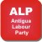 | 4 | 7
 | 0 | -
 | 1 | 1
 | 0 | -

PERCENTAGE VOTES BY PARTY 2009
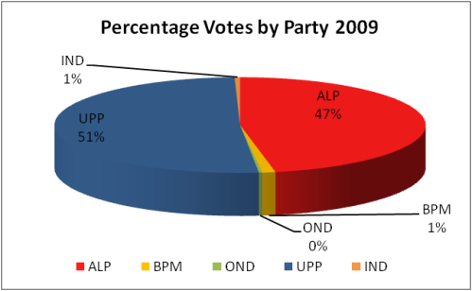

DISTRIBUTION OF VOTES BY PARTY 2009
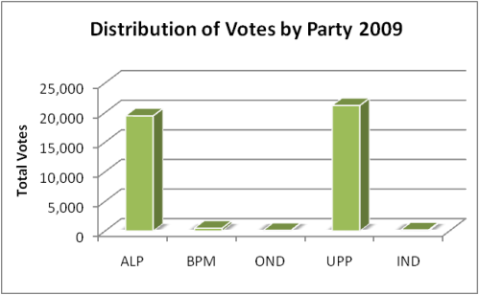

input.doc

The Report of the Commonwealth Observer Group to the Elections in Antigua and Barbuda of 9 March 1999 commented that the following five points should be adopted: 1) every political party shall keep an account book into which shall be recorded monetary and in-kind contributions and donor name and information; 2) no political party shall accept contributions exceeding five thousand dollars unless it can identify the source; 3) every political party procuring the election of a candidate shall file a report of the contributions made by individuals and entities; 4) Every political party shall grant access to examine the records; and 5) the Commission shall impose a penalty of two thousand dollars a day for failing to comply with this section.
See front page articles in The Daily Observer for April 22 and 23 2009.

