OEA/Ser.G
CP/doc.4426/09
10 August 2009
Original: Spanish

PROVISIONAL AGENDA OF THE 84th REGULAR MEETING OF THE
DIRECTING COUNCIL OF THE INTER-AMERICAN CHILDREN’S INSTITTUTE (IIN)/

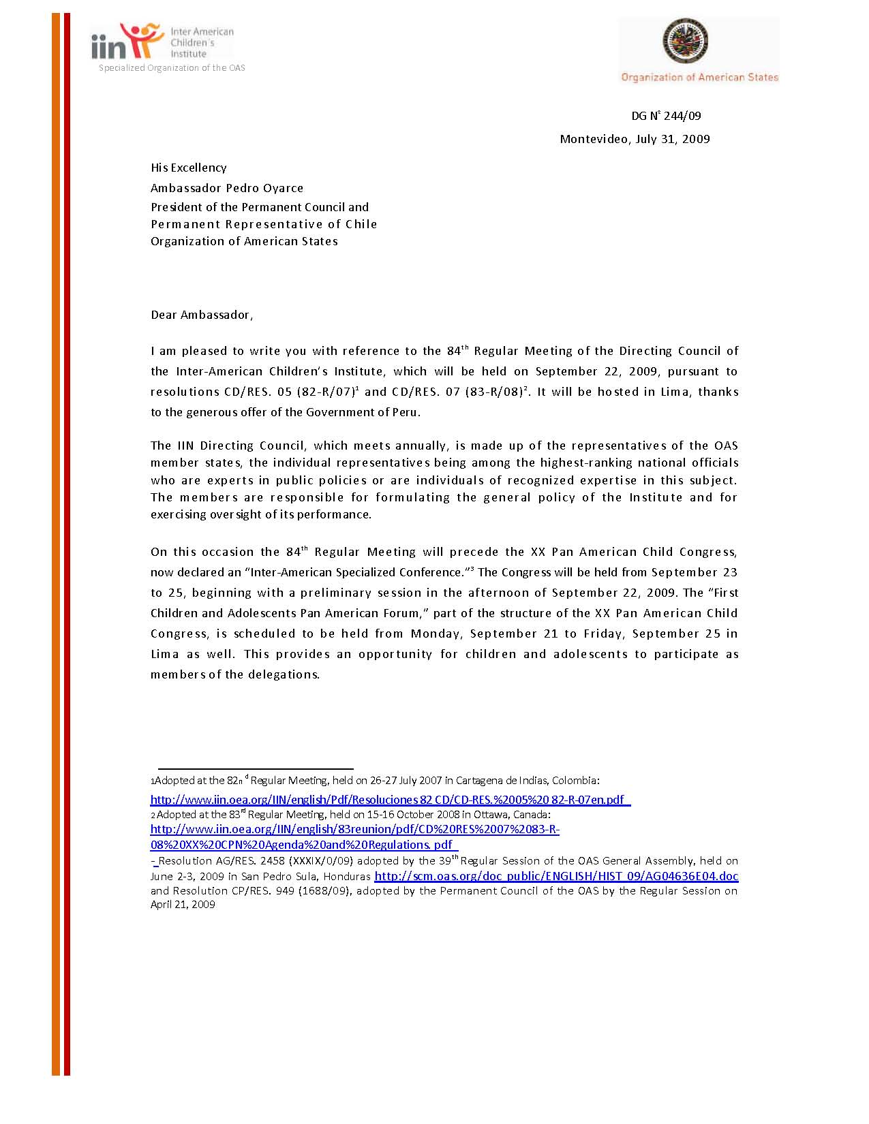
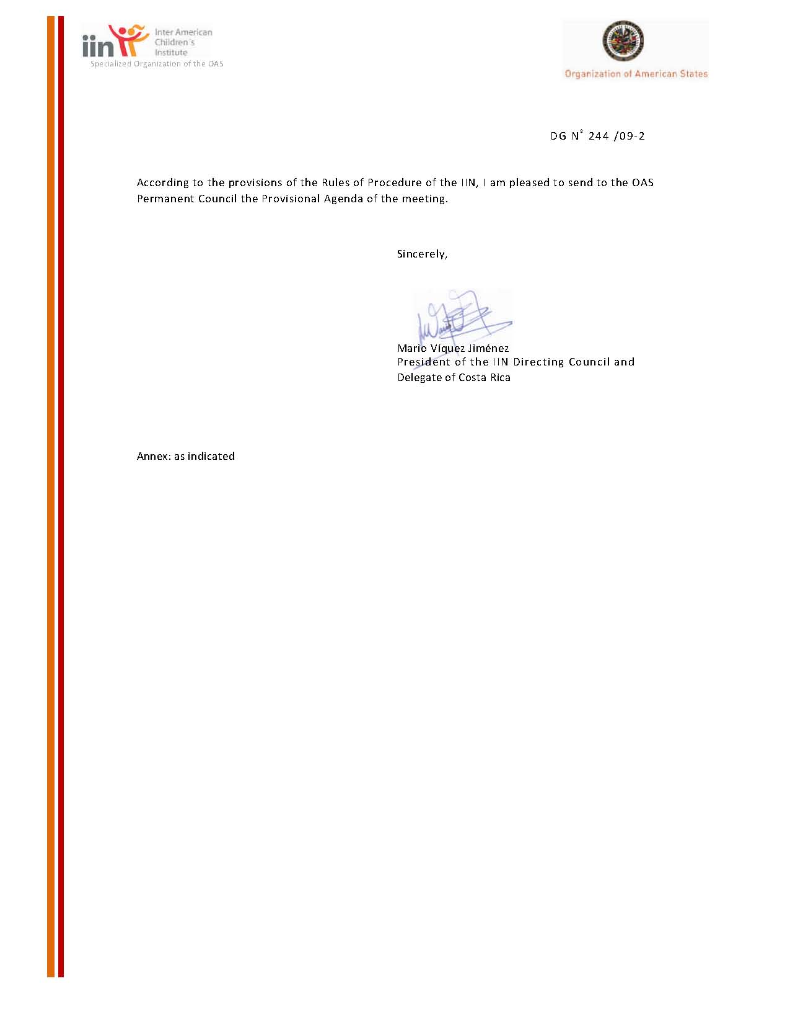

Annex 1

CD/doc.2/09
July 17, 2009

DRAFT AGENDA

A. TOPICS INCLUDED IN ACCORDANCE WITH THE STATUTE AND RULES OF PROCEDURE OF THE IIN:

- Approval of the Agenda (Article 2 of the Rules of Procedure)
- Order of Precedence (Article 7 of the Rules of Procedure)
input.doc
- Report of the Secretary on credentials (Article 6.3 of the Rules of Procedure)
- Approval of the Procedure (including the integration of a Commission) and establishment of deadline for the submission of draft resolutions (Article 14 of the Rules of Procedure)
- Appointment of a Working Group to review the agreements signed by the Director General ad referendum of the Directing Council (Article 9.d of the Statute and Article 14 of the Rules of Procedure)
- Presentation of the Report of the Director General of the IIN - October 2008 to September 2009 (Articles 9.c and 26.c of Statute)
  - Actions pursuant to the Plan of Action 2007-2011 [CD/RES. 11 (82-R/07)]
  - Final Report of the 83rd Regular Meeting of the Directing Council, held on October 15-16, 2008 in Ottawa, Canada (Article 39 of the Rules of Procedure)
- Date and venue of the 85th Regular Meeting of the Directing Council (Articles 9.k and 12 of the Statute)

B. TOPICS INCLUDED IN ACCORDANCE WITH THE RESOLUTIONS ADOPTED BY THE IIN DIRECTING COUNCIL

1. General overview of the XX Pan American Child Congress, including the First Pan-American Child and Adolescent Forum [CD/RES. 05 (82-R/07) and CD/RES. 07
(83-R/08)]

?. Submitted to the Permanent Council pursuant to article 2.1 of the Rules of Procedure of the IIN, which states that “The draft agenda of each meeting shall be submitted for the consideration of the Directing Council at its first Plenary Session and its adoption will require the majority vote of the member states. Prior to its adoption, the Council shall consider the observations made by the OAS Permanent Council and the comments and proposals received in accordance with Article 1.5 in these Rules of Procedure, as well as any other relevant observations….”

