OEA/Ser.G
CP/doc.4443/09
27 October 2009
Original: English

NOTE FROM THE PERMANENT MISSION OF THE UNITED STATES OF AMERICA REQUESTING THE INCLUSION OF THE TOPIC AND ENCLOSED DRAFT RESOLUTION “CONVOCATION OF THE SIXTH MEETING OF THE REMJA WORKING GROUP ON CYBER-CRIME, PURSUANT TO RESOLUTION AG/RES.2462 (XXXIX-O/09) AND THE CONCLUSIONS AND RECOMMENDATIONS OF THE MEETING OF MINISTERS OF JUSTICE OF OTHER MINISTERS OR ATTORNEYS GENERAL OF THE AMERICAS”
ON THE ORDER OF BUSINESS OF THE NEXT REGULAR MEETING
OF THE PERMANENT COUNCIL

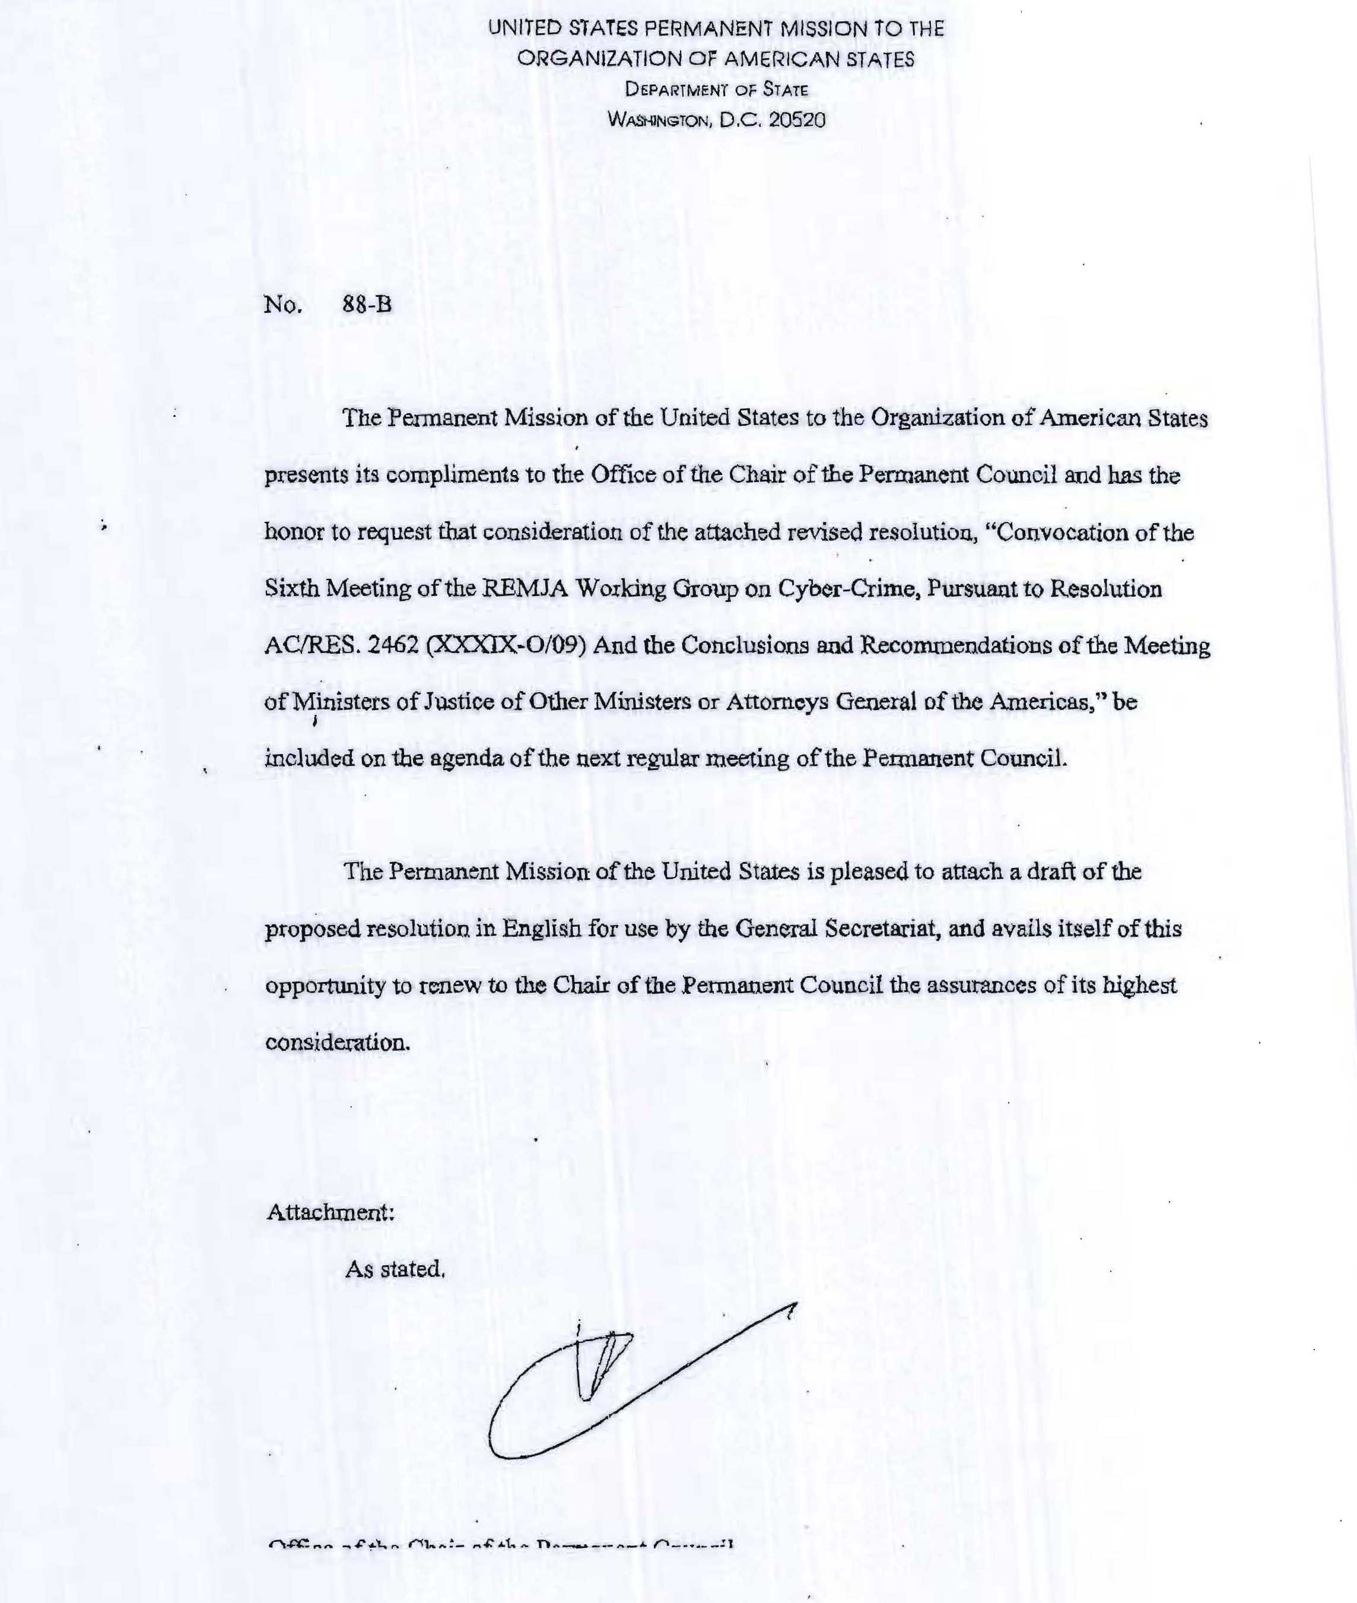
CONVOCATION OF THE SIXTH MEETING OF THE REMJA WORKING GROUP ON CYBER-CRIME, PURSUANT TO RESOLUTION AG/RES. 2462 (XXXIX-O/09) AND THE
CONCLUSIONS AND RECOMMENDATIONS OF THE MEETING OF MINISTERS OF
JUSTICE OR OTHER MINISTERS OR ATTORNEYS GENERAL OF THE AMERICAS
(REMJA-VII)
input.doc
THE PERMANENT COUNCIL OF THE ORGANIZATION OF AMERICAN STATES,

CONSIDERING the conclusions and recommendations of the Seventh Meeting of Ministers of Justice or other Ministers or Attorneys General of the Americas (REMJA-V1I/doc.7/08 rev. 1) and resolution AG/RES. 2462 (XXXIX-O/09), in which the General Assembly requested the Permanent Council to convene the Sixth Meeting of the REMJA Working Group on Cyber-crime;
TAKING INTO ACCOUNT that the "Document of Washington" at paragraph 17 establishes that the meetings of working groups shall be formally convened by resolution of the Permanent Council of the OAS,
RESOLVES:
1. To convene the Sixth Meeting of the REMJA Working Group on Cyber-crime, to be held at OAS headquarters on January 21 and 22, 2010, for the purpose of carrying out the mandates referred to in the conclusions and recommendations of the Seventh Meeting of Ministers of Justice or other Ministers or Attorneys General of the Americas (REMJA-VII).
2. To ask the General Secretariat to provide the necessary technical and administrative support to prepare for that meeting and to make provisions for it to be held in accordance with resources allocated in the program-budget of the Organization and other resources for 2010.

