OEA/Ser.G
CP/doc.4522/10
10 noviembre 2010
Original: español

NOTA DE LA MISION PERMANENTE DE COSTA RICA REMITIENDO UN PROYECTO DE RESOLUCION PARA SER PRESENTADO AL CONSEJO PERMANENTE DURANTE LA SESION EXTRAORDINARIA A CELEBRARSE EL 11 DE NOVIEMBRE DE 2010
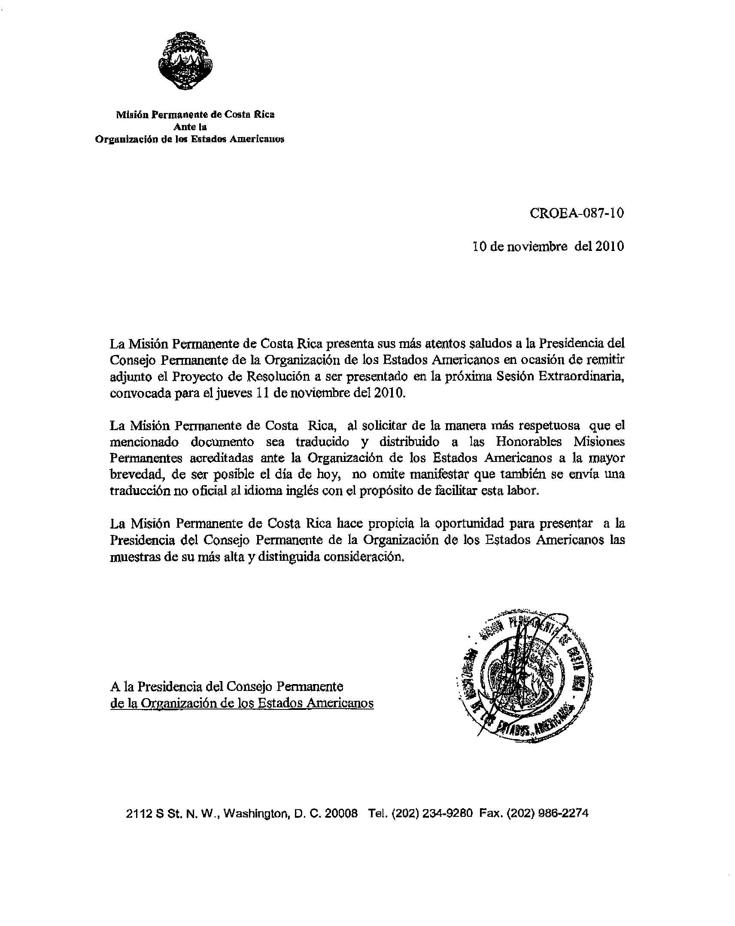
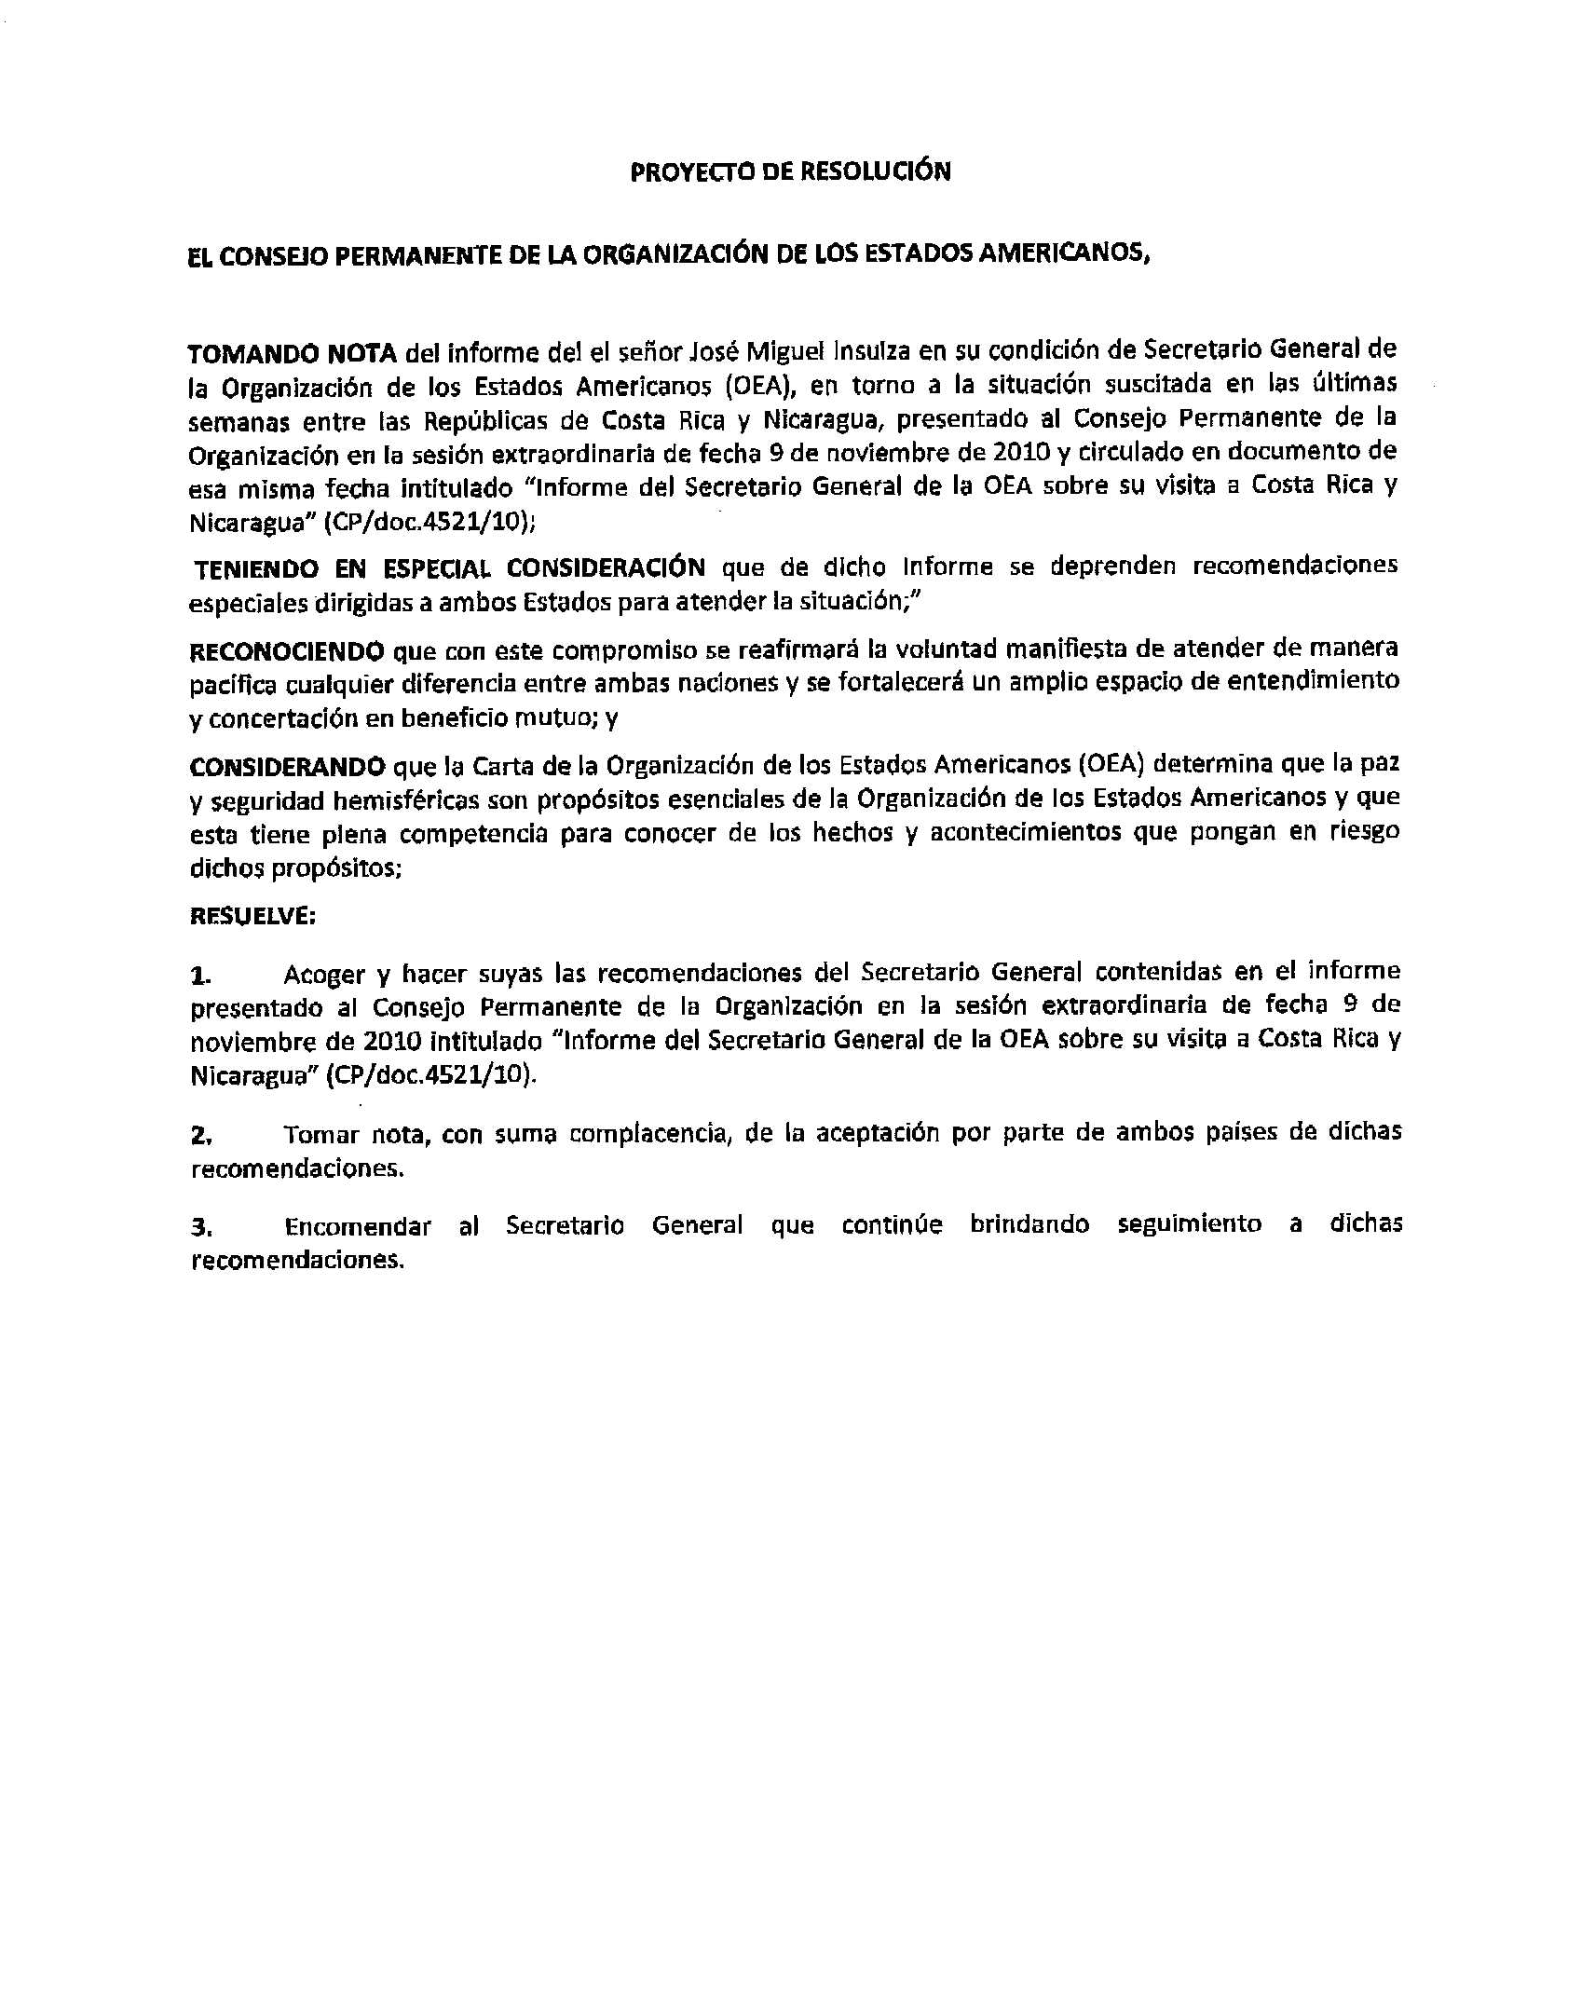
DRAFT Resolution

The Permanent Council of the Organization of American States,

Taking Into Account the report by Mr. José Miguel Insulza, in his capacity as the Secretary General of the Organization of American States (OAS), regarding the situation that has arisen in recent weeks between the Republics of Costa Rica and Nicaragua, presented to the Permanent Council of the Organization at its special meeting on November 9, 2010 and circulated as a document with the same date entitled ¨Report by the Secretary General of the OAS on his visit to Costa Rica and Nicaragua¨ (CP/doc.4521/10);

Taking into Special Consideration that the aforementioned report contains special recommendations for both States on ways to address the current situation:

Recognizing that this commitment would reaffirm the manifest will to address any difference between the two nations in a peaceful way and would afford ample opportunity for understanding and consensus-building to their mutual benefit; and

Considering that the Charter of the Organization of American States determines that peace and hemispheric security are essential purposes of the Organization and that it has full competence to take cognizance of the facts and events that jeopardize the aforementioned purposes;

Resolves:

- To welcome and endorse the recommendations made by the Secretary General included in his report to the Permanent Council of the Organization during its special meeting of November 9, 2010, entitled ¨Report by the Secretary General of the OAS on his visit to Costa Rica and Nicaragua¨ (CP/doc.4521/10);
- To note, with great satisfaction, the acceptance by both countries of the aforementioned recommendations;
- To instruct the Secretary General to continue monitoring the aforementioned recommendations.

input.doc

input.doc

