OEA/Ser.G
CP/doc.4688/12
2 March 2012
Original: Spanish

REPORT OF THE SECRETARY GENERAL
ON THE IMPLEMENTATION OF RESOLUTION AG/RES. 2685 (XLI-O/11)

“STRENGTHENING OF THE INTER-AMERICAN COMMISSION OF WOMEN”

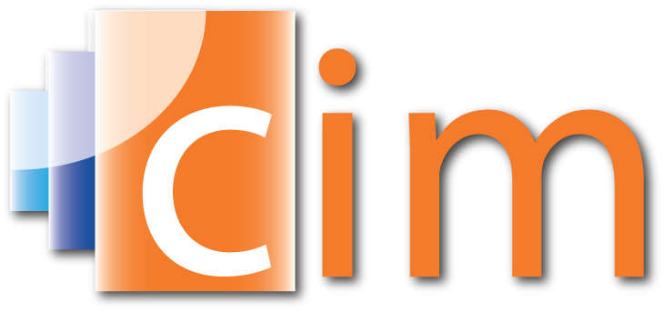
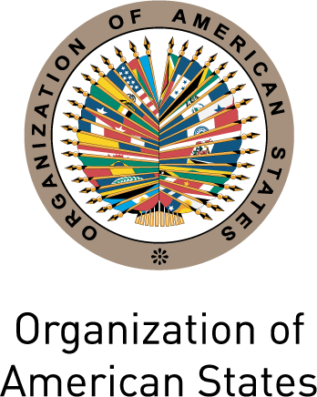

INTER-AMERICAN COMMISSION OF WOMEN

OEA/Ser.L
CIM/doc.--/12
6 March 2012
Original: Spanish

REPORT OF THE SECRETARY GENERAL
ON THE IMPLEMENTATION OF RESOLUTION AG/RES. 2685 (XLI-O/11)
“STRENGTHENING OF THE INTER-AMERICAN COMMISSION OF WOMEN”

I. General characteristics

Since 2005, the General Assembly of the Organization of American States (OAS) has adopted resolutions instructing the Secretary General to support the Inter-American Commission of Women (CIM); to allocate the necessary human and financial resources so that the CIM might fulfill its mandates; and to include CIM projects and programs among the priorities presented to external donors for funding.

In compliance with these successive mandates, the Secretary General has provided significant political support to the CIM through his enhanced participation in CIM events:
- He inaugurated the First Hemispheric Forum on Women’s Leadership for a Citizens’ Democracy (Aril 4th to 6th 2011, Washington, DC) with Prime Minister Kamla Persad Bissessar of Trinidad and Tobago, and CIM President, Rocío García Gaytán,
- He held an exchange with the members of the Regional Working Group on Women’s Full Citizenship for Democracy, during which they analyzed some of the obstacles faced by democratic systems in guaranteeing women’s rights and gender equality.
- He closed the Fourth Meeting of Ministers or of the Highest-Ranking Authorities Responsible for the Advancement of Women in the Member States (November 1st 2011, San Salvador); and
- He presided over the first High-Level Inter-sectoral Dialogue between the Ministries of Labour and the National Mechanisms for the Advancement of Women, which looked at some of the challenges that women continue to face in the world of work, as well as some of the progress that has been made in the formulation and implementation of gender-responsive labour policies.

The strengthening of the CIM is closely linked to the internal coordination activities it carries out in all areas of the Organization and to its activities designed to adequately incorporate the gender perspective. Accordingly, as part of the initiatives it promotes, the CIM is working on core issues related to the four pillars of the OAS’ work, which constitute integral elements of its Strategic Plan 2011-2016, namely: i) women’s substantive political citizenship for democracy and good governance; ii) women’s human rights and gender-based violence; iii) citizen security from a gendery perspective; and iv) women’s economic security and citizenship.

Among the preliminary results of this process; the CIM has obtained funds for the continuation of some of its existing projects and has prepared project proposals in each of the areas of its Strategic Plan in order to support the mobilization of new specific funds.

However, the is a pressing need to strengthen the CIM for the full implementation of its Strategic Plan, and its current mandates that are still in force yet require the necessary budgetary allocations to ensure their full implementation. These mandates include: serving as the organ for follow-up, coordination, and evaluation of the Inter-American Program on the Promotion of Women’s Human Rights and Gender Equity and Equality [AG/RES. 1732 (XXX-O/00)]; acting as the Secretariat of the Conference of the States Parties and the Committee of Experts of the Mechanism to Follow Up on Implementation of the Convention of Belém do Pará [AG/RES. 2138 (XXXV-O/05)]; and organizing a meeting of ministers or of the highest-ranking authorities responsible for the advancement of women in the member states (REMIM) every four years [AG/RES. 1741 (XXX-O/00)], among others.

In 2011, the CIM received several contributions from OAS Member States and Permanent Observers, as well as from other international organizations:

- The Governments of Argentina, Mexico and Trinidad and Tobago contributed, respectively, US$15,000, US$25,478 and US$30,000 to support the operation of the Follow-up Mechanism to the Belém do Pará Convention (MESECVI).

- The Government of Mexico contributed US$150,000 to support the activities of the Regional Working Group on Women’s Full Citizenship for Democracy and hosted its first meeting (September 12th to 14th 2011, Mexico City).

- The United States’ Department of States contributed US$14,000 towards the participation of CIM Delegates from the Caribbean in the Fourth Meeting of Ministers or of the Highest-Ranking Authorities Responsible for the Advancement of Women in the Member States (November 1st 2011, San Salvador)
input.doc
- The Spanish Agency for International Development Cooperation contributed US$550,000 to the execution of the second year of the project on “Development of capacity for women’s leadership and incidence in public policy for gender equality”

- UN Women contributed US$65,000 towards the organization of the First Hemispheric Forum, and US$50,000 to support the activities of the Regional Working Group on Women’s Full Citizenship for Democracy.

