OEA/Ser.G
CP/doc.4711/12
21 May 2012
Original: Spanish

REPORT OF THE SECRETARY GENERAL
ON THE RECOMMENDATIONS OF THE WORKING GROUP OF THE PERMANENT
COUNCIL TO REFLECT ON THE WORKINGS OF THE INTER-AMERICAN COMMISSION
ON HUMAN RIGHTS WITH A VIEW TO STRENGTHENING THE INTER-AMERICAN
HUMAN RIGHTS SYSTEM AND THE INTER-AMERICAN JURIDICAL COMMITTEE

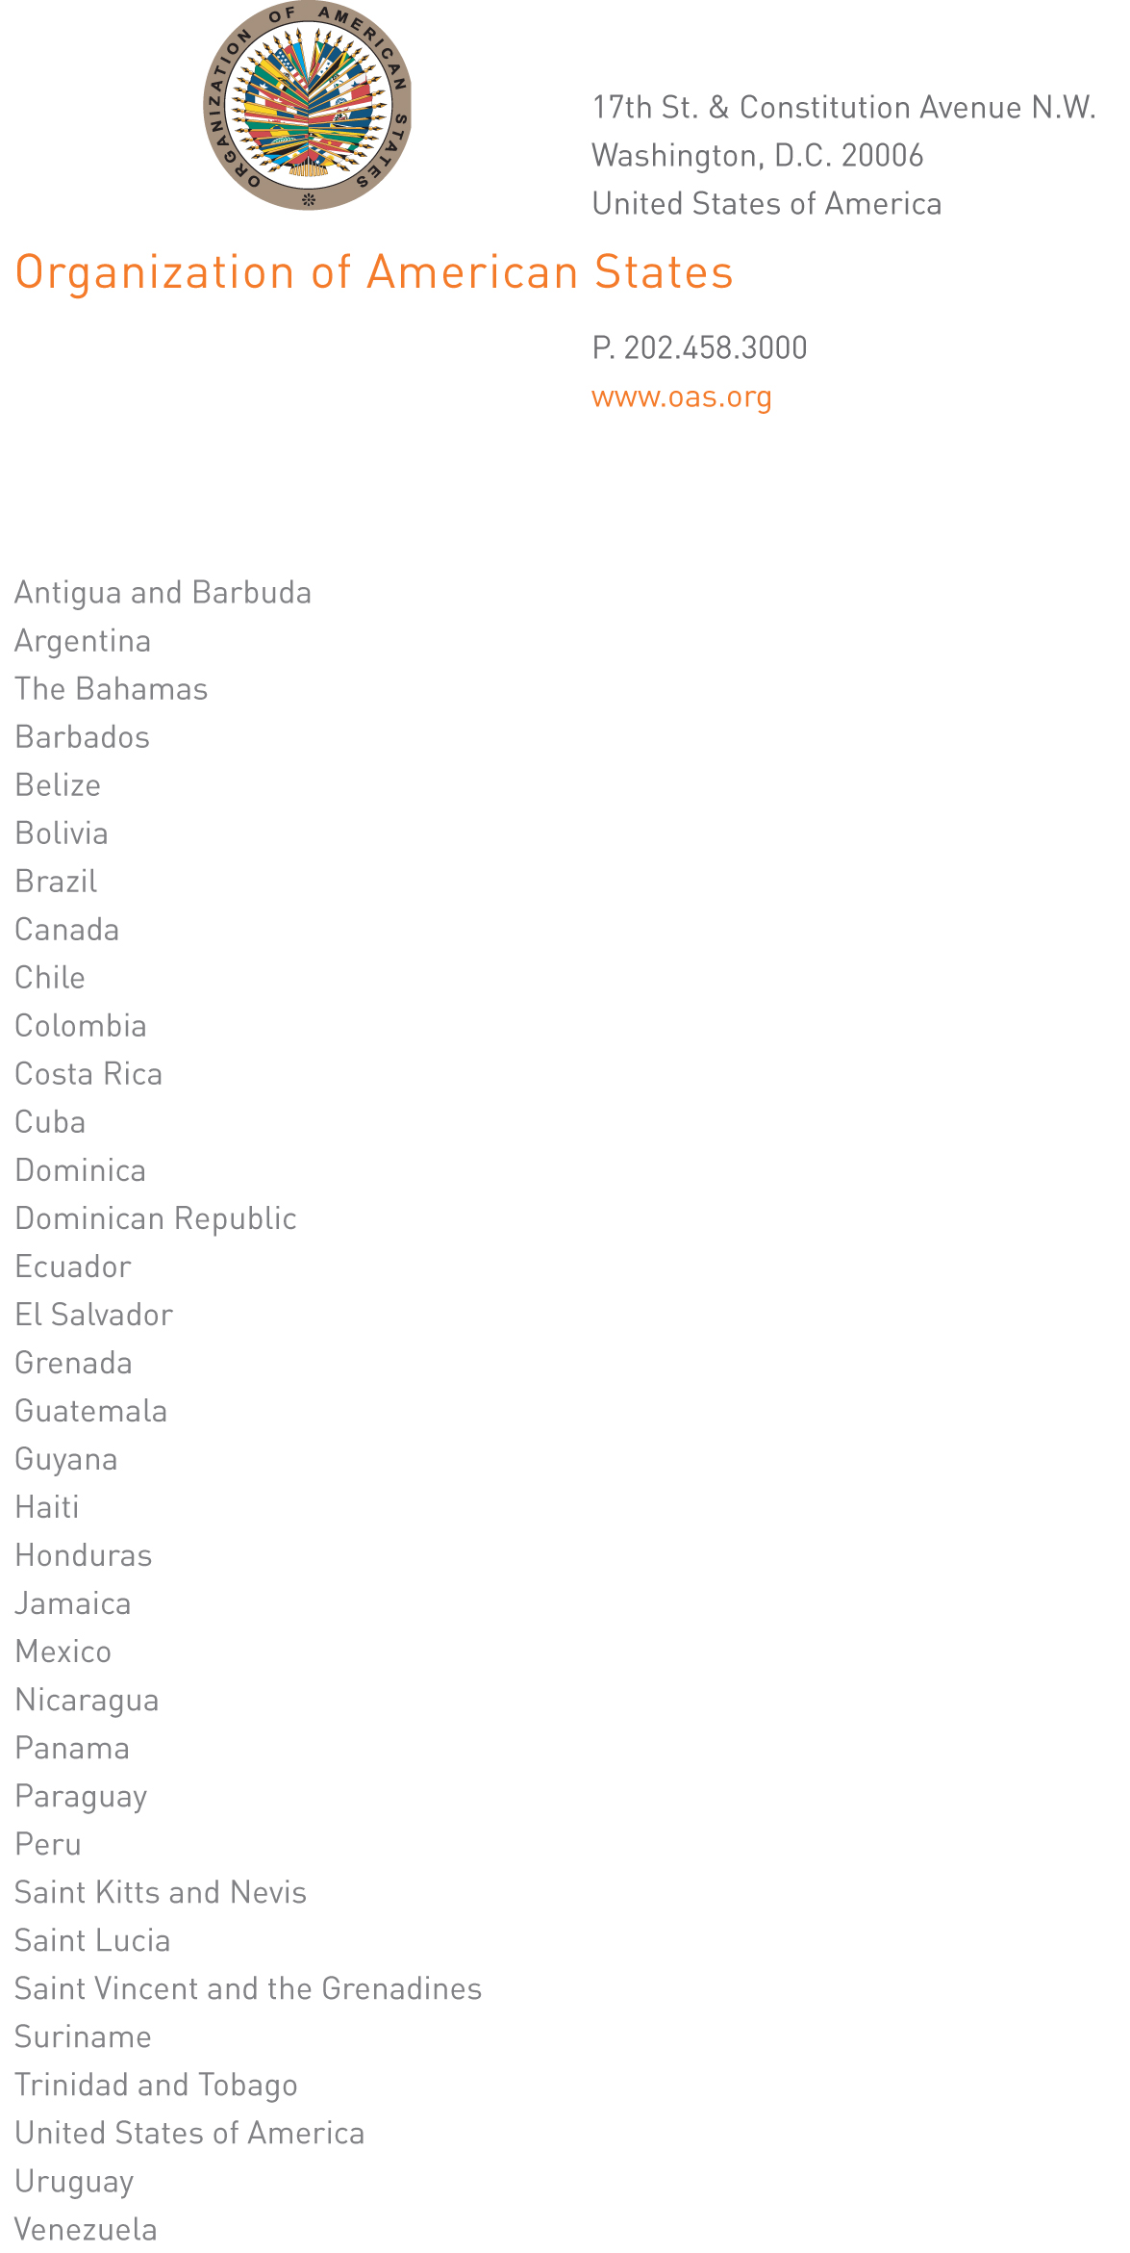

May 21, 2012

Mr. Chair,

In keeping with the mandate entrusted to me, I hereby present to the Permanent Council my report on implementation of the recommendations contained in the Report of the Permanent Council’s Working Group to Reflect on the Workings of the Inter-American Commission on Human Rights with a view to Strengthening the Inter-American Human Rights System.

In the report, I have taken into account the proposals of the Inter-American Juridical Committee on the matter, which were made at the request of the General Assembly.

The basic criterion used in drawing up the attached report was to make a contribution to strengthening the inter-American human rights system, which is the primary purpose of this exercise, as stated on numerous occasions by the member states, by the Committee members, and by myself. In that connection, I have deemed it advisable to specify which measures would have to be taken to implement the unanimously approved recommendations, through the consideration of possible amendments to the Statute or Rules of Procedure of the Commission. I consider that this will help clarify the discussion, in the framework already established for the approved recommendations.

His Excellency
Ambassador Leonidas Rosa Bautista
Permanent Representative of Honduras
to the Organization of American States
and Chair of the Permanent Council

Moreover, I deem it important to emphasize that an essential component for strengthening the system is the legal certainty afforded by the rules governing it. That is why precision in those rules and a clear commitment by all actors in the system to strict adherence to them will doubtless be one of the key factors in deepening the strengthening process. This will make it possible to increase the degree of predictability in the implementation of the rules, thus avoiding unnecessary and inadvisable discrepancies.

I remain at the disposal of the Permanent Council, Mr. Chair, for any additional information or clarifications requested concerning this report.

José Miguel Insulza
Secretary General

Report of the Secretary General on the Recommendations of the Working Group of the Permanent Council to Reflect on the Workings of the Inter-American Commission on Human Rights with a View to Strengthening the Inter-American Human Rights System
and the Inter-American Juridical Committee

The Working Group of the Permanent Council, established pursuant to a mandate from the General Assembly to further reflect on the workings of the Inter-American Commission on Human Rights in the framework of the American Convention on Human Rights and its Statute, with a view to strengthening the inter-American human rights system, presented a report on its work on January 25, 2012 (CP/doc.4675/12). Moreover, in March 2012, the Inter-American Juridical Committee (CJI), pursuant to a mandate from the General Assembly, adopted resolution CJI/RES. 192 (LXXX-O/12) containing the “Report of the Inter-American Juridical Committee: Strengthening the Inter-American System of Protection and Promotion of Human Rights” (CJI/doc.400/12 rev.3), which it forwarded to the Permanent Council.

In light of the mandate given to me by the Permanent Council to prepare and present to the General Assembly a report on implementation of the recommendations set forth in the document approved by the Permanent Council, this report aims to summarize the recommendations contained in the two documents, particularly those that warrant an amendment either to the Statute (to be approved by the General Assembly) or the Rules of Procedure of the Inter-American Commission on Human Rights (IACHR) (to be approved by the Commission itself).

1. Precautionary measures

The recommendations from the Working Group of the Permanent Council and the CJI on precautionary measures do not, in most cases, specifically reference the instrument in which they could be implemented.

We must bear in mind, however, that such measures are not provided for either in the American Convention on Human Rights or in the Statute of the IACHR, but rather only in Article 25 of the Commission’s Rules of Procedure. The only reference in the Statute of the IACHR to a similar arrangement is to “provisional measures,” in Article 19(c), giving the Commission the power to “request the Inter-American Court of Human Rights to take such provisional measures as it considers appropriate in serious and urgent cases which have not yet been submitted to it for consideration, whenever this becomes necessary to prevent irreparable injury to persons,” pursuant to the provisions of Article 63(2) of the American Convention./

There is also an article in the Inter-American Convention on Forced Disappearance of Persons stipulating that “[f]or the purposes of this Convention (i.e. limited only to the topic of forced disappearance of persons), the processing of petitions or communications presented to the Inter-American Commission on Human Rights alleging the forced disappearance of persons shall be subject to the procedures established in the American Convention on Human Rights and to the Statue and Regulations of the Inter-American Commission on Human Rights and to the Statute and Rules of Procedure of the Inter-American Court of Human Rights, including the provisions on precautionary measures”. However, not only is that Convention limited to the subject of forced disappearance, it applies only to the 14 States that have ratified it.

Thus, the Commission’s Statute has a gap on precautionary measures that can be filled by the OAS General Assembly, which approves its Statute. It should also be borne in mind that the Statute outranks the Rules of Procedure, and the latter need to be adjusted to be consistent with the former.

Amending the Statute to establish when the IACHR should apply precautionary measures would make it possible to constructively standardize the positions of the General Assembly and the IACHR on a matter of such relevance, avoiding new dissent and allowing for better understanding between the two bodies. This would also provide legal certainty to the system on a matter of great importance, since the Statute would reflect, without leaving any doubt or anything open to interpretation, what are the legal obligations undertaken by the States and what is their scope.

Since some member states question whether the IACHR should issue precautionary measures in general, the General Assembly, as the Organization’s senior governing body, can directly settle this dispute or even take into consideration the Working Group’s recommendation to request an advisory opinion from the Inter-American Court of Human Rights, before approving any amendments thereon to the Statute.

The Working Group of the Permanent Council recommended, in various paragraphs, granting a reasonable amount of time for states to implement precautionary measures and, in particular, mentioned the following:

a. Regarding the criteria for adopting precautionary measures, specifically “gravity”, “urgency”, and “context”, the CJI recommended specifically that the IACHR incorporate in its Rules of Procedure the content of each of these criteria, which in practice have already been implemented by the Commission./

b. Regarding the imminence of the harm, recommendation (c) of the Working Group was to define objective criteria or parameters for determining the imminence of the harm, taking into account the different risk levels.

c. When, due to the urgency of the situation, no information is solicited from the State in question, the CJI recommended that the decision be taken by an absolute or special majority of Commission members, as occurs in other cases indicated in its Rules of Procedure.

d. Recommendation (f) of the Working Group recommended in those cases that such measures be reviewed as soon as possible in consultation with the State and that the Commission’s decision be adopted by a special or qualified majority.

e. With respect to lifting precautionary measures, the CJI recommended including all situations in which such measures are normally lifted, to avoid situations that could lead to the cessation or unjustified maintenance of the measures. In that regard, the CJI specifically recommended amending Article 25(8) of the Rules of Procedure.

f. Regarding other reasons for lifting precautionary measures, recommendation (k) of the Working Group was to establish, as a reason for lifting such measures, the refusal of the beneficiaries to accept precautionary measures, their misuse thereof, or a change in the circumstances that prompted them.

g. In terms of monitoring precautionary measures, the CJI recommended establishing a periodic mechanism, with the participation of the beneficiary, the petitioner, and the State, in order to contribute to their fulfillment, and determine whether they need to be maintained or potentially lifted.

2. Procedural matters in processing cases and individual petitions

The Working Group of the Permanent Council recognized the need to promote efficiency and transparency in the IACHR’s management mechanisms. In that regard, both the Working Group and the CJI made specific recommendations on the following topics:

a. Deadlines. There are general recommendations from the Working Group and from the CJI. In particular, in recommendations (c), (i), and (j), the Working Group recommends establishing deadlines for each procedural stage, and that those deadlines, and any extensions, be reasonable. With the understanding that the issue of deadlines cuts across all the Rules of Procedure, any amendments should be made to the corresponding parts of the Rules of Procedure.

There are also more specific recommendations on deadlines:

b. Deadline for initial review of petitions. There is not currently a specific deadline. Recommendation (f) of the Working Group was to ensure prompt notification of initial petitions to states, immediately after they have been registered. The CJI, in turn, recommended that the IACHR establish a deadline of no more than three months from receipt of the petition for a decision on its potential processing. The CJI recommended that this amendment be made in the Rules of Procedure (Article 29 on initial processing).

c. Deadline for contesting petitions. In general, the Working Group, in recommendation (i), recommended granting reasonable deadlines and extensions for states to relay observations on petitions, considering the time elapsed since the facts stated in the petition, the volume of the background material, and/or the complexity of the matter. Specifically, the CJI discussed the timeframe for contesting petitions, recommending an initial period of four months, and allowing for possible extensions. Those amendments would be to Article 30 of the Rules of Procedure.

d. Deadlines for following up on the recommendations of the IACHR. Recommendation (j) of the Working Group was to take into account their nature and the scope of the actions requested of the State.

On this point, the CJI recommended considering whether the recommendation entailed the Congress derogating or passing a law, judicial processing of those responsible for the Judicial Power, or for coordinating different regional or federal entities with some degree of autonomy. These recommendations would entail reforms to the Rules of Procedure.

e. Joining the admissibility and merits stages. Recommendation (d) of the Working Group was to define objective criteria or parameters for joining the admissibility and merits stages. The CJI observed that such a move should be exceptional and that the IACHR should provide grounds and supporting evidence in each case for such a decision. The CJI recommended that these criteria be established in the Commission’s Rules of Procedure.

f. Determining and individually identifying the alleged victims. The Working Group of the Permanent Council issued recommendation (e) to establish mechanisms for determining and individually identifying alleged victims. This would entail amending the Rules of Procedure.

g. Updating the facts. The Working Group of the Permanent Council also recommended, in recommendation (g), providing factual updates on initial petitions that are transmitted to states a considerable time after registration or in the event of long periods of procedural inactivity. This would entail amending the Rules of Procedure.

h. Setting aside a petition. The Working Group recommended, in recommendation (b), developing and broadening the criteria for setting aside petitions, including, in particular, those in which there has been a protracted period of procedural inactivity. The CJI, in turn, made recommendations along the same lines, alluding to the specific case in which the petitioner does not continue with the cause for a prolonged time; or if the case has lost juridical relevance; or if the petitioner has not exhausted domestic remedies. The CJI also recommended that the IACHR report annually on cases that are not filed but rather kept on hold until a given requisite is satisfied, to have a clear and sure notion of the causes or petitions that are really pending. This would involve amending Article 42 of the Rules of Procedure of the IACHR.

3. Friendly settlements

The recommendations on friendly settlements can be implemented through amendments to Article 23 of the Commission’s Statute or Article 40 of its Rules of Procedure.

With regard to establishing deadlines for reporting on friendly settlement procedures once the IACHR is notified of the agreements, the Working Group of the Permanent Council recommended [recommendation (d)] that they be flexible. The CJI, in its report, recommends that the period should not exceed six months.

Regarding the stage in which the IACHR makes itself available to the parties, the Working Group of the Permanent Council recommended, in recommendation (c), broadening the availability of friendly settlements to not only during the petition’s examination, but also, as appropriate, after it is registered and even after the report on merits is issued.

With respect to the possibility of the Commission holding hearings to follow up on compliance with friendly settlement agreements, the CJI recommended establishing this possibility in the Statute or Rules of Procedure, to allow for greater supervision and transparency in compliance with and implementation of friendly settlements, while also ensuring greater effectiveness of those agreements.

4. Preparing Chapter IV of the annual report of the IACHR

The Working Group of the Permanent Council believed that the criteria and the methodology for preparing Chapter IV needed to be revised. Although it prepared specific recommendations for the IACHR, they did not have concrete content and seemed to leave broad discretion to the Commission on how to implement them. The Group also did not specifically reference the instruments and articles that would need to be amended. Therefore, those recommendations could be implemented either through the Rules of Procedure, or through the Statute, through a decision by the General Assembly, on the following:

a. Revising the criteria, methodology, and procedure for preparing Chapter IV.

b. Analyzing objectively and comprehensively the human rights situation in all countries of the region, regardless of whether or not they are states parties to the Convention.

c. Including consideration of economic, social, and cultural rights. The CJI also made a recommendation along these lines.

The CJI was more specific on the matter, recommending that the IACHR include in its Rules of Procedure the five criteria it has established for a state to be included in Chapter IV.

Moreover, the CJI recommended increasing the time states have to respond to the preliminary reports of the IACHR, establishing an initial deadline of six months, renewable for six additional months if complex, delicate internal consultations were required. This would entail amending Article 44 of the Rules of Procedure.

5. Promotion of human rights

The Working Group of the Permanent Council made various recommendations, two of which could form amendments to the Statute of the IACHR (Articles 18, 19, and 20 on its functions and powers):

a. Collaborate with states in strengthening their domestic law enforcement and justice administration institutions or authorities, including in the training of their officials.
input.doc
b. Provide advisory services to the states for compliance with the IACHR’s recommendations.

. That article stipulates that, “[i]n cases of extreme gravity and urgency, and when necessary to avoid irreparable damage to persons, the Court shall adopt such provisional measures as it deems pertinent in matters it has under consideration. With respect to a case not yet submitted to the Court, it may act at the request of the Commission”.
. With regard to the concept of gravity, the following aspects must be taken into account: (a) the tone of the threats received (oral, written, symbolic, and other messages) and their materialization against one or more members of a group of persons; (b) the antecedents of actions of aggression against persons in similar situations; (c) any acts of direct aggression perpetrated against the possible beneficiary; (d) any increase in threats that shows the need to take preventive actions; and (e) elements such as apology and incitation to violence against a person or group of persons. The concept of urgency entails the following: (a) the existence of cycles of threats and acts of aggression that reveal the need to act immediately; (b) the continuity and temporal proximity of the threats; (c) the existence of a credible “ultimatum” through which, for example, the possible beneficiary is shown that he should abandon the region he lives in or else he will be the victim of violations. Finally, as regards context, this establishes the following: (i) the existence of armed conflict; (ii) the reality of a state of emergency; (iii) the degree of efficiency and impunity in the functioning of the judicial system; (iv) the indices of discrimination against vulnerable groups; and (v) the controls exercised by the Executive Power over the other powers of the State.

