OEA/Ser.G
CP/doc.4814/13
11 January 2013
Original: Spanish

NOTE FROM THE PERMANENT MISSION OF ECUADOR ANNOUNCING THE RESIGNATION OF DR. WILSON VALLEJO BAZANTE FROM HIS POSITION AS
MEMBER A OF THE BOARD OF EXTERNAL AUDITORS OF THE OAS AND NOMINATING
DR. CARLOS PÓLIT FAGGIONI, COMPTROLLER GENERAL OF THE REPUBLIC OF ECUADOR, TO SUCCEED DR. VALLEJO ON THE BOARD OF EXTERNAL AUDITORS

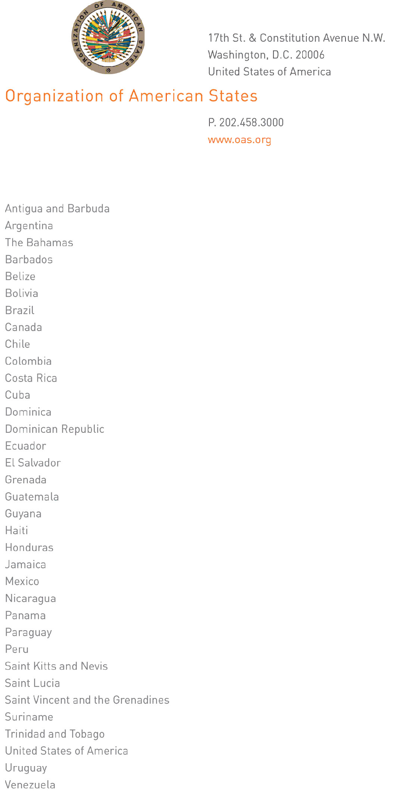
January 9, 2013

Excellency:

I have the honor of writing in order to relay a request from the Permanent Mission of Ecuador for the inclusion on the Permanent Council agenda of an item entitled “Election of a member of the Board of External Auditors” in light of the resignation of the Ecuadorian member elected to said Board.

Accept, Excellency, the renewed assurances of my highest and most distinguished consideration.

Ambassador Hugo de Zela
Chief of Staff of the Secretary General

His Excellency
Denis Moncada Colindres
Ambassador, Permanent Representative of Nicaragua
to the Organization of American States
Chair of the Permanent Council
Washington, D.C.
REPUBLIC OF ECUADOR Ministry
MISSION OF ECUADOR TO THE of Foreign Affairs,
ORGANIZATION OF Trade, and Integration
AMERICAN STATES

Note No. 4-2/3/2013

The Permanent Mission of Ecuador to the Organization of American States (OAS) presents its compliments to the General Secretariat of the OAS and encloses herewith official letter No. 00138-SCG of January 3, 2013, by which Dr. Wilson Vallejo Bazante, Deputy Comptroller General of the Republic of Ecuador, formally resigns his duties as a member of the Board of External Auditors of the OAS, to which position he was elected by the Permanent Council of the Organization at its meeting of November 7, 2012.

Further to the above, the Permanent Mission of Ecuador to the Organization of American States would cite operative paragraph 4 of resolution CP/RES. 124 (164/75) rev. 2 corr. 1, which states, “4. If one of the members of the Board resigns or ceases to hold his official position in his country, he shall cease to be a member of the Board. To succeed him, the government of the country of the outgoing member may nominate a new candidate, so that the General Assembly or the Permanent Council, if the Assembly is not in session, may elect him to fill out the remainder of the term for which the original member was elected.”

Therefore, on behalf of the Government of Ecuador, the Permanent Mission of Ecuador to the Organization of American States has the pleasure of nominating Dr. Carlos Pólit Faggioni, Comptroller General of the Republic of Ecuador, to succeed Dr. Wilson Vallejo Bazante on the Board of External Auditors of the OAS. A current curriculum vitae of the new Ecuadorian candidate is attached hereto.

Finally, the Permanent Mission of Ecuador to the Organization of American States respectfully requests the General Secretariat of the OAS to ask the Chair of the Permanent Council of the Organization to convene a meeting of the Council in order to examine Ecuador’s application and proceed in accordance with the provisions contained in the above-cited resolution.

The Permanent Mission of Ecuador to the Organization of American States avails itself of this occasion to convey to the General Secretariat of the OAS renewed assurances of its highest and most distinguished consideration.

Washington, D.C., January 7, 2013

General Secretariat of the
Organization of American States
Washington, D.C.
00138 –SCG

Section: Office of the Deputy Comptroller General

Subject: Resignation Board of External Auditors

Quito, January 3, 2013

Sir,

It is with regret that I am writing to tender to you and, through you, the Organization my formal resignation from my duties in representation of the Office of the Comptroller General of the Republic of Ecuador as a member of the Board of External Auditors of the Organization of American States, to which position I was appointed by the Permanent Council on November 7 last year.

I would like to take this opportunity to reiterate my gratitude to you and the Organization of American States for the above appointment.

Yours sincerely,

Dr. Wilson Vallejo Bazante
Deputy Comptroller General

His Excellency
Jose Miguel Insulza
Secretary General of the
Organization of American States
Washington, D.C.
USA

cc: Ambassador Joel Antonio Hernández García
Chair of the Permanent Council of the OAS

http://scm.oas.org/pdfs/2013/CP29981 CV.pdf
input.doc

