OEA/Ser.G
CP/doc.4828/13
20 February 2013
Original: Spanish

REPORT OF THE SECRETARY GENERAL ON THE IMPLEMENTATION
OF RESOLUTION AG/RES. 2710 (XLII-O/12).

“STRENGTHENING THE INTER-AMERICAN COMMISSION OF WOMEN”
TO THE FORTY-THIRD REGULAR SESSION OF THE GENERAL ASSEMBLY

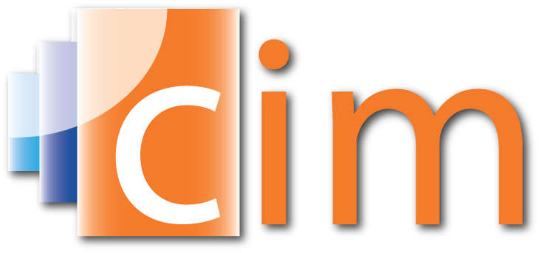
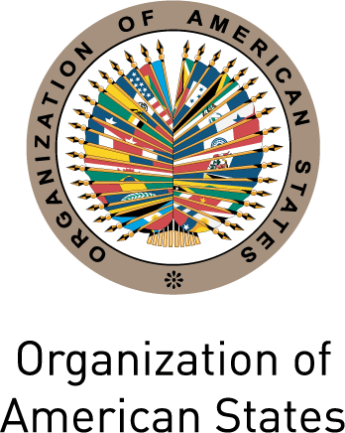

INTER-AMERICAN COMMISSION OF WOMEN

OEA/Ser.L
CIM/doc.120/13
29 January 2013
Original: Spanish

REPORT OF THE SECRETARY GENERAL ON THE IMPLEMENTATION OF RESOLUTION
AG/RES. 2710 (XLII-O/12)

“STRENGTHENING OF THE INTER-AMERICAN COMMISSION OF WOMEN”

REPORT OF THE SECRETARY GENERAL ON THE IMPLEMENTATION OF RESOLUTION
AG/RES. 2710 (XLII-O/12)

“STRENGTHENING OF THE INTER-AMERICAN COMMISSION OF WOMEN”

I. General aspects

Beginning in 2005, the General Assembly of the Organization of American States (OAS) has approved resolutions in which it instructs the Secretary General to support the Inter-American Commission of Women (CIM), assigning it personnel and resources adequate for it to perform its functions and to include the CIM’s projects and programs among the priorities presented for obtaining financing from external donors.

The strengthening of the CIM depends on its internal coordination with all the areas of the Organization and its participation in the activities to ensure appropriate inclusion of the gender component. In that sense, and as part of the initiatives that the CIM itself is promoting, the CIM is working on the main issues related to the four pillars of the OAS, which are key lines of its own 2011-2016 Strategic Plan: (i) Women’s substantive political citizenship for democracy and good governance; (ii) the human rights of women and gender violence; (iii) citizen security from a gender perspective; and (iv) women’s economic security and citizenship.

In furtherance of these mandates, the Secretary General and the Member States of the OAS, during the period examined, have provided important support to the CIM through their participation in events organized by the Commission, seeking resources for existing or new projects, and providing human resources to the Executive Secretariat of the CIM. In particular, the Secretariat for Administration and Finance of the OAS undertook to fill the vacant positions in the Secretariat beginning in January 2013 to ensure the CIM’s operational continuity. In the same period the CIM has received three interns from the OAS internship program.

As a result of this process of strengthening, the CIM has obtained funds for carrying out new projects and has prepared project documents in all the areas of its 2011-2016 Strategic Plan for obtaining new specific funds. In 2012, the CIM received several contributions from the Member States of the OAS, and from other international organizations:

- The Canadian International Development Agency (CIDA) contributed US$591,682 for carrying out two specific projects on evaluation and monitoring of exercise on the rights of women, with an emphasis on the right to live free from violence and other commitments acquired in the Convention of Belém do Pará.

- The Governments of Argentina, Mexico, and Suriname contributed US$15,000, US$14,333, and US$2,000, respectively, for the operations of the Mechanism to Follow Up on Implementation of the Convention of Belém do Pará (MESECVI).
- The Government of the United States of America contributed US$14,000 to finance part of the cost of the participation of the Delegates from the Caribbean at the Thirty-sixth Assembly of Delegates of the CIM (October 29 and 30, 2012, San José, Costa Rica).

- The Government of Argentina contributed US$5,000 to support the work of the CIM, in particular the organization of the 47th Policy Roundtable of the OAS, “Challenges in the Protection of Human Rights of Women living with HIV and AIDS” (November 28, 2012, Washington, D.C.), which was organized as follow-up to the CIM project “Integration of policies and programs on HIV and violence against women from a human rights perspective in Central America and the Caribbean.”

- UN Women contributed US$114,136.37 as support for the organization of the Second Hemispheric Forum “Full Citizenship of Women for Democracy” (July 18-21, 2012, Santo Domingo).

- International IDEA made several in-kind contributions to support the work of CIM in the area of Women’s substantive political citizenship for democracy and good governance, including conducting and printing a comparative study of the parity processes in Latin America with experiences and lessons learned in Bolivia, Costa Rica, and Ecuador (2013) and a publication that pulls together the work of the Regional Working Group on Women’s Citizenship for Democracy (2013).

Nonetheless, as noted by the numerous resolutions on strengthening the CIM, the human and financial resources allocated to the Commission continue to be insufficient to carry out all its mandates effectively. In the evaluation of the situation of human and financial resources at the CIM Executive Secretariat special mention should be made of the following:

- Of the more than 1,700 mandates given to the OAS by the General Assembly and other authorities, the CIM has more than 250 (15.4%), including specific and permanent mandates from its Assembly of Delegates, its Executive Committee, the Meetings of Ministers or of the Highest-Ranking Authorities responsible for the Advancement of Women in the Member States (REMIM), the General Assembly of the OAS, and the Summits of the Americas (see CIM/Inf.1/12 for more information);
- CIM receives 1.54% of the funds from the regular budget of the OAS;
- CIM has 1.8% (8 staff members) of OAS personnel (Regular Fund);
- From 2010 to 2012, the regular budget (non-personnel) of CIM declined 7.10% (see Table 1).

Table 1 - Regular budget of the CIM (non-personnel funds)

Funds | 2010 |  | 2011 |  | 2012 |  | 2013
Funds | Approved | Received | Approved | Received | Approved | Received | Approved | Received
Funds | $255,100 | $244,669  (- 4.0%) | $237,000  (- 7.10%) | $237,000 | $237,000  (± 0%) | $237,000 | $237,000  (± 0%) | N/A

It is urgent to strengthen the CIM for the full implementation of its Strategic Plan, for in addition it has received mandates that are current and that were not accompanied by budget allocations so as to make their full implementation possible. These mandates include: serving as the organ for follow-up, coordination, and evaluation of the Inter-American Program on the Promotion of Women’s Human Rights and Gender Equity and Equality (PIA) [(AG/RES. 1732 (XXX-O/00)]; holding a meeting of Ministers or of the Highest-Ranking Authorities responsible for the Advancement of Women in the Member States (REMIM) every four years [(AG/RES. 1741 (XXX-O/00)]; supporting the institutionalization of gender in the policies, projects, meetings, forums, and other activities of the OAS (Plan of Action of the Third Summit of the Americas, 2001); and serve as Secretariat of the Conference of States Parties and of the Committee of Experts of the Mechanism to Follow-up on Implementation of the Convention of Belém do Pará [(AG/RES. 2138 (XXXV-O/05)].
input.doc

. AG/RES. 1451 (XXVII-O/97), AG/RES. 1592 (XXVIII-O/98), AG/RES. 1625 (XXIX-O/99), AG/RES. 1777 (XXXI-O/01), AG/RES. 1941 (XXXIII-O/03), AG/RES. 2021 (XXXIV-O/04), AG/RES. 2124 (XXXV-O/05), AG/RES. 2161 (XXXVI-O/06), AG/RES. 2323 (XXXVII-O/07), AG/RES. 2441 (XXXIX-O/09), AG/RES. 2560 (XL-O/10), AG/RES. 2685 (XLI-O/11) and AG/RES. 2710 (XLII-O/12)

