OEA/Ser.G
CP/doc.4833/13
5 March 2013
Original: Spanish

ANNUAL REPORT OF THE
INTER-AMERICAN INSTITUTE FOR COOPERATION ON AGRICULTURE (IICA)
TO THE FORTY-THIRD REGULAR SESSION OF THE GENERAL ASSEMBLY

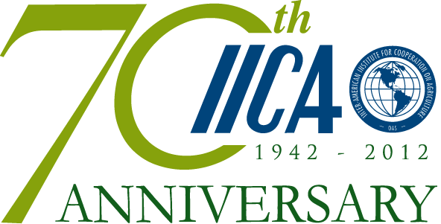

2012 Annual Report of IICA

Promoting competitive and sustainable
agriculture in the Americas

Sowing innovation to harvest prosperity

Forty-third Regular Session of the
General Assembly of the Organization
of American States (OAS)

March 2013

Inter-American Institute for Cooperation on Agriculture (IICA), 2013

IICA’s 2012 Annual Report is licensed under a Creative Commons
Attribution-NonCommercial-ShareAlike 3.0 Unported License
Available in PDF format at www.iica.int
ISBN 978-92-9248-449-1

Photos by: Depositphotos, IICA, Juan Rodriguez (Dominican Republic),
Shutterstock and Rafael Cartin (Costa Rica).

The Institute encourages fair use of this document. Proper citation is requested.

Contents

Message from the Director General……………………………………………………………….  Executive summary………………………………………………………………………………………..  About IICA………………………………………………………..…………………………………………….  Main achievements in 2012 based on the 2010-2014 Medium-term Plan………  Objective 1: Improve the productivity and competitiveness of the agricultural sector………………………………………………………………………………………………………………………..  Objective 2: Strengthen agriculture’s contribution to the development of territories and the well-being of the rural population………………………………………………………………...  Objective 3: Improve agriculture’s capacity to mitigate and adapt to climate change, and make better use of natural resources………………………………………………….…..  Objective 4: Improve agriculture’s contribution to food security……………………………..  Objective 5: Conduct strategic analyses for agriculture…………………………………………..  Celebration of IICA’s 70th anniversary……………………………………………………………  Governance and official meetings……………………………………………………………….…..  Administrative management geared toward technical cooperation………………  Annex…………………………………………………………………………………………………………….  Annex 1: List of multinational projects financed by IICA’s Technical Cooperation Fund…………………………………………………………………………………………………………………………..  Annex 2: Profiles and cooperation projects prepared by IICA in 2012………………………...  Annex 3: IICA’s knowledge-based products…………………………………………………………………  Acronyms……………………………………………………………………………………………………….. | v  vii  1  2  2  15  19  22  23  25  26  27  31  31  33  34  35

Message from the Director General

The year 2012 was a very important one for agriculture in the hemisphere within the framework of the Inter-American System. In the final documents of the Sixth Summit of the Americas, held in Cartagena de Indias, Colombia, the leaders of the countries of the Americas expressed their strong commitment to technological innovation. They recognized it as a source of progress in the rural sector and as a vital area for strengthening productivity, sustainability, and competitiveness in the agrifood sector, and thereby helping to reduce poverty levels and achieve food security.

The issue of food security was also the focus of the dialogue that took place at the Forty-second Regular Session of the General Assembly of the Organization of American States (OAS), held in Cochabamba, Bolivia. IICA derived great satisfaction from the fact that it was asked to prepare the document that served as the basis for lively discussions at the meeting. Even more satisfactory, however, was the fact that, despite the diverse political positions of the countries taking part in the Assembly, all the OAS Member States clearly believe that access to food is a right that everyone should be able to exercise.

Agriculture is the first link in the chain that affords people access to food, which makes it a very important social and economic sector. At IICA, we recognize the great desire of our member countries to position the agricultural sector as a key element of development, but daunting challenges must be overcome if political will is to be translated into action.

Fortunately, the hemisphere as a whole has the potential required to make agriculture a source of development. In fact, agriculture in the Americas has the capacity to feed much of the world’s population.

Undoubtedly, the countries need to improve public policies for the rural sector, increase investment in agriculture, integrate producers into markets more efficiently, and ensure that the benefits of the global economy reach every segment of the rural population; but they are moving in the right direction. Furthermore, multilateral efforts are helping to offset many of the constraints at the national level.

Governments, the citizenry, public institutions, and producers’ organizations, supported by the international organizations, are faced with a number of challenges. These include raising productivity by means of innovation, incorporating producers of all kinds into value chains, adapting agriculture to climatic variations, making sustainable use of land and water resources and, in particular, feeding an ever-growing population.

During 2012, IICA continued to enhance its technical strengths, which enabled it not only to support the countries’ efforts to achieve agricultural development and the well-being of the rural population, but also to meet the needs in those areas by promoting multilateral action.

Our work, which is based on continuous dialogue and interaction with the Member States to obtain feedback, is underpinned by a dynamic hemisphere-wide agenda that we implement through our technical programs for innovation, agribusiness, agricultural health, area-based development, natural resource management, and food security. The specific activities in each Member State are linked to the respective IICA country strategy, which serves as the frame of reference not only for our work at the national level, but also for horizontal cooperation actions and the establishment of new strategic partnerships.

The Institute is presently implementing more than 350 projects throughout the region, designed to promote innovation, value added, the integration of family agriculture into the wider economy, the modernization of public institutions, and the adaptation of agriculture to climate change, among other objectives. As those projects indicate, IICA’s work complements the efforts of the governments. It combines both the international and national agendas, and integrates the work of many different stakeholders.

In 2012, the year in which we celebrated our 70th anniversary, we renewed our commitment to agriculture and sustainable rural development throughout the hemisphere, as this report demonstrates.

Víctor M. Villalobos
Director General

Executive summary

The mission of the Inter-American Institute for Cooperation on Agriculture (IICA) is to “provide technical cooperation, innovation, and specialized knowledge to contribute to the competitive and sustainable development of agriculture in the Americas.” Created in 1942 by the Governing Board of the Pan American Union, IICA is recognized by the Organization of American States (OAS) as the agency of the Inter-American System specializing in agriculture and the well-being of the rural population. For IICA, 2012 was a year of celebration and recognition of the work that it has performed for seven decades on behalf of agriculture in the hemisphere. Its current Director General is Dr. Víctor Villalobos, a citizen of Mexico.

The Institute’s main activities were designed to provide the Member States with updated or new instruments for the modernization of their national innovation systems and government plant and animal health services; and to strengthen the capabilities of the public and private sectors, to enable them to take advantage of the opportunities for agricultural trade and address issues such as the management of territories, biotechnology, biosafety, food security, climate change, and the mitigation of greenhouse gases.

In Guatemala, Honduras, Nicaragua, and Panama, appraisals were carried out that led to improvements being made to the national organic production systems, while in El Salvador, Nicaragua, Costa Rica, Uruguay, Paraguay, Peru, Bolivia, and Mexico reviews were conducted of the capabilities for institutional development and the design of policies for agricultural innovation. In addition, through the Observatory of Institutional Innovations and the Network for the Management of Innovation in the Agrifood Sector (Red INNOVAGRO), IICA shared nearly 50 innovation experiences and systematized four institutional research models. The Institute’s efforts also led to innovations in the Caribbean in the areas of agribusiness, production in greenhouses, and the breeding of small ruminants.

A good example of the institution’s activities is the application of the agricultural innovation model used in the Family Agriculture Plan (PAF) of the Ministry of Agriculture and Livestock (MAG) of El Salvador, specifically under the PAF- Production Chains Program. Nearly 16,000 producers benefitted from a series of production tools and methods, and support in areas such as associativity, marketing, and institution building.

Furthermore, the Institute enhanced the expertise in pest risk analysis of over 106 professionals in Mexico, Dominican Republic, Ecuador, Colombia, Peru, Bolivia, Paraguay, Brazil, and a number of Central American and Caribbean countries; promoted an exhaustive discussion of international sanitary standards, and contributed to the historic vote on the acceptance of the maximum residue levels for ractopamine, a process spearheaded by the Codex Coordinating Committee for Latin America and the Caribbean (CCLAC). The foregoing demonstrates that IICA has consolidated its position in international forums as a go-to organization for plant health issues that has also increased the active participation of its Member States in the global and hemispheric bodies related to the Codex and sanitary measures.

The application of the Performance, Vision, and Strategy (PVS) instruments for food safety and inspection also led to the drafting of work plans and reports for Jamaica, Suriname, Bahamas, Guyana, Nicaragua, Ecuador, and Venezuela.

Thanks to the Institute’s support for agribusiness development, 31 businesses, 36 producer organizations, and more than 600 stakeholders in 20 member countries improved their export capabilities, business management, agro-tourism operations, product safety, and organization of chains. In the public institutional frameworks of 25 Member States, officials acquired new expertise in areas such as marketing, value added, associativity, insurance, and agrifood chains. Furthermore, 1400 persons working in the public and private sectors of Belize, Costa Rica, El Salvador, Guatemala, Honduras, Nicaragua, Panama, Dominican Republic, Paraguay, Uruguay, and Brazil enhanced their institutional and technical capabilities for leading and implementing effective processes for area-based management.

Through the IICA-led mechanisms for collaboration and joint action, the Central American Integration System (SICA) adopted the guidelines of the Central American Strategy for Rural Area-based Development (ECADERT), which is enabling countries in the region to improve the incorporation of regulatory, technical, and institutional frameworks into their area-based development policies, programs, and projects. Another of the Institute’s contributions was the multinational project “Innovative Policies for the Development of Rural Territories in Latin America (PIDERAL),” financed by the Spanish Agency for International Development Cooperation (AECID). Under the initiative, Peru, Ecuador, Costa Rica, and Dominican Republic received assistance with the design and implementation of policies for the development of rural territories.

With respect to interinstitutional relations and forms of cooperation, IICA played a key role in the meeting of the Group of 20 (G20), assisting Mexico, which chaired the event, with the implementation of forums, terms of reference for the agricultural scientific leaders, and an interagency document on productivity. Moreover, the Institute prepared a report entitled “The Food Security Situation in the Americas,” which was used as the basis for the discussions during the Forty-second Regular Session of the OAS General Assembly, held in Cochabamba, Bolivia; and, in collaboration with the Economic Commission for Latin America and the Caribbean (ECLAC) and the UN Food and Agriculture Organization (FAO), produced the report, The Outlook for Agriculture and Rural Development in the Americas: A Perspective on Latin America and the Caribbean.

IICA has a wide variety of partners, including those already mentioned, the United Nations Organization, the Government of Finland, Germany’s Deutsche Gesellschaft für Internationale Zusammenarbeit (GIZ), Canada’s International Development Research Centre (IDRC), the international agricultural research centers of the CGIAR System, and numerous agricultural universities, among others.

It is worth noting that, in partnership with Mexico’s National Science and Technology Council (CONACYT), the Institute implemented a scholarship program to promote technical capabilities in agriculture, thanks to which 30 students began master’s and doctoral degree courses in that country. IICA’s Competitive Fund for Technical Cooperation (FonCT) also approved 18 new multinational technical cooperation projects financed with the organization’s own resources.

In 2012, the Thirty-second Regular Meeting of the Executive Committee (EC) was held at the Institute’s Headquarters in Costa Rica. A number of institutional reports and studies were approved, including one related to the methodology and policy for the Institutional Net Rate (INR) that is used in the administration of technical cooperation projects.

The Institute has implemented a financial strategy designed to bring about continuous improvements in institutional management, while at the same time lowering internal costs and making the most efficient possible use of resources. The SAP (Systems, Applications, and Products) financial administration platform has now been installed in 97% of IICA’s Offices in the member countries, via which 300 technical cooperation projects are administered efficiently and transparently.

Furthermore, action was taken to address the effects of the freezing of the quota contributions of the Member States for more than 16 years, thanks to which several countries will increase their contributions or offer to make special ones. Apart from the financial benefits, such contributions and the fact that 98.7% of quotas were collected on time in 2012 are an endorsement of the Institute’s work on behalf of agriculture and the well-being of rural dwellers in the Americas.

About IICA

The Inter-American Institute for Cooperation on Agriculture (IICA) is the agency of the Inter-American System whose mission is:

“…to provide technical cooperation, innovation, and specialized knowledge to contribute to the competitive and sustainable development of agriculture in the Americas and to improve the lives of rural dwellers in the member countries.”
(IICA 2010-2014 Medium Term Plan)

The goal of the Institute is to be a cutting-edge organization that provides innovative technical cooperation aimed at achieving competitiveness of the agrifood system, the sustainable development of agriculture, food security, the reduction of poverty and improved living conditions in the rural territories of the Americas, based on its technical strength and capacity to respond to the new challenges faced by the hemisphere’s agricultural sector.

The Institute was created in 1942 by the Governing Board of the Pan American Union. Its highest governing body is the Inter-American Board of Agriculture (IABA), the primary ministerial forum for analyzing policies and strategies for the improvement of agriculture and rural life in the Americas.

IICA’s Headquarters are located in San Jose, Costa Rica. The Institute’s executive body is the General Directorate, which is headed by Víctor M. Villalobos, a citizen of Mexico.

IICA coordinates its technical cooperation actions through a broad network of offices that interconnects its 34 member countries. It also has a Permanent Office for Europe, located in Madrid, Spain, that promotes relations and actions with strategic partners in the European Union (EU). In addition, one of the Institute’s four technical cooperation programs, Agribusiness and Commercialization, coordinates its actions from Miami, Florida, United States.

Main achievements in 2012 based on the
2010-2014 Medium-term Plan

In these times of global economic crisis, and in a context characterized by price volatility and climate variability, agriculture is under intense scrutiny, particularly in relation to food and nutritional security. This provides an opportunity to expand linkages between the public and private agricultural sectors, formulate comprehensive policies, increase investment in the countryside and devise new formulas to promote innovation, competitiveness and sustainability in agriculture and rural areas.

In 2012, the Inter-American Institute for Cooperation on Agriculture (IICA) focused its actions on achieving the strategic objectives defined in its 2010-2014 Medium-term Plan and on the cooperation activities established in the IICA country strategies. To contribute to the attainment of those objectives, the Competitive Fund for Technical Cooperation (FonTC) was consolidated as an instrument for implementing more projects of multinational interest. In the second call for projects, launched in 2012, 18 new projects were approved (See Annex 1), adding to the 16 already in operation.

Below is a sample of the results achieved through our efforts to accomplish these objectives for the benefit of our 34 Member States.

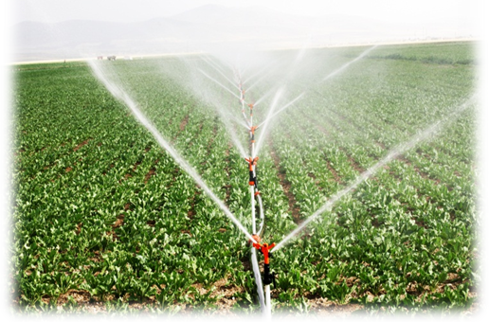 | Objective 1: Improve the productivity and competitiveness of the agricultural sector  IICA seeks to generate technological and organizational innovations to help its Member States improve their trading conditions, increase production and enhance their business capabilities in agribusiness management.
- Strengthening national technological innovation systems

The Institute improved the management of the national agricultural innovation systems (NAIS) and of the national agricultural research institutes (NARIs) of the Americas, through the following actions: a) application of diagnostic tools to assess the capacity for institutional development and policy design in El Salvador, Nicaragua, Costa Rica, Uruguay, Paraguay, Peru, Bolivia and Mexico; b) dissemination of nearly 50 successful experiences through the Observatory of Institutional Innovations; c) identification, systematization and dissemination of four new institutional research models to institutions linked to the Network for the Management of Innovation in the Agrifood Sector (Red INNOVAGRO); d) design of an accreditation system for technical and institutional capabilities in extension services; and e) implementation of four projects in Central America financed by the Inter-American Development Bank (IDB), the Swiss Agency for Development and Cooperation (SDC), the European Union(EU) and Korea.

Among these four initiatives, the SICTA-COSUDE project was particularly important, given that it doubled the bean production of 30 Nicaraguan producers’ organizations, increased the productivity of maize and bean crops by 30% and reduced post-harvest management costs by 70% in the district of Toledo, in Belize.

Furthermore, a new project got under way in Belize to support the Sugar Industry Research and Development Institute (SIRDI). The EU contributed USD3.2 million to finance the transfer of improved technologies to sugarcane producers, and provide them with extension services.

Other achievements
Antigua and Barbuda | Pig farmers in Antigua and Barbuda were introduced to low cost bio-digester technology, thereby strengthening their knowledge in the management of swine waste. The small ruminant sector was assessed and recommendations for improving organization, management and productivity were given to farmers and livestock technicians in order to improve the sector.
Bolivia | IICA worked with the National Institute for Agricultural and Forestry Innovation (INIAF) to establish the Network for Genetic Improvement of Dairy Cattle in the Bolivian Highlands and a technical group to support technology research and development related to quinoa.
Chile | IICA conducted a comparative study on institutional experiences in the management of germplasm banks in Brazil, Argentina, Costa Rica, Mexico and New Zealand. The study was used as a guide to modernize Chilean institutions that carry out reference practices in this field.
Dominican Republic | The Ministry of Agriculture, Ministry of Environment, and several producers’ associations acquired knowledge of innovative intensive silvopastoral systems. These were put into practice by approximately 50 crop farmers and livestock producers, who increased their production yields and reduced costs.
St. Kitts and Nevis | In collaboration with the Caribbean Agricultural Research and Development Institute (CARDI), IICA has enabled farmers and agro producers to strengthen their production capabilities in product processing with respect to root and tuber crops, and to enhance food security with new varieties and agro-processing equipment.

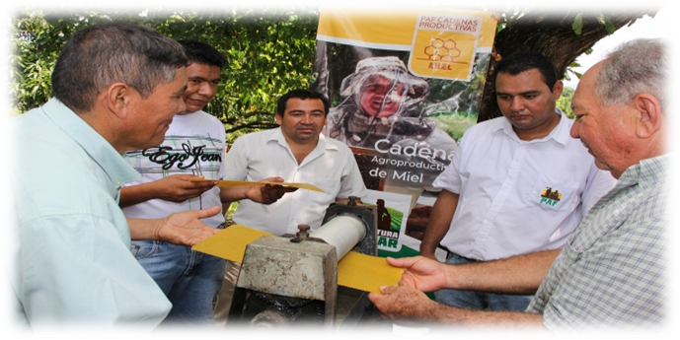
Experience of the Family Agriculture Program (PAF) in El Salvador

The Institute developed an agricultural innovation model that was successfully applied in the Family Agriculture Plan of the Ministry of Agriculture and Livestock (MAG) of El Salvador, specifically in the PAF-Production Chains Program, which benefits 16,000 producers. The application of this model made it possible to:

- Establish eight technical groups on agricultural production chains, as forums for effective dialogue. These groups produced 12 studies (characterizations of chains), laid the foundations for a public policy to support the competitiveness of those chains and designed four cross-cutting public policy programs (marketing, credit, cooperatives and infrastructure).
- Establish 28 collection and service centers, as basic mechanisms to promote associativity.
- Train 608 producers in the management of agricultural enterprises using the methodology known as “Competency-based economies through entrepreneurship training.”
- Design new business models outlined in 21 plans, which resulted from more than 366 work sessions at the local level, focusing on coordination of production, market insertion and product innovation.
- Formulate 24 investment projects that provided training to 1289 agricultural entrepreneurs and leveraged USD1.5 million in non-reimbursable funds for the capitalization of cooperative enterprises.
- Establish 588 production development centers, which promoted the use of different technological innovations. The farmers who used the centers increased their crop yields by at least 15% and their income by 10%.
- Enhance the institutional capabilities of the MAG and of the National Center for Agricultural and Forestry Technology (CENTA) to provide technical assistance services to small and medium-scale producers. Direct training was given through field visits, exchange of experiences and other events.
- Implement a modern online follow-up and monitoring system, in the context of the PAF-Production Chains Program; this provided the national authorities and 300 technicians and extension workers with real time information generated in the field.

- Improving the safe use of agro-biotechnologies

IICA’s Member States improved their capabilities in the regulation of biotechnology and biosafety through education and training activities organized in Costa Rica, Ecuador, Nicaragua and Panama; the training of inspectors on the topics of adventitious presence and low level presence in 15 countries; the Institute’s contribution to policymaking in Costa Rica, El Salvador, Ecuador and the Caribbean (participation in UNEP-GEF projects); the design of a project for maize seed production in Ecuador; support to various institutions to facilitate their participation in international events such as the COP-MOP 6; and a number of studies that provided countries with more and better tools and information for the development of biotechnology in agriculture.

Other achievements
IICA-Canada | IICA’s member countries negotiated several agreements in the areas of biosafety and low level presence of genetically modified organisms (GMOs) in food, feed and processing. Agreement was also reached on the need to harmonize positions at two workshops on biotechnology, coordinated and held in Argentina and Panama for 16 Latin American and Caribbean (LAC) countries.
Chile | Six specialists of the Subsecretariat for Agriculture and of the Office for Agricultural Studies and Policies (ODEPA) of Chile, together with members of the Southern Region’s Public Policy Group on Biotechnology and the Negotiating Group of the Cartagena Protocol, received training in biotechnology and biosafety issues and discussed IICA’s working documents on these topics.
Paraguay | The National University of Asunción (UNA) and the Institute of Agricultural Biotechnology (INBIO) implemented a Master’s Program in Agricultural Biotechnology, which was designed with IICA’s support.
Panama | IICA organized three training activities for 180 technicians from various institutions, including the Ministry of Agricultural Development (MIDA), in the areas of biosafety, use of biotechnology in agriculture and genetically modified organisms.

- Promoting new uses for agricultural products

The application of tools designed by the Institute to conduct assessments and promote institutional development resulted in improvements in the management of the national systems for the control of organic production in Guatemala, Honduras, Nicaragua and Panama. These tools also supported regional harmonization processes and the promotion of public certification systems. A specific example was the approval of standards for organic agriculture by the ministers of agriculture of Dominican Republic and the Central American countries.

Other achievements
Belize | Six non-governmental organizations and producers’ organizations involved in organic agriculture received support from IICA in delivering assistance on organic certification to over 1000 producers in the districts of Toledo and Cayo.
Grenada | The Grenada Organic Agriculture Movement (GOAM), endorsed by the Ministry of Agriculture, was established and is functioning as a facilitating entity for the promotion and development of the country’s organic farming subsector. In addition, 20 agriculture technicians and 18 potential organic produce farmers increased their knowledge of organic agriculture through participation in the workshop “Development of National Standards for Organically Produced Foods” and the definition of recommendations for the way forward for organic agriculture in Grenada.
Paraguay | Small and medium-scale producers interested in organic agriculture expressed their satisfaction to the MAG authorities regarding the National Plan for the Development of Organic and Agro-ecological Production, a tool launched by the MAG and designed with IICA’s support.
Suriname | Through field visits by experts organized by the Institute, chili pepper entrepreneurs are now aware of policies for accessing the European market with organic chili pepper. Their management skills have also been strengthened, thereby enhancing their competitiveness for penetrating international markets.

- Promoting the use of clean energies

The regional Energy and Environment Partnership (EEP) financed by the Government of Finland has provided key stakeholders in Bolivia, Colombia, Ecuador and Peru with access to practical solutions for renewable energies and energy efficiency generated through 18 projects (worth USD3.78 million) and studies on sustainable access to energy in rural and/or peri-urban areas.

In the province of Manabí, Ecuador, IICA provided technical cooperation to farmers who have live fences of jatropha (piñon). This enabled them to obtain additional income from the sale of jatropha seed, which is used to produce pure jatropha vegetable oil at the extraction plant installed in the Experimental Station of the National Autonomous Institute for Agricultural Research (INIAP), located in Portoviejo and financed for the Deutsche Gesellschaft für Internationale Zusammenarbeit (GIZ). This oil will be sold to the Galapagos Electricity Company (ELECGALAPAGOS), which will use it as biofuel to operate electricity generators on the Island of Floreana.

- Linking producers to markets

With IICA’s support, 18 organizations (2800 members), 31 private companies and more than 450 food industry workers in at least 20 countries improved their export capabilities. Another 18 organizations (548 members) strengthened their business management skills. In addition, 115 business owners and technicians acquired knowledge on how to operate agro-tourism enterprises; and the actors of nine agrifood chains developed their management capabilities as a mechanism to increase their competitiveness.

At the same time, the public and private sectors improved their capacity to take informed and timely decisions on public policies, make investments and plan market strategies. This was made possible through the preparation of nine studies and technical assessments on the institutional framework and capacities of the ministries of agriculture in the area of agribusiness; the implementation of external networks with 2900 participants; the participation of 800 of these actors in three meetings organized by IICA on agribusiness; and the generation and dissemination of five new cooperation instruments.

Other achievements
Bahamas | Three agricultural cooperatives and six producers’ associations improved their associative capabilities and participation in marketing chains, thanks to the assistance provided by IICA in carrying out studies and in establishing cooperative groups in the livestock, egg production and aquaculture sectors, among others. The Institute received support from the Department of Cooperative Development and the Bahamas Cooperative League, in the case of the three cooperatives, and of the Bahamas Agricultural and Industrial Corporation (BAIC), for six associations.
Guatemala | The Business Linkages Program, an initiative systematized by IICA, was made available to the Guatemalan Exporter Association (AGEXPORT) and provides a valuable tool for linking small-scale vegetable and coffee producers to international markets, reducing poverty and boosting the economies of rural communities in the country’s western highlands.
Guyana | IICA supported five training sessions, market intelligence and fact-finding missions to overseas markets resulting in 200 entrepreneurs and producer organizations becoming better placed to access regional and international markets. So far, two producers have increased the varieties and volumes of products exported to Canada. As many as 85 farmers and householders adopted shade technology as a result of a joint effort involving the Ministry of Agriculture (MoA), Ministry of Education (MoEd), National Agricultural Research and Extension Institute (NAREI), the FAO, Partners of the Americas (PoA), and Caribbean and African Self Reliance International (CASRI).
Haiti | Under a project funded by the EU, IICA helped to strengthen 67 community-based organizations involved in the mango value chain, resulting in the grafting of more than 53,000 mango trees to improve the quality of the fruit produced.
Venezuela | Officials of the Ministry of the Popular Power for Agriculture and Land (MPPAT), of the Ministry of the Popular Power for Food (MINPPAL), and of governors’ offices and mayors’ offices, and farmers learned about successful experiences in agricultural markets and were provided with relevant methodologies and tools for the implementation of strategies related to market information, agricultural negotiations, local quality seals and brands, and the improvement of the cacao chain.

- Modernization of markets

The public institutions of 25 Member States increased their capacity to offer better services, specifically:

  - In Costa Rica, more than 900 producers benefited from the new price information service that uses cell phone technology, known as “Agromensajes,” promoted by the National Production Council (CNP), the Costa Rican Electricity Institute (ICE) and the Integrated Agricultural Marketing Program (PIMA).
  - In El Salvador and Panama, IICA contributed to improvements in the operation of commodity market information services, with the support of the Market Information Organization of the Americas (MIOA). Nine countries of the Caribbean Community (CARICOM) joined this organization, which was strengthened after presenting its report to the Executive Committee of IICA and obtaining its support.
  - Technicians of Ecuador’s Subsecretariat for Agriculture, of Peru’s Program for the Development of Rural Agricultural Production (AGRORURAL) and the Subsecretariat for Value Added of Argentina improved their knowledge of value added.
  - Professionals of 22 public institutions of Paraguay, Ecuador and Guatemala received training in the design of projects for the development and consolidation of associativity.
  - The Institute worked with the Regulatory Council on Geographical Indications (GI) of Honduras to design a strategy for promoting and marketing products with GI. It also trained 20 representatives of the coffee chain in that country in systematization methodologies and the benefits of GI.
  - Nine chains in Panama and eight in El Salvador (in the context of the PAF) received technical support from IICA to develop framework agreements on competitiveness. In Guatemala, the Institute disseminated methodologies for carrying out rapid assessments and identifying investment needs among eight production chains.
  - IICA contributed to the training of 100 officials from Dominica, Haiti, El Salvador, Panama and Colombia in strategies to link farmers to markets and improve the quality of their products.
  - With IICA’s support, 30 Panamanian officials received training in agricultural insurance programs.

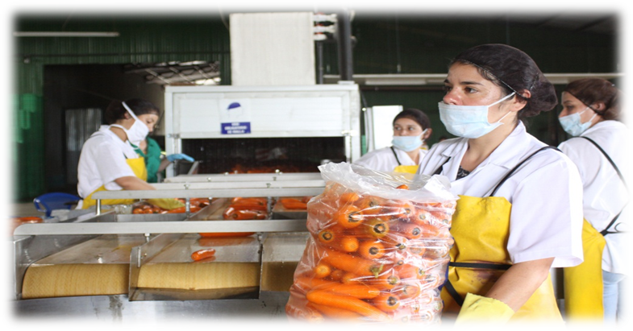
Agroindustry and value added

Retaining and adding value to agricultural products and services, particularly those of family agriculture, has become an important objective of the Institute’s cooperation efforts.

As a result of training provided by IICA:

- More than 1900 producers and technicians from several provinces in Argentina updated their knowledge on quality certification, organic agriculture, marketing systems, and good agricultural, livestock and manufacturing practices. These activities enabled the Ministry of Agriculture, Livestock and Fisheries (MAGyP) and territorial organizations to improve their capacity to promote and implement strategies and differentiation tools and to add value to production.
- In Grenada, 20 banana producers and 16 agricultural technicians participated in the reorganization and modernization of the country’s banana industry.
- In Honduras, two associations of small-scale farmers efficiently operated a grain processing center and ten producers’ associations implemented a traceability system for grains. All these organizations are beneficiaries of Purchase for Progress (P4P), an initiative of the World Food Programme (WFP).
- In St. Kitts and Nevis, 36 organizations of small and medium-scale producers improved their technical capabilities in processing sweet potato and yucca, in business management and in the design and implementation of organizational strategies to improve their market competitiveness.
- Groups of farmers in Trinidad and Tobago began applying methods for preparing products derived from goat’s milk, roots and tubers, fruits, vegetables, goat meat and lamb.

- Risk management and risk reduction

The Institute helped raise awareness of the need to have agricultural insurance programs in place in Argentina, Bolivia, Chile, Ecuador, Guatemala, Honduras, Nicaragua, Paraguay, Uruguay and Venezuela. IICA also made available to the member countries a publication entitled “Agricultural insurance in the Americas: an instrument for risk management,” which contains the basic concepts of risk management and insurance, as well as individual profiles of insurance programs applied in various countries of the hemisphere.

In Bolivia, IICA supported the drafting of policy guidelines and the training of public and private actors, through an information system on agro-climatic risks operated by the Rural Contingency Unit of the Ministry of Rural Development and Land (MDRyT).

- Implementation of agreements and participation in meetings on sanitary and phytosanitary measures

Thanks to IICA’s technical cooperation, the LAC countries increased their participation in international meetings on sanitary and phytosanitary measures, playing a more effective part and contributing to the development of international agricultural health and food safety (AHFS) standards. Among the results achieved in this area with the Institute’s support were the following:

  - The Codex Coordinating Committee for Latin America and the Caribbean (CCLAC) organized 12 virtual coordination sessions for the national Codex committees and implemented the Digital Notification System for the CCLAC, ensuring more effective communication among its members.
  - A comprehensive discussion took place on proposals for international sanitary standards involving 13 Caribbean and 15 Latin American countries. Of particular importance was the historic vote to accept maximum residue limits for ractopamine, with the CCLAC, United States, Canada, Australia and New Zealand spearheading the efforts to secure approval.
  - Guatemala, Costa Rica, Colombia and Uruguay actively participated in the 40th Session of the Codex Committee on Food Labeling, which became the second Codex Committee to receive financial support from Canada.
  - Trinidad and Tobago and St. Vincent and the Grenadines managed to resolve a number of issues related to black Sigatoka disease, the Codex and the U.S. Food Safety Modernization Act.

Other achievements
Bolivia, Costa Rica | Robust discussion forums were established based on the national Codex committees and the technical inspection committees.
Canada | The Conference Board of Canada and the Canadian International Development Agency (CIDA), under the Canada-Americas Trade-Related Technical Assistance Project (CATRTA), approved a project aimed at strengthening the capacities of small and medium-scale agrifood enterprises in Colombia and Peru. The aim was to improve their sanitary and phytosanitary measures and compliance with standards.
Dominica | Consumer confidence in AHFS systems improved as a result of an operational National Codex Committee in Dominica, the development of a National Codex Guideline Manual and training for private and public sector personnel on the work of Codex and national food safety programs.
Peru | The competent agricultural health authorities (the National Agricultural Health Service, the General Directorate of Environmental Health, and the Fisheries Technological Institute) and private sector leaders developed their capacity in strategic aspects of agricultural health, such as the Codex Alimentarius standards, food safety, export requirements and early warning systems; in particular, 60 officials of the Andean Region’s health services increased their knowledge of inspection and certification systems in AHFS, through a workshop organized in partnership with the Canadian Government and the General Secretariat of the Andean Community.

- Modernization of national animal and plant health services

The Institute strengthened countries’ capabilities to improve their official AHFS services by making available updated or new tools and supporting their implementation. Examples include the Performance, Vision and Strategy (PVS) tool for National Food Safety Monitoring Systems and Services (third edition), as well as tools for the characterization of laboratories, food inspection services and capacity to respond to health emergencies. As a result of the application of the different PVS tools available, eight reports and ten work plans were made available to Jamaica, Suriname, Bahamas, Guyana, Nicaragua, Ecuador and Venezuela.

IICA also implemented the online course of the International Plant Protection Convention (IPPC) on pest risk analysis (used worldwide and available on the IPPC website), which was imparted to over 80 professionals from Mexico, Dominican Republic, Central America, Ecuador, Colombia, Peru, Bolivia, Paraguay and Brazil. Together with the IPPC, two regional consultation workshops were organized to discuss draft international phytosanitary standards, one for Latin America (15 countries, COSAVE and OIRSA) and one for the Caribbean (13 countries).

In collaboration with the University of the West Indies (UWI), IICA imparted a course on quarantine and plant health procedures, which benefited 26 participants from 21 Caribbean countries.

The region’s institutional framework for AHFS was consolidated following IICA’s support in implementing the annual action plans of the Plant Health Committee of the Southern Cone (COSAVE) and the Permanent Veterinary Committee of the Southern Cone, as well as the Sanitary and Phytosanitary Measures Plan of the Central American Agricultural Council (CAC). In addition, IICA reactivated the plant health coordination groups, strengthened the Caribbean forums and advised the Andean Region countries on inspection procedures, sanitary and phytosanitary certification and food safety.

Other achievements
IICA-Canada | Action plans on AHFS were revised and approved for Bolivia, Colombia, Ecuador and Peru, after 60 AHFS regulatory bodies in the Andean Region received training on AHFS inspection and certification procedures.
Haiti, Dominican Republic | Through implementation of the Project to Strengthen International Quarantine in Haiti and Dominican Republic, IICA assisted the ministries of agriculture in their efforts to reinforce their quarantine services, facilitate trade, purchase equipment, and revise and update standards for the countries’ quarantine services.
Jamaica | IICA conducted an assessment of the national plant protection organizations and the food safety system using the PVS tool, under the Agricultural Competitiveness Programme financed by the IDB and executed by the Ministry of Agriculture and Fisheries (MOAF). The Institute provided the baseline information on the status of the plant health and food safety systems in Jamaica, and assisted with formulating a modernization strategy.

- Food safety

With the support of the Pan American Health Organization (PAHO) and the Global Initiative for Food Systems Leadership of the University of Minnesota, IICA organized the Second Series of the Executive Leadership in Food Safety (ELFS) Program, which provided training to 34 professionals from 20 countries, and created a support network among the participants and mentors. Thanks to initiatives of this kind, different analyses and reviews of good agricultural and livestock practices, and various education and information activities, which have been sustained over time, there is a greater awareness of these issues in the countries, with many implementing food chain strategies to guarantee food safety, based on a “farm to table” approach.

In addition, more than 230 officials in the Andean Region, Brazil, Nicaragua and Barbados improved their capabilities in the areas of food safety and food inspection and certification systems.

An important achievement was obtaining funding of more than USD900,000 from the Standards and Trade Development Facility (STDF) for the Regional Virtual Food Inspection School project in the seven Central American countries and Dominican Republic, currently under implementation.

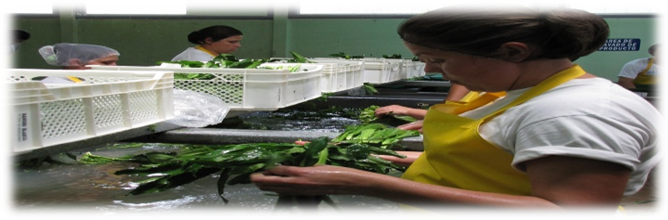

The “family” of good agricultural practices in the Hemisphere

The concept of good practices is commonly used in sectors that are seeking to achieve more sustainable environmental, economic and social processes through the application of standardized criteria, which will result in healthier foods. Therefore, good practices are employed in the agriculture, fisheries, forestry, manufacturing and food production sectors.

The Institute actively promotes such practices, as is evident from the following efforts:

- Argentina: the Institute coordinated several actions with the National Agrifood Health and Quality Service (SENASA), provided support for the organization of the Third Regional Seminar on Good Agricultural Practices (GAP) and collaborated in the creation of an electronic forum to exchange experiences in the application of GAPs in Argentina, Brazil and Paraguay. All these efforts served to strengthen the knowledge and capabilities of national, provincial and municipal institutions, as well as those of 600 producers, authorities and other private sector actors, in the application of GAPs and international phytosanitary standards.
- Dominica: In collaboration with the Bureau of Standards, Dominica Export-Import Agency and the Division of Agriculture, IICA trained over 25 farmers, extension workers and inspectors through workshop sessions on food safety systems with specific focus on GAPs, Good Manufacturing Practices (GMPs), food legislation, and food safety regulations. IICA also hosted, in collaboration with the Division of Agriculture, a training workshop for 20 agro processors in GMPs and product development.
- Guatemala: Five thousand small maize and bean farmers associated with 67 organizations involved in the Purchase for Progress (P4P) Program, executed by the World Food Programme (WFP) and IICA, with financial support from the Howard G. Buffet Foundation and the Government of Canada, implemented GAPs in the program’s production and post-harvest components and established new ways of marketing their products.
- Nicaragua: Under the project “Strengthening the Certification System of Accredited Services and Implementation of Sanitary and Phytosanitary Measures, Quality and Safety of Agricultural Products” (MOTSSA), financed by the World Trade Organization (WTO), IICA developed a critical mass for the implementation of GAPs and hazard analysis and critical control point (HACCP) systems, and the strengthening of the national inspection system.
- Venezuela: IICA cooperated with various networks, associations, cooperatives, communities, producers’ organizations and public institutions to develop a work plan aimed at implementing GAPs, good manufacturing practices (GMPs), good food hygiene practices, and HACCP systems in production chains, thereby contributing to improve public health and food security.

Other achievements
Barbados | In cooperation with the Ministry of Health and the PAHO, IICA planned and executed a workshop on hazard analysis and critical control points (HACCP) and the auditing of food safety for the food industry in Barbados. A total of 21 officials from the Ministry of Health and the Ministry of Agriculture were trained and received the International HACCP Alliance certificate, thus strengthening the capacity in the area of food safety audits within these ministries.
Panama | The Institute spearheaded the creation of a technical advisory team on the issue of traceability in fisheries and agriculture, with specialists from Mexico, Peru and Uruguay. This team provided guidelines for the National Coordination of Agricultural Traceability of the Ministry of Agricultural Development (MIDA), collaborated on a review of the Traceability Act, to which improvements were made, and disseminated information on practical experiences in traceability implemented in other countries.

- Addressing AHFS emergencies

In Mexico, the Institute supported the National Service for Agrifood Health, Safety and Quality (SENASICA) in its efforts to achieve the objectives of its health policies, particularly those of the National Campaign to Combat Fruit Flies, which resulted in 51 % of the national territory being declared free of that pest. The Moscafrut program exceeded the targets set for the production of pupae of the fly species Anastrepha ludens (129 million/week), A. obliqua (52 million/week) and Diachasmimorpha longicaudata (26 million/week) and produced insects of a quality superior to that established by international standards. In addition, as a result of a study carried out by the Office of Genetic Sexing, the program began the mass breeding of the Tapachula-7 strain of A. ludens and implemented the “naked pupation” technique, which substantially reduced production costs.

Similarly, in at least four areas of Brazil, Suriname and Guyana affected by the Carambola fruit fly, IICA improved the capabilities of the official plant health services and promoted the development of technological innovations for the control and eradication of this pest.

In Guyana, the Institute supported the capacity-building efforts of technicians from the Ministry of Agriculture’s National Carambola Fruit Fly Programme, the development of operational manuals for the program, and the execution of national monitoring and surveillance activities (baiting and trapping) to increase early detection in infested areas of the country.

As a result of the implementation of the Veterinary Epidemiologist/Para-Epidemiologist Training Project (VEP), and a simulation exercise conducted with 27 officers of the Animal Health and Production Division of the Ministry of Agriculture of Saint Vincent and the Grenadines, IICA strengthened the animal disease surveillance and detection systems employed by the ministry. This enabled the ministry to enhance its capabilities for responding to any outbreaks of exotic animal diseases.

Thanks to the successful implementation of the Beekeeping Project of the European Union Banana Support Programme (EU-BSP), Jamaica now has an improved pest and disease management system for the beekeeping sector. As a result, the incidence of American foulbrood disease is under effective control. IICA’s support in the implementation of this project enabled beekeepers in six parishes to be trained in apiculture and business management. Additionally, IICA facilitated the establishment of commercial apiaries for the two beekeeping associations; a refurbished apiculture laboratory at the Bodles Agricultural Research Station; and the documentation on bee pest and diseases, beekeeping regulations, and the protocol for American foulbrood disease.

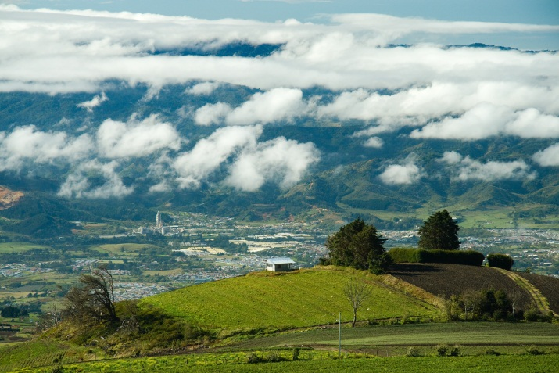 | Objective 2: Strengthen agriculture’s contribution to the development of territories and the well-being of the rural population  The Institute provides support to agriculture sector institutions that play a key role in ensuring that agriculture, and especially smallholders and family farmers, contribute to the achievement of well-being and sustainable development in rural territories.
- Implementation of rural area-based development
IICA worked with nearly 1400 public and private sector stakeholders in 11 countries of the hemisphere to enhance the institutional and technical capabilities for overseeing and implementing effective collaborative and intersectoral area-based management processes.

In the Central Region, the Central American Integration System (SICA) adopted the supranational policy framework and guidelines of the Central American Strategy for Rural Area-based Development (ECADERT) as one of the instruments of the integration process. The Regional Platform for Technical Support (PRAT) to ECADERT was created to coordinate and articulate technical cooperation, led by IICA and comprised of international, regional, and national institutions associated with the effort.

The development of spaces and mechanisms for collaboration, consensus-building, and joint action promoted by IICA enabled Honduras, El Salvador, Guatemala, Costa Rica, Panama, and Belize to incorporate into their national policies, programs, and projects the institutional frameworks, definitions, and strategic guidelines of the ECADERT.

Furthermore, the Institute’s support made it possible for a number of rural organizations in territories prioritized by the eight SICA countries to begin implementation of 13 rural area-based development projects, with an investment of USD1.8 million from the Regional Fund for ECADERT (2012 Call for Proposals).

Peru, Ecuador, Costa Rica, and Dominican Republic strengthened their institutional capabilities for the design and implementation of a development policy that coordinates sectoral policies with the needs and proposals of rural territories, under the multinational project “Innovative Policies for the Development of Rural Territories in Latin America (PIDERAL),” financed by AECID.

The Institute helped to draft and implement plans aimed at economic inclusion, development, and land use management, e.g., in the province of Chimborazo in Ecuador; in the Mancomunidad del Señor Cautivo, in the province of Ayabaca, department of Piura, Peru; and in the Rómulo Gallegos municipality of the state of Apure in Venezuela, among others.

In addition, in Mexico the Network for the Area-based Management of Rural Development (Red GTD) conducted research on area-based management models that make it possible to implement and coordinate interinstitutional programs and capabilities, and on the integration of small-scale agricultural production systems for area-based sustainable development, the results of which were published in the book Extensionismo y gestión territorial para el desarrollo rural. In the same country, 15 states implemented a model Special Participatory State Program (PEC/Estatal) in the rural sector devised by the Mexican Association of Secretaries of Agricultural Development (AMSDA) and IICA that facilitated institutional development and innovation, the articulation of institutional competences, and the strengthening of sectoral capabilities.
Other achievements
Bolivia | Twenty technical officers of the Ministry of Rural Development and Land (MDRyT) were trained in the use of the biogram methodology to design a productive and technological observatory.
Brazil | IICA carried out a study on the rural typologies established by multilateral cooperation agencies and other international organizations, and assisted with the process to update the conceptual framework on the rural setting and the characterization of urban and rural areas in Brazil, Chile, Costa Rica, Spain, Ecuador, France, Holland, Mexico and Uruguay. This information was made available to public institutions and social organizations in Brazil.
Costa Rica | With IICA’s support, the new National Rural Development Institute (INDER) drafted regulations for the country’s territorial councils, trained 150 officials in the management of rural territories, and formed intersectoral teams to plan the development of those areas.
Paraguay | The Institute took part in the creation and implementation of the departmental groups for interinstitutional coordination in Caazapá, Concepción, San Pedro, Guairá and Caaguazú; the regulatory and management framework of these groups was approved and consensus reached on their project portfolios.

- Strengthening of family agriculture
In the area of family agriculture, the Institute provided support for the Specialized Meeting on Family Farming (REAF) of the Southern Common Market (MERCOSUR); collaborated in the updating of studies on the subject, in the strengthening of the capabilities for producers’ organizations, and in the design of strategies and policies; supported the Ministry of Agriculture, Livestock, and Fisheries (MAGyP) of Argentina in the production of the book Las cooperativas agropecuarias en la República Argentina: diagnóstico y propuestas, which was used in seminars and debates held in that country and in Chile; and participated in the study Las asociaciones económicas no cooperativas de la agricultura familiar, which was made available to the extension workers and technical officers of the MAGyP and the National Agricultural Technology Institute (INTA).

In Venezuela, with support from IICA the UCV, UCLA, LUZ, UPEL, UNELLEZ, UBV, Politécnica Territorial José Félix Ribas and UNEFA universities; the Boyacá Barinas Division of Petróleos de Venezuela S.A. (PDVSA); the MPPAT; the Academy of Agricultural Sciences of Venezuela; the Ministry of Science and Technology; agricultural producers in Santa Cruz and in the Colonia Tovar of Aragua state, members of the cooperative family systems of Las Lajitas and Guamuy in Lara state, and fish farmers in Socopó in Barinas state enhanced their capabilities for promoting the cohesiveness of territories and improving their management. More than 500 people were trained in the conceptual and implementing frameworks of the public policies and programs for strengthening and consolidating family farming.

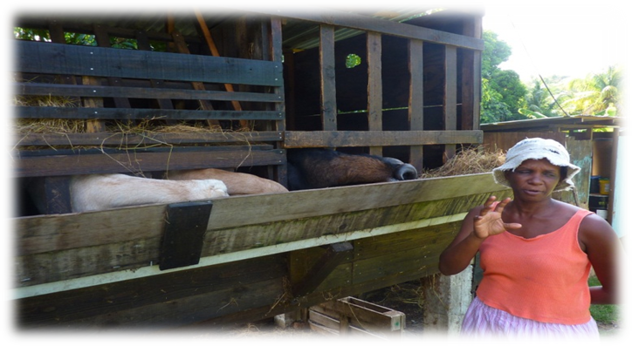
The leading role played by Caribbean women in agriculture

Thanks to the interest of Caribbean countries in guaranteeing women greater inclusion in production activities, IICA has a wide-ranging work program related to the issue and is providing support to women producers.

- In Bahamas, the United Nations Entity for Gender Equality and the Empowerment of Women (UN Women) approved and began implementing the Project in Support of Female Craft Artisans on the Exuma Islands, designed to strengthen the inclusion of rural women in alternative activities. The project was subsequently expanded to benefit craft artisans living on other islands who are members of the Bahamas National Craft Association (BNCA).
- In Dominica, 15 women from the north and north-east districts of the country took part in onion production under a UN Women-funded project, administrated jointly with the Dominica National Council of Women. Three model demonstration units were used to assist in the training of the women. In addition, 20 young persons were introduced to beekeeping in interactive training workshops organized in collaboration with the Dominica Bee Keepers Cooperative. The participants received hives, protective gear, and basic honey processing equipment.
- The St. Vincent and the Grenadines Network of Rural Women Producers received and accepted the draft Medium Term Plan for the organization, developed by IICA. The organization adopted a strategic focus to position itself as a major producer organization in the country. In addition, twenty-one members of the Women in Agriculture for Rural Development are now positioned to pursue a new diversification alternative in vegetable production as a result of IICA's support to the consultative processes within the organization, as well as for the development and submission of a project proposal for small grants funding to the Australian Agency for International Development.
- The network of rural women producers of Trinidad and Tobago was strengthened through the development and submission of a project to mobilize resources and build capacities in farmers’ organizations.

Also worthy of note is the work that IICA carried out in 2012 to promote the effective incorporation of young people into agriculture, which included leadership training programs and activities related to crop management, sustainable farming methods, postharvest handling, agribusiness, beekeeping and horticulture, among others, in Antigua and Barbuda, Paraguay, Barbados, Guyana, and Saint Lucia.

The foregoing was complemented with the agreement that IICA signed with Mexico’s National Science and Technology Council (CONACYT) for the implementation of a program of 100 annual scholarships designed to promote the development and strengthening of technical capabilities in agriculture. Under the agreement, 30 professionals began postgraduate courses and specializations in Mexican higher education institutions. In addition, IICA selected a further 128 applicants, who are awaiting confirmation of a place on the course of their choice. With this group, the Institute expects to reach its target of 100 scholarships, the number available under the program for the 2012-2013 academic year.

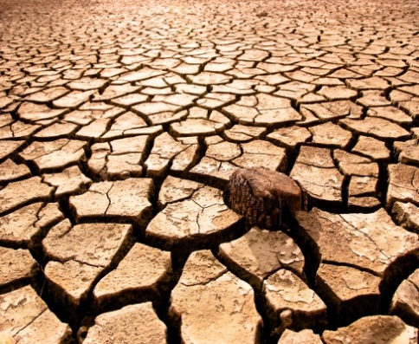 | Objective 3: Improve agriculture’s capacity to mitigate and adapt to climate change, and make better use of natural resources  IICA promotes more environmentally-friendly forms of production, contributes to the design of policies and strategies to enable the agricultural sector to mitigate and adapt to climate change, and works to position this issue on national agendas.
- Adaptation of agriculture to climate change
Public and private institutions improved their capacity to access and analyze information on the adaptation of agriculture to climate change, and the mitigation of greenhouse gas (GHG) emissions from agriculture. At the same time, the ministries of agriculture and environment of Mexico, Uruguay, Costa Rica, Dominican Republic, and Ecuador included this issue in their agendas and created synergies between environment/agriculture with the aim of developing public goods that will make it possible to address the challenges of climate change. This was achieved thanks to:

  - The International Scientific and Technical Network of the Intergovernmental Program for Cooperation on Climate Change – Opportunities and Challenges in Agriculture (PRICA-ADO), a network operating at the level of Mesoamerica and Colombia with four national hubs, which facilitated a conceptual and methodological framework for the area-based management of adaptation to climate change, as well as instruments for geo-prospective analysis and the management of knowledge on the effects of climate change in rural territories.
  - The online platform developed by IICA, which includes seven methodologies and tools for analyzing the impact of climate change, nine reference documents and seven case studies on this issue, as well as various technical papers related to international agreements on climate change (CoP 17 and CoP 18) and progress reports on the CoP 18.
  - Training on the application of the Nationally Appropriate Mitigation Action (NAMA) methodology, implemented with support from the GIZ, to guide implementation of appropriate actions to mitigate climate change at the country level in Costa Rica’s transport, waste management and agriculture sectors.
  - A course for training trainers in the use of tools for adaptation to climate change, with 20 participants from Mexico, Costa Rica, Bolivia, Honduras, Nicaragua and Peru, with support from the GIZ.
  - Four technical meetings on topics related to agriculture and climate change, in which nearly 650 persons took part, both in person and on line.
  - The operation of the Standing Forum for the Management of Meteorological and Climate Information in the MERCOSUR Countries, a mechanism that enables the meteorological services, academic institutions and government ministries of those countries to exchange information and knowledge on methodologies for the analysis of agro-climatic data and improve their capabilities in this field.

The Institute facilitated various technical cooperation actions carried out by Brazil, Argentina, Paraguay and Uruguay to mitigate desertification processes in areas with high levels of environmental degradation and rehabilitate those territories. It also provided support in identifying the main climatic vulnerabilities affecting different reference territories of Argentina (San Juan, Corrientes and Las Breñas), Chile (Padre Las Casas, Vilcún, Cauquenes and Talagante) and Uruguay (Canelones, Colonia, Salto), as well as general measures for adaptation to climate change applied to production systems in those areas.

In addition, several public institutions and organizations of Argentina’s agrifood sector improved their capacity to design policies and strategies for mitigation and adaptation of agriculture to climate change, thanks to IICA’s support in facilitating the participation of more than 200 technicians and officials in workshops and seminars on this topic. IICA also supported the design of methodologies to adapt family agriculture to climate change, the preparation of reports on this topic, and a study on the carbon footprint in the international trade in beef, wine, citrus fruits, and foodstuffs.

- Reducing agriculture’s negative impact on the environment
IICA made available to its member countries information, knowledge, and tools for the design and implementation of strategies, policies, and actions aimed at mitigating or eliminating the negative impacts of agricultural activities on the environment, through an online platform that provides interested countries and stakeholders with access to:

- Eight tools and five case studies on natural resource management for sustainable agriculture.
- Two studies on market trends aimed at reducing agriculture’s negative impact on the environment.
- Seven reference documents on environmental responsibility in production processes.

In Dominican Republic, the Ministry of Agriculture, other agricultural institutions, and producers received training in the application of the innovative system of rice intensification. Some 50 producers implemented this system in part or in full, thereby increasing their productivity and competitiveness, lowering their production costs, and mitigating environmental impacts.

- Efficient management of natural resources
In view of the growing competition for natural resources such as water, soil, and biodiversity, IICA has taken on more of a leading role in promoting the sustainable use of those resources, striking a balance between that objective and the urgent need to make the hemisphere’s agricultural sector more productive and competitive.

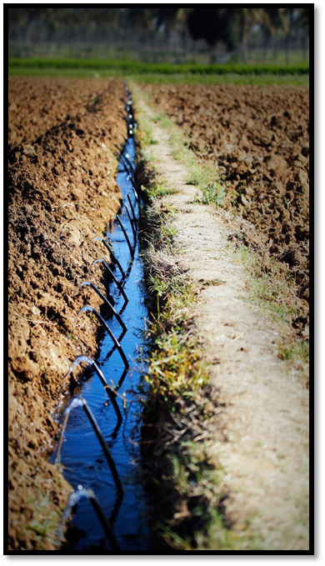 | Water for agriculture  IICA’s work agenda in this area focused on designing plans and methodologies for the implementation of irrigation and drainage projects in the province of Bolívar in Ecuador, along with national strategies and policies on irrigation and drainage for agricultural land, which were made available to the Ministry of Natural Resources and Agriculture of Belize.  In Honduras, IICA worked to enhance the technical capabilities of the government authorities in charge of designing the National Irrigation Plan in the area of integrated management of irrigation and drainage systems.  The Institute also contributed to efforts to reduce weaknesses in the articulation and coordination of public institutions of the water sector in two areas of Brazil with low development indices. This improved efficiency in the use of water and the provision of water services, and increased the quantity, quality, and sustainability of the water supply.

Under the Regional Program for Sustainable Forest Management (SFM) financed by the Government of Finland, 35 pilot projects and feasibility studies were implemented at a cost of nearly USD5.56 million. Through these projects, key actors in Bolivia, Colombia, Ecuador, and Peru benefited from innovations aimed at increasing the economic, social, and environmental advantages of sustainable management of forests and forest plantations.

IICA also provided the Government of Peru with lessons learned to strengthen the MINAGRO Program, an initiative aimed at creating synergies between agriculture and mining in rural areas, based on success stories in Canada and Peru. In the latter case, successful activities carried out in Cajamarca, Ancash, Cuzco, and the Cerro de Pasco were systematized.

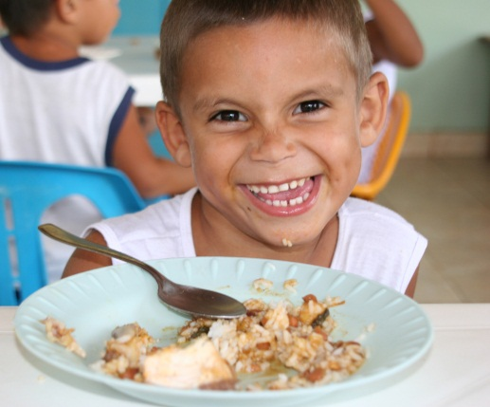 | Objective 4: Improve agriculture’s contribution to food security  The Institute carries out actions aimed at improving the quality and availability of, and access to, safe and nourishing food, and promoting the modernization and strengthening of domestic agricultural markets.

- Outlook for food security in the hemisphere
At the request of the OAS, IICA supported the process of preparation and implementation of the Forty-second Regular Session of the General Assembly, which took place in Cochabamba, Bolivia, and focused on the topic of food security. Prior to the Assembly, the Institute assisted the OAS in organizing workshops and meetings, both in Washington and in Bolivia, to discuss that crucial issue. These activities were attended by distinguished experts, young people, and representatives of civil society.

In that context, the Institute prepared a report entitled “The Food Security Situation in the Americas,” which was used as the basis for the discussions held during the Assembly, and contributed to the drafting of the final resolution on this issue. The report was published and disseminated widely, helping to raise awareness of the situation and outlook for food security in the hemisphere among important stakeholders in agriculture and the rural milieu.

In addition, IICA launched the Food Security Observatory of the Americas, a tool for monitoring and consultation on policies, strategies, and tools related to food security implemented by the countries of the hemisphere. The Observatory also provides information on projects, organizations, events, and food security indicators.

In the Caribbean, the profile of agriculture was strengthened and its contribution to food security reappraised, as a result of the participation of key actors in the Caribbean Week of Agriculture, an event held in Antigua and Barbuda with IICA’s support. During this event, a number of strategic issues were analyzed and agreement was reached on regional agricultural development. A specific program was implemented with Antigua and Barbuda, in coordination with the FAO, aimed at eradicating hunger in that country.

Other achievements
Belize | The Institute worked with the Ministry of Rural Development to establish the Belize Rural Area-based Development Strategy (BRADS), aimed at improving living conditions in rural communities. It also financed a pilot project and assisted in the negotiation of two projects - tilapia production and agro-tourism - in the Belize River Valley, which will contribute to the economic development and food security of more than 100 families.
Canada/Guatemala | IDRC approved an IICA project developed in collaboration with McGill University and Universidad Rafael Landivar in order to address food and nutrition insecurity in Guatemala using science-based tools to guide governmental, non-governmental and donor agencies in replicating effective food security programs.
Haiti | A 10-15% increase in food availability was achieved for 23,920 families in six of the country’s departments, thanks to the introduction of improved varieties of kitchen garden vegetables, beans (DPC-40), sweet potato, banana, and yam facilitated by IICA.

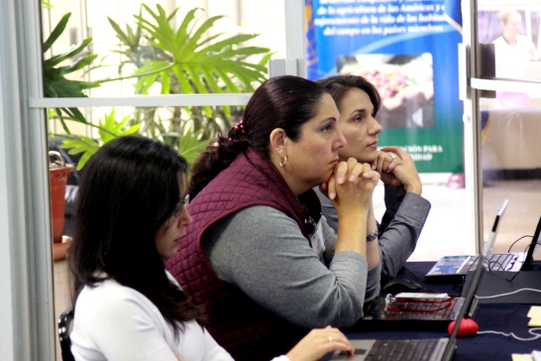 | Objective 5: Conduct strategic analyses for agriculture  IICA provides its member countries with strategic analyses of agricultural issues that enable them to anticipate developments, respond to emergencies, formulate public policies and develop long-term visions.

- Prospective and strategic analyses
IICA’s Member States had access to strategic analyses of agricultural and public policy issues that have the greatest impact on this sector, as a result of the publication and dissemination of the joint ECLAC-FAO-IICA report entitled “The Outlook for Agriculture and Rural Development in the Americas: A Perspective on Latin America and the Caribbean,” the organization of nine technical meetings, and the updating of the system of statistics and indicators, among other efforts.

In Uruguay, producers and technicians from Uruguayan institutions improved their capacity to analyze sectoral policies through the contributions of national and international experts who participated in the ninth series of lectures entitled “State Policies: the agricultural sector in the years ahead,” organized by IICA in Montevideo, and through the “Agriculture in focus” meetings, organized in the country’s interior.

- Design and analysis of policies, methodologies and tools
The Institute supported the design of work plans, strategies, and agrifood policies in Antigua and Barbuda, Bahamas, Grenada, Costa Rica, El Salvador, Guatemala, Guyana, Haiti, St. Kitts and Nevis, Panama, Trinidad and Tobago, Peru, and Paraguay. In addition, 105 technical officers from public institutions in Peru, Chile, Ecuador, Costa Rica, Paraguay, and Dominican Republic received training in the analysis of agricultural policies.

At the same time, the ministries of agriculture of Panama, Barbados, and St. Lucia completed their strategic planning processes and/or revised their procedures for the provision of services.

In a new activity, IICA provided assistance in identifying bottlenecks that limit access to, and the use and impact of, information and communication technologies in the public institutions of countries such as Uruguay, Paraguay, Peru, and Costa Rica. To help solve the problem, the Institute designed methodologies for assessments, and prepared proposals for institutional modernization.

In Panama, nine technical secretaries of the country’s agrifood chains improved their management capabilities and use of computer tools through training activities carried out by IICA specialists and international experts, which focused on managing quantitative information. This will allow for improved decision-making on national production projections, import quotas, and production incentives.

- Taking advantage of international trade
In conjunction with the WTO, IICA inaugurated the Reference Center for the Americas, while promoting capacity-building efforts in the countries in the areas of agricultural negotiations and access to WTO information. The Institute also prepared a report on the potential trade links between six LAC countries and Canada.

In the Central Region, the Institute assisted the ministries of agriculture, trade and industry, as well as exporters’ associations in Honduras, Guatemala, and Panama, in training officials and entrepreneurs to identify those products that afford the greatest opportunities under the existing trade agreements with the United States, Mexico, and the European Union. IICA also supported the same countries in the task of systematizing experiences related to fruit and vegetable exports, particularly those involving smallholders, in order to facilitate the insertion of those products in international markets.
Celebration of IICA’s 70th anniversary

In 2012, IICA commemorated 70 years at the service of agriculture in the Americas. The official ceremony took place on October 8 at the National Theater of Costa Rica, in San Jose, just a few kilometers from the Institute’s Headquarters. Two special guests honored IICA with their presence: the President of Costa Rica, Laura Chinchilla, and the Executive Director of the WFP, Ertharin Cousin.

In their addresses, both highlighted the Institute’s virtues, especially its relevance at a time when agriculture is facing enormous global challenges:

“This anniversary is an excellent opportunity for further reflection on the agricultural sector, where the sharpest contrasts and most urgent challenges of our societies are to be found,” President Chinchilla remarked. | 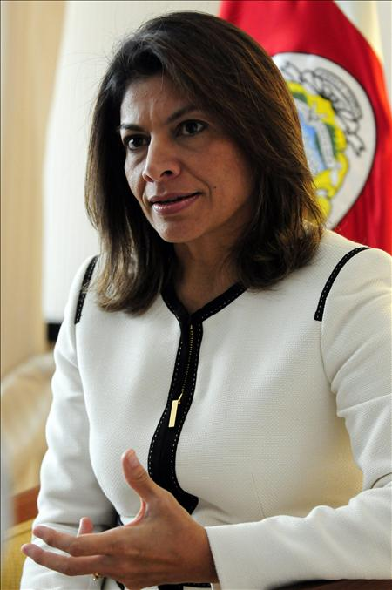

 | “IICA is among the most energetic and forward-looking agriculture organizations in the world. At a time when agriculture has returned to the centre of the development agenda, this institute has successfully leveraged its knowledge and rallied resources, making inclusive agriculture not just a vision for the future, but a reality that is changing the global food security agenda and transforming the lives of the hungry poor,” Cousin pointed out.

The Institute’s Director General also addressed everyone present: “Thanks to [the daily efforts of] our international professional personnel and our local staff, both at Headquarters and in our national Offices, (…) I can affirm that IICA is an organization with technical capacity, institutional strength and with a future filled with opportunities.”

The activity held in San Jose, one of many organized to commemorate the 70th anniversary in IICA’s 34 member countries, coincided with the annual meeting of the Institute’s Executive Committee, during which the 16 delegations in attendance also recognized IICA’s contribution to the efforts to improve the living conditions of both women and men in rural areas.
Governance and official meetings

The Thirty-second Regular Meeting of IICA’s Executive Committee (EC) took place from October 8-10 at the Institute’s Headquarters in San Jose, Costa Rica. The Member States sitting on the EC that attended the meeting were Argentina, Colombia, Costa Rica, Ecuador, Guyana, Haiti, Nicaragua, Panama, Paraguay, Suriname, and the United States of America. Canada, Dominica, and Mexico also participated in an observer capacity, along with Spain (Associate County) and Israel (Observer Country).

The most important issues addressed at the meeting were as follows:

- Institute policy and technical cooperation services: The EC approved the 2011 Annual Report of IICA and accepted the reports on the Institute’s joint activities with the Tropical Agriculture Research and Higher Education Center (CATIE) and the Caribbean Agricultural Research and Development Institute (CARDI), as well as the report on the progress made in strengthening ties between IICA and the Consultative Group on International Agricultural Research (CGIAR).

- Budgetary and financial matters: The EC accepted IICA’s financial statements for 2011 and the report of the external auditors, who attested to the fact that the Administration had managed the Institute’s financial resources in accordance with the Institute’s rules and international auditing standards. The EC also approved the Eighteenth Report of the Audit Review Committee (ARC) and accepted the report on the collection of the Member States’ quota contributions to IICA. With regard to the recovery of the costs incurred in managing externally funded projects, the EC studied the methodology and criteria recommended for establishing the Institutional Net Rate (INR), and instructed the Director General to put them into practice.

- Matters pertaining to IICA’s governing bodies: The EC decided to hold its Thirty-third Regular Meeting in Mexico in the first half of 2013, and accepted the report of the 2012 Regular Meeting of the Special Advisory Commission on Management Issues (SACMI), the report of the Representative of the Inter-American Board of Agriculture (IABA) to the Governing Council of CATIE for the period 2011-2012, and the reports on the status of the resolutions of the Sixteenth Regular Meeting of the IABA and the Thirty-first Regular Meeting of the EC.

The following is a summary of the details of the two official meetings held in 2012:
Official name | Date | Place held | Place and date of publication of report or proceedings of the event
2012 Regular Meeting of the Special Advisory Commission on Management Issues | July 12 | IICA, San Jose,  Costa Rica | http://www.iica.int/Eng/infoinstitucional/oRGANOS/CCEAG/Pages/Informes.aspx
Thirty-second Regular Meeting of the Executive Committee | Oct. 9-10 | IICA, San Jose,  Costa Rica | http://www.iica.int/Eng/infoinstitucional/oRGANOS/CE/Pages/Informes.aspx
Administrative management geared toward
technical cooperation

During 2012, IICA, as an international organization, was not immune to the negative impact of the world economic situation. Accordingly, it continued to implement the financial strategy in place since 2010, under which the Institute is called upon to execute its resources with austerity, rationality, equity, and discipline, so that it can continue to carry out its operations in a stable manner.

That strategy, which systematically promotes continuous improvements to processes, made it possible to find new ways of using resources to focus on and address specific thematic issues, generate economies of scale, manage resources more efficiently, and consolidate the bases for the careful use of resources in the years ahead.

Figure 1
Resources of the Regular Fund allocated by chapter in 2012
(in millions of USD and as a %)
Ch. I Technical
Cooperation
Services (89%)
USD 27.8
Ch. II Management
Costs (5%)
USD 1.7
Ch. III General
Costs &
Provisions (4%)
USD 1.3
Ch. IV
Infrastructure &
Equipment
(2%)
USD 0.5

Source: Programming, Budgeting, and Control Division

- Financial management

The design and implementation of the IICA Quick Start methodology made it possible to speed up the process of implementing the SAP (Systems, Applications and Products) financial management platform in the IICA Offices in the countries and reduce the costs involved. By the end of 2012, the number of Offices using the system had increased from three to thirty-three.

The benefits of implementing the SAP platform include an increased response capacity and greater security and reliability in the administration of the resources of nearly 300 projects, as well as a considerable reduction in risks, errors, and the re-entering of budgetary and accounting-financial information. The use of the platform also made it possible to eliminate parallel systems, improve communication between Offices, and streamline administrative, accounting, and financial transactions.

Furthermore, IICA carried out a detailed review of institutional standards, processes, and management controls within the framework of the four pillars of the European Union (EU). As a result of the review, the Institute maintained its status as an international organization accredited to execute large-scale EU-financed projects.

The Institute’s financial statements through December 31, 2011 were delivered to the external auditors as and when required. In their report, the auditors once again highlighted IICA’s sound management of its financial resources, in accordance with international standards of transparency and accountability.

The Executive Committee approved the study of the Institutional Net Rate (INR), which was used to establish the policy that the Institute should apply in managing externally funded projects to recover the indirect costs that IICA incurs in the short term and, in that way, be in a position to continue to provide quality technical cooperation services, and remain competitive in the provision of such services.

In addition, a technical study was carried out to explain to the governing bodies why a solution was needed to the effects of the freezing of Member States’ quotas for over 16 years. As a result, Argentina, El Salvador, Guatemala, Guyana, Mexico, Panama, Paraguay, and Uruguay decided to increase their contributions, and Argentina, Mexico, and the United States offered to make special contributions. The importance of this result goes beyond the economic impact (timely collection of 98.7% of quotas in 2012), as it constituted an endorsement of the work that the Institute has been carrying out.

- Management of human talent

The improvements made to the Individual Performance Evaluation System made the personnel evaluation process more objective, accurate, and transparent. Thanks to the electronic tool, which underpins the culture of results-based evaluation promoted by IICA, the process is now performed 60% more quickly. The system was also used to assess staff training needs, based on which a corporate training plan was prepared for 2013.

The Institute embarked on a reengineering process to improve its human talent management, which enhanced sensitivity to staff members’ needs, and improved communication and contact with them. The process also fostered staff cohesiveness, teamwork, the critical analysis of the current situation, and helped identify areas in which human development needed to be improved. This process will continue in 2013, and the results presented in the corresponding report.

Some 136 new members of staff were hired and more than 50 replaced, making it possible to maintain a high-quality team to meet the growing demand for technical cooperation and promote the Institute’s social contribution.

Table 1
Distribution of IICA’s human resources by category from 2001-2012
2001
2002
2003
2004
2005
2006
2007
2008
2009
2010
2011
2012
International Professional Personnel
109
100
97
91
95
95
94
91
89
83
77
79
Local Professional Personnel
183
237
217
198
219
225
234
279
336
290
276
400
General Services Personnel
524
501
385
366
379
383
374
407
437
442
519
629

Total
816
838
699
655
693
703
702
777
862
815
872
1108
Source: Human Talent Management Division

Table 2
Distribution of IICA’s human talent by category
and source of financing in 2012
Category
Total
Percentage
Number
Percentage
Number
Percentage
IPP
75
6.77
4
0.36
79
7.13
LPP
214
19.31
186
16.79
400
36.10
GSP
340
30.69
289
26.08
629
56.77
Total
629
56.77
479
43.23
1108
100.00
Source of financing
Regular Funds
External Funds
Source: Human Talent Management Division

- Management of programming, budgeting, and control

The quality of the Institute’s legal instruments was improved by standardizing and then disseminating them, thereby contributing to the process of reaching agreement on, negotiating, approving, and implementing externally funded projects. Part of that effort was set out in the document “Guidelines and models for preparing legal instruments.”

In line with the policy of tight budgetary control, based on the principles of rationality, equity, transparency, and discipline in the use of resources, preventive and corrective measures were taken in certain Offices when expenditure exceeded income.

- Management of administrative services

The Institute promoted the rational and disciplined use of its resources to strengthen its management capabilities and support technical cooperation, which yielded the following results: a) an 8% reduction in IICA’s electricity bill compared with 2011, which, added to the 52% cut with respect to 2010, represented savings of more than 60%; b) an 18% reduction in the cost of courier services compared with 2011; and, c) a 5% reduction in fuel consumption during the same period, even though prices rose by nearly 12%. It should be pointed out that the above savings were achieved despite the impact of inflation, which was approximately 3.42% (Headquarters).

Furthermore, a number of administrative processes and standards were reviewed in order to adapt procedures to current needs, optimize execution times, reduce control spans, improve efficiency, and cut costs. The Institute’s physical infrastructure was improved by providing facilities and equipment more suited to the organization’s current needs. A case in point was the expansion of the areas used for the meetings of the governing bodies and working groups, and other institutional activities. By making greater use of IICA’s own infrastructure, resources were saved that were plowed back into the implementation of actions to improve the institutional image and the working conditions of the staff.

In general, the Institute exceeded the goals set for the management of administrative services in 2012, and the challenges that arose during the year were met effectively. To that end, permanent, coordinated, pertinent, and integrated efforts were made that created an enabling environment for more solid, reliable, and efficient corporate management. The organization reduced its internal costs, made more specific and efficient use of resources and capabilities, and focused unstintingly on efforts aimed at improved management, adhering closely to the established rules and procedures. All of the above helped to ensure that the best possible use was made of resources for the benefit of the Member States, pursuant to the principles established in IICA’s Strategic Plan and 2010-2014 Medium-term Plan.

Annex 1: List of projects of the Competitive Fund for Technical Cooperation (FonTC) approved in 2012

Name of project | Countries involved | Amount allocated in 2012 (USD)
Revitalizing a Cherished Crop: Mango Chain Development in Haiti | Haiti, United States | 5000
Development of local strategies for adapting to climate change (DLSACC) for sustainable development in municipalities in Guatemala, Honduras and El Salvador | Guatemala, Honduras, El Salvador | 16300
Appropriate intensive small ruminant production systems for the Caribbean, based on local feed resources | Barbados, Jamaica, Suriname, Trinidad & Tobago, Dominican Republic | 6525
Economic, social and environmental management of small- and medium-size rural properties in seven countries of Latin America | Brazil, Chile, Honduras, Paraguay, Peru, Dominican Rep., Ecuador | 13050
Agricultural innovation for the sustainability of the biodiesel and biokerosene value chain | Brazil, Colombia, Mexico | 15000
Reducing the Impact of Climate Change on Agriculture: Enhancing Institutional Capacity to Promote and Support Climate Smart Agriculture in the Caribbean Region | Dominican Republic, Jamaica, Grenada, Saint Lucia, Saint Vincent and the Grenadines | 2400
Design of a strategy for the differentiation of products from the family agriculture sector based on their ties to the territory | Argentina, Brazil, Uruguay, Spain, PROCISUR | 25000
Virtual school for phytosanitary inspectors | Argentina, Bolivia, Brazil, Chile, Colombia, Paraguay, Peru, Uruguay | 3100
A systemic tool for evaluating the economic, social, environmental and institutional impacts of agricultural research and innovation | Ecuador, Mexico, Peru, Uruguay | 6600
Validation of a framework instrument for the preparation of tourism development programs in rural territories of Latin America | Spain, Paraguay, Venezuela, Panama | 6550
Improvement of public tuberculosis and brucellosis programs in the Southern Cone | Argentina, Brazil, Paraguay, Uruguay, PROCITROPICOS | 25615
Improvement of public tuberculosis and brucellosis programs in the Andean Region | Bolivia, Colombia, Ecuador, Peru, Venezuela | 3544
Establishment of Innovative Financing Schemes to Strengthen Market Access of Rural Women Entrepreneurs Involved in Community Development in the Caribbean | Dominica, Grenada, Guyana, Saint Lucia, Jamaica, Trinidad & Tobago | No funds allocated in 2012
System for issuance of sanitary early warnings in territories susceptible to climate change | Paraguay, Peru | 10000
Identification and description of campesino and indigenous technologies used in Highland production systems susceptible extreme climatic events in the Andean Region and Meso America | Bolivia, Ecuador, Guatemala, Peru | 17400
Implementation of a group traceability system for beef in Bolivia | Bolivia, Costa Rica, Uruguay | 24800
Formulation of a methodology for using renewable sources of energy in agroindustrial and agricultural activities in rural territories, as a means of increase competitiveness and mitigate the impacts of climate change | Bolivia, Colombia, Ecuador, Venezuela | No funds allocated in 2012
Repositioning the concept of “rural” and its implications for public policies in Latin America | Brazil, Chile, Ecuador, Costa Rica, Mexico, Uruguay | 35000

Source: Technical Secretariat of the FonCT.
Annex 2: Profiles and cooperation projects prepared by IICA in 2012

Country-level advanced profiles and/or projects for the formulation of feasibility studies | - Argentina: Integrated management of water resources for farm irrigation in the southern region of Buenos Aires Province  - Paraguay: Competitiveness of poultry farming and strengthening of IPTA  - Panama: Development and competitiveness of fruit crops
Country-level projects with content guidelines for the formulation of advanced profiles | - Costa Rica: Genetic improvement of beef cattle  - Guatemala: Development of fruit growing  - Paraguay: Development of sheep farming  - Guatemala: Territories of Huistas and Chorti
Regional-level projects or advanced profiles | - Caribbean Region: Intra ACP Agriculture Policy Programme, SPS Component of EPA Capacity Building Programme, and the Strategic Plan for the Caribbean Network of Rural Women Producers/Processors (CANROP)  - Central Region: Strategic plan and investment program for the genetic improvement and competitiveness of coffee within the framework of PROMECAFE; Pre-investment for the feasibility study of the Central American Integrated Water Resource Management Plan for agricultural irrigation and drainage systems  - Southern Region: Development program in the tri-national border area of Ucayali, Madre de Dios and Pando within the framework of PROCITROPICOS
Projects designed at the hemispheric level | - Competitive fund for innovation in agriculture and food security in the Americas, designed for the Howard G. Buffet Foundation  - Pre-feasibility study for the project, “Facility for foodstuffs and processing of agricultural products for the private sector of partner countries in the former Panama Canal Zone” (Argentina, Ecuador, Mexico, Paraguay, and Uruguay)

Source: Directorate of Technical Cooperation.

Annex 3: IICA’s knowledge-based products

Alliance of Agricultural Information Services SIDALC  www.sidalc.net | This alliance, comprising 171 national institutions in 23 countries, facilitated access to scientific knowledge for 577,074 individuals interested in the agriculture of the hemisphere.
RURAL PRO | Small and medium-scale producers in seven member countries received training in the use of a computer program, thereby improving the market insertion of their products.
INFOTEC | This system facilitated an intense exchange of knowledge through the incorporation of more than 500 information elements (documents, links, news, events, and technologies) and the dissemination of 14 e-newsletters to over 21,000 subscribers.
RED INNOVAGRO | The network comprises 59 institutions in Spain, Holland and 14 Latin American countries, and offers a conceptual and methodological framework for managing innovation and appraising national innovation systems. By systematizing successful experiences and new practices, and sharing them with members, INNOVAGRO has improved the management of innovation and its impact on the development of family farming and the agrifood sector.
Technical publications | In 2012, IICA produced over 60 technical publications, all of which are available on its website (www.iica.int).

Source: Inter-American Information and Editorial Production Center.

Acronyms

AECID Agency for International Development Cooperation
CARDI Caribbean Agricultural Research and Development Institute
CARICOM Caribbean Community
CATIE Tropical Agriculture Research and Higher Education Center
COSAVE Plant Health Committee of the Southern Cone
EC Executive Committee (IICA)
ECADERT Strategy for Rural Area-based Development
ECLAC Commission for Latin America and the Caribbean
EU European Union
FAO Food and Agriculture Organization (United Nations)
FonCT Competitive Fund for Technical Cooperation (IICA)
G20 Group of 20
GIZ Deutsche Gesellschaft für Internationale Zusammenarbeit
(Germany)
input.doc
HACCP Hazard Analysis and Critical Control Points
IABA Inter-American Board of Agriculture
IDB Inter-American Development Bank
IDRC International Development Research Centre (Canada)
IICA Inter-American Institute for Cooperation on Agriculture
IPPC International Plant Protection Convention
LAC Latin America and the Caribbean
MAGyP Ministry of Agriculture, Livestock, and Fisheries (Argentina)
MERCOSUR Southern Common Market
MIOA Market Information Organization of the Americas
OAS Organization of American States
P4P Purchase for Progress
PAHO Pan American Health Organization
PROCISUR Cooperative Program for Agri-food and Agro-industrial Technological Development of the Southern Cone
PROCITROPICOS Cooperative Program on Technology Generation and Transfer for the South American Tropics
SACMI Special Advisory Commission on Management Issues (IICA)
SDC Swiss Agency for Development and Cooperation
SICA Central American Integration System
WFP World Food Programme
WTO World Trade Organization

Basic grains, honey, dairy products, cacao, coffee, fruits, vegetables and aquaculture.
PVS for national plant protection organizations, national food safety services, and national veterinary services.
With the plan, a study was published entitled “COSAVE: An experience in regional plant health integration”, which systematizes the experience of phytosanitary integration in the Southern Cone. This could serve as a guide for other regions seeking to improve their regional coordination in plant health issues.
Belize, Costa Rica, El Salvador, Guatemala, Honduras, Nicaragua, Panama, Dominican Republic, Paraguay, Uruguay and Brazil.
In the Bahía de Jiquilisco watershed in El Salvador; the northeast and southwest regions of Costa Rica; the Valle del Sensenti, Belén-Gualcho and Lenca in Honduras; and Rio de Jesús and Santa Fe in Panamá, among other territories.

