PREPARATORY MEETING FOR THE OEA/Ser.K/III.24.1
TWENTY-THIRD INTER – AMERICAN CONGRESS CIDI/TUR-XXIII/RP/doc.3/15
OF MINISTERS AND HIGH-LEVEL AUTHORITIES 17 June 2015
OF TOURISM Original: English
June 25 and 26, 2015
Washington, D.C.

REPORT ON ACTIVITIES IN SUPPORT OF TOURISM

(Presented by the Culture and Tourism Section of the Department of
Economic Development)

Introduction

This report of the General Secretariat relates to the activities which have been undertaken since the XXII Inter-American Congress of Ministers and High-Level Authorities of Tourism, which was held in Bridgetown, Barbados during September 3-4, 2014 as well as developments relating to the General Secretariat’s execution of tourism projects in furtherance of the mandates emanating from that meeting. It also includes a review of the performance of key indicators of tourism in the Americas over the last year.

Tourism Industry Overview

International tourism arrivals, in a show of strong growth, reached 1.1 billion in 2014, 51 million more than in 2013 (UNWTO World Tourism Barometer). This growth accounts for the fifth consecutive year of relatively strong growth since the 2009 economic crisis. This figure echoes the sentiments that Tourism is a strong and resilient economic activity that has been a fundamental contributor to the economic recovery by generating billions in exports and creating millions of jobs (UNWTO World Tourism Barometer). With regard to receipts, International tourism receipts increased by US$ 48 billion in 2014 to reach a record US$ 1.2 trillion, according to the data from the UNWTO. An additional US$ 221 billion was generated from international passenger transport, bringing the total export earnings from international tourism up to US$ 1.5 trillion (see Figure 1).

Figure 1

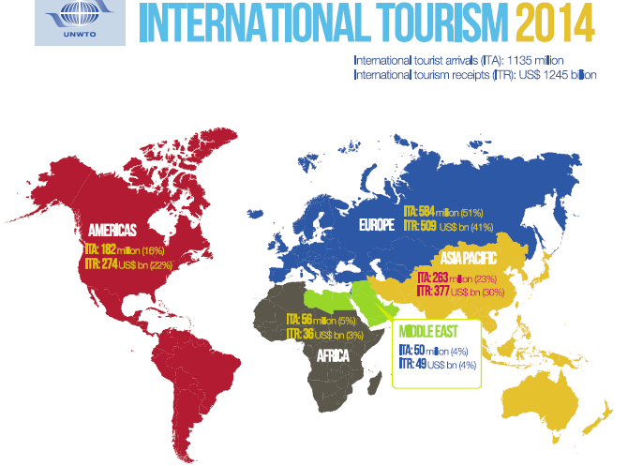
© World Tourism Organization (UNWTO) 2015

Data from the UNWTO indicates that in 2014 tourism accounted for 9% of global GDP (direct, indirect and induced impact), 1 in every 11 jobs, US $1.5 trillion in exports, 6% of the world’s exports total and 30% of services exports (see Figure 2).

Figure 2
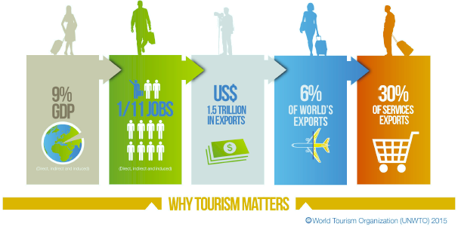

Top Spenders: Outbound Tourism

In terms of outbound tourism, the world’s top spender China continued its exceptional pace of growth with a 28% increase in expenditure in 2014, reaching a total of US$ 165 billion (UNWTO World Tourism Barometer). The world’s second largest spender, the United States, posted a 7% increase. The United Kingdom jumped to 4th with a 4% increase from 5th place (see Figure 3).

Figure 3
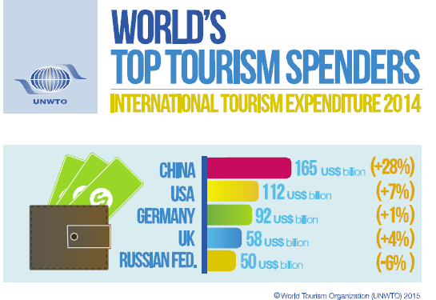

Tourism in the Americas

The Americas was the fastest growing region in the world in relation to international tourist arrivals in 2014, with growth of 8.1 percent compared wit the next best performer, the Asia and Pacific Region with growth of 4.2 percent. International tourist receipts on the other hand grew much slower, at just 3.0 percent , slower than any of the other sub-regions and well lower than the world average of 3.7 percent. The region increased its share slightly of worldwide arrivals at 16% (+1%), while its share of receipts also increased at 22% (+2%).

Figure 4
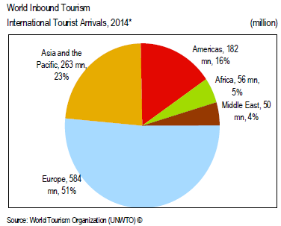
International Tourism Arrivals and % share, 2014*

Figure 5

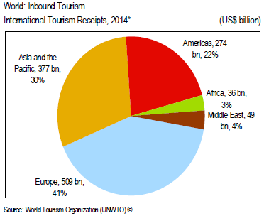
International Tourism Receipts and % share, 2014*

North America welcomed 120.9 million international tourists accounting for 10.7% out of the 16% share that the region (see Figure 6) received. South America received 28.5 million (2.5% share) of international tourists, with the Caribbean 22.5 million (2.0% share). Arrivals to North America grew by 9.3 percent, the fastest of the sub-regions of the Americas, with the Caribbean, Central America and South America growing by 6.5, 5.6, and 5.2 percent respectively, all well above the rate recorded in 2013.

The region (Americas) received 16% of the total international arrivals in 2014 (figure 6) but 22% of total receipts (figure 7). North America accounted for the largest share of both international arrivals and international tourist receipts at 10.7% and 16.9 percent respectively, while the Caribbean, despite having a smaller share of arrivals (2%) compared to South America’s 2.5 percent, had a relatively larger share of receipts, 2.2% compared with South America at 2.1%

Figure 6

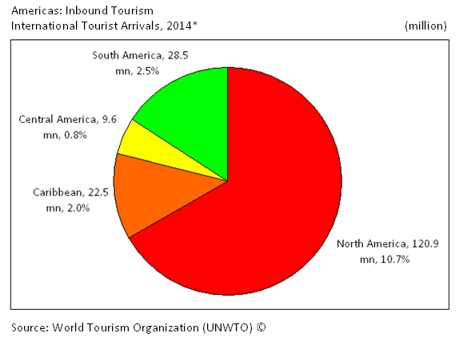
International Tourism Arrivals and % share, 2014*

North America received the largest share of the region’s international tourism receipts US$ 210 billion accounting for 16.9% of the 22% share of world’s tourism receipt that the region received in 2014 (see Figure 7). The Caribbean was second with US$ 27 billion despite receiving less visitors than South America. This latter point can be attributed to higher average visitor spending in the Caribbean at $1210 compared with $910 per visitor in South America (figure 8)

Figure 7

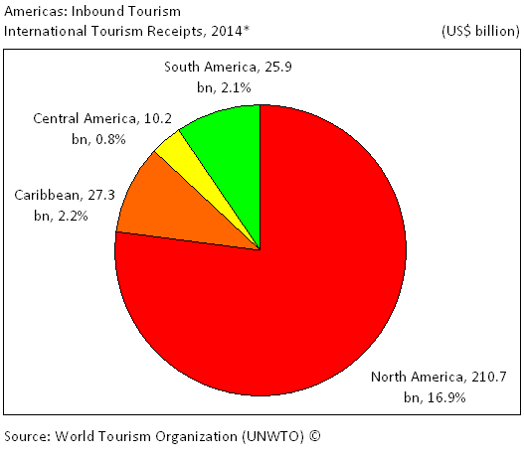
International Tourism Receipts and % share, 2014*

Figure 8

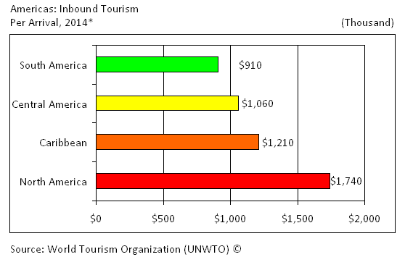
Average spending per visitor, 2014*

Average visitor spending for the region as a whole in 2014 was $1483.50 with only North America at $1740, above the regional average and with South America at $910 significantly below the average spend for the Americas as a whole. However, average spending per visitor dropped by more than five percent, the largest decrease in a decade (See Figure 9). This decrease however was mainly attributed to an almost 8 percent decline in average visitor spending in North America as average visitor spending increased marginally elsewhere in the region.

Figure 9

Source: World Tourism Organization (UNTWO), own calculations

Figure 10

Source: World Tourism Organization (UNTWO), own calculations
The available estimates for Peru in 2014 suggest that our host country faced a year with very similar figures than 2013 with 3.2 millions of arrivals and 3 millions of US dollars in receipts. In contrast, the country experienced three years of consistent increase in both arrivals and receipts between 2010 and 2013 (37.6% and 49.9% respectively).

General Secretariat Tourism Activities

The Culture and Tourism Section has accumulated considerable experience and provides with great efficiency and cost effectiveness, technical cooperation to OAS member states in the area of tourism. Moreover, the continues to support member states activities, particularly in relation to micro, small and medium enterprises in the industry, sustainable destinations, tourism safety and security focusing on the fulfillment of the mandates, resolutions and recommendations emanating from the various forums and organs of the OAS.

PROJECTS AND ACTIVITIES

Since the XXII Inter-American Congress of Ministers and High-Level Authorities of Tourism, the Section participated in various activities and projects to support member states in the region.

Support for Tourism SMEs

Small Tourism Enterprises Network (STEN)

Background

The Small Tourism Enterprises Network (STEN) was designed as a unified network that integrates public, private and community sector strategies to provide strategic support to micro, small and medium enterprises (MSMEs) in the tourism industry. STEN seeks to contribute to enhanced marketability and viability of small tourism enterprises in the Caribbean through delivery of a self-sustaining mechanism that addresses the need for increased market access, more effective promotion/communication between the tourism MSMEs and the target market, and facilitates the packaging of ‘tourism experiences.

Results September 2014-Present:

During this reporting period, the Small Tourism Enterprise Network (STEN) supported the Second (2nd) Inter-American Encounter of Owners and Operators of Small Hotels. This event was held in Quito Ecuador September 24-25, 2014 and was organized by the Inter-American Network of Owners and Operators of Small Hotels. Over 100 owners and operators of small hotels were present at the event from 19 member states countries – Ecuador, Guatemala, El Salvador, Nicaragua, Trinidad and Tobago, St. Vincent and the Grenadines, Antigua and Barbuda, Honduras, Mexico Peru, Costa Rica, Bahamas, St. Lucia, United States, Bolivia, Panama, Barbados, Argentina, and Uruguay.

Under the umbrella of the STEN project the Culture and Tourism Section supported and collaborated with the Association of Caribbean States (ACS) and the Regional Port Society of Cartagena and the Ministry of Commerce, Industry and Tourism of Colombia to organize a regional workshop on Entrepreneurial Strengthening in the Tourism Sector: Opportunities for Women. This workshop was held in Cartagena de Indias, Republic of Colombia, October 23-24, 2014. Twenty-one (21) women Artisan Entrepreneurs participated in the workshop, representing a cross-section of 15 OAS Member Countries from the four geographic sub-regions. Countries represented were Barbados, Colombia, Costa Rica, Dominica, Grenada, Guatemala, Honduras, Jamaica, Mexico, Nicaragua, Republica Dominicana, Panama, St. Lucia, St. Vincent and the Grenadines, and Trinidad and Tobago.

The Culture and Tourism Section collaborated with the Office for the Caribbean of the International Labor Organization (ILO) and the ACS to organize the First Meeting of the Regional Network of Artisans of the Greater Caribbean on March 23rd, 2015 and the Regional Entrepreneurship Training Workshop - March 24-26, 2015, in Montego Bay, Jamaica. Women Artisan Entrepreneurs from nine (9) member states participated in the First Meeting of the Regional Network of Artisans of the Greater Caribbean workshop, representing St. Lucia, Barbados, Jamaica, Guatemala, Nicaragua, Colombia, Mexico Panama, and the Dominican Republic. Eight (8) leading regional women Artisan Entrepreneurs and Sixteen (16) local women participants serving the Tourism sector in Jamaica -- a total of twenty-four (24) took part in the training Regional Entrepreneurship Training workshop. Participants came from nine (9) member state states including St. Lucia Barbados, Jamaica, Central America: Guatemala, Nicaragua, Colombia, Mexico Panama and the Dominican Republic

Sustainable Destination Management

Increasing Tourism Competitiveness through Sustainable Destination Management and Capacity Building in the Caribbean and Central America.

Background

Through the Sustainable Destinations Alliance for the Americas (SDAA), this project is executed in collaboration with the United States Permanent Mission to the Organization of American States, Royal Caribbean Cruises Ltd., Sustainable Travel International, the Caribbean Tourism Organization, and the Central American Tourism Integration Secretariat (SITCA), and seeks to contribute to increasing tourism destination competitiveness in the Caribbean and Central America by promoting sustainable destination management. The SDAA plans to positively impact more than one million lives of residents in the Caribbean and Central America in 30 tourism destinations by:
• Strengthening the region’s competitiveness in the global marketplace
• Protecting the region’s terrestrial and marine resources
• Maximizing the benefits of tourism for local people
• Improving the way tourism is managed locally
• Embedding sustainability practices in the day-to-day management of destinations

Four Pilot Destinations were selected during the XXII Congress in Barbados to be part of this initiative -- Barbados, Honduras, Jamaica and Nicaragua financed by resources provided through the US Permanent Mission to the OAS.

Results September 2014 – Present and Next Steps

SDAA Methodology Step | Honduras | Nicaragua | Jamaica | Barbados
Step 1: Rapid Sustainable Destination Diagnostic (Onsite 1) | Complete | Complete | Complete | Complete
Step 2: Action Planning (Onsite 2) | Complete | July 2015 | TBD | TBD
Step 3: Online Course | Under development with OAS Portal Team
Step 4: Destination Monitoring System | Data being gathered by Destination Liaisons and STI
Step 5: Sustainability Storytelling  (On-site visits, ongoing) | Interviews and b-roll footage initiated | Interviews and b-roll footage initiated | Interviews and b-roll footage initiated | Interviews and b-roll footage initiated

Inter-American Committee on Tourism (CITUR)

At the XXII Inter-American Congress of Ministers and High-Level Authorities of Tourism in Bridgetown, Barbados, in September 2014, the Ministers instructed “the Inter-American Committee on Tourism (CITUR), with the support of Executive Secretariat for Integral Development (SEDI), to develop a medium term strategy to enhance tourism cooperation and competitiveness in the Americas which covers, among others, the following areas: sustainability, infrastructure, innovation and quality, tourism security, and promotion. An initial draft of a medium term strategy to Enhance Tourism Cooperation and Competitiveness in the Americas was prepared by the Culture and Tourism Section of the Department of Economic Development as Technical Secretariat to the Inter American Committee on Tourism (CITUR) in conjunction with the Chair of the CITUR (Honduras). This draft was presented at the First Meeting of the CITUR Authorities and TROIKA held in Tegucigalpa, Honduras, March 26-27 2015. The draft document was discussed by delegates at the First Authorities meeting and received additional written comments from each of the delegates in the weeks following the March 26-27 meeting. The Technical Secretariat then incorporated the written comments received from the CITUR Authorities and TROIKA, and resent to the delegates for their approval on April 15, 2015. The resulting draft was approved by the CITUR Authorities and TROIKA May 7, 2015. This draft medium term strategy has been sent to the rest of the membership of the CITUR for their comments and input. Following the comments and inputs, the resulting document will then be put for the Ministers' approval at the XXIII Inter-American Congress of Ministers and High-Level Authorities of Tourism in Peru in September 2015.

Hemispheric Tourism Fund (FHT)

The purpose of the Fund is to finance cooperation among ministries and national authorities of Tourism in order to support those communities in the member states in situations of extreme poverty which, despite having tourism potential in their surrounding areas, are unable to fully access conditions for development. The current balance in the fund stands at ……….

Projects from the first programming cycle in Barbados and El Salvador have been completed. Barbados executed the Tour Guide Training Project for Historic Bridgetown and Its Garrison through a number of activities from January 2014 to November 2014. The FHT contributed of US$ 25,000 while the coordinating country contributed US$ 17,000. The project was designed to facilitate the development of tours within Historic Bridgetown and its Garrison, in order to ensure these tours meet requisite standards. Main activities undertaken by the project were execution of a train-the-trainer program and the delivery of training and certification to tour guiding personnel to meet standards established by the World Federation of Tourist Guide Associations and Barbados World Heritage Committee.

In addition through this project, 185 miniature mahogany cannons were produced by a local manufacturer to reflect the history of Barbados’ military and the Historic Bridgetown and Its Garrison. These cannons were distributed as gifts to the participants of the XXII Inter-American Congress of Ministers and High-Level Authorities of Tourism hosted in Bridgetown, Barbados September 3-4, 2015.

In December 2015, the Culture and Tourism Section received the results from the project “Entrepreneurial Capacity Strengthening of Indigenous Communities in Sonsonate Department, Republic of El Salvador, through Eco-tourism” The FHT contributed US$25.000 out of a total budget of US$34.000. El Salvador Ministry of Tourism and the Coordinator Association of Indigenous Communities of El Salvador (ACCIES) funded the remaining amounts. The project benefited 48 indigenous leaders from six different indigenous communities around the Nahuat-Pipil route, through the implementation of workshops and experience exchanges, the elaboration of project handbooks and a website, and the building of basic infrastructure for tourism. Thanks to these activities, the participants improved their innovation skills to take advantage of the available local resources, and raised awareness of the importance of cooperation in community-based projects. In sum, the beneficiaries boosted their capabilities as tourism entrepreneurs to exploit the tourism potential of the Nahuat-Pipil route

The Culture and Tourism Section of the Department of Economic Development as Technical Secretariat to the Hemispheric Tourism Fund initiated the call for proposal for the Second Programming Cycle. One project “Fortalecimiento de las Capacidades Locales en la Gestión de las Expresiones Creativas y Culturales de las Islas de la Bahía,” was presented by Honduras to benefit the communities of the Bay Islands (Guanaja, Utila and Roatan). This project complies with the provisions of the Statutes and Regulations of the FHT and has been sent to the Nonpermanent Specialized Committees (CENPE) for review. Upon review, CENPE will present their recommendations to CITUR Authorities. Consistent with the Rules of Procedure of the FHT, the CITUR with the support of the General Secretariat shall be the body responsible for approving those projects that are to receive FHT funding and for determining the resource allocation to the project.

Tourism Safety and Security

The Culture and Tourism Section supported Ecuador in organizing the Third Tourism Security Conference of the Americas which took place in Quito, Ecuador, Oct 21-23, 2014. In addition, the Culture and Tourism Section supported the Trinidad and Tobago Tourism Development Company in organizing a Tourism Safety and Security Symposium for Tour Guides in November 2014. This symposium created an opportunity for Tour Guides, Tourism officials, Security experts and other stakeholders to discuss issues of safety and security for visitors when exploring sights and attractions in Trinidad and Tobago, and developed a safety and security protocol document.

Tourism and Culture
In January 2015, the Culture and Tourism Section began implementation of the second phase of the project Expanding the Socio- Economic Potential of Cultural Heritage in the Caribbean: Implementation of Project Components. This initiative financed by resources provided by the US Permanent Mission to the OAS will strengthen the capacity of participating Caribbean countries in the preservation, development, and use of cultural heritage resources with local community participation in the following areas: legislation and fiscal policy; monitoring, registration, planning and evaluation; sustainable tourism; and education and professional development. More concretely, one of the expected results of the project will be the establishment of a regional model for engaging the public in sustainable heritage tourism: utilizing methodologies successfully implemented in the environmental and geo-tourism fields, combined with mutual mentoring of young entrepreneurs and traditional practitioners to offer sustainable economic and conservation benefits that can be shared among multiple stakeholders.

Scholarships Program

The General Secretariat, through the Department of Human Development, Education and Employment has a robust scholarships program supporting professional development in many aspects of tourism development. The Culture and Tourism Section collaborates with this department in the selection of courses offered and screening of candidates. Table 4 below provides a list of the selected tourism related professional development courses awarded since 2014. It includes the number of scholarships that were awarded for participation in these courses, the year that the scholarships were awarded, the title/name of the courses, the offering intuitions, the countries of study and the language of instruction.

Year | Course Name | # of Scholar-ship Awards | Offering Institution (O.I) | Country of Study | Language of Instruction
2014 | Diplomado en Gestión del Turismo Sostenible (May 7th to November 7th, 2014) | 10 | Fondo Verde-Perú | Online | Spanish
2014-2015 | Turismo Sostenible y Desarrollo Local (October 6th, 2014 to April 30th, 2015) | 2 | Centro Internacional de Formación de la OIT | Online | Spanish
2015  input.doc  input.doc  input.doc | Diplomado en Gestión del Turismo Sostenible (May 6 to November 6 2015) | 25 | Fondo Verde-Perú | Online | Spanish
2015-2016 | Diploma de Ecoturismo (August 5th, 2015 to March 9th, 2016 |  | Fondo Verde-Perú | Online | Spanish
2015-2016 | Diploma en Gestión del Turismo Sostenible (July 15th, 2015 to February 17th, 2016) |  | Fondo Verde-Perú | Online | Spanish

CIDI04721E01

Previously the Office of Tourism. The portfolio of Culture was added to the activities of the Office of Tourism with the July 1, 2014 restructuring of the SEDI Secretariat.
Activities in two additional pilot destinations – Dominica and Antigua and Barbuda – are being financed through resources provided by Royal Caribbean Cruises Ltd.

