JOINT WORKING GROUP OF THE OEA/Ser.T/VIII
PERMANENT COUNCIL AND CIDI ON THE DRAFT GTC/CASA/Doc.207/13 rev. 2
PLAN OF ACTION OF THE SOCIAL CHARTER 21 March 2013
OF THE AMERICAS Original: Spanish

TABLE SUMMARIZING THE PURPOSES AND GUIDING PRINCIPLES OF THE PROPOSED PLAN OF ACTION OF THE SOCIAL CHARTER OF THE AMERICAS

Purposes and guiding principles of the Plan of Action of the Social Charter:

SOCIAL JUSTICE WITH EQUITY, SOCIAL INCLUSION, AND POVERTY ERADICATION
Areas of intervention to be pursued under the Plan in order to fulfill those purposes:
GLOSSARY
Areas of intervention: Central issues covered in the Plan of Action.
Objective: General statement of intention with regard to an area of intervention.
[BRA: Specific goals: Quantifiable statement of intention within a specified period to achieve a goal. (No more than two or three priorities are recommended for the region).
- Strategic lines of action: Policy recommendations for states to be able to meet their goals.
Crosscutting issues: Issues to be included in each area of intervention.
Crosscutting methods: Forms of approach to the Plan of Action.
- Prerequisites: Topics that [CHAIR: will not be pursued under the Plan of Action because they] are contingent on another set of public policies but are recognized as vital to fulfilling the purposes of the Plan, regardless of the degree of progress in each country.

GENERAL FRAMEWORK FOR PREPARATION OF THE PLAN OF ACTION:

* Plan of Action for states for which the Social Charter is the main frame of reference.

* The Secretariat will provide states support to implement the Plan, according to priorities identified by the states.

* Tracking indicators will be selected at a later stage.

* The Working Group will work closely with the relevant areas of the Secretariat and with specialized agencies such as the ILO, PAHO, ECLAC, IDB, IICA, UNDP, IOM [BRA: and FAO].

* The mandates arising from the Summits and ministerial or other hemispheric meetings will also serve as background for the contents of the Plan. A list of best practices could be added to this as well.

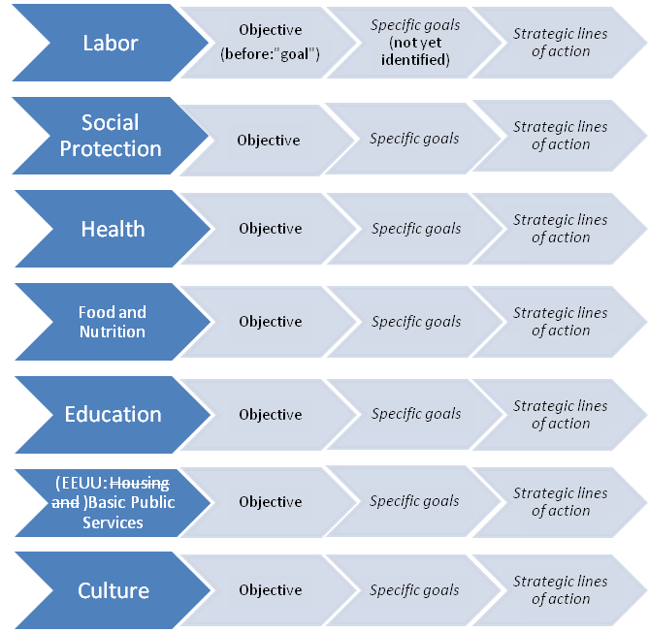

CROSSCUTTING ISSUES
[ARG: Equity and Gender equity perspective], priority attention to poor and vulnerable populations [PRES: (including people of African descent, indigenous peoples, immigrants, children, older persons, and persons with disabilities)], sustainable development, and the environment.

CROSSCUTTING METHODS
Participation, inter-sectoral action, inter-American solidarity and cooperation, respect for diversity, promotion and observance of human rights [BRA: and synchronization with social policies pursued by other multilateral agencies in the Americas].

PREREQUISITES
Economic [VEN: development growth] with equity, democracy, a culture characterized by transparency and fighting corruption, legal certainty [BRA: and civil society participation], [USA: private sector], [VEN: and other social actors].

(COMMENT BRA: Bearing in mind the complexity of the Plan's negotiation process, its breadth, and the fact that many discussions on goals, including the post-2015 Development Agenda, are currently underway in the framework of specialized organizations, we suggest that goals of the kind proposed in the glossary not be established.)
input.doc
input.doc

