PREPARATORY COMMITTEE OEA/Ser.P
AG/CP/INF. 727/19
13 December 2019
Original: English

NOTE FROM THE PERMANENT MISSION OF ANTIGUA AND BARBUDA AND THE PERMANENT MISSION OF SAINT VINCENT AND THE GRENADINES ENCLOSING A LETTER FROM THE PRIME MINISTER OF ANTIGUA AND BARBUDA IN HIS OWN NAME AND THAT OF THE PRIME MINISTER OF SAINT VINCENT AND THE GRENADINES FORMALLY NOMINATING MS. MARÍA FERNANDA ESPINOSA FOR THE POSITION OF OAS SECRETARY GENERAL FOR THE 2020–2025 TERM

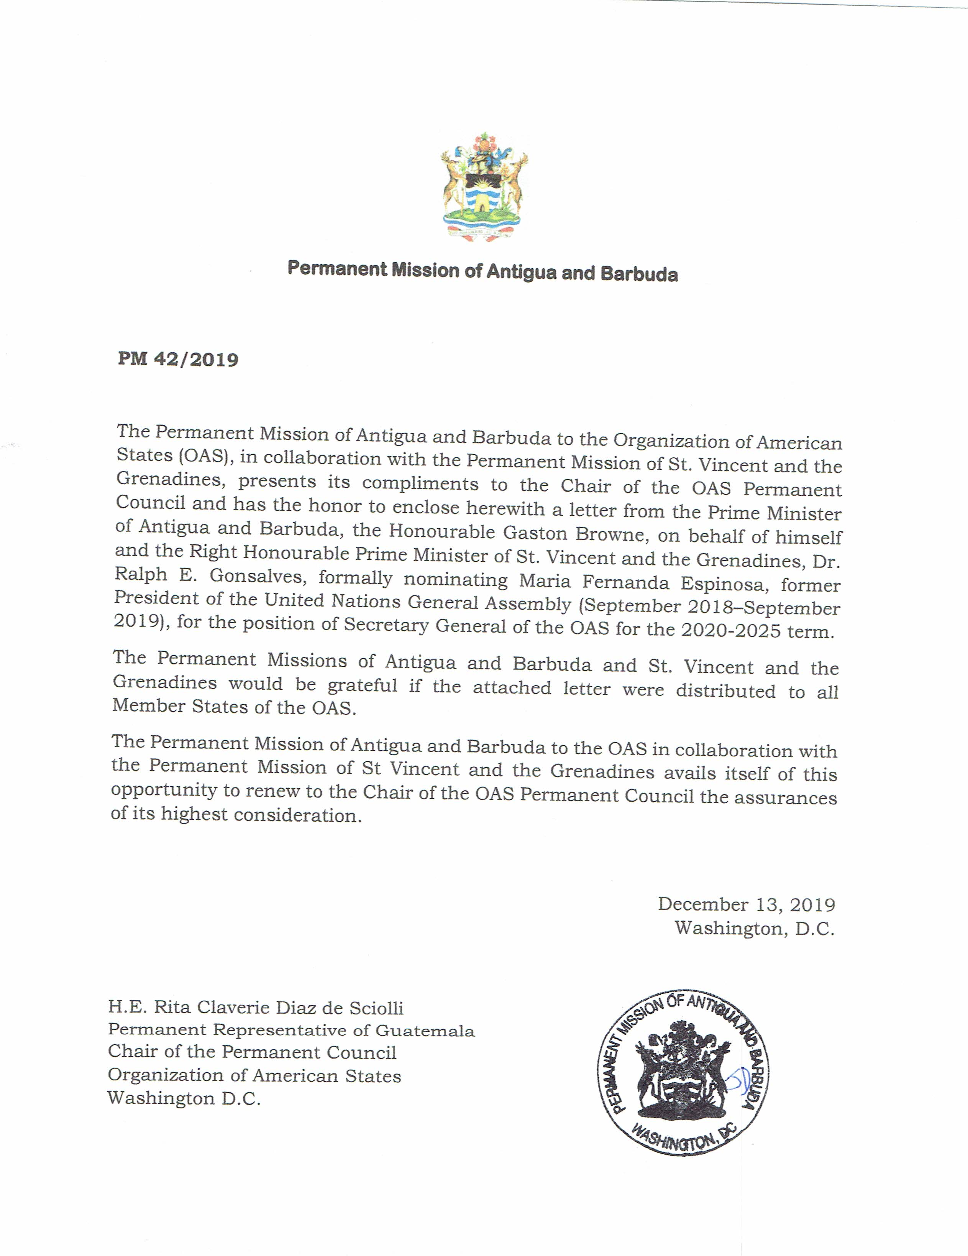

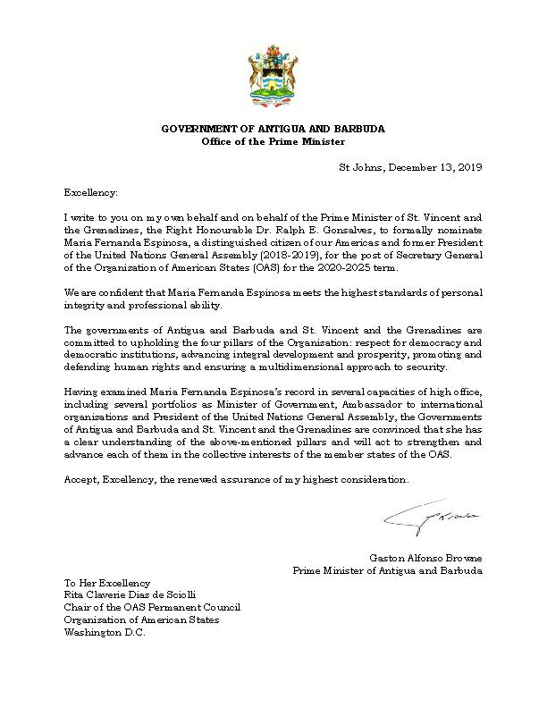
Curriculum Vitae: Spanish English
input.doc

