COMMITTEE ON PARTNERSHIP-- OEA/Ser. W
FOR-DEVELOPMENT POLICIES CIDI/CPD/doc.45/13
11 December 2013
Original: English

PRELIMINARY INPUT OF THE EXECUTIVE SECRETARIAT FOR INTEGRAL DEVELOPMENT (SEDI) TO THE COMMITTEE ON POLICIES, IN CONSIDERATION OF GENERAL ASSEMBLY MANDATE TO PREPARE THE IMPLEMENTATION PLAN FOR CARRYING OUT THE COMPREHENSIVE EVALUATION OF THE OAS SCHOLARSHIPS AND TRAINING PROGRAM REFERRED TO IN OPERATIVE PARAGRAPH 10.d of AG/RES. 1 (XLV-E/13)

(Presentation of Ms. V Sherry Tross, Executive Secretary for Integral Development,
during the meeting held December 6, 2013)

Mandate from the Special GA, forwarded to the Committee on Policies, paragraph 10 (d):

“To request that the Inter-American Council for Integral Development (CIDI) initiate a comprehensive, evaluation of the OAS Scholarship and Training Program, further to Article 60 of the Program’s Manual of Procedures, in order to evaluate the impact, relevance, sustainability, efficiency and cost effectiveness of the program to reach its stated goal of supporting human resource development in member states, bearing particularly in mind, the efforts made in the past to preserve the quality and quantity of scholarships, boost the Program’s efficiency, and increase the size of the fund with external sources of financing. To further request that CIDI, in collaboration with the General Secretariat, prepare an implementation plan which would include terms of reference for the evaluation, timeline, estimated cost and options for sources of funding by January 31, 2014”.

The mandate from the Special General Assembly to the CIDI and the Secretariat clearly lays out:

- The purpose of the evaluation: to determine whether the Scholarships Program meets its goal of supporting human resource development in member states;
- The objectives of the evaluation: to measure 5 areas, namely impact, relevance, sustainability, efficiency, and cost effectiveness; and
- A time delineated request: to prepare an implementation plan which would include 4 key elements:
  - Terms of reference of the evaluation
  - Timeline for the evaluation
  - Estimated cost of the evaluation
  - Suggested options for sources of funding.

Some Issues for Consideration

As the Committee deliberates on the evaluation mandate, I believe it would be useful to provide delegations with some background information that can help inform the thinking as the Committee, in collaboration with the Secretariat, as we work over the course of the coming weeks to draft an implementation plan that will meet the stated objectives.
- History: The OAS Scholarship and Training Program was created in 1958 to study in OAS member states into a Program that now offers scholarship opportunities to pursue Bachelor’s, Master’s and Ph.D. degrees, as well as professional development training in member and observer states. Over the program’s 55-year life span, it has evolved from a Graduate Scholarship Program to a Partnerships Program offering scholarships for graduate, undergraduate and professional development training and capacity strengthening for citizens of the Americas. Citizens in every member state of the OAS have benefited from this program.

- Existing Quantitative and Qualitative Data: Delegations are in possession of recent documents that address program impact.

  - Over 100,000 scholarships for all types of post-secondary education have been granted by the OAS over the past five and a half decades;
  - The publication to commemorate the 50th anniversary of the Scholarship Program featured OAS Scholars who have made significant contributions to their fields of study/work and the development of their countries, and attest to the Scholarship Programs’ positive impact on development in the Americas. To remind of a few: the winner of the 2009 National Prize in Education in Chile, who led his country’s successful efforts to universalize basic education beginning in the 1960s; an American who heads a large US university; a Panamanian who guides the sustainable use of water for his country; a young Guyanese leader who helps lead the Guyana Energy Agency; and a Canadian scholar who studied the impact of NAFTA from Mexico’s perspective and now shares his research with Canadian foreign affairs officials. All of these accomplishments have been achieved with the help of the OAS;
  - In March 2013, the Secretariat reported to the CIDI in a report entitled “Investing in Human Capital: Implications for Development” (CIDI/doc.32/13) on the results of the first phase of a survey, initiated by the Department, to measure the impact of the Programs by sampling a group of scholarship recipients. The overall responses received were positive and show that the majority of scholarship recipients surveyed:
    - studied in their native language;
    - returned home after they completed their programs of study;
    - successfully found work;
    - were able to apply the acquired knowledge in their job;
    - expanded their professional network; and
    - indicated that they would not have been able to pursue their academic degree without the OAS scholarship.

- Cooperation for Development: In its current form, this program currently represents one of the strongest areas of inter-American cooperation. In its first year of existence, the OAS Scholarship and Training Program awarded approximately 165 scholarships for graduate studies in US universities. In 2013, over 1000 scholarships were awarded for graduate and undergraduate studies, professional development training and capacity strengthening. In 2013, as a direct result of our partnership and cooperation programs, students were placed in over 300 universities in 29 countries. International student mobility and financing of higher education are no longer primarily South-North. Increasingly, that movement is South-South and North-South, reflecting other trends in inter-American relations and cooperation.

- Evolution of the Human Development Program: The following timeline provides an overview of the initiation and ongoing evolution of the OAS Education and Human Development Program and the expansion of educational opportunities for citizens of the Americas.

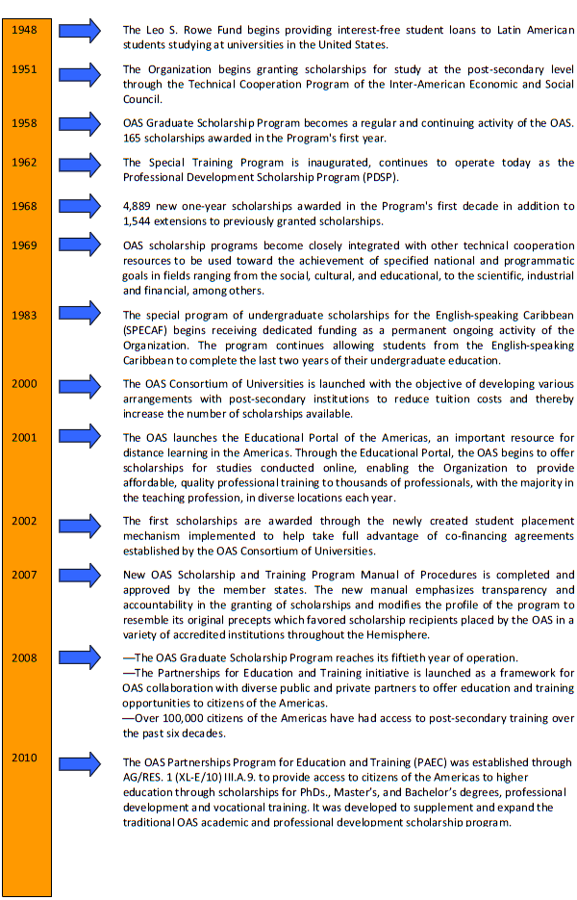

Preliminary Suggestions for Consideration by the Committee on Policies

Period of Evaluation: Given that the Program is 58 years old, consideration will have to be given to the time period to be included in the study both for purposes of substantive relevance as well as study cost. Bearing in mind that the nature of the Human Development and Education Program has significantly changed over time, including the creation of the OAS Consortium of Universities to leverage OAS scholarship funding by partnering with universities to share costs and the creation of the Partnerships Program for Education and Training (PAEC) in 2010, the study could cover an indicative period of time e.g. 2009 to 2013.

Scope of Evaluation: The proposed evaluation should cover the OAS Scholarships and Training Program and the Partnerships Program for Education and Training, taking into account that the majority of the first group of PAEC scholarship recipients will complete their academic studies between 2013-2015. Given that all Member States have citizens that have been beneficiaries of the Program, thought should be given to geographic distribution of scholars.

Independence of Evaluation: The Secretariat supports the tacit recommendation of Member States for independent evaluation as indicated in its call for “identifying sources of funding” to conduct the evaluation. The Secretariat has begun reaching out to partners to help in identifying independent experts with experience in the field of education and evaluation.
input.doc

Drafting of Implementation Plan: The Secretariat proposes to draw on existing data on the OAS Scholarship and Training Programs, as well as examples of evaluations and impact studies of other Scholarship Programs to help guide the drafting of the implementation plan that is due by January 31, 2014. The outcomes of today’s deliberations will also inform the drafting effort.

Clarification of Request: An element of the mandate which is less clear to the Secretariat is the phrase “bearing particularly in mind, the efforts made in the past to preserve the quality and quantity of scholarships, boost the Program’s efficiency, and increase the size of the fund with external sources of financing.” To honor not only the letter but spirit of the mandate, the Secretariat considers that, given the ongoing evolution of the program and partnership initiatives underway that the evaluation should also bear in mind current efforts and initiatives. Guidance on this matter is sought.

Finally, in line with Member State recommendations, program evaluation has become the new normal. A process of continuous evaluation is currently built into programming. While there is always room for improvement, the Secretariat is pleased to report that, with the help of a consortium partner, the OAS recently refined its survey system and developed a new database to interactively remain in contact with scholarship recipients during their period of study and after completion of their studies. This is expected to contribute significantly to the Secretariat’s reporting ability and its capacity to continuously evaluate programming aimed at continuous improvement.

