PERMANENT COUNCIL OF THE OEA/Ser.G
ORGANIZATION OF AMERICAN STATES CP/CAAP-3880/23 add. 1
21 February 2023
COMMITTEE ON ADMINISTRATIVE Original: English/Spanish
AND BUDGETARY AFFAIRS

SEMIANNUAL FINANCIAL REPORT
AS OF DECEMBER 31, 2022

(Partial submission of the Semiannual Resource
Management and Performance Report)
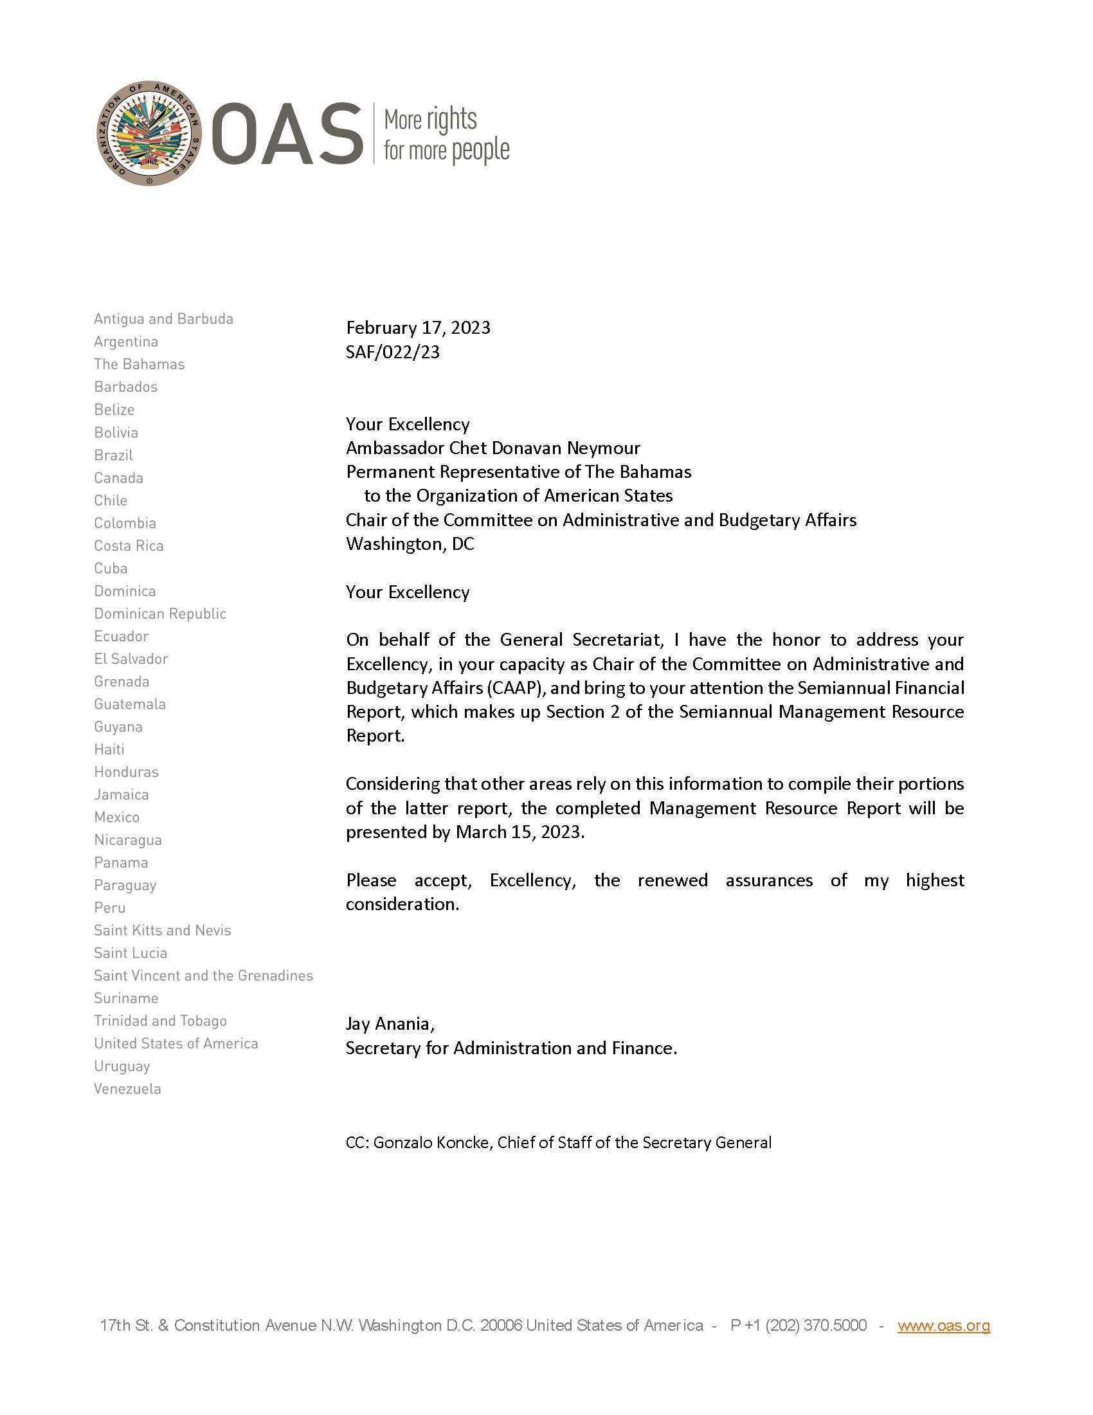

Click the link to access the Semiannual Financial Report
CP47207E01

