Committee on Migration Issues OEA/Ser.W
CIDI/CAM/INF.109/22
16 May 2022
Original: Spanish

COMMITTEE ON MIGRATION ISSUES

MIGRATION GOVERNANCE AND INTERNATIONAL AND REGIONAL MIGRATION MECHANISMS AND PROCESSES: TOWARDS THE DEVELOPMENT OF A COMPREHENSIVE AND HEMISPHERIC APPROACH (GCM, RCM, CAM, SACM, Quito Process, Platform R4V, GCM, MIRPS)

AGENDA
May 17, 2022
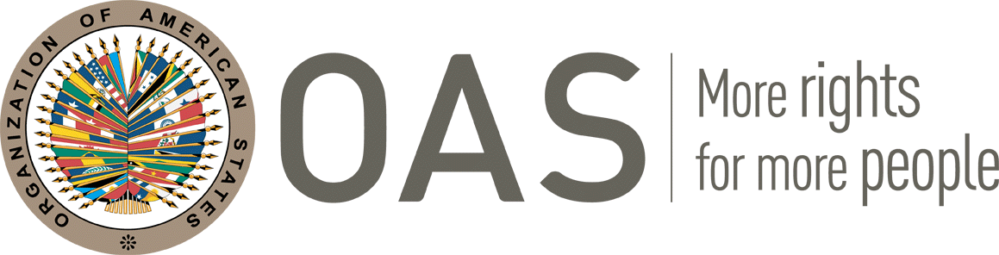

COMMITTEE ON MIGRATION ISSUES

MIGRATION GOVERNANCE AND INTERNATIONAL AND REGIONAL MIGRATION MECHANISMS AND PROCESSES: TOWARDS THE DEVELOPMENT OF A COMPREHENSIVE AND HEMISPHERIC APPROACH (GCM, RCM, CAM, SACM, Quito Process, Platform R4V, GCM, MIRPS)

AGENDA
May 17, 2022
14:30 - 14:40 Opening remarks
- Ms. Ana Gabriela Vasquez Rivasplata, Chair, Committee on Migratory Issues (CAM)
14:40 - 16:30 Panel discussion: “Migration governance and international and regional migration mechanisms and processes: towards the development of a comprehensive and hemispheric approach”
Panelists:
- Ms. Cindy Mariella Portal, Vice Minister of Diaspora and Human Mobility of El Salvador, Pro Tempore Presidency of the Regional Conference on Migration (CRM).
- Mr. Pedro Hernández, Deputy Director of International Migration of Chile, Pro Tempore Presidency, South American Conference on Migration (CSM).
- Ms. Rosa Posadas, Head of the Office of Assistance to Returned Migrants, Honduras, Pro Tempore Presidency of the Comprehensive Regional Framework for Protection and Solutions (MIRPS).
- Mr. Ricardo Rizzo, Focal Point of the Pro Tempore Presidency of the Quito Process, based in Brasilia.
- Mr. Zachary Thomas and Ms. Lorena Nieto, Coordinators of the Interagency Coordination Platform for Refugees and Migrants from Venezuela (Plataforma R4V)
- Ms. Maria Bances del Rey, Senior Protection Coordinator for the Americas, UNHCR
- Ms. Ana Gabriela Vasquez Rivasplata, Chair, Committee on Migratory Issues (CAM).
Methodology:
Regarding the methodology of the session, it is planned to have two rounds of questions with the panelists in which, within 7 minutes per question, they will respond to the following questions:
1. What are the main challenges and good practices that the mechanism or process you represent has developed to respond to migration and/or forced displacement?
2. What opportunities and spaces for articulation, coordination and cooperation do you see between the mechanism or process you represent, and the other processes or mechanisms present in this session to improve migration governance at the hemispheric level in the Americas?
16:30 - 17:20 Dialogue with delegations of member states
17:20 - 17:30 Closing remarks
- Ms. Ana Gabriela Vasquez Rivasplata, Chair, Committee on Migratory Issues (CAM)
- Ms. Betilde Muñoz-Pogossian, Director, Department of Social Inclusion, OAS
CIDRP03522E01

