OEA/Ser.W
CIDI/INF. 551/23
7 June 2023
Original: English

NOTE FROM THE PERMANENT MISSION OF THE COMMONWEALTH OF THE BAHAMAS PROPOSING THAT THE VI Regular Meeting of the Inter-American Committee for Sustainable Development (CIDS) reconvene on June 30th, 2023

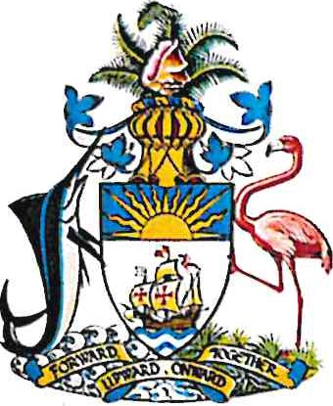
PERMANENT MISSION OF THE COMMONWEALTH OF THE BAHAMAS TO THE

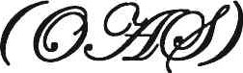
600 NEW HAMPSHIRE AVENUE, NW, SUITE 640
WASHINGTON, DC 20037

NOTE NO. 33/2023
The Permanent Mission of the Commonwealth of The Bahamas to the Organization of American State (OAS) presents its compliments to Chair of the Inter-American Council for Integral Development (CIDI) of the OAS and has the honor to refer to the convocation of the 6th Regular Meeting of the Inter-American Committee for Sustainable Development (CIDS).

In this vein, the Permanent Mission wishes to inform that the Government of The Bahamas, in its capacity as Chair of the Inter-American Committee for Sustainable Development (CIDS), wishes to propose that the ensuing 6th Regular Meeting of the Inter-American Committee for Sustainable Development (CIDS) be rescheduled to be convened on June 30th, 2023 in Washington DC in hybrid format.

The Permanent Mission would be grateful for the assistance of the Chair with informing the OAS Secretariat of the aforementioned and subsequently with circulation of the notice to OAS Member States.

The Permanent Mission of the Commonwealth of The Bahamas avails itself of this opportunity to renew to the Chair of the Inter-American Council for Integral Development (CIDI) of the OAS the assurances of its highest consideration.
Washington, D.C., 5 June, 2023
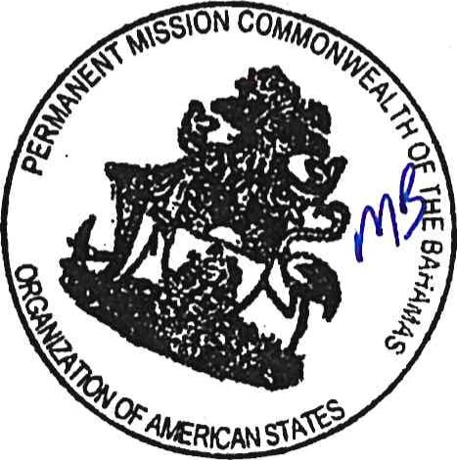
Chair of the Inter-American Council for Integral Development
Organization of American States
1901 Pennsylvania Ave., N.W., Suite 775
Washington, D.C., 20006

Link to the original note: http://scm.oas.org/pdfs/2023/NPMB33CIDS.pdf
CIDRP03906E01

