OEA/Ser.W

CIDI/INF.410/21

22 February 2021

TEXTUAL

REGULAR MEETING OF THE

INTER-AMERICAN COUNCIL FOR INTEGRAL DEVELOPMENT (CIDI)

FEBRUARY 23, 2021

GUEST SPEAKERS BIO

**CARLOS MANUEL RODRIGUEZ**

Lawyer by profession, politician by choice, and conservationist at heart, Carlos Manuel Rodriguez was elected as CEO and Chairperson of the Global Environment Facility by its governing body, the GEF Council, in June 2020.

The former Costa Rican Environment and Energy Minister was a pioneer in the development of Payment for Ecosystem Services initiatives and strategies for forest restoration, ocean conservation, and de-carbonization, and is an internationally recognized expert on environmental policy, multilateral environmental negotiations, and financing for nature conservation. During his three terms as Minister of Environment and Energy, Costa Rica doubled the size of its forests, made its electric sector 100 percent clean and renewable, and consolidated a National Park System that has positioned the Central American country as a prime ecotourism destination.

Rodriguez has held various technical and political positions over the past 30 years. In the early 1990s, he worked as Director of Costa Rica’s National Parks Service and is also founder and board member of many environmental NGOs and tropical research institutes. Since the 1992 UN Sustainable Development Summit in Rio, he has participated in all multilateral environmental negotiations, as an expert negotiator in UNFCCC, CBD, and UNCCD, and participated in negotiations for the creation and implementation of the GEF and the Green Climate Fund. After his second tenure as Minister, he was Vice-President for Global Policy at Conservation International, for 12 years, working in 30 tropical countries in Central and South America, Africa, and Southeast Asia.

**PA OUSMAN JARJU**

Pa Ousman Jarju is Director of GCF's Country Programming Division. Formerly, he was the Gambian Minister of Environment, Climate Change and Natural Resources and Chair of the Least Developed Countries (LDC) Group to the United Nations Framework Convention on Climate Change (UNFCCC). Pa Ousman was Special Climate Change Envoy of the Gambia and has extensive diplomatic experience across the 47 LDCs, China, the United States and the European Union. He has gained wide-ranging managerial experience in the Gambia's Department of Water Resources as its Director and then overseeing Minister. Pa Ousman holds advanced diplomas from the Institute of Commercial Management (UK) and the IHE Institute for Water Education (the Netherlands), as well as a Bachelor of Engineering in Chemical Engineering.

**LEONARDO MARTINEZ-DIAZ**

Senior Advisor to John Kerry, U.S. Special Presidential Envoy for Climate.  Mr. Martinez-Diaz was previously the Global Director of the Sustainable Finance Center at the World Resources Institute in Washington, D.C., where he headed a team of researchers working to promote the flow of public and private finance for climate action. During the Obama Administration, he served as Deputy Assistant Secretary for Energy and Environment in the United States Department of the Treasury.  In that capacity, he represented the United States on the governing bodies of the Global Environment Facility and the Green Climate Fund.  He also negotiated finance elements of the Paris Agreement and helped design and implement President Obama's executive orders on climate change and international development and climate change and national security. Prior to that, Mr. Martinez-Diaz served as Deputy Assistant Secretary for the Western Hemisphere at the United States Department of the Treasury, and before that, as Director of the Office of Policy in the United States Agency for International Development (USAID). Martinez-Diaz is author, with Alice C. Hill, of *Building a Resilient Tomorrow: How to Prepare for the Coming Climate Disruption* (Oxford, 2019). He also served on the Climate-Related Market Risk Subcommittee convened by the Commodity Futures Trading Commission and served as co-editor of the Subcommittee's final report, *Managing Climate Risk in the U.S. Financial System*.

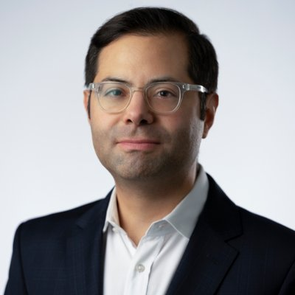

CIDRP03103T01