FORFIFTIETH REGULAR SESSION OEA/Ser.P

October 20 and 21, 2020 AG/INF. 699/20

VIRTUAL 16 October 2020

Original: Spanish/English

DIALOGUE OF THE HEADS OF DELEGATION, THE SECRETARY GENERAL, ASSISTANT SECRETARY GENERAL WITH THE PERMANENT OBSERVERS TO THE OAS

DRAFT PROGRAM

OCTOBER 19, 2020 AT 9:00 - 11:30 A.M.

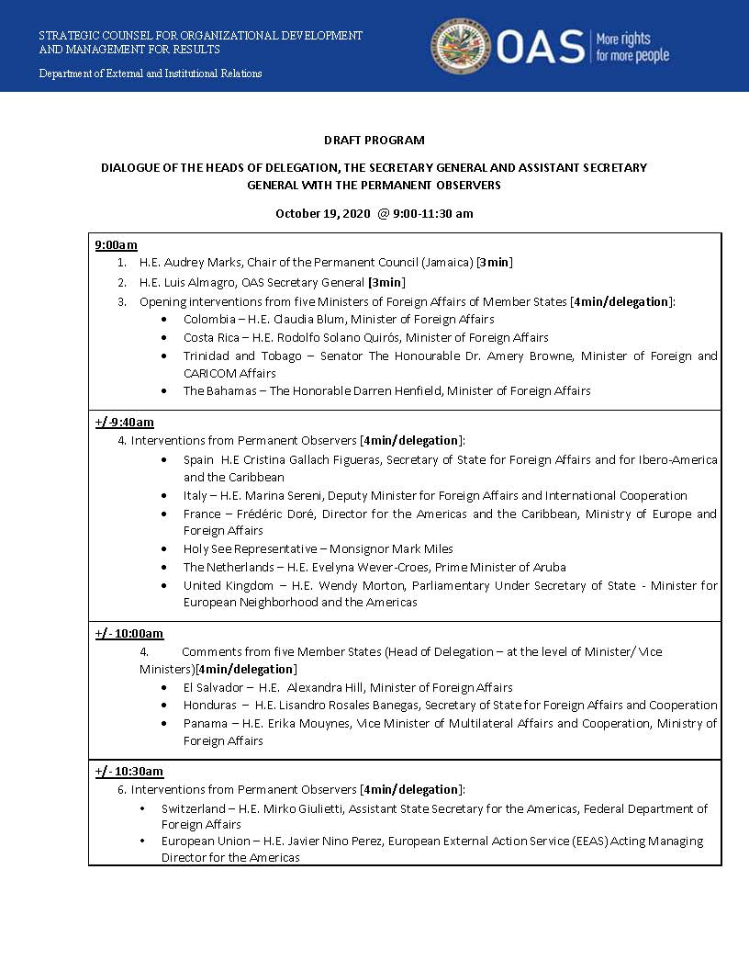

AG08151E01

