OEA/Ser.W
CIDI/INF.394/20
13 November 2020
Original: English

NOTE FROM THE PERMANENT MISSION OF SAINT VINCENT AND THE GRENADINES SUBMITTING A NOMINATION FOR MEMBERSHIP OF THE MANAGEMENT BOARD OF THE NTER-AMERICAN AGENCY FOR COOPERATION AND DEVELOPMENT FOR THE 2020-2022 TERM

PERMANENT MISSION OF SAINT VINCENT AND THE GRENADINES
TO THE ORGANIZATION OF AMERICAN STATES
1627 K STREET, N.W., SUITE 1202 • WASHINGTON, D.C. 20006 TELEPHONE: (202) 364-6730 • FAX: (202) 364-6736

Our Ref: MOFA/PMOAS/DC OAS Note No: 56/20

The Permanent Mission of Saint Vincent and the Grenadines to the Organization of American States (OAS) presents its compliments to the Executive Secretariat for Integral Development (SEDI) and has the honour to refer to the upcoming elections for membership on the Management Board of the InterAmerican Agency for Cooperation and Development (IACD) for the period 2020 to 2022.

In this connection, the Permanent Mission of Saint Vincent and the Grenadines, aware of the importance of addressing matters of cooperation and development within the multi-lateral framework, is pleased to submit its candidacy for election as a member of the Management Board of the InterAmerican Agency for Cooperation and Development (IACD) for the referenced period.

The Permanent Mission of Saint Vincent and the Grenadines to the Organization of American States (OAS) avails itself of this opportunity to renew to the Executive Secretariat for Integral Development the assurances of its highest consideration.

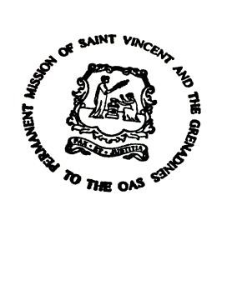
November 12, 2020 Washington, D.C.

CIDRP03040E01

