OEA/Ser.W
CIDI/INF.429/21
19 May 2021
Original: English

NOTE FROM THE PERMANENT MISSION OF ANTIGUA AND BARBUDA FORWARDING THE DRAFT RESOLUTION TO CONVENE THE NINTH REGULAR MEETING OF THE INTER-AMERICAN COMMITTEE ON EDUCATION

Permanent Mission of Antigua and Barbuda to the Organization of American States

PM/21/2021

The Permanent Mission of Antigua and Barbuda to the Organization of American States presents it compliments to Chair of the Inter-American Council for Integral Development (CIDI) and has the honour to submit the draft resolution: "Convocation of THE NINTH regular MEETING OF THE INTER-AMERICAN COMMITTEE ON EDUCATION (CIE) to be held virtually on October 14-15, 2021.
The Permanent Mission of Antigua and Barbuda respectfully request that the consideration of this draft resolution be included in the agenda for the next meeting of CIDI scheduled for May 25, 2021.
The Permanent Mission of Antigua and Barbuda to the Organization of American
States avails itself of this opportunity to renew to the Chair of the Inter-American Council for Integral Development (CIDI) of the Organization of American States the assurances of its highest consideration.
19th May 2021
Washington, D.C.
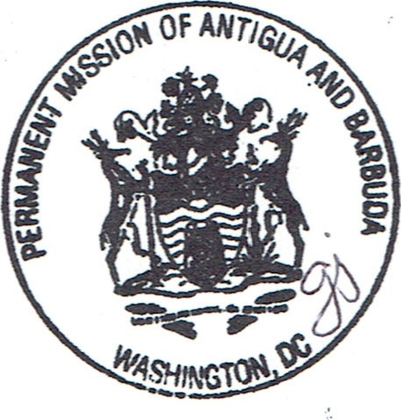
Ambassador Luis Cordero
Permanent Representative of Honduras to the OAS
Chair of the Inter-American Council for Integral Development Organization of American States Washington, D.C.

Link to the original note: http://scm.oas.org/pdfs/2021/NOTAAB21IXCIE.pdf

DRAFT RESOLUTION

CONVOCATION OF THE NINTH REGULAR MEETING OF THE
INTER-AMERICAN COMMITTEE ON EDUCATION

(Presented by the Delegation of Antigua and Barbuda in its capacity as Chair of the Inter-American Committee on Education)

THE INTER-AMERICAN COUNCIL FOR INTEGRAL DEVELOPMENT (CIDI),

CONSIDERING that the Inter-American Committee on Education (CIE) is a committee of the Inter-American Council for Integral Development whose purpose is to coordinate the implementation of inter-American ministerial dialogue in the area of Education, identify relevant multilateral initiatives, and contribute to the execution of OAS policies in the area of partnership for development in accordance with the Comprehensive Strategic Plan of the Organization,

RECALLING:

That each InterAmerican Committee shall hold a regular meeting at the headquarters of the Organization of American States every three years as part of the corresponding Triennial Ministerial Cycle and bearing in mind the six-year calendar of ministerial meetings that CIDI updates each year pursuant to resolution AG/RES. 2904 (XLVII-O/17).

That the General Secretariat, through the Technical Secretariat of the corresponding process, shall notify CIDI of proposed dates for the meeting, determined in consultation with the Chair of the Committee in question, at least 120 days in advance so that CIDI may decide on its convening.

BEARING IN MIND Permanent Council resolution, “Update of Costs of Conferences and Meetings Funded by the OAS” CP/RES. 982 (1797/11),

RESOLVES:

- To convene the Ninth Regular Meeting of the Inter-American Committee on Education to be held virtually on October 14-15, 2021.

- To request that U$29,158 be allocated from the resources provided for under Chapter 7, Subprogram 74F of the program-budget of the Organization for 2021, in keeping with the guidelines set forth in resolution CP/RES. 982 (1797/11), to prepare and hold the Ninth Regular Meeting of the Inter-American Committee on Education.

3. To instruct the General Secretariat, through the Executive Secretariat for Integral Development (SEDI), to support the work of preparing and organizing the Ninth Regular Meeting of the Inter-American Committee on Education and to report to the Inter-American Council for Integral Development (CIDI) on the results thereof.
CIDRP03190E01

