OEA/Ser.W
CIDI/INF. 444/21
19 August 2021
Original: Spanish

NOTE FROM THE PERMANENT MISSION OF GUATEMALA PROPOSING
A THEME AND GUIDELINES FOR THE IX INTER-AMERICAN MEETING OF MINISTERS AND HIGHEST APPROPIATE AUTHORITIES OF CULTURE
AND REQUESTING COMMENTS THEREON

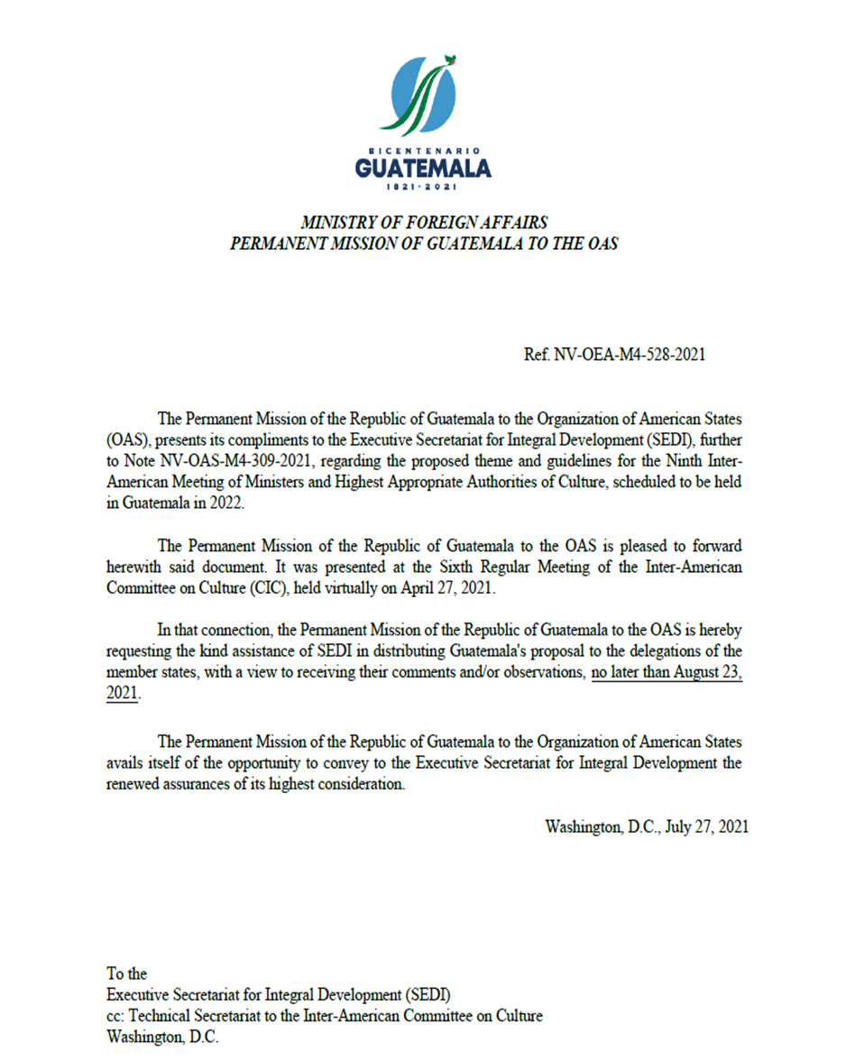

PROPOSED THEME AND GUIDELINES FOR THE

NINTH INTER-AMERICAN MEETING OF MINISTERS OF CULTURE

AND HIGHEST APPROPRIATE AUTHORITIES

PRESENTED BY THE DELEGATION OF GUATEMALA

Considering that one of the purposes of the sixth regular meeting of the Inter-American Committee on Culture (CIC) is to agree on the theme for the next ministerial meeting, due to be held in Guatemala City, Guatemala in 2022, and to provide guidelines to the Secretariat for drawing up the annotated agenda, the delegation of Guatemala submits the following proposal for consideration by the CIC at its sixth regular meeting.

NINTH INTER-AMERICAN MEETING OF MINISTERS OF CULTURE AND HIGHEST APPROPRIATE AUTHORITIES OF THE ORGANIZATION OF AMERICAN STATES (OAS)

Proposed theme

“Technology, creativity, and innovation as an opportunity for the development and strengthening of culture”

“TECHNOLOGY, CREATIVITY, AND INNOVATION AS AN OPPORTUNITY FOR THE DEVELOPMENT AND STRENGTHENING OF CULTURE”

Objective

To analyze and evaluate which paths, strategies, and types of technology could continue to be applied to promote culture at the international level.

CORE ISSUES

METHODOLOGIES AND POLICIES FOR PROMOTING MANAGEMENT AND CONSUMPTION OF THE ARTS AND LITERATURE

CULTURAL DEVELOPMENT RESEARCH MODELS

ECONOMY AND CREATIVE INDUSTRIES

STRENGTHENING HERITAGE AND CULTURAL EXPRESSIONS

METHODOLOGIES AND POLICIES FOR PROMOTING MANAGEMENT AND CONSUMPTION OF THE ARTS AND LITERATURE

Lines:

How to rescue and promote outstanding Ibero-American literary works and artists using technology.
How to foster artistic activities using technology as a means of projection.
How to strengthen the training of professional artists through new methodologies that integrate technology as a factor that maximizes outreach.

CULTURAL DEVELOPMENT RESEARCH MODELS

Lines:

How to use technology to generate research focused on rescuing pre-Hispanic cultural heritage.
How to optimize the implementation of sociocultural research models for cultural policy development.
How to promote consumption of arts and culture through market research models by which to generate digital strategies that promote dignity and consumption.

ECONOMY AND CREATIVE INDUSTRIES

Lines:

How to strengthen micro, small and medium-sized enterprises (MSMEs) in the creative industry by means of business incubator and accelerator models, using technology as a basis for maximizing outreach.
How to strengthen measurement of the economic contribution of the creative industry through systematization and technology within culture satellite accounts.
How to use data analysis models at the Inter-American level to compare indicators between countries and generate an index of sustainable cultural development.

STRENGTHENING HERITAGE AND CULTURAL EXPRESSIONS

Lines:

How to strengthen tangible and intangible heritage through innovation and the use of new technologies for dissemination and practice.
How recognize and socialize the contribution of indigenous and Afro-descendent culture in the heritage and cultural expressions of the Americas.

NINTH INTER-AMERICAN MEETING OF MINISTERS OF CULTURE AND HIGHEST APPROPRIATE AUTHORITIES

PRESENTED BY THE DELEGATION OF GUATEMALA

Tentative date: second half of 2022

Place: Guatemala City, Guatemala

Format: Plenary sessions, exchange of good practices, ministerial dialogue, roundtables, and networking opportunities

Special considerations: Evaluate the possibility of holding meetings face to face or virtually.

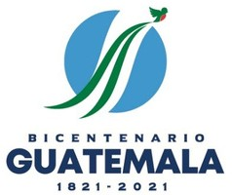
CIDRP03277E01

