OEA/Ser.W
CIDI/INF. 508/22
26 July 2022
TEXTUAL

REGULAR MEETING OF THE

INTER-AMERICAN COUNCIL FOR INTEGRAL DEVELOPMENT (CIDI)

JULY 26, 2022

ON:

“DIGITAL TRANSFORMATION AND INTEGRAL DEVELOPMENT”

BIOGRAPHY OF THE INVITED SPEAKERS

REGULAR MEETING OF THE

INTER-AMERICAN COUNCIL FOR INTEGRAL DEVELOPMENT (CIDI)

JULY 26, 2022

BIOGRAPHY OF THE INVITED SPEAKERS

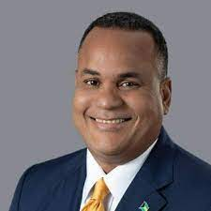

The Honorable Michael B. Halkitis
Minister of Economic Affairs of the Commonwealth of The Bahamas

The Honorable Michael B. Halkitis earned a Bachelor of Arts Degree in Economics from the University of Western Ontario. Mr. Halkitis qualified as a Chartered Financial Analyst in 1995.

Mr. Halkitis was first elected to The Parliament of The Bahamas in 2002 and again in 2012. He currently serves as Minister of Economic Affairs and Leader of Government Business in The Senate.

His portfolio responsibilities include Promotion of Financial Services, Small Business Development, Ease of Doing Business, Consumer Protection and International Trade.

Under his many years of leadership, the Bahamas’ Ministry of Finance was not only brought into the modern age through the digitization of its operations, but also through the implementation of major taxation reforms which have been applauded for their seamless integration. Currently, he oversees the nation’s trade, financial services industry, aims to improve our country’s ease of doing business, and directs our country’s digitization efforts. He will play an important role in helping to stabilize the country’s finances.

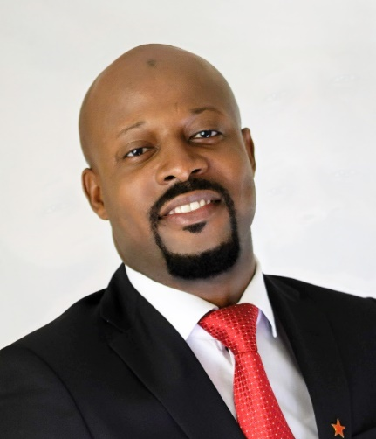

HON. CARLOS JAMES, ESQ. MP
Minister of Tourism, Civil Aviation, Sustainable Development and Culture – Government of the State of Saint Vincent and the Grenadines.

Honourable Carlos James, Esq. MP is an elected Parliamentarian and serves in the Cabinet of the Government of Saint Vincent and the Grenadines as the Minister of Tourism, Civil Aviation, Sustainable Development and Culture.

He is a former Speaker of the House in the Parliament of Saint Vincent and the Grenadines and also served as a Senator and Deputy Speaker.

Minister James has ministerial responsibility for Tourism, Aviation, Sustainable Development, Climate Change, Oceans, Heritage and Recreational Sites, National Parks and Beaches, Culture, Filming, Copyright, Memorial Hall, the National Trust and a number of government agencies and statutory bodies, which provides services covering the aforementioned areas.

Minister James brings a wealth of professional experience to the Government of Saint Vincent and the Grenadines and the Ministry of Tourism, Civil Aviation, Sustainable Development and Culture, having spent over a decade as a practising Barrister-at-Law and Solicitor.

He holds a Bachelor of Laws (LL.B) Hons. and a Master of Laws (LL.M). He is a graduate of the City Law School (formerly Inns of Court School of Law), London UK and is a member of the Honourable Society of Gray’s Inn (London, UK). He is called to the Bar of England and Wales and the Bar of Saint Vincent and the Grenadines respectively.

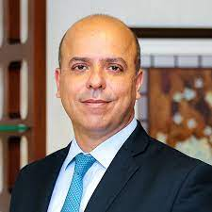

Carlos Alexandre Da Costa
Chief Representative of the Foreign Office of the Ministry of Economy of Brazil

Economist graduated from the State University of Rio de Janeiro (UERJ), with a master's degree and Ph.D (ABD) in Economics from the University of California, Los Angeles.

Mr. Da Costa was Deputy Ministry for Productivity and Competitiveness at the Ministry of Economy of Brazil, responsible for leading the economic reforms to the Brazilian productive sector. He was director of Planning, Credit and Technology at the National Bank for Economic and Social Development (BNDES); president of the Institute of Performance and Leadership; resident executive at JP Morgan and partner-director of Ibmec Educacional. He also presents a vast performance in the academic sector, having been a professor of Economics and Finance at Ibmec, UERJ, and the Brazilian Institute of Capital Markets. He has also developed research activities in several areas such as "Economics and Regulation", "Foreign Investment", "Sectoral Regulation", and "Macroeconomic Reforms". He is currently Chief Representative of the Foreign Office of the Ministry of Economy in Washington-DC

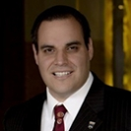 | Ramon Sanchez Sc.D.  Principal Investigator  Development of Innovation and Sustainability Ecosystems  Research Associate, Department of Environmental Health  Harvard T.H. Chan School of Public Health  rsanchez@hsph.harvard.edu

Dr. Ramon Sanchez is the former Director of the Sustainable Technologies and Health Program at the Harvard T.H. Chan School of Public Health. He has 15 records of invention of those 5 are U.S. Patents and the rest are trade secrets.

Dr. Sanchez has helped to create and secure funding for more than 200 startups in health and sustainability since August of 2014. Ramon is currently Principal Investigator in research projects to strengthen local innovation ecosystems around the world (to have innovation hubs like Boston and Silicon Valley around the planet).

He is the lead instructor of the courses “Design of Renewable Energy Projects”, “Sustainable Product Design and the Innovation Ecosystem” and “Innovative Technologies for Climate Change Resilience” at Harvard University. In these courses, he helps people to gain knowledge and develop skills on how to design renewable energy and sustainable technology projects, how to assess their sustainability and health benefits, how to create business proposals to facilitate financing and how to work with international investors and stakeholders in different communities to implement sustainable financing projects in an equitable way. Dr. Sanchez also teaches the winter course “Social and Sustainable Innovation Driven by the Sustainable Development Goals” for students in all graduate schools at Harvard University.

Since early May of 2020, he has been teaching online weekly courses on technologies and practices to prevent COVID-19 and strategies to contain this pandemic outbreak. To date, more than 3,000 people have participated in these classes, among them are university presidents, governors, legislators, hotel and property managers, manufacturing and plant managers, transportation and logistics’ professionals, small business owners, and public health officials in several countries.

Ramon Sanchez received a Doctor of Science and Master of Science Degrees in Environmental Health from the Harvard University; he also has a Master of Science Degree in Manufacturing Systems and a Mechanical Engineering Degree from the Tec of Monterrey Campus Monterrey. Before coming to Harvard University, he was an automotive engineer, director of engineering and manufacturing in a large manufacturing company where he supervised hundreds of engineers and thousands of workers in seven departments with operations in 3 countries (Mexico, China, and the USA).
CIDRP03610T01

