PERMANENT COUNCIL OF THE OEA/Ser.G
ORGANIZATION OF AMERICAN STATES CP/CAAP-3880/23 add. 2 corr. 1
24 March 2023
COMMITTEE ON ADMINISTRATIVE Original: English/Spanish
AND BUDGETARY AFFAIRS

SEMIANNUAL FINANCIAL REPORT
AS OF DECEMBER 31, 2022

(Presentation by the Department of Financial Services)
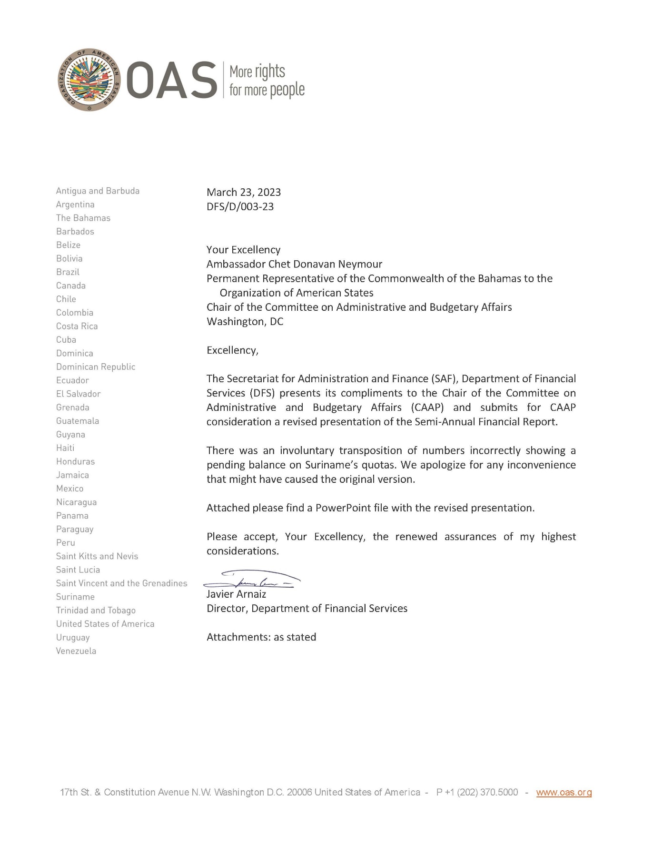

Click on the link to access the PRESENTATION
CP47407E01

