OEA/Ser.W
CIDI/INF.392/20
28 October 2020
Original: English

NOTE FROM THE PERMANENT MISSION OF BARBADOS SUBMITTING A NOMINATION FOR THE CHAIRMANSHIP OF THE COMMITTEE ON PARTNERSHIP FOR DEVELOPMENT POLICIES FOR THE 2020-2021 TERM

No. 062/2020
The Permanent Mission of Barbados to the Organization of American States (OAS) presents its compliments to the Executive Secretariat for Integral Development of the OAS and has the honour to inform that it has nominated Mr. Jovan Reid, First Secretary/Alternate Representative of Barbados to the OAS, for the Chairmanship of the Committee on Partnership for Development Policies for the 2020-2021 term.

Mr. Reid has held portfolios for sustainable development, resilience and the environment for over ten years in the Foreign Service of Barbados, and has previously been assigned to the Inter-American Agency for Cooperation and Development, the Inter-American Committee on Education, the Department of Sustainable Development as well as the Committee for Administrative and Budgetary Affairs, as Alternate Representative of Barbados. The Permanent Mission is confident that Mr. Reid will continue the efficient leadership and Chairmanship of this important Committee during the challenging term ahead.

The Permanent Mission of Barbados to the Organization of American States (OAS) avails itself of this opportunity to renew to the Executive Secretariat for Integral Development of the OAS the assurances of its highest consideration.

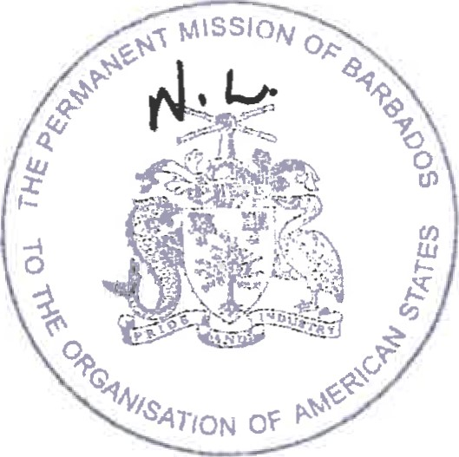
Permanent Mission of Barbados
to the Organization of American States
Washington, D.C.

October 28, 2020
CIDRP03037E01

