OEA/Ser.W
CIDI/INF. 576/23
21 noviembre 2023
TEXTUAL

REUNIÓN ORDINARIA DEL

CONSEJO INTERAMERICANO PARA EL DESARROLLO INTEGRAL (CIDI)

27 DE NOVIEMBRE DE 2023

SOBRE el tema:

“Aspectos importantes del desarrollo sostenible de las culturas de las Américas”

BIOGRAFÍA DE LOS PANELISTAS INVITADOS

REUNIÓN ORDINARIA DEL

CONSEJO INTERAMERICANO PARA EL DESARROLLO INTEGRAL (CIDI)

27 DE NOVIEMBRE DE 2023

BIOGRAFÍA DE LOS PANELISTAS INVITADOS

- Señora Giselle Gónzalez Villarué, Ministra de Cultura de Panamá

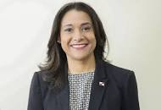

La Ministra González Villarué es licenciada en Ciencias de la Comunicación Social, posee una maestría en Mercadeo con énfasis en creatividad y ha ocupado los cargos de gerente sénior de programación en Corporación Medcom (1997-2019) y productora de imagen de los servicios informativos de TVN (1996).

- Mr. Yuri Peshkov is the Head of Culture Programme of the UNESCO
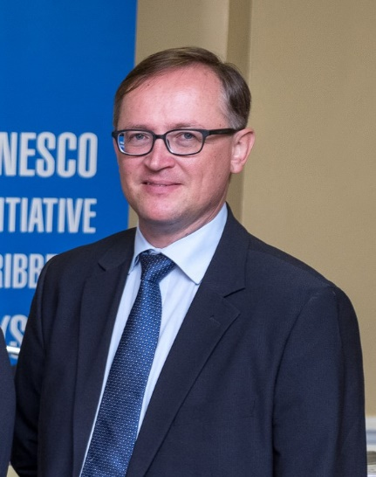

Mr. Peshkov is the Head of Culture Programme of the UNESCO, Office for the Caribbean since March 2016.
Being the Head of Culture Programme of the UNESCO Office for the Caribbean, Yuri is involved into implementation of the UNESCO Culture Conventions including those protecting and safeguarding of the World Heritage and Living Heritage, preventing Illicit Trafficking of Cultural Properties, as well as promoting of the Diversity of Cultural Expressions in the English and Dutch speaking Caribbean. His work mainly focused on promotion of culture for sustainable development and protection of cultural diversity through implementation of integrated operational and normative projects.

Mrs. Trinidad Zaldívar, Chief at the Creativity and Culture Unit at the Inter-American Development Bank’s (IDB) Knowledge, Innovation, and Communications Sector

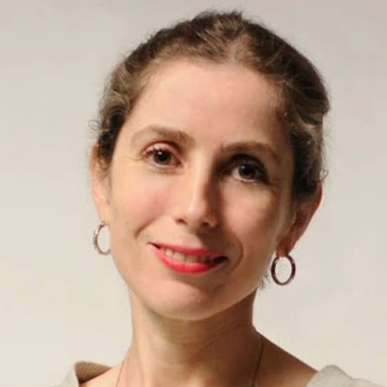

Mrs. Trinidad Zaldívar is a specialist in the creative and cultural industries, and her work harnesses the worlds of culture and creativity to infuse innovative thinking into the full spectrum of the Bank’s work. She has experience in change management, international practices of development and cultural analysis. She graduated with a PhD in History from Pontificia Universidad Católica de Chile and Universitè Paris 1, Pantheon Sorbonne. She has produced and published more than twenty articles, books about Chilean culture, art exhibitions and scripts. Prior to joining the IDB, she’s had twenty years of experience working at several international organizations and cultural institutions, such as the World Bank and the Organization of the American States (OAS), where she led the OAS Museum's fundraising and development efforts.
CIDRP04019T01

