OEA/Ser.W
CIDI/INF. 552/23
7 June 2023
Original: English

NOTE FROM THE PERMANENT MISSION OF THE COMMONWEALTH OF THE BAHAMAS PROPOSING DATE AND SITE FOR THE FOURTH INTER-AMERICAN MEETING OF MINISTERS AND HIGH-LEVEL AUTHORITIES ON SUSTAINABLE Development

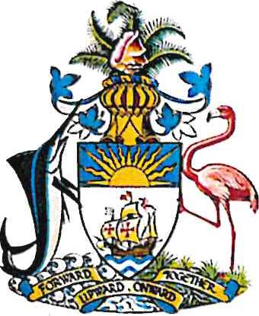
PERMANENT MISSION OF THE COMMONWEALTH OF THE BAHAMAS TO THE
600 NEW HAMPSHIRE AVENUE, NW, SUITE 640
WASHINGTON, DC 20037

NOTE NO. 34/2023

The Permanent Mission of the Commonwealth of The Bahamas to the Organization of American State (OAS) presents its compliments to Chair of the Inter-American Council for Integral Development (CIDI) of the OAS and has the honor to refer to the convocation of the 4th Inter-American Meeting of Ministers and High-Level Authorities on Sustainable Development.

In this vein, the Permanent Mission wishes to inform that the Government of The Bahamas, in its capacity as Chair of the Inter-American Committee for Sustainable Development (CIDS), wishes to propose that the 4th InterAmerican Meeting of Ministers and High-Level Authorities on Sustainable Development be convened on October 3rd 4th , 2023 in Nassau, The Bahamas.

The Permanent Mission would be grateful for the assistance of the Chair with informing the OAS Secretariat of the aforementioned and subsequently with circulation of the notice to OAS Member States.

The Permanent Mission of the Commonwealth of The Bahamas avails itself of this opportunity to renew to the Chair of the Inter-American Council for Integral Development (CIDI) of the OAS the assurances of its highest consideration.

Washington, D.C., 5 June, 2023

Chair of the Inter-American Council for Integral Development
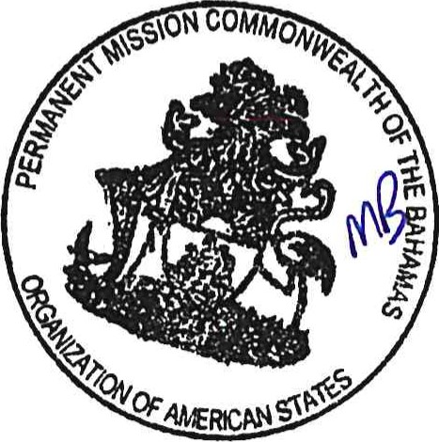
Organization of American States
1901 Pennsylvania Ave., N.W., Suite 775
Washington, D.C., 20006

Link to the original note: http://scm.oas.org/pdfs/2023/NPMB34MINISTERIALDESARROLLOSOSTENIBLE.pdf
CIDRP03907E01

