OEA/Ser.W
CIDI/INF. 526/22 rev.2
24 October 2022
TEXTUAL

REGULAR MEETING OF THE

INTER-AMERICAN COUNCIL FOR INTEGRAL DEVELOPMENT (CIDI)

OCTOBER 25, 2022

ON:

Artificial Intelligence and Digital Transformation for a Sustainability Agenda in the Americas: Public Policies and Ethical Considerations to Promote Sustainable Development and Tackle Climate Change

BIOGRAPHY OF THE INVITED SPEAKERS

REGULAR MEETING OF THE

INTER-AMERICAN COUNCIL FOR INTEGRAL DEVELOPMENT (CIDI)

OCTOBER 25, 2022

BIOGRAPHY OF THE INVITED SPEAKERS

Ryan Hagemann is the Co-Director of the IBM Policy Lab and a Technology Policy Executive on the company's government and regulatory affairs team, where he manages the company’s global AI issue policy portfolio. He was previously a senior policy fellow at the International Center for Law & Economics. Before joining the International Center for Law & Economics, he was a senior fellow at the Niskanen Center, where he also served as the senior director for policy and director of technology policy.

His policy expertise focuses on regulatory governance of emerging technologies, as well as a broader research portfolio that includes genetic modification and regenerative medicine, bioengineering and healthcare IT, artificial intelligence, autonomous vehicles, commercial drones, the Internet of Things, and other issues at the intersection of technology, regulation, and the digital economy. His work on “soft law” governance systems, autonomous vehicles, and commercial drones has been featured in numerous academic journals, and his research and comments have been cited by The New York Times, MIT Technology Review, and The Atlantic, among other outlets. He has been published in The Wall Street Journal, Wired, National Review, The Washington Examiner, U.S. News & World Report, The Hill, and elsewhere.

Mr. Hagemann graduated from Boston University with a B.A. in international relations, foreign policy, and security studies and holds a Master of Public Policy in science and technology policy from George Mason University.
www.ibm.com/blogs/policy/

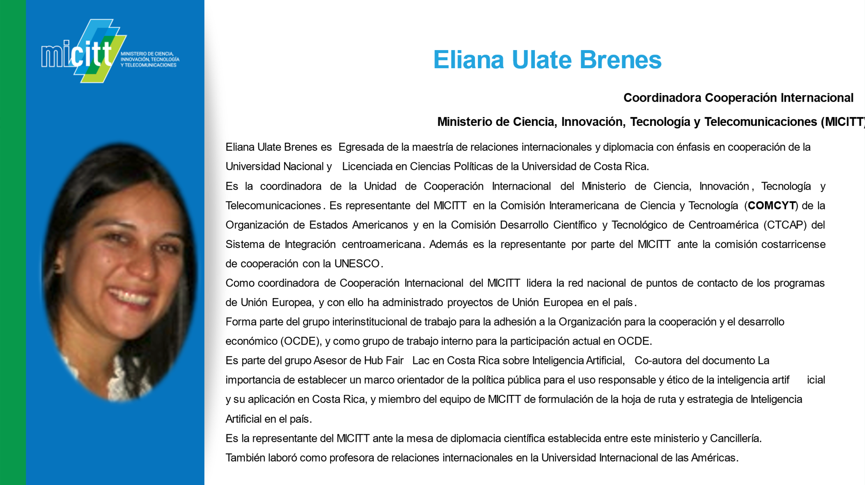

Angélica Díaz

Angélica Díaz es Bióloga de la Universidad Javeriana, con maestría en Ciencias Biológicas de la Universidad de los Andes y candidata a doctora en Biología en la Universidad de Antioquia.

Investigadora del Instituto Humboldt en Colombia. Interesada en temáticas como la conservación, la biogeografía, el fototrampeo, la adaptación a la presencia de felinos, la promoción del uso de tecnologías para la conservación, la comunicación y la colaboración en la ciencia.

Mark Lambrides
Director, Department of Sustainable Development
Organization of American States

Mark Lambrides has over 30 years of experience working to drive the transition to clean renewable energy solutions around the world. Mark has just left The Nature Conservancy where he led the organization’s energy and climate partnerships team. He supported programs in Europe, Asia, Africa, and Latin America in efforts to accelerate deployment of renewable energy solutions which bring climate, conservation and community benefits.

Mr. Lambrides has a long history of working with international finance and policy institutions where he designed multi-stakeholder initiatives in the renewable energy and energy efficiency arena. Prior to joining The Nature Conservancy in 2018, he worked at the World Bank where he managed the preparation and implementation of renewable energy, energy efficiency, and grid rehabilitation project investments in Latin America and the Caribbean. Previously, he developed and led the Sustainable Energy Division at the Organization of American States (OAS), where he coordinated energy policy and technical assistance initiatives for over fifteen years.

Mr. Lambrides earned a master’s from the School of Advanced International Studies (SAIS) of The Johns Hopkins University and has a bachelor’s degree from Kalamazoo College.
CIDRP03723T01

