OEA/Ser.W CIDI/INF. 455/21
16 September 2021
Original: English

NOTE FROM THE PERMANENT MISSION OF JAMAICA INFORMING OF THE DECISION OF THE GOVERNMENT OF JAMAICA TO PRESENT THE CANDIDATURE OF THE HONOURABLE EDMUND BARTLETT FOR CHAIRMANSHIP OF THE INTER-AMERICAN COMMITTEE ON TOURISM (CITUR)

Permanent Mission of Jamaica
to the Organization of the American States
1520 New Hampshire Ave., N.W. Washington D.C. 20036
Telephone: (202) 986 0123 Fax: (202) 452 9395
Email: jamaica@oas.org Or pmdc@jamaicaoas.org

Ref: 6/70/4

The Permanent Mission of Jamaica to Organization of American States (OAS), presents its compliments to the Executive Secretariat for Integral Development (SEDI), and has the honour to refer to the Chairmanship of the Inter-American Committee on Tourism (CITUR), for the period 2021-2024, for which elections are scheduled to be held during the XXV Congress of Ministers and High-level Authorities of Tourism, to be held virtually on the 6th October 2021.

In this connection, the Mission has the further honour to inform of the decision of the Government of Jamaica to present the candidature of the Honourable Edmund Bartlett, the Minister of Tourism of Jamaica and current Vice-Chair of CITUR and Chair of the Working Group to develop a Recovery Action Plan for the Airline and Cruise Industries ("Working Group 4"), as Chair of CITUR, for the period 2021- 2024.

The Permanent Mission of Jamaica to the Organization of American States avails itself of this opportunity to convey to the Executive Secretariat for Integral Development of the Organization of American States, the assurances of its highest consideration.

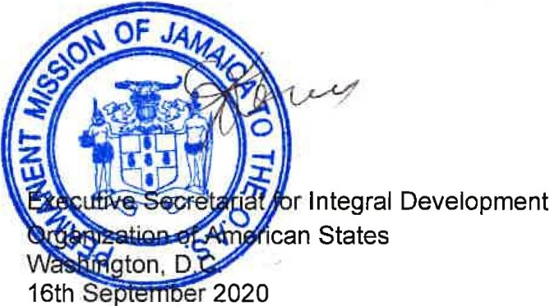
CIDRP03318E01

