OEA/Ser.G
CP/INF. 9008/21
30 June 2021
Original: Spanish

NOTE FROM THE PERMANENT MISSION OF PERU, ADVISING THAT AMBASSADOR HUGO DE ZELA, PERMANENT REPRESENTATIVE OF PERU, WILL NOT BE ABLE TO ASSUME THE CHAIR OF THE PERMANENT COUNCIL THAT FALLS TO PERU FROM JULY 1 TO SEPTEMBER 30, 2021

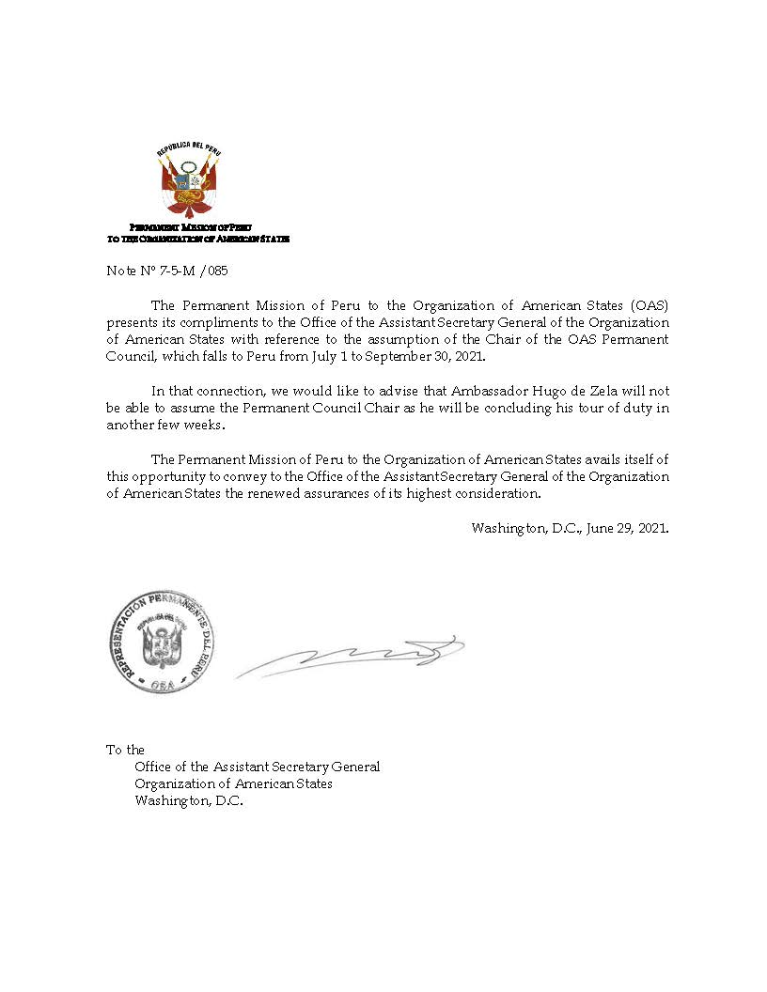
CP44301E01

