OEA/Ser.W
CIDI/INF. 475/21
11 November 2021
Original: Spanish

NOTE FROM THE PERMANENT MISSION OF GUATEMALA SUBMITTING FOOTNOTE TEXT FOR INCLUSION IN OPERATIVE PARAGRAPH 47 OF THE RESOLUTION “ADVANCING HEMISPHERIC INITIATIVES ON INTEGRAL DEVELOPMENT: PROMOTING RESILIENCE”

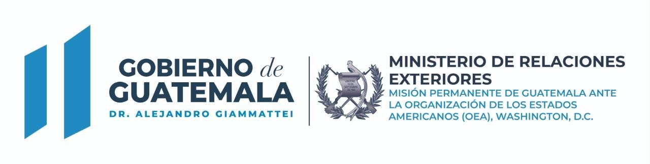
Ref. NV-OEA-M4-No.877-2021

The Permanent Mission of Guatemala to the Organization of American States (OAS) presents its compliments to the honorable Secretariat of the Inter-American Council for Integral Development (CIDI) of the OAS, and notes its wish to make reference to the resolution “Advancing Hemispheric Initiatives on Integral Development: Promoting Resilience.”

The Permanent Mission of Guatemala to the Organization of American States (OAS) respectfully submits a footnote to be inserted under ‘racial superiority’ in paragraph 47 of the strategic line “Fostering the promotion and protection of the human rights of migrants, including migrant workers and their families, in accordance with the Inter-American Program on this subject to enhance their contribution to development”:
CIDI04802E04

In keeping with the language set out in Objective 17, paragraph 33, of the Global Compact for Safe, Orderly and Regular Migration, which states: “We commit to eliminate all forms of discrimination, condemn and counter expressions, acts and manifestations of racism, racial discrimination, violence, xenophobia and related intolerance against all migrants in conformity with international human rights law,” the State of Guatemala does not recognize the term “racial superiority” in migration issues. In accordance with the New York Declaration, it takes measures to counter racially discriminatory attitudes and behaviors and crimes driven by prejudice related to hate speech and racial violence.

The Permanent Mission of Guatemala to the Organization of American States (OAS) avails itself of the opportunity to assure the honorable Secretariat of the OAS Inter-American Council for Integral Development (CIDI) of its highest consideration.
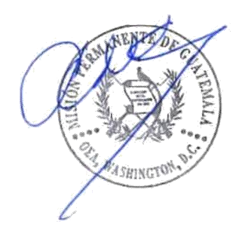

Washington, D.C., November 5, 2021
To the honorable Secretariat of the Inter-American Council for Integral Development (CIDI) of the OAS
Organization of American States (OAS)
Washington, D.C.

22nd Street NW Washington, D.C. 20037
Tel: 00 1202-8334015 / 00 1202 833-4016 /17

