OEA/Ser.W
CIDI/INF. 452/21
14 September 2021
Original: Spanish

NOTE FROM THE PERMANENT MISSION OF ECUADOR OFFERING TO HOST THE XXVI INTER-AMERICAN CONGRESS OF MINISTERS AND HIGH-LEVEL AUTHORITIES OF TOURISM AND SUBMITTING CANDIDACY

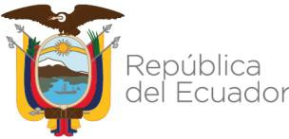
Ministry of Foreign Affairs and
Human Mobility

PERMANENT MISSION TO THE OAS IN WASHINGTON

4 - 2 - 241 / 2021

The Permanent Mission of Ecuador to the Organization of American States (OAS) presents its compliments to the Executive Secretariat for Integral Development (SEDI) and has the honor to submit herewith the offer by the Ministry of Tourism to host the Twenty-Sixth Inter-American Congress of Ministers and High-Level Authorities of Tourism in 2024, as well as its candidacy for one of the positions of Vice Chair of CITUR, further to the announcement made by the Ecuadorian delegation at the September 3, 2021 preparatory meeting for said Ministerial.

The Permanent Mission of Ecuador to the Organization of American States avails itself of this opportunity to convey to the Secretariat for Integral Development (SEDI) renewed assurances of its highest consideration.

Washington, D.C., September 3, 2021

To the
Executive Secretariat for Integral Development (SEDI)
CIDRP03311E04

