OEA/Ser.W
CIDI/INF. 538/23
27 March 2023
Original: English

NOTE FROM THE PERMANENT MISSION OF THE COMMONWEALTH OF THE BAHAMAS INFORMING OF ITS GOVERNMENT OFFER TO HOST THE FOURTH INTER-AMERICAN MEETING OF MINISTER AND HIGH-LEVEL AUTHORITIES ON SUSTAINABLE DEVELOPMENT AND PRESENTING A NOMINATION FOR CHAIRMANSHIP OF THE INTER-AMERICAN COMMITTEE ON SUSTAINABLE DEVELOPMENT (CIDS)
PERMANENT MISSION OF THE COMMONWEALTH OF THE BAHAMAS TO THE
600 NEW HAMPSHIRE AVENUE, NW, SUITE 640
WASHINGTON, DC 20037

NOTE NO. 13/2023
The Permanent Mission of the Commonwealth of The Bahamas to the Organization of American State (OAS) presents its compliments to the Executive Secretariat for Integral Development of the OAS and has the honor to refer to the convocation of the 4th Inter-American Meeting of Ministers and High-Level Authorities on Sustainable Development and 6th Regular Meeting of the Inter-American Committee for Sustainable Development (CIDS), respectively.

In this vein, the Permanent Mission wishes to inform that the Government of The Bahamas wishes to advise of the intention of The Bahamas to host the 4th Inter-American Meeting of Ministers and High-Level Authorities on Sustainable Development in October 2023. Further, the Permanent Mission also wishes to inform that the Government of The Bahamas wishes to offer the candidacy of Senator the Honourable Michael Halkitis, Minister for Economic Affairs, to serve in the capacity as Chair of the Inter-American Committee for Sustainable Development (CIDS).

The Permanent Mission would be grateful for the assistance of the Secretariat with circulation of this Note to all Member States.

The Permanent Mission of the Commonwealth of The Bahamas avails itself of this opportunity to renew to the Executive Secretariat for Integral Development of the OAS the assurances of its highest consideration.
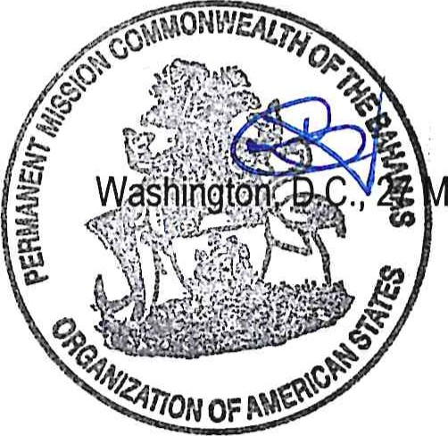
March, 2023
Executive Secretariat for Integral Development
Organization of American States 1889 F St NW
Washington, D.C.

Link to the original note: http://scm.oas.org/pdfs/2023/BAHAMASNV13DESARROLLOSOSTENIBLE.pdf
CIDRP03807E01

